Inside AI Student Lab Sheet
A 10th/11th-grade extension to AI, the Brain, and Serviam

Big idea
AI is not magic. It is math trained on patterns. Human wisdom decides whether, when, and how to use it.

The pathway
What happens after you press Enter?
Prompt -> Tokens -> Token IDs -> Vectors -> Weights -> Loss -> Probability -> Attention -> Response -> Human Review

Core terms
Term | Student-friendly meaning | Math or CS link
Token | A chunk of text, such as a word, subword, punctuation mark, or character. | Text processing
Token ID | A number assigned to a token so the computer can process it. | Data representation
Vector | A list of numbers. Example: robot = [0.12, -0.44, 0.81, ...] | Arrays and geometry
Embedding | A vector that helps represent relationships learned from data. | Similarity search
Weight | A number that controls how strongly one input affects the next step. | Weighted sum
Loss | A score for how far the model output was from the target output. | Error measurement
Softmax | A step that turns scores into probabilities that add up to 1. | Probability distribution
Attention | A weighting method that helps the model decide which words matter most in context. | Context relationships
Loop | A repeated set of steps. A base language model predicts, adds, and continues. | Pseudocode
Human review | The final check for accuracy, privacy, fairness, and purpose. | Responsible use

Three simple models
Idea | Model | Meaning
Function | f(x) = y | Input -> model -> output
Weighted sum | z = w1*x1 + w2*x2 + b | Weights decide which signals matter more
Attention | compare -> weight -> combine | The model weights relationships in context

Website simulation 1: Tokens and Similarity
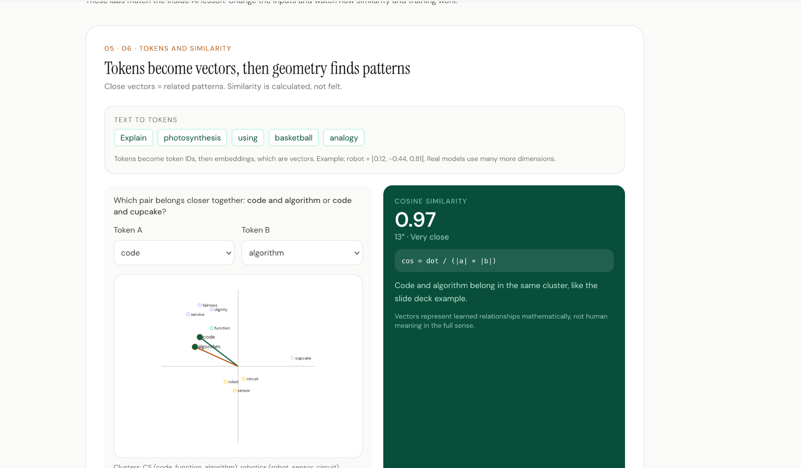
Simulation 1 shows token chips, vector clusters, and cosine similarity. Use it to compare related and unrelated terms.
Step | Student task
1 | Choose code and algorithm. Record the cosine similarity.
2 | Change Token B to cupcake. What happens to similarity?
3 | Explain why code and algorithm cluster closer than code and cupcake.
4 | Use the word justice. Which cluster would it belong near: code, robotics, or service? Defend your answer.

Website simulation 2: Weights and Loss
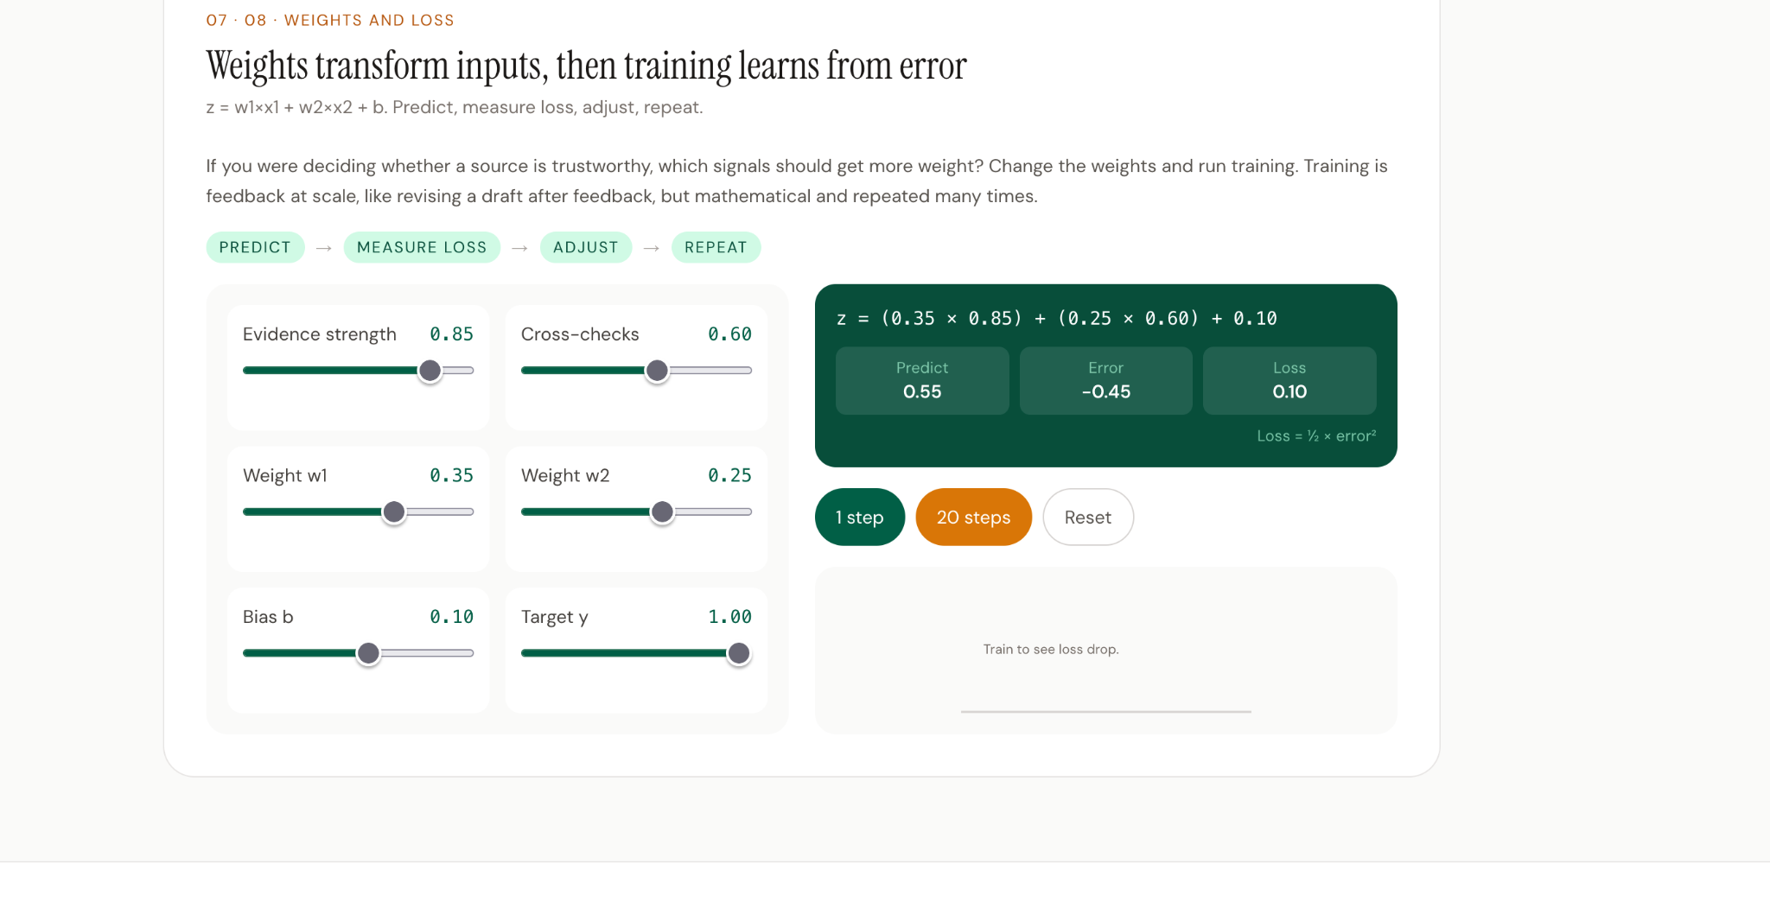
Simulation 2 shows sliders for inputs and weights, then visualizes prediction, error, and loss.
Step | Student task
1 | Set evidence strength and cross-checks high. Predict whether loss should be high or low.
2 | Change one weight. What happens to prediction, error, and loss?
3 | Run 1 step, then 20 steps. What changes after training?
4 | Write one sentence connecting training to feedback and revision.

Exit ticket: explain how AI works
4 to 5 sentence challenge
Explain how AI creates a response. Include one math idea, one computer science idea, one science/testing idea, and one reason human review still matters.
Sentence starter | Your explanation
AI starts by... | __________________________________________________________________
The math part is... | __________________________________________________________________
The computer science part is... | __________________________________________________________________
The model generates by... | __________________________________________________________________
A human still needs to review because... | __________________________________________________________________

