*This is a simple guide to get Selenium IDE running to play automated test scripts. A more in depth guide can be seen* [*here*](http://www.seleniumhq.org/docs/02_selenium_ide.jsp#installing-the-ide)*.*

**Selenium IDE Setup**

1. Download Firefox
   1. <https://www.mozilla.org/en-US/firefox/new/>
2. Add Selenium IDE extension for Firefox
   1. <https://addons.mozilla.org/en-US/firefox/addon/selenium-ide/>
3. Restart Firefox > Open hamburger menu > Customize > Click the Selenium Icon and move it next to the hamburger menu > Exit Customize

**Opening Selenium IDE and Running Scripts**

1. Click the Selenium icon on Firefox and the Selenium IDE window should open
2. Copy the HTML code from which script you want to run
3. Go to Selenium IDE window and click “Source.” Paste the HTML code into the script-editing window
   1. 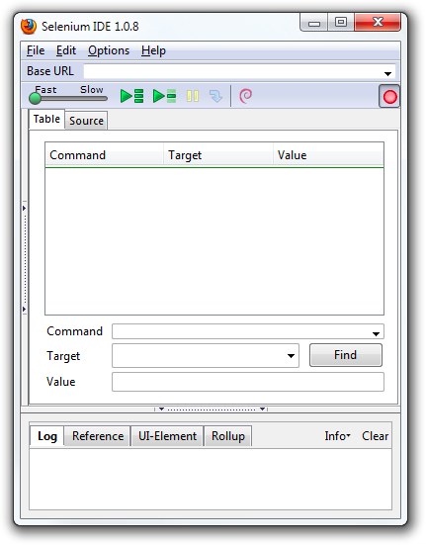
4. Click “Table” and run the script by pressing the green play button on the Selenium IDE toolbar
   1. 