Trace-cmd screenshot for normal thread execution interrupted by a signal.
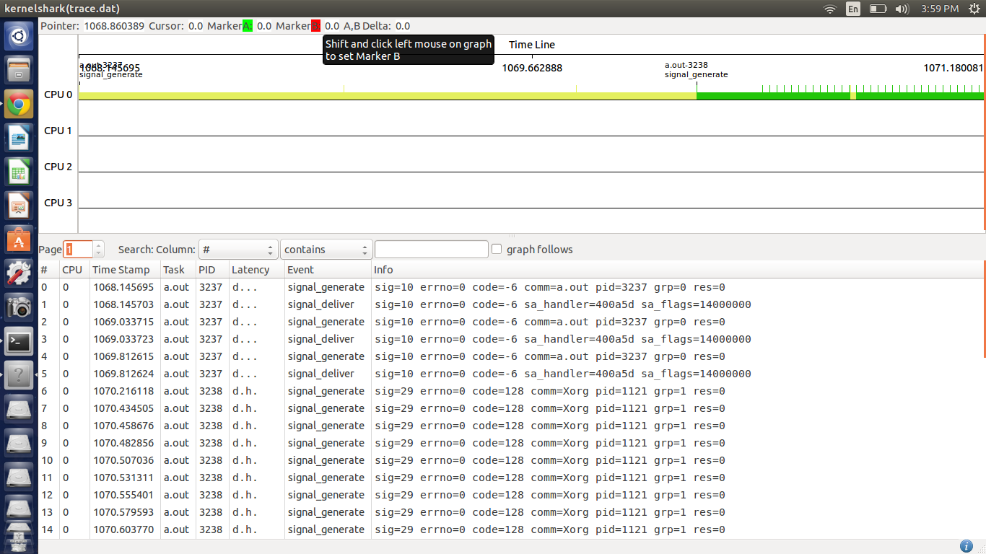

Signal is handled normally.

Trace-cmd screenshot of highpriority thread running along with a low priority thread
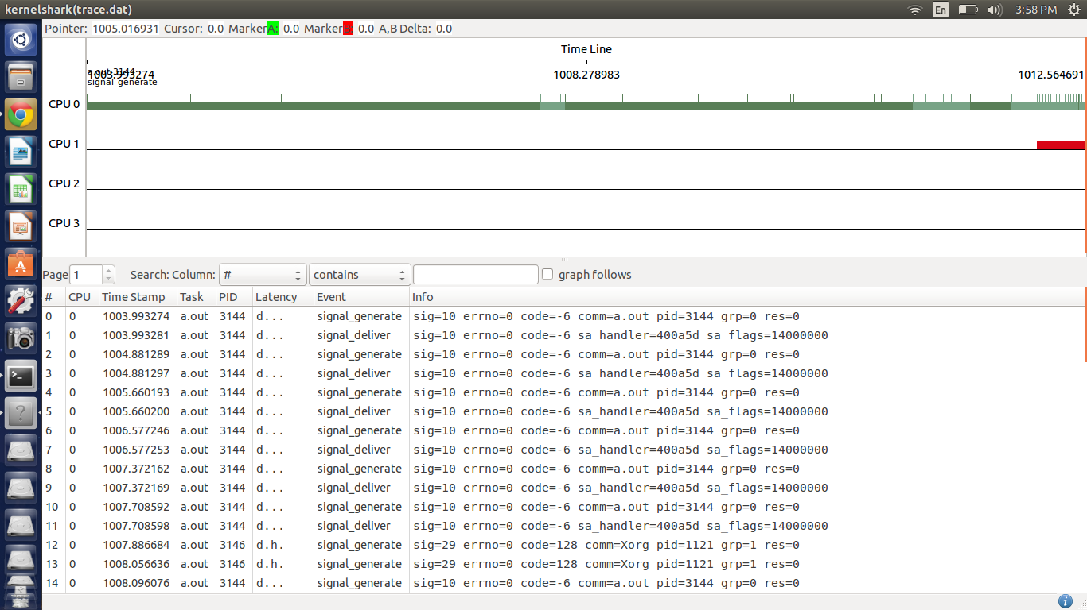
In this case the low priority thread is preempted and highpriority thread assumes execution making it the signal reciever for that process.

Screen shot for Sem_wait thread.
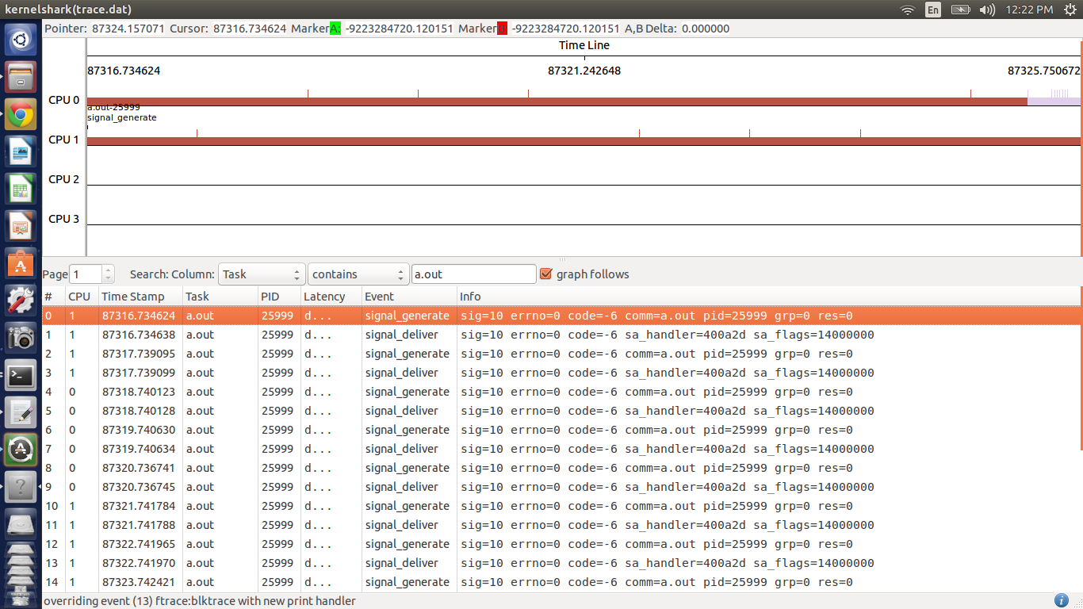
Here the thread will come out of semaphore wait and will set EITR if signal flag is not set to SA_RESTART. If it is set it will go back to waiting.

Screen shot for sleeping thread thread.
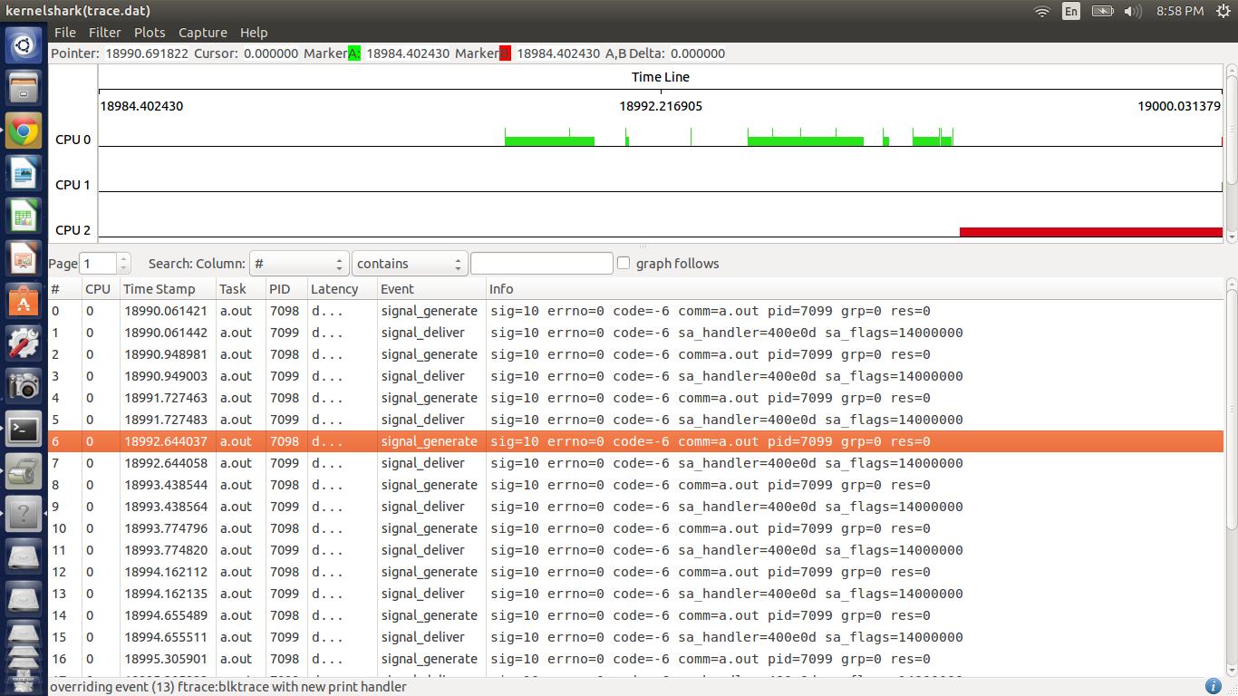
Here the sleeping thread wakes up handles the signal and then doesnot go back to sleep instead assumes its normal course.

