Real Time Embedded System
Assignment-1
Real Time Scheduling of Threads

ID:
1207888353
Name:
Shivanshu Shukla
the input file is as follows:

4 6000
P 20 20 10 L1 1995000 U1 300
P 80 25 40 L1 200000 U1 100
P 40 30 20 L2 400000 U2 100
A 10 0 500

Scheduling of tasks as shown in kernelshark:
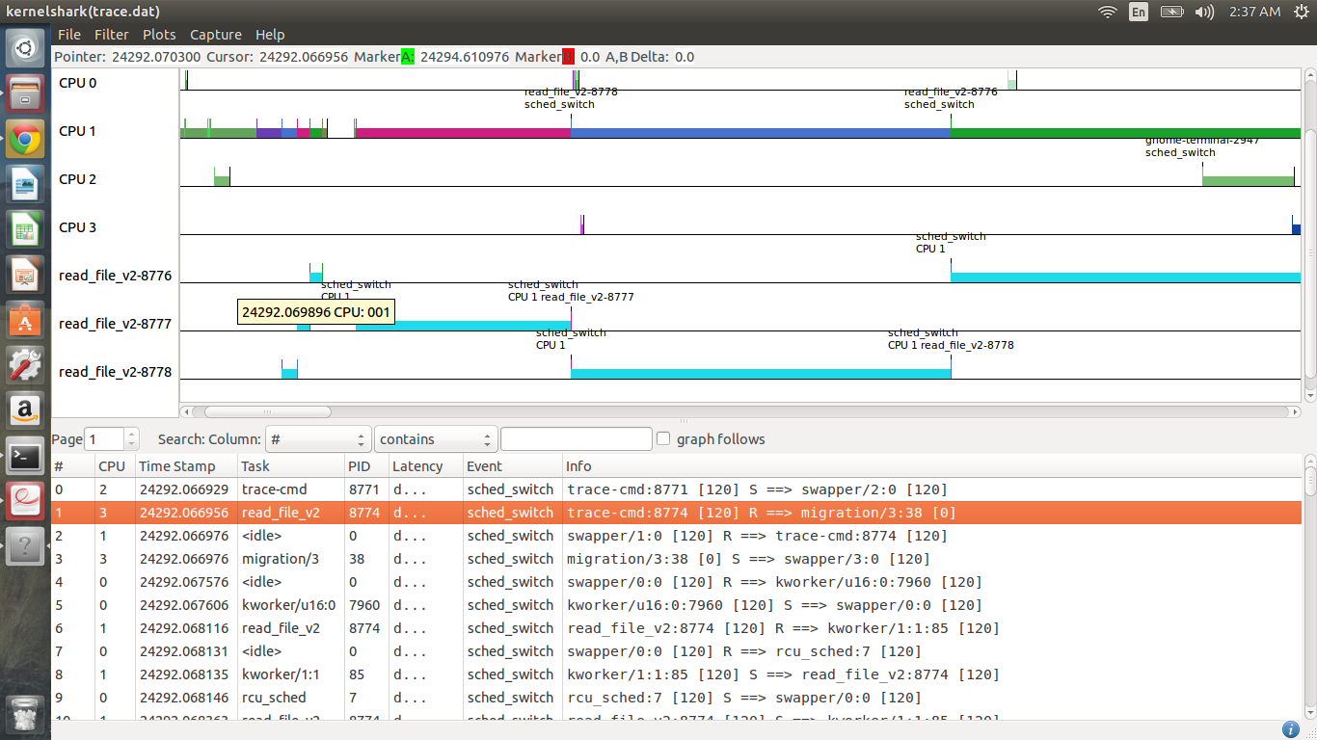
in the image pid-8777 has the highest priority hence is scheduled immediately then comes 8778 with priority as 40 and then comes 8776 with priority as 20.

complete execution image:
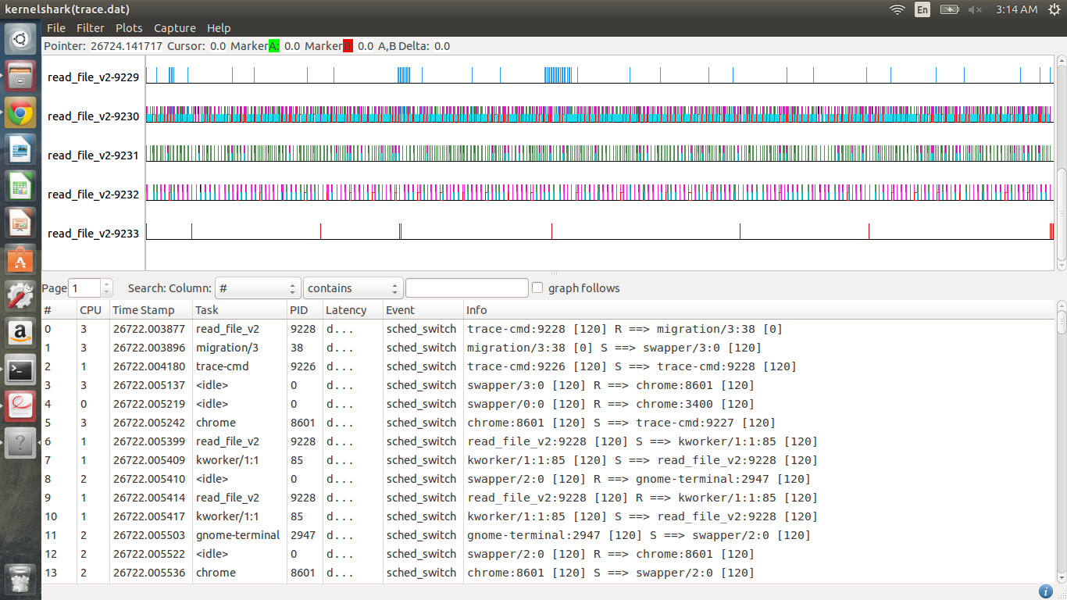
Task overrun condition occuring:
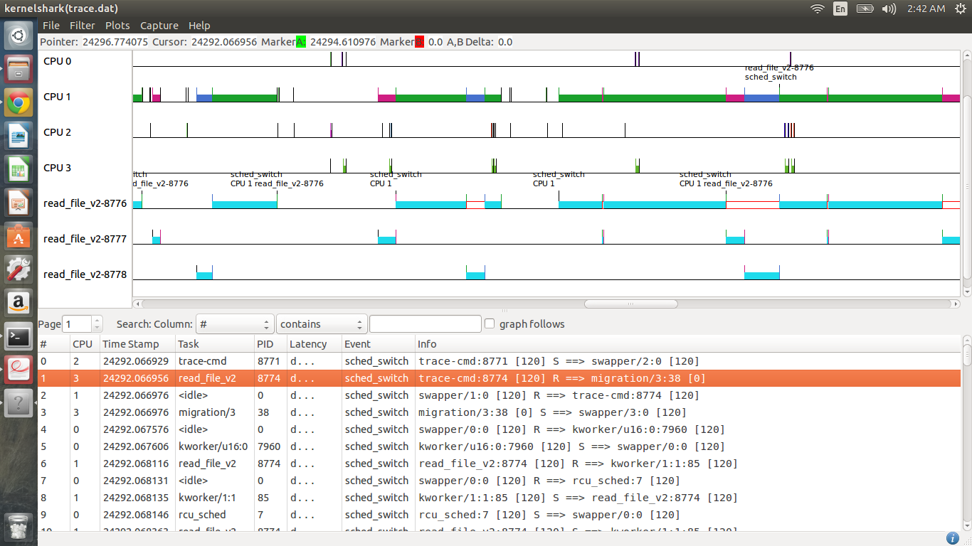
In this image pid-8776 is overrunning due to preemption by 8777 and 8778 pid.

Priority inversion observation:
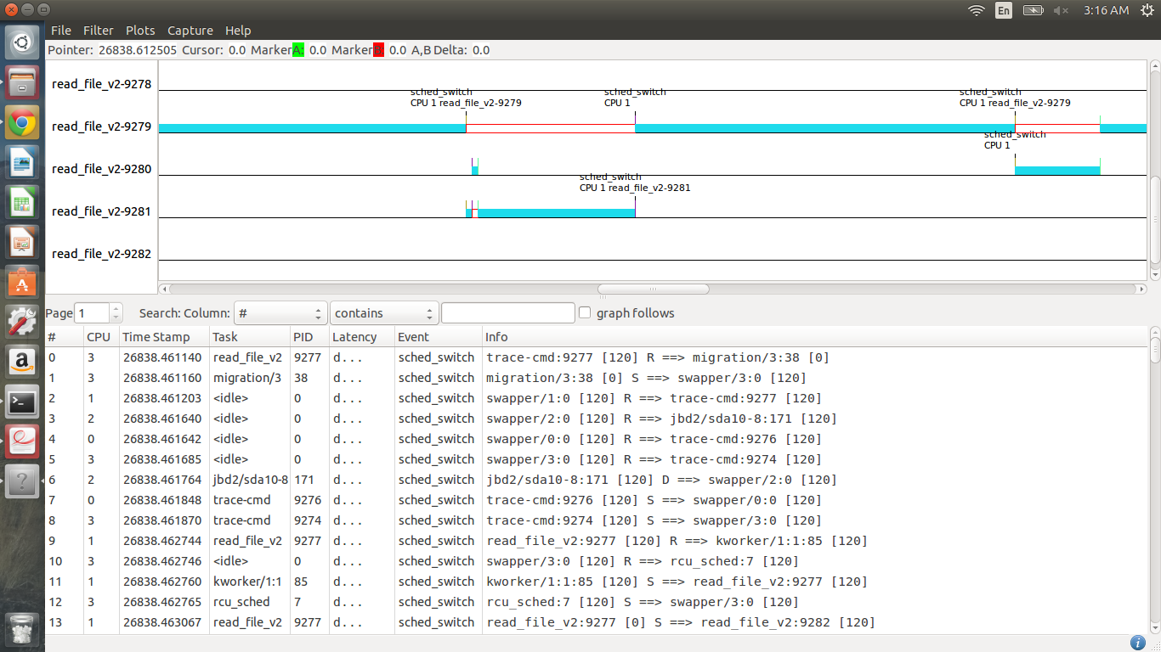
Here task 9279 is running and is holding lock L1 now 9280 with priority 80 tries to acquire L1 but is unable to acquire hence moves to blocked state and at the same time 9281 with priority 40 enters and preempts 9279.

Priority inheritance:
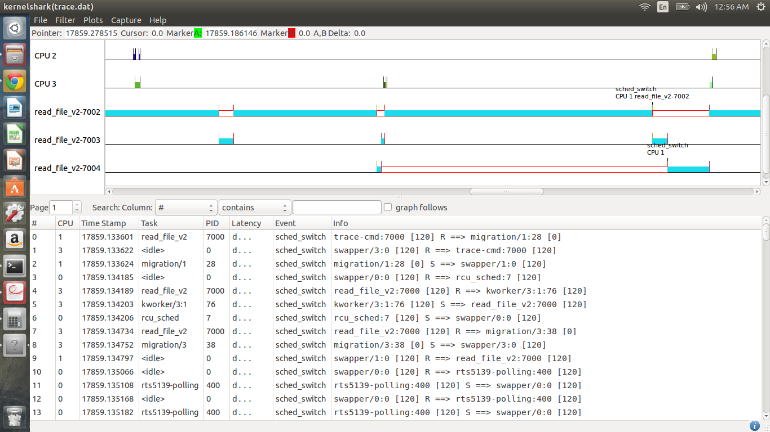
In this image task 7002 is holding L1 and now 7003 tries to acquire it but cannot acquire the lock so gets blocked now task 7004 with priority 40 tries to run but is preempted by 7002 which is now of temporary priority 80.

