VIEWFLIX - Database Management System Report
Movie & TV Streaming Platform - COMP2004 Term Project
Defne Kaya - Goktug Karaca | Instructor: Pinar Efe | June 2026

1. Introduction
VIEWFLIX is a relational database system for a streaming platform that manages users, content, subscriptions and user interactions efficiently, while ensuring data integrity and reducing redundancy through a fully normalized design.

2. Objective
- Minimize data redundancy through normalization.
- Ensure data integrity using primary and foreign keys.
- Efficiently handle many-to-many relationships.
- Support scalable data management for a streaming platform.

3. System Analysis and Requirements
The VIEWFLIX database supports: user registration and account management; subscription plans (Basic, Standard, Premium) and payment status; movies and TV series under one content model; genre categorization; cast and crew (actors, directors, writers, producers); watch history; favorites; and ratings and reviews.

4. Database Design Approach
A relational model is used where each entity is a table and relationships are implemented with foreign keys. Many-to-many relationships are resolved using bridge (associative) tables: Content_Genres (Content-Genres), Content_Cast (Content-People) and Favorites (Users-Content).

5. Normalization (3NF)
1NF: all attributes are atomic and repeating groups are eliminated. 2NF: all non-key attributes are fully dependent on the whole primary key; composite-key tables such as Content_Genres have no partial dependency. 3NF: there are no transitive dependencies - each attribute depends only on its table's primary key. The design eliminates redundancy and ensures consistency.

6. Entity Relationship Diagram
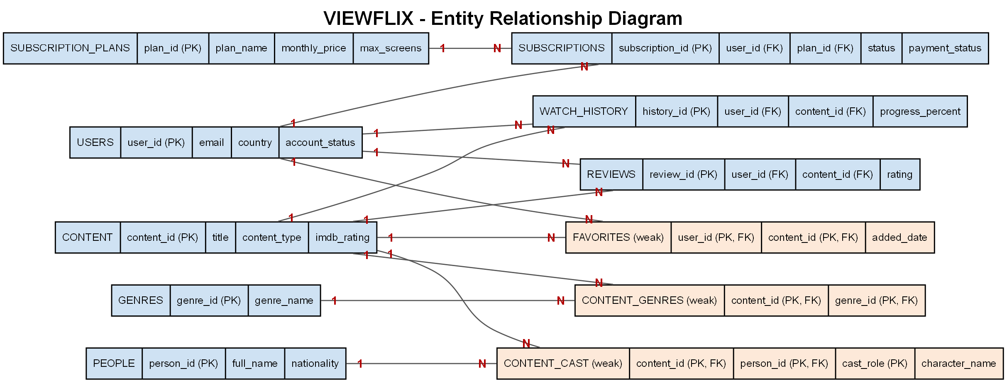
Blue = strong entities; orange double-border = weak/associative entities. All relationships are 1:N.

7. Entities and Keys
Strong entities (own primary key): Users (user_id), Subscription_Plans (plan_id), Subscriptions (subscription_id), Content (content_id), Genres (genre_id), People (person_id), Watch_History (history_id), Reviews (review_id).
Weak / associative entities (composite primary key): Content_Genres (content_id, genre_id); Content_Cast (content_id, person_id, cast_role); Favorites (user_id, content_id).
Primary keys uniquely identify each record; foreign keys maintain relationships and referential integrity (e.g. each subscription links to a valid user and plan; each review links to a valid user and content). Extra constraints include UNIQUE (email) and CHECK (e.g. rating between 1 and 10).

8. SQL Implementation
DML: meaningful INSERT, UPDATE and DELETE operations (e.g. suspend a user, cancel a subscription, update a review rating, remove a favorite, mark watch history complete).
Queries: 15 statements in three groups - 5 simple (filtering/sorting), 5 complex (JOIN and subquery) and 5 aggregation (GROUP BY / HAVING). Examples: movies ordered by IMDb rating; content rated above the average (subquery); average rating per title (GROUP BY); monthly revenue per plan; genres linked to more than one title (HAVING).

9. Conclusion
VIEWFLIX successfully models a streaming platform using a fully normalized relational structure. It ensures data integrity, reduces redundancy and supports scalable operations. By applying 3NF and proper relational design, the system achieves efficient and consistent data management.

