The Android emulation has encountered so many issues and so much has changed since I started less than a year ago that a whole new set of commands and actions are required. If the following is encountered:
Npx cap sync results in error:
System updates can mangle the process: it was first necessary to update all capacitor packages to the same version:
npm install @capacitor/core@latest @capacitor/cli@latest @capacitor/ios@latest @capacitor/android@latest

CURRENT STATE [ANDROID]:
- The capacitor project, including node_modules, configurations, android and ios emulators, etc. is located in ~/src/ktesa_app. The app code itself is completely contained in the www/ sub-folder (under git version control), whereas everything above that is related to the emulator and Capcitor tools. Note that any reference to assets in the app must all be held in the www/ folder. E.g. I originally had webpack emit the bundle to ktesa_app/dist, but the emulator could not ‘see’ it, so I moved it to: ktesa_app/www/scripts.
- Particulary for jQuery $.ajax commands, the Capacitor’s HTTP ‘native bridge’. This is specified in the ktesa_app/capacitor.config.json file:
{
"appId": "com.nmhikes",
"appName": "Offline Maps",
"webDir": "www",
"plugins": {
"CapacitorHttp": {
"enabled": true
}
}
}
Note: after making this change (if not previously there), run npx cap sync android
- Another important config item is in android/app/src/main/AndroidManifest.xml where permissions are set. Primarily: “android.permission.INTERNET”
- Multiple plugins are required for the project. They appear to be held in the android/app/src/main/assets/capacitor.plugins.json, but there may be other locations (?). At the very least, it can be seen what plugins are being utilized by examining this file:
[
{
"pkg": "@capacitor-community/background-geolocation",
"classpath":
"com.equimaps.capacitor_background_geolocation.BackgroundGeolocation"
},
{
"pkg": "@capacitor-community/sqlite",
"classpath":
"com.getcapacitor.community.database.sqlite.CapacitorSQLitePlugin"
},
{
"pkg": "@capacitor/filesystem",
"classpath": "com.capacitorjs.plugins.filesystem.FilesystemPlugin"
},
{
"pkg": "@capacitor/geolocation",
"classpath": "com.capacitorjs.plugins.geolocation.GeolocationPlugin"
}
]
}
]

- ** Every time the app code is changed, the following commands must be issued:
npm run build
npx cap sync android
- The ‘Play’button in Android Studio [Green right-pointing triangle at the top] does not display the emulator window, so it has to be accomplished ‘manually’ with several shell commands. These commands are kept in the executable script ktesa_app/emulate-Android:
#!/bin/bash
emulator -avd Pixel_5 -gpu host &
echo "Waiting for emulator to boot..."
until adb shell getprop sys.boot_completed 2>/dev/null | grep -q "1"; do
sleep 2
done
echo "Emulator ready: clear cache"
adb shell pm clear com.nmhikes
cd android
. /gradlew installDebug
adb shell am start -n com.nmhikes/.MainActivity

NOTE: To restart the app without killing the emulator window [./killProc-Android]:
adb shell am force-stop com.nmhikes
adb shell am start -n com.nmhikes/.MainActivity

- To terminate emulation:
  - ctl-C to kill emulator shell activity
  - The pkill commands are now in an executable: ktesa_app/killProc-Android:
  - #1 #!/bin/bash
  - #2 echo “Shutting down Android emulator and all related processes:
  - #3 adb devices | grep “emulator-” | while read -r emulator _; do
  - #4 echo “ Killing emulator: $emulator
  - #5 adb -s “$emulator” emu kill-server
  - #6 done
  - #7 adb kill server
  - #8 pkill -9 -f “emulator” 2>/dev/null
  - #9 pkill -9 -f “qemu-system 2>/dev/null
  - #10 pkill -f ‘GradleDaemon’ 2>/dev/null
  - #11 pkill -f ‘java.*gradle’ 2>/dev/null
  - #12 pkill -f ‘java.*android’ 2>/dev/null
  - #13 pkill -f ‘cap run android’ 2>/dev/null
  - #14 pkill -f ‘ionic serve’ 2>/dev/null
  - #15 pkill -f ‘vite.*android\|webpack.*watch’ 2>/dev/null
  - #16 echo “Done. Verifying nothing remains…”
  - #17 ps aux | grep -E “emulator|qemu|adb|gradle” | grep -v grep

- The CapacitorJs documentation says to supply a key:value pair – encoding: FilesystemEncoding.UTF8 when writing a string to Directory.Data [apparently I can no longer use Directory.Documents, not sure why]. In order for the constant to be recognized, it is important to include: import {Filesystem, Directory, Encoding}
- Writing to files:
  - When using mkdir, make sure to specify ‘recursive: true’
  - When writing (saving) a file to the Filesystem, the ‘path:’ must end in a filename.
  - Generally (not required) append an extension to clarify what’s being stored.

- Android vs iOS locations:

- Once the emulator window is live and the app is loaded, the standard Chrome dev window can be used to display the console, breakpoint source code, etc. Open Chrome and type in the address bar: Chrome://inspect A tab will open – click on the ‘inspect’ link near the bottom of the text. Now the dev window/console should open.
- Due to having to update to a new android version, other changes are also now required. The Android Studio no longer will display the /data listing when selecting View→Tool Windows → Device Explorer, so shell commands must be used to examine the file system, read and/or delete files (when the emulator is running). The shell commands have been saved as executables (but file names will need to be changed):
  - adbDeleteFolder: adb shell run-as com.nmhikes rm -rf /data/data/com.nmhikes/files/_folder
  - abdDiskUsage: adb shell run-as com.nmhikes du -sh /data/data/com.nmhikes/files/*
  - abdListFiles: adb shell run-as com.nmhikes ls -la /data/data/com.nmhikes/files
  - adbReadFile: adb shell run-as com.nmhikes cat data/data/com.nmhikes/files/_textFile
  - abdTBDeleted: adb shell run-as com.nmhikes find /data/data/com.nmhikes/files/_folder -type f

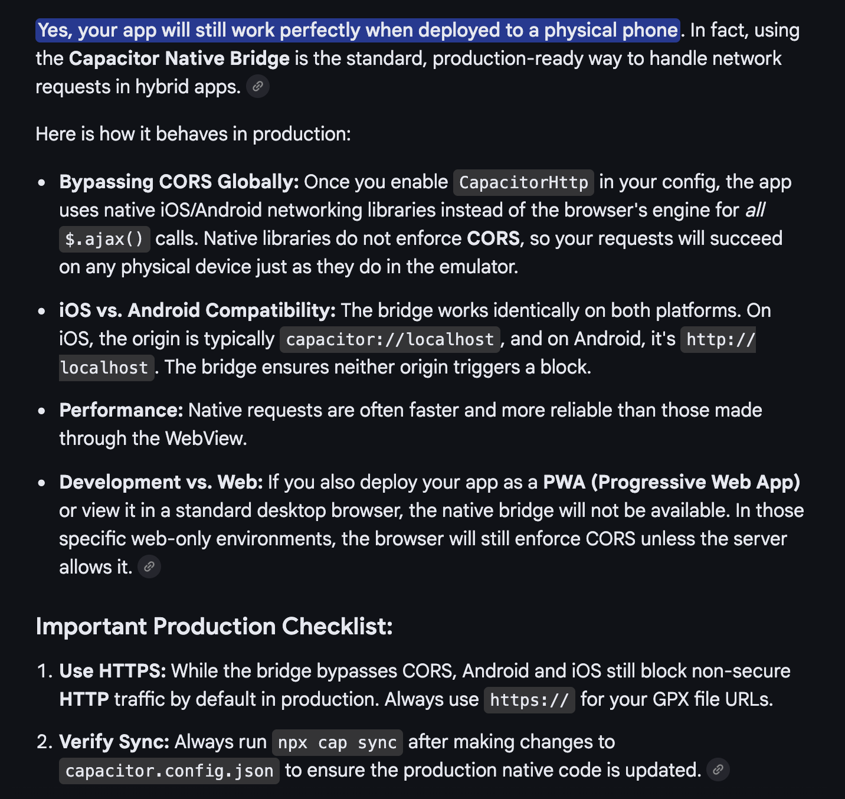
AI Answer to my concern about use the Capacitor HTTP bridge in my app:
For some reason the emulator went kablooey and I had to reinstall things with AI help. It took a couple of hours to resolve! After finally successfully troubleshooting, the comments were:

For future reference, if this ever happens again the fix is:
- rm -rf the corrupted system image folder manually :
rm -rf ~/Library/Android/sdk/system-images/android-33/google_apis/arm64-v8a
- verify it’s gone:
ls ~/Library/Android/sdk/system-images/android-33/google_apis/
- sdkmanager reinstall it fresh:
sdkmanager "system-images;android-33;google_apis;arm64-v8a”
- avdmanager create to recreate the AVD:
avdmanager create avd \
-n Pixel_5 \
-k "system-images;android-33;google_apis;arm64-v8a" \
-d "pixel_5"
- Repeat above but replace ‘5’ with ‘7’

The root cause was almost certainly an SDK update that corrupted or partially removed the system image, combined with sdkmanager --uninstall not cleaning up properly. Good luck with the Capacitor app!

