The current mode of distribution is “Test Flight - Internal”. This allows distribution of up to 99 testers (including self).

SETTING UP TEST FLIGHT:
Requirement: Sign up for access at: developer.apple.com/programs/enroll for a annual fee of $99. Builds are available almost immediatedly. In addition to the early debug process using ‘Internal’ distribution, ‘External’ distribution allows for up to 10,000 testers. Builds for external testing require a brief Beta App Review from Apple, taking a day or two (?). Once enrolled at the above site, download the free app “Test Flight” onto your iPhone.

After enrollment (requiring Apple ID), signing in to developer.app.com/ will take you to the ‘Account’ page. Here appears App Store Connect; Certificates, IDs and Profiles (needed when rebuilding ios), and Services. Clicking on the App Store Connect→Apps takes you to a page of your apps (after first install, only ‘NM Hikes’).

[FIRST TIME] For a brand new app, click on the ‘+’ icon next to ‘Apps’. See “APP DISTRIBUTION [FIRST TIME USE]”, below, to first set up the Bundle Identifier (usually com.appname for CapacitorJS apps) in the ‘General’ tab. This must be done before proceeding, as the ‘+’ process requires a ‘Bundle ID’ matching the General tab spec. For ‘SKU’ supply the desired name for your app. If an ‘Export Compliance’ popup appears, answer ‘No’ for standard apps. When the app appears on the Apps page, click on the ‘Test Flight’ tab. Hit the ‘+’ icon, go to ‘Testers’ and add yourself under the ‘Internal’ testing (create a name, here ‘NMHikesTeam’). An email invite will go out to install the app.

If not new, click on NM Hikes to see a page with tabs, including Test Flight. The Test Flight page lists all uploaded builds to date, and on the sidebar, ‘Testers: Internal and External’. Under ‘Internal’ is listed ‘NMHikesTeam’.

[continued...]

ADDING NMHikesTeam MEMBERS:
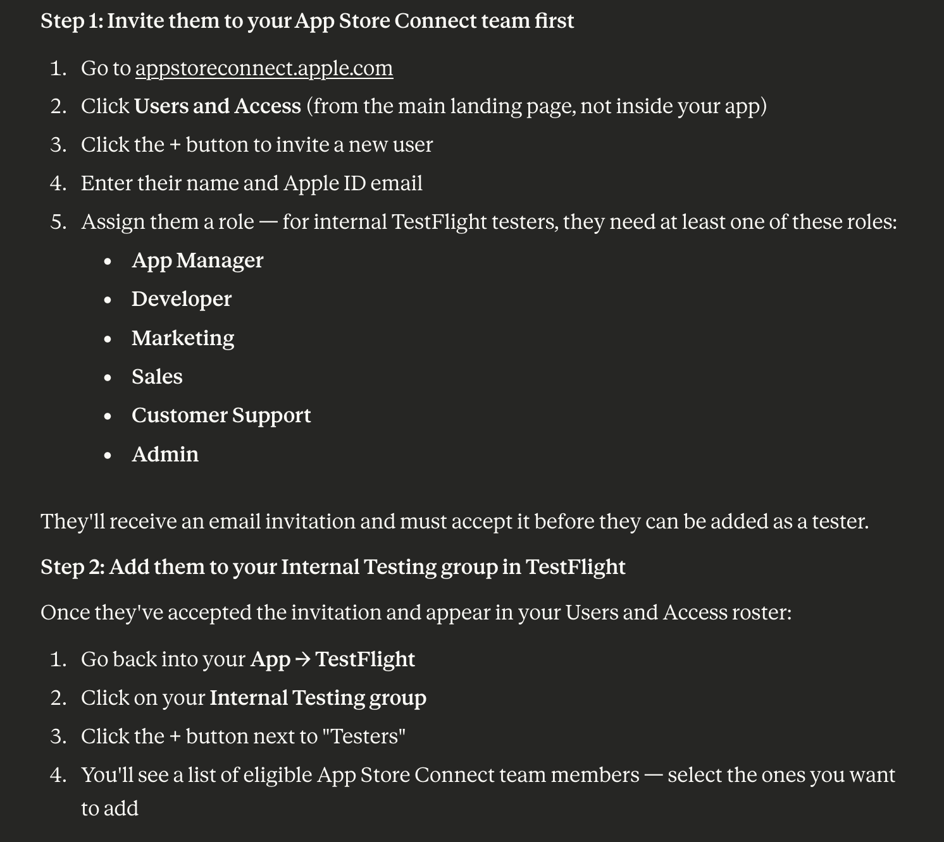

IMPORTANT!!
The invitation must be sent to the user’s email account that is associated with his Apple ID, and must be able to be read on his laptop/desktop. Accessing and responding to the link from iPhone email can lead to a frustrating experience where the link goes to a blank page with a non-responsive spinning wheel! The user reads and responds to the invitation from the laptop/desktop and is taken to a place where he must login, again using the Apple ID. Once in, there may be a ‘Redeem Code’ he will have to use when he opens Test Flight. If no code is present, he simply opens Test Flight and installs the app.

NOTE: The role assigned only affects what the individual can do inside App Store Connect. Most restrictive (best use here) are ‘Marketing’ and ‘Customer Support’.

APP DISTRIBUTION:
Use the following process to ensure up-to-date and consistent results:

npm run build
npx cap sync ios [or leave off ios to sync both ios and android]
npx cap open ios
In the left-hand sidebar of the ios window, click on the folder icon, and then ‘App’ and also ‘Targets: App’ in the main window to see the various setup tabs. Select ‘Any iOS Device (arm64) in the top status bar:
[FIRST TIME USE]: In the ‘Signing & Capabilities’ tab, the process required NOT using ‘Automatically manage signing’, but using an uploaded profile (defined later). In the ‘General’ tab, under ‘Background Modes’, make sure ‘Location updates’ is checked. The ‘Identity’ section will later show, under the ‘Bundle Identifier’ [com.nmhikes], the latest version and build number uploaded to App Store Connect.

[NEW UPDATED BUILDS:]
Change the version number and/or build number for each update (General Tab, Identity). Then, from the top menu bar:
Product→Archive
If the build is successful, this will open an ‘Organizer Window’, showing the latest archive, version and build just completed. Make sure the version and build number are ‘solid’ by leaving the tab and returning to see the status. There have been occasions wherein those numbers did not register before creating the archive, resulting in a duplicate archive which cannot be distributed (!)
In the Organizer Window:
Select the new archive (make sure version & build are not duplicates)
Click on Distribute App
Check ‘Test Flight’
Wait for completion. Emails will automatically go out to the internal team for update installation. When received, go to the iPhone’s Test Flight app, open and install the update.

NEXT: External Testing

EXTERNAL TESTING:
