Debugging the app installed on Test Flight (iPhone):

FIRST-TIME SETTINGS:
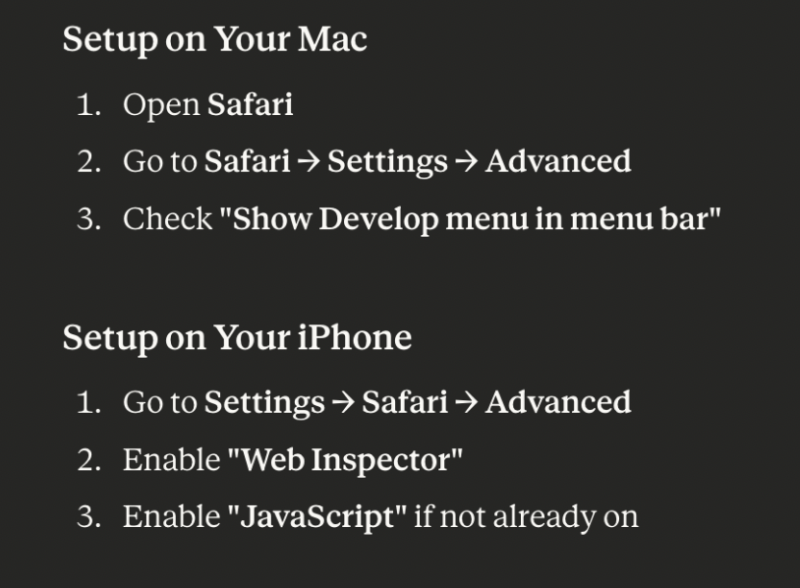

DEBUG PROCESS (VIEWING IN SAFARI BROWSER)
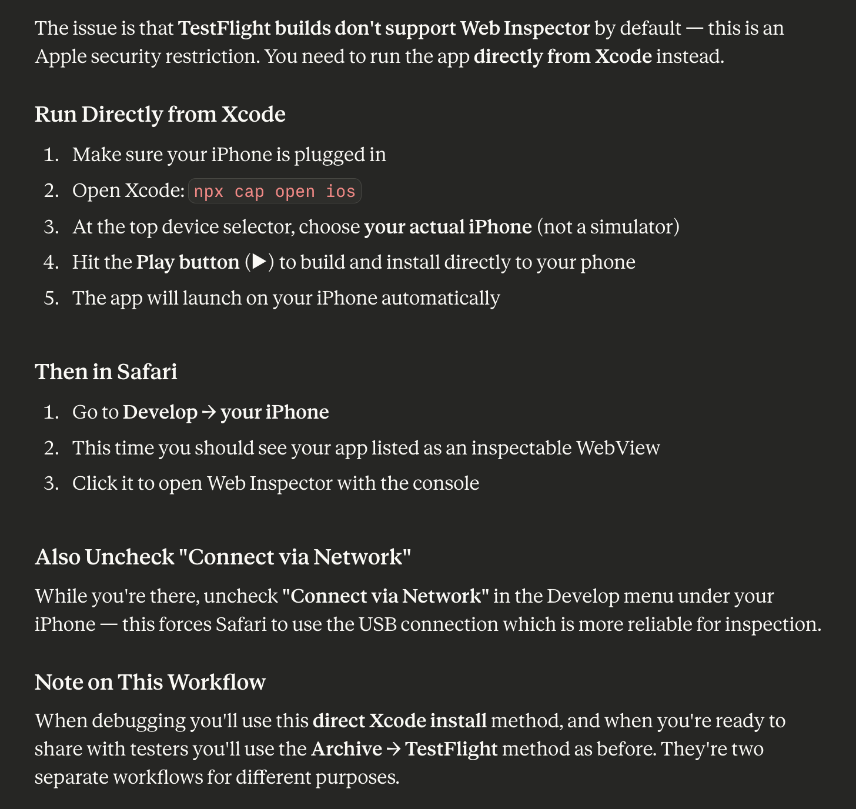

Top bar of Xcode window must show iPhone:
Here’s an interesting by-product of this process:
Whatever was previously installed on the iPhone is now replaced with what was built using Xcode.
E.g. I had version 1.3(4) installed, but was trying to debug the app. I added debug code, rebuilt and re-synced, ran ‘npx cap open ios’, hit the play button, and the new build now resides on the iPhone!! This is a ‘cheap’ way to do testing without re-distributing a new build!!!

SPECIAL CONSIDERATIONS:
When the CapacitorJS ‘ios’ directory was re-generated due to corruption or other issues, some key information was lost (after ‘rm -rf ios’, then using ‘npx cap add ios’). Specifically, the Info.plist needs to have the following additions in order to recognize and use BackgroundGeolocation (without this a crash will happen):

<key>NSLocationWhenInUseUsageDescription</key>
<string>NM Hikes uses your location to show your position on the map.</string>
<key>NSLocationAlwaysAndWhenInUseUsageDescription</key>
<string>NM Hikes uses your location to track your hike even when the app is in the background.</string>
<key>NSLocationAlwaysUsageDescription</key>
<string>This app needs access to location when in the background to track your
route.</string>

and:

<key>UIBackgroundModes</key>
<array>
<string>location</string>
</array>
Also, ensure the following:
- npx open ios; Select ‘Existing Project’; Select the item App→App.xcworkspace.
- Select ‘Signing and Capabilities’ tab
- In Background Modes, make sure “Location updates” is checked.

The above is sufficient to operate BackgroundGeolocation without crashing. However, when distributed to Test Flight and being used on the iPhone, there still may be issues not tracking in background mode. If so, update the ios->App->App->AppDelegate.swift file to add Geolocation as appears below.

import UIKit
import Capacitor
import BackgroundGeolocation // ← Add this import

@UIApplicationMain
class AppDelegate: UIResponder, UIApplicationDelegate {

var window: UIWindow?

func application(_ application: UIApplication,
didFinishLaunchingWithOptions launchOptions: [UIApplication.LaunchOptionsKey: Any]?) -> Bool {
// ← Add this line
BackgroundGeolocation.initialize(launchOptions: launchOptions)
return true
}
// ...
}

When testing on TestFlight, specifically watch for these two distinct failure modes since they point to different fixes:
- App works in foreground but stops updating location when backgrounded → This would point to the AppDelegate.swift hook being needed, or possibly an entitlement issue in your provisioning profile.
- App crashes immediately on BackgroundGeolocation.start() → More likely a provisioning/entitlement mismatch rather than the AppDelegate hook, since the emulator runs fine without it.
One thing to do before your TestFlight upload: make sure your App ID in the Apple Developer portal has the Background Modes capability with Location enabled. This is separate from Xcode — it lives in developer.apple.com → Certificates, Identifiers & Profiles → your App ID → Capabilities. If that's not enabled, TestFlight builds can silently fail on background location even when everything looks correct locally.
To verify:
Log in to developer.apple.com, and under the category “Certificates, IDs and Profiles” click on the Identifiers item, which takes you to a page where com.nmhikes should appear. Click on the app id (com.nmhikes) and a list appears. Check for “Background GPU Access”; if not clicked already, click on it. If not previously checked, a ‘Save’ button appears. Click Save and a popup will appear:

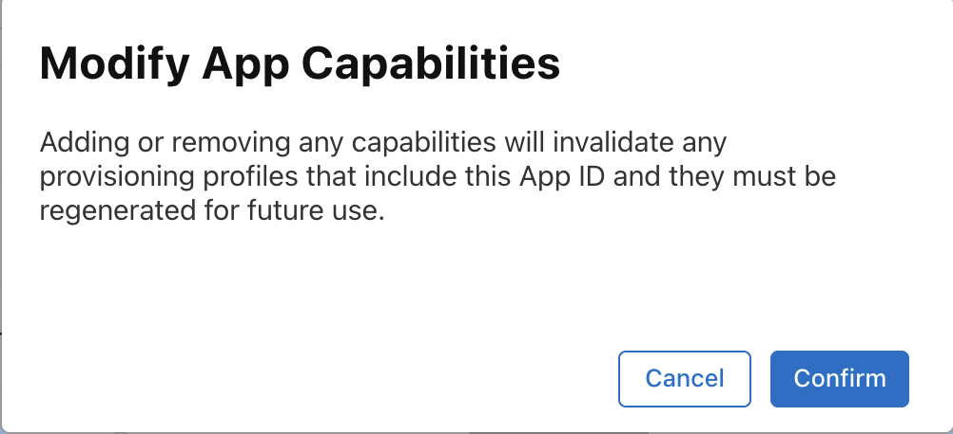

Hit ‘Confirm’ and regenerate the Provisioning profile (named NmhikesProfile) as folows:
Select ‘Profiles’ in the left sidebar. Note the profile name – it may be followd by ‘invalid’. If so, click on ‘Edit’. Regenerate (‘Save’) to generate a new profile which will be downloaded as .mobileprovision.
Double click the file in the Downloads folder which will automatically update Xcode. Open Xcode and select “Existing Project”, then App→xcworkspace. Ensure that, in the top bar, App>Any ios device (arm64) is showing, and not iPhone (iPhone should be disconnected from the Mac and the ios simulator must not be running. Go to the ‘General’ tab and update the build number (and version if needed), the select Product→Archive from the command bar. When the build completes, the Organizer Window opens. When ready, ‘Distribute’ the new archive (to Test Flight). An email should be sent advising of the new update for the iPhone.

