All offline maps are defined by their geographic bounds in terms of latitudes and longitudes. The map bounds are rectangular in nature, and two points are utilized to identify the rectangular bounds: the upper left corner (northwest), and the lower right corner (southeast). The upper left corner has lat/lng’s identified as ‘startX’, and ‘startY’, whereas the lower right corner uses lat/lng’s termed ‘endX’ and ‘endY’. When placed on a tiled map (such as OSM, USGS, Thunderforest, etc), the upper left corner (ul) and lower right corner (lr) will fall within tiles which are identified by their matrix coordinates. Each tile has a unique [row, or “x”, and column, or “y”] identifier, and is further identified by zoom level. Once these corner tiles are identified, the complete set of rectangular tiles can be calculated.

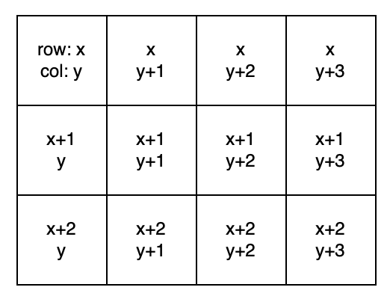
Standard [row, col] designation of tile matrix for any given zoom level

Map bounds on tile matrix at map’s zoom_level
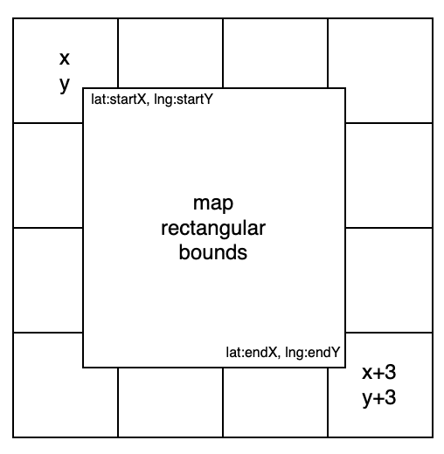

To calculate the tiles needed to represent the map, [startX, startY] and [endX, endY] must be mapped onto their respective tiles (in the case above, [x,y] and [x+3,y+3]. Given these locators, all the tiles intersecting the map can be identified. The function that performs the mapping in the ktesa_app code is ‘getTileUrl(lat, lng, zoom)’ which returns an array [row, col] for the specified zoom. This function is invoked in the ‘idTileCorners()’ function which established the upper-left map tile coordinates (ur[]) and the lower-right coordinates (lr[]). Note that these functions treat the matrix as shown above, regardless of how tiles are fetched.

There are three sets of tiles that need to be saved to the phone’s filesystem: tiles for the current saved map’s zoom level, tiles for zoom levels less than that (when user ‘zooms out’), and tiles for zoom levels greater (when user ‘zooms in’), up to level 16. All map tile coordinates (standard matrix) are saved to the variable tile_coords[] where there is a set of coordinates for each zoom level required to be saved. Hence, for zoom level 13, the map tile coordinates representing the map saved at that level is tile_coords[13] = [ ]. The array of tile_coords at 13 will comprise all map tiles to be saved at that level, where each tile is represented as an object: {x: row, y: col}

CAVEAT: This is where there is a significant difference in the map tile servers and thus each tile url to be fetched. For ‘osm’ the fetch consists of the expected “z/x/y.png” url, whereras the ‘usgs’ fetch is “z/y/x”. When the tile url is created in the code, it includes the ‘tile_server’ (either ‘usgs’ or ‘osm’), leaving it to the tileDownloader class to construct the correct url.

Base map tile set: The set of tiles needed for representing the offline map has already been determined by virtue of identifying the upper-left and lower-right corners. Before saving those tiles, idTileCorners() is invoked to ensure that the coordinates are arranged as expected in the matrix. Due to the fact that phone displays are not square, in order to ensure that the phone’s screen is consumed by the base map’s tiles, a set of ‘padding tiles’ is added to the map and saved at the base map zoom level. The padding tiles are not added to the ‘bounds’ object, which is used to zoom in on the bounded region.

Zoom out tile set: The zoom-out set comprises tiles for each level below the current base map zoom, down to level 10 (to reduce amount of storage required). First, the tile_coords arrays are loaded with the appropriate zoom level tile objects by invoking loadZoomoutTiles(corner, max_zoom, min_zoom).
Next a loop is executed to save the tiles for each of the zoom-out levels.

Zoom-in tile set: The zoom in tiles are loaded as a ‘region’ in the tileDownloader class. The region is specified in the ‘bounds’ variable. The class downloads all tiles in the region.

