KBD75 Default layout
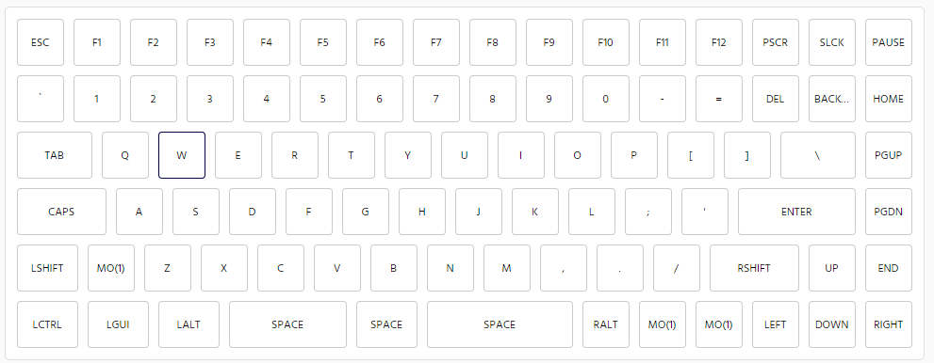
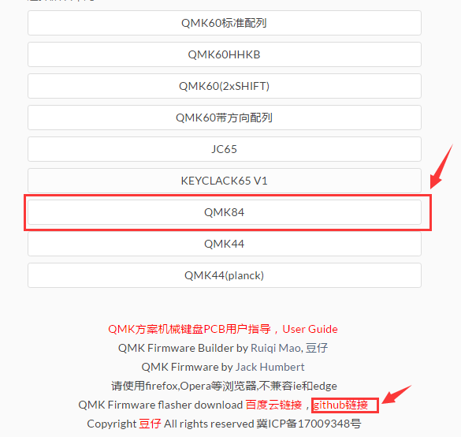
FN+Q RGB-ON/OFF
FN+W RGB-MODE
FN+E RGB- Hue -
FN+R RGB- Hue +
FN+T RGB-saturation -
FN+Y RGB-saturation +
FN+U RGB-brightness -
FN+I RGB_brightness +

Fn+c led -
Fn+v led on/off
Fn+b led up
Fn+n led Step

Program web link
http://qmkeyboard.cn/

If you do not use the plate, the space can be split, but need 5-pin switch

Email:kbdfans@gmail.com
www.kbdfans.cn

