**st824t02:**

AS07-pass

CC1-fail

Its earning 50 points 2 times, should be one. Price 6.98 is correct:

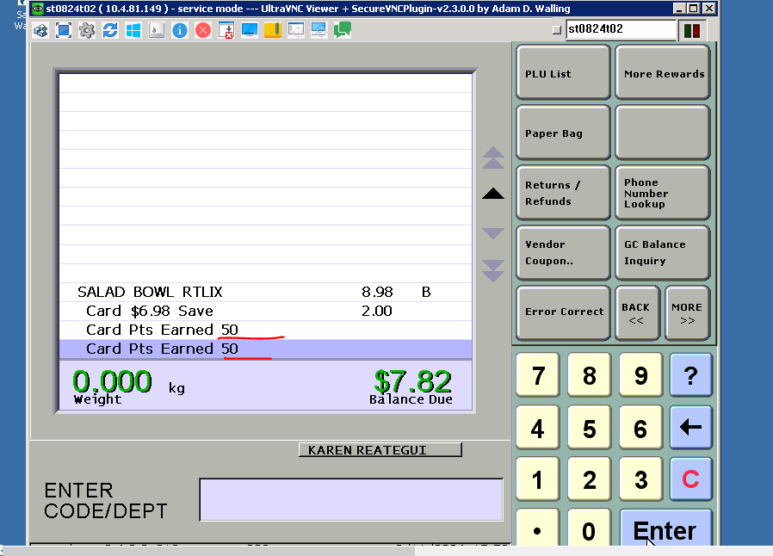

CC3-fail

Didn’t fire: Buy 3 get 50 points

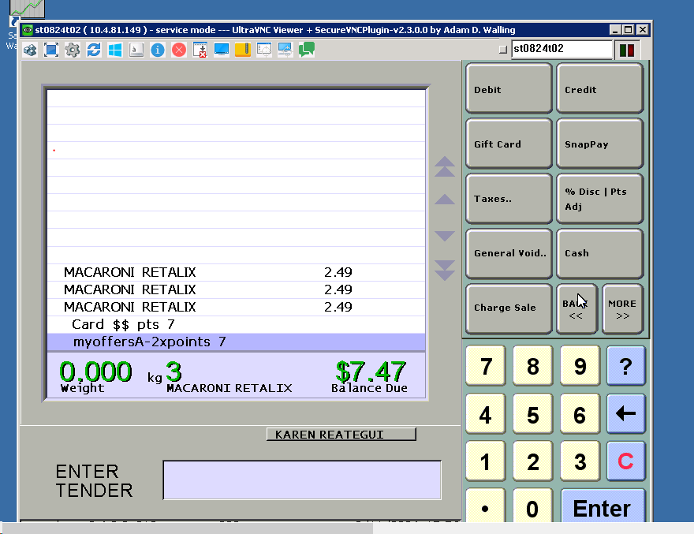

CC7-pass

CC23-fail

Item has a discount of 1: 2.99-1. Should only have the amount of 2.99

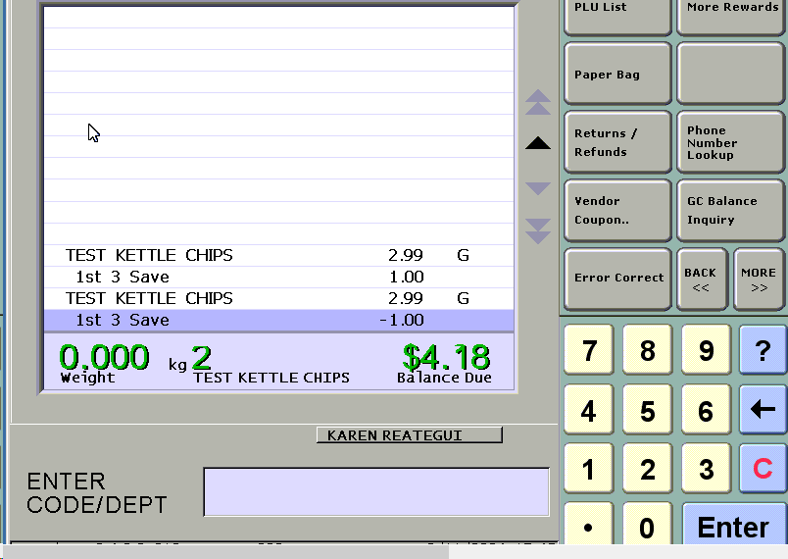

CC-24-cannot test, requires scale

**St0828t01:**

AS07-fail: Spent 100 didn’t get 100 points

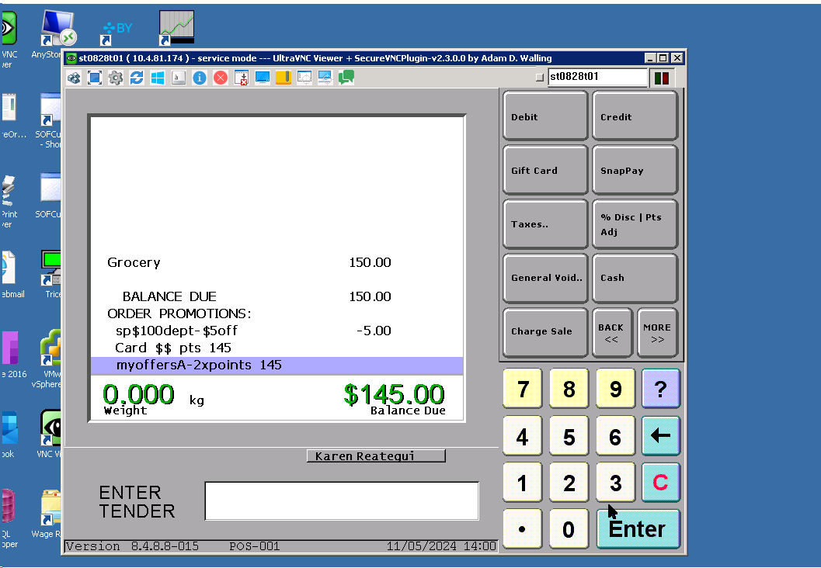

CC1-pass

CC3-fail. Bought 3 items but didn’t get 50 points

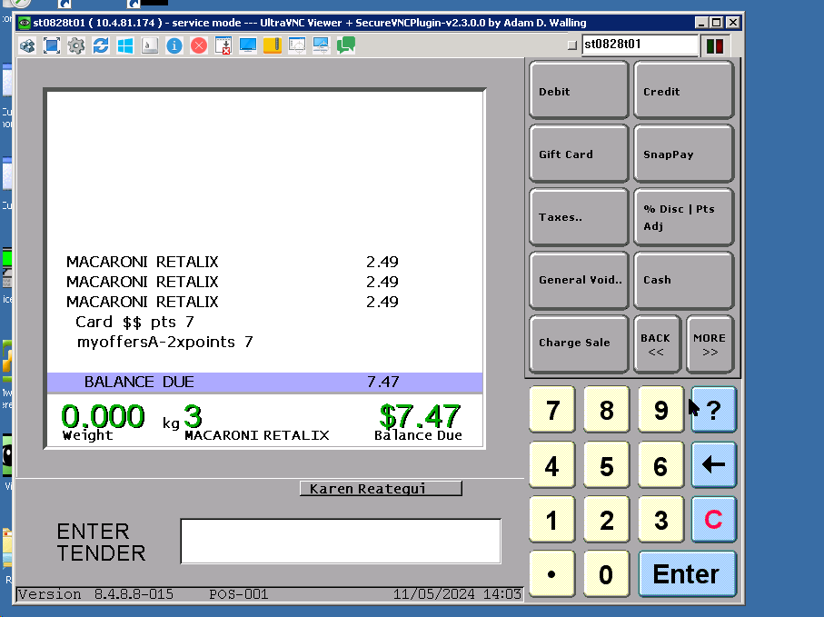

CC7-pass

CC23-fail Item has a discount of 1: 2.99-1. Should only have the amount of 2.99

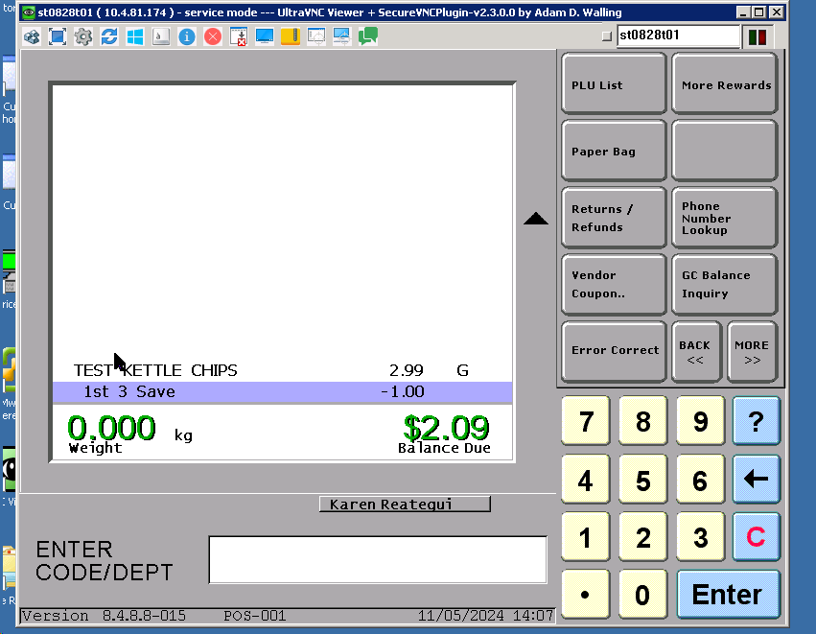

CC24-cannot test. Weight item