ISTE-230 Introduction to Database & Data Modeling

## Homework # 2 – Interpret and Transpose a Single Entity E-R Diagram in MySQL

**Name: Korben Reehill /100**

**All assignments will be graded using the coding standards that were discussed in class, which can be found in the Coding Standards folder in the content area.**

**Submit this document to the Homework #2 assignment folder, edited to include your answers.**

**Part 1 - 40 points**

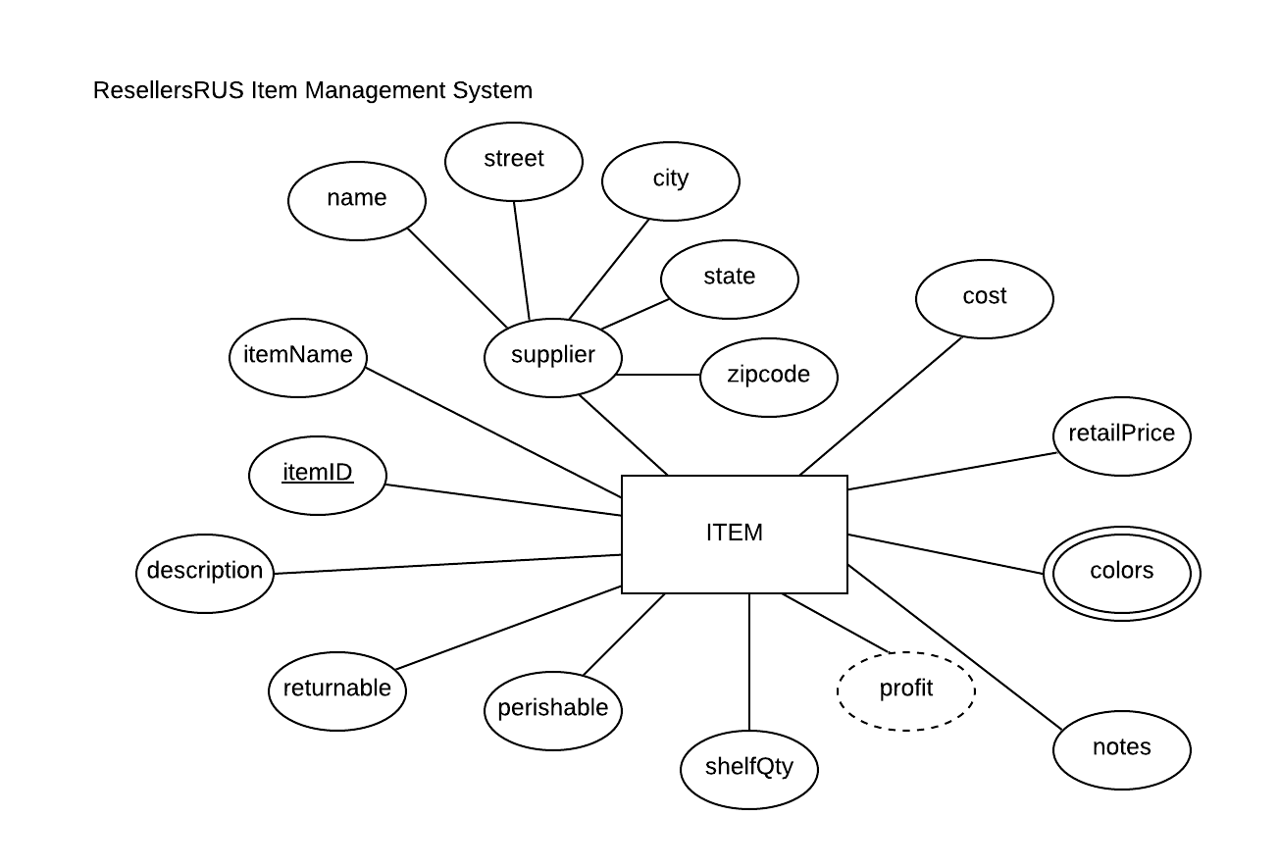

For the table below, please classify each attribute specified based on the E-R diagram above. Please place the best answer for each column that best describes the attribute.

|  |  |  |  |  |
| --- | --- | --- | --- | --- |
| **Attribute** | **Composite**  **or**  **Simple** | **Single-valued**  **or**  **Multi-valued** | **Stored**  **or**  **Derived** | **Identifier ?**  **(Yes or no)** |
| profit | Simple | Single-Valued | Derived | No |
| street | Simple | Single-Valued | Stored | No |
| itemID | Simple | Single-Valued | Stored | Yes |
| supplier | Composite | Single-Valued | Stored | No |
| colors | Simple | Multi-Valued | Stored | No |

**Part 2 - 22 points**

Using relational structure notation, transpose the E-R diagram below into a relational schema. You do not need to normalize the relation.

**Your Answer (relational schema):**

BOOK(isbn13Number, title, author, releaseDate, numberOfPages, phoneNum, url, address, name)

**Part 3 - 38 points**

Using relational structure notation, transpose the E-R diagram below into a relational schema. You do not need to normalize the relation.

*NOTE:* The transposed ITEM relation includes a 'colors' attribute, therefore it would not pass the 1NF (the criteria for a relation). Although the ITEM relation is not in 1NF, there is an approach that we will learn next week to resolve this issue.



**Your Answer (relational schema):**

ITEM(itemID, cost, retailPrice, cost, notes, shelfQty, perishable, returnable, description itemName, colors, name, street, city, state, zipcode)