ISTE-230 Introduction to Database & Data Modeling

## Practice Exercise 1

**Name: Korben Reehill**

**Part 1**

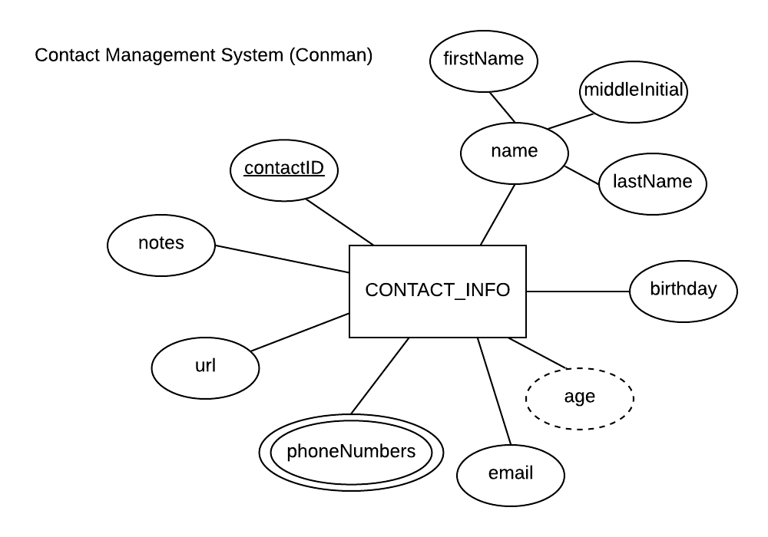

Using the E-R diagram above, which uses the Chen notation covered in Week 1, classify each attribute in the table below by indicating the characteristic in each column that best describes each attribute.

|  |  |  |  |  |
| --- | --- | --- | --- | --- |
| **Attribute** | **Composite**  **or**  **Simple** | **Single-valued**  **or**  **Multi-valued** | **Stored**  **or**  **Derived** | **Identifier?**  **(Yes or no)** |
| name | Composite | Single-Valued | Stored | No |
| age | Simple | Single-Valued | Derived | No |
| lastName | Simple | Single-Valued | Stored | No |
| contactID | Simple | Single-Valued | Stored | Yes |
| phoneNumbers | Simple | Multi-Valued | Stored | No |

**Part 2**

Using relational notation, please transpose the E-R diagram below into a relational schema.

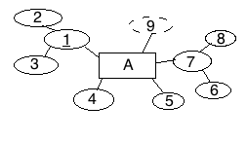

**Your Answer (relational schema):**

A(2,3,4,5,6,8)

**Part 3**

* The relations below are not transposed from the ER diagram in Part 2 and there is no connection between them.
* For each relation below, state whether the relation is in 1NF. If the relation is not in 1NF, list the characteristic(s) being violated.

A(1, 2, 3, 4, 5, 6, 6, 7)

**Your Answer:** No, this relation is not in 1NF. There are column entries (attributes) with the same value (6 and 6), meaning that this model would store copies of the same data and give duplicate names to two of the columns.

B(1, 2, 3, 4)

**Your Answer:** No, this relation isn’t in 1NF – this is because B has no primary key, meaning that it’s possible to have multiple instances/rows of data that are identical.

C(1, 2, 3, 4, 5, 6, 7, 8)

**Your Answer:** Yes, this relation is in 1NF.