ISTE-230 Introduction to Database & Data Modeling

Homework # 4 – Normalization
Name: _Korben Reehill_

All assignments will be graded with regard to the standards that were discussed in class, which can be found in the Standards Content area. Submit this document edited to include your answers, for the six tasks, to the HW#4 Assignment Folder by the stated deadline.

Task #1 (12 points)
MUSIC(title, artist, numGrpMembers, year, producer, producerURL, category, categorySales, media, mediaPrice)

Business Rules:
- Each “album” (CD) is uniquely identified by its title. Note that, for the rest of the business rules, the “Title” attribute of MUSIC refers to the name of the “album”.
- An artist may either be a single person or a band made up of multiple members (the count being recorded in NumGrpMembers, which can be 1).
- Each album has one release year.
- Each album is produced by one music production company (producer).
- Each producer has one company URL.
- A specific album has only one artist.
- Each album is classified into one music category (Rock, Country, etc.)
- Each category is associated with one category sales value, which is the year-to-date sales for that given category.
- For convenience, the music company sells all of its music at the same price based on the media type. For example, all cassettes are $9.99, all CDs are $16.99, etc.

List ALL functional dependencies for the MUSIC relation above, according only to the business rules listed. Use the format A B. Then, for each functional dependency denote with a ‘Y’ or ‘N’ if the respective functional dependency causes 2NF or 3NF violation in the MUSIC relation.

Functional Dependencies | 2NF violation? | 3NF violation?
title artist, numGrpMembers, year, producer, producerURL, category, categorySales, mediaPrice | Y | N
artist numGrpMembers | N | Y
title year | N | N
title producer | N | N
producer producerURL | N | Y
title artist | N | N
title category | N | N
category categorySales | N | Y
media mediaPrice | Y | N

Task #2 (9 points)
For the relation below, determine the highest normal form the relation is in, the reason, and if necessary normalize the relation, and all resulting relations, through BCNF. Use proper relational notation and include reference statements for any foreign keys.

Q1( a, b, c, d )
Functional Dependencies:
a, b c, d
c d
YOUR ANSWER:
The above relation in 2NF, because the 2nd dependency (c d) creates a transitive dependency, which isn’t allowed in 3NF.

Q1(a, b, c)
Q1(c) must exist in Q2(c)
Q2(c, d)

Task #3 (12 points)
For the relation below, determine the highest normal form the relation is in, the reason, and if necessary normalize the relation, and all resulting relations, through BCNF. Use proper relational notation and include reference statements for any foreign keys.

Q2(a, b, c, d)

Functional dependencies:
a, b c, d
a c
b d
YOUR ANSWER:
The Q2 relation is in 1NF, because the dependencies ac and bd create partial dependencies, which isn’t allowed in 2NF.

Q2(a,b)
Q2(a) must exist in Q3(a)
Q2(b) must exist in Q4(b)
Q3(a,c)
Q4(b,d)

Task #4 (17 points)

Given the E-R diagram, the resulting relation, and the functional dependencies below, normalize the ITEM relation and resulting relations through BCNF. Be sure to use proper relational notation and reference statements for foreign keys.

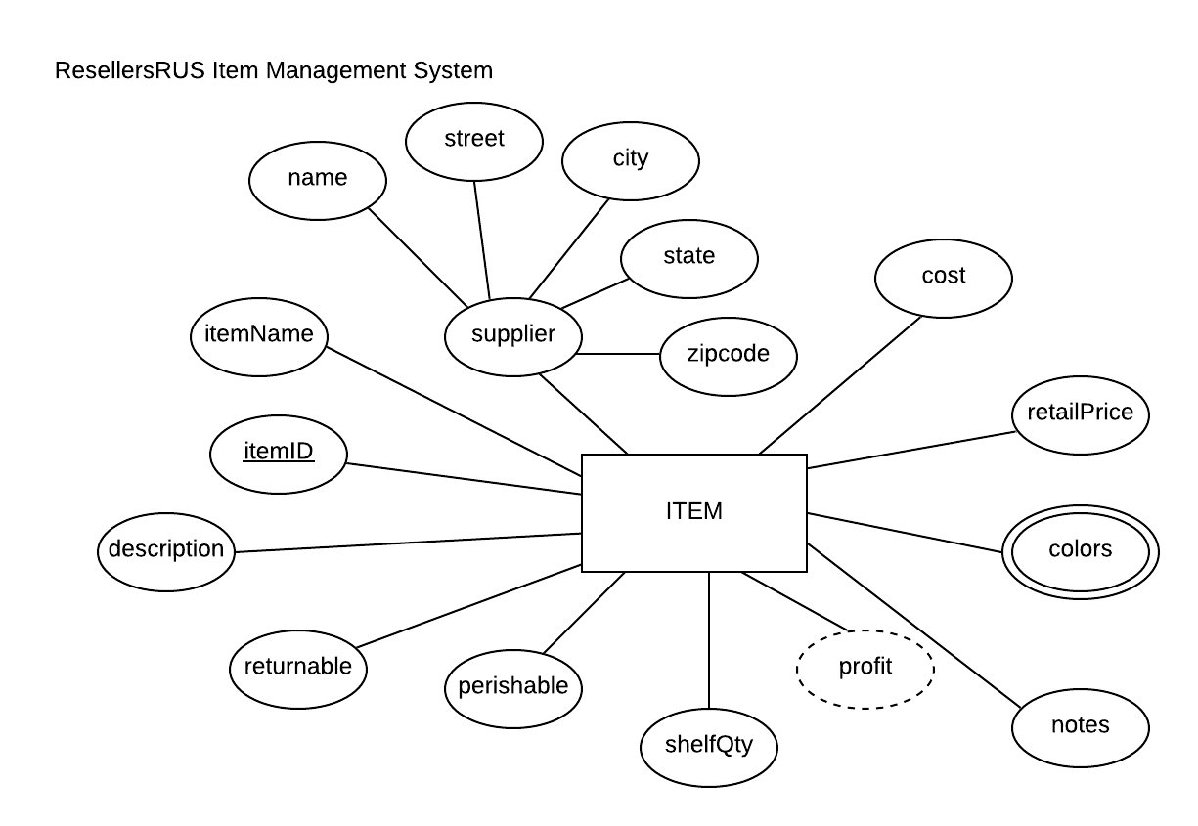
Resulting Relation:
ITEM(itemID, itemName, name, street, city, state, zipcode, cost, retailPrice, color1, color2, notes, shelfQty, perishable, returnable, description)

Functional Dependencies:
itemID itemName, name, street, city, state, zipcode, cost, retailPrice, color1, color2, notes, shelfQty, perishable, returnable, description

name street, city, state, zipcode

YOUR ANSWER (Final set of relations normalized to BCNF):
ITEM(itemID, name, itemName, cost, retailPrice, color1, color2, notes shelfQty, perishable, returnable, description)
ITEM(name) must exist in SUPPLIER(name)

SUPPLIER(name, street, city, state, zipcode)

Task #5 (23 points)

Given the relation and functional dependencies below, normalize the SALE relation and resulting relations through BCNF. Be sure to use proper relational notation and reference statements for foreign keys.

SALE(invoice#, item#, custID, custName, custAddress, itemName, itemPrice, itemQtyPurch, salesPerson#, salesPersonName, subtotal, tax, totalDue)

Functional Dependencies:
invoice#, item# custID, custName, custAddress, itemName, itemPrice, itemQtyPurch, salesPerson#, salesPersonName, subtotal, tax, totalDue

item# itemName, itemPrice

invoice# custID, custName, custAddress, salesPerson#, salesPersonName, subtotal, tax, totalDue

custID custName, custAddress

salesPerson# salesPersonName

YOUR ANSWER (Final set of relations normalized to BCNF):

SALE(invoice#, item#, custID, itemQtyPurch, salesPerson#, subtotal, tax, totalDue)
SALE(item#) must exist in ITEM(item#)
SALE(custID) must exist in CUSTOMER(custID)
SALE(salesPerson#) must exist in SELLER(salesperson#)

ITEM(item#, itemName, itemPrice)

CUSTOMER(custID, custName, custAddress)

SELLER(salesPerson#, salesPersonName)

Task #6 (27 points)

Given the relation and functional dependencies below, normalize the relation and resulting relations through BCNF. Be sure to use proper relational notation and reference statements for foreign keys.

A(1, 2, 3, 4, 5, 6, 7, 8, 9, 10)

Functional Dependencies:
1, 2, 3, 4->5, 6, 7, 8, 9, 10

1->5, 6
5->1,6

2,3->7,8
7->8

4->9,10
9->10
10->9

YOUR ANSWER (Final set of relations normalized to BCNF):
A(1,2,3,4)
A(1) must exist in B(1)
A(2, 3) must exist in C(2, 3)
A(4) must exist in D(4)
B(1,5,6)

C(2,3,7)
C(7) must exist in E(7)

D(4,9,10)

E(7, 8)

