ISTE-230 Introduction to Database & Data Modeling

Homework # 5 – HAS-A and IS-A Relationships
Name: Korben Reehill

Submit this document, edited to include your answers, to the HW#5 Assignment folder by the stated deadline.

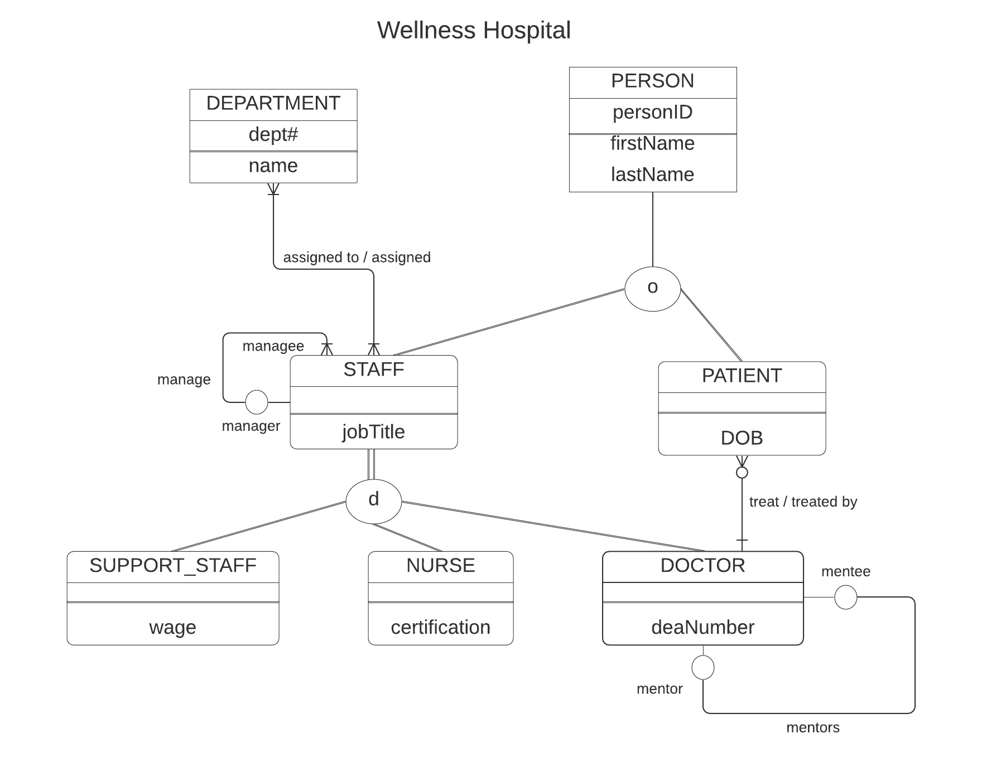

Using the E-R diagram for Wellness Hospital, that appears on the previous page, please provide your answer to the following questions.

- (5 points) List the relationship verb phrase for each 'HAS-A' relationship that appears in the diagram.
YOUR ANSWER:
- DEPARMTENT assigned STAFF
- STAFF assigned to DEPARTMENT
- DOCTOR treats PATIENT
- PATIENT treated by DOCTOR
- STAFF:manager manages STAFF:managee
- STAFF:managee managed by STAFF:manager

- (5 points) List the relationship verb phrase for each binary relationship that appears in the diagram.
YOUR ANSWER:
- DEPARTMENT assigned STAFF
- STAFF assigned to DEPARTMENT
- PATIENT treated by DOCTOR
- DOCTOR treats PATIENT

- (5 points) List the relationship verb phrase for each recursive relationship that appears in the diagram.
YOUR ANSWER:
- STAFF:manager manages STAFF:managee
- STAFF:managee managed by STAFF:manager
- DOCTOR:mentee mentored by DOCTOR:mentor
- DOCTOR:mentor mentors DOCTOR:mentee

- (5 points) List the name of each supertype entity that appears in the diagram.
YOUR ANSWER:
- PERSON
- STAFF

- (6 points) List the name of each subtype entity that appears in the diagram.
YOUR ANSWER:
- STAFF
- PATIENT
- DOCTOR
- SUPPORT_STAFF
- NURSE

- (5 points) Provide an example of an entity instance of PERSON.
YOUR ANSWER:
- A doctor working at the hospital

- (5 points) List the relationship verb phrase for every 1:1 relationship that appears in the diagram.
YOUR ANSWER:
- DOCTOR:mentee mentored by DOCTOR:mentor
- DOCTOR:mentor mentors DOCTOR:mentee
- (5 points) List the relationship verb phrase for every 1:N (N:1) relationship that appears in the diagram.
YOUR ANSWER:
- DOCTOR treats PATIENT(s)
- STAFF:manager manages STAFF:managee(s)

- (5 points) List the relationship verb phrase for every M:N relationship that appears in the diagram.

YOUR ANSWER:
- DEPARTMENT assigned STAFF
- STAFF assigned to DEPARTMENT

- (5 points) List the name of each strong entity that appears in the diagram.

YOUR ANSWER:
- DEPARTMENT
- PERSON

- (6 points) List the name of each weak entity that appears in the diagram.

YOUR ANSWER:
- STAFF
- PATIENT
- SUPPORT_STAFF
- NURSE
- DOCTOR

- (4 points) Must a STAFF:managee be managed by a manager? Explain how you determined your answer from the E-R diagram provided.

YOUR ANSWER:

Any manager must have at least one managee, but not every managee will be managed by a manager. This is denoted by the empty circle over the word “manager” on the ER diagram, corresponding to the verb phrase “managee managed by manager”, which denotes that for this phrase, a manager is optional, and can be at least zero.

- (4 points) Can there be an instance of DOCTOR that is not an instance of STAFF? Explain your answer.

YOUR ANSWER:

No, this is because the DOCTOR is connected to the supertype STAFF through a disjoint total specialization, which requires at least one and only one subtype apply to each entity instance of the supertype.

- (4 points) Can a DOCTOR treat more than one PATIENT? Explain how you determined your answer from the E-R diagram provided.

YOUR ANSWER:

Yes, a DOCTOR can treat more than one PATIENT. In this binary relationship, the direction of the notation shows that any DOCTOR can have zero to many PATIENT(s). In the ER diagram, optional attributes (w/ a min of zero) are shown with an empty circle, and multi-valued attributes (w/max greater than one) are shown with the crow’s foot (three lines in the direction of the related entity).

- (4 points) Must every instance of PERSON belong to a subtype? Fully explain how you determined your answer from the E-R diagram provided.

YOUR ANSWER:

No, some PERSON entities are solely a generic PERSON entity. This is because the circle below the PERSON entity on the diagram only has one line attached, denoting partial specializiation (the supertype doesn’t have to belong to a subtype).

- (4 points) Could an instance of PERSON be both a STAFF and a PATIENT? Fully explain how you determined your answer from the E-R diagram provided.

YOUR ANSWER:

Yes, the circle beneath the PERSON attribute denotes an overlap in subtypes using an “o”, meaning that any instance of the supertype can belong to multiple subtypes, which are STAFF and PATIENT in this case.

- (4 points) Must every instance of STAFF belong to a subtype? Fully explain how you determined your answer from the E-R diagram provided.

YOUR ANSWER:

Yes, the circle connecting STAFF to its subtypes has two lines, which communicates total specialization, meaning the supertype must belong to one of its subtypes.

- (4 points) Could an instance of STAFF be both a SUPPORT_STAFF and a DOCTOR? Fully explain how you determined your answer from the E-R diagram provided.

YOUR ANSWER:

No, the circle connecting SUPPORT_STAFF and DOCTOR to STAFF has a “d” inside of it. This denotes a disjoint between the subtypes, meaning any given instance of the supertype should only belong to one subtype.

- (5 points) If a discriminator were to be added to PERSON, fully explain what that would entail and why?

YOUR ANSWER:

Adding a discriminator to PERSON would entail adding an attribute to PERSON, that, given different values, would allow a user to tell the difference between PERSON instances that are just a PERSON, or a PERSON with a subtype of STAFF, a PERSON with a subtype of PATIENT, or a PERSON with bth subtypes. These could be denoted with a different character for each, possibly an empty string(“”) or underscore(“_”)for being a generic PERSON, STAFF being “s”, PATIENT being “p”, and both being “b”. This allows full distinction between these subtypes and the ability to recognize when they overlap.
Additionally, all instances of a subtype would all have to have either its respective letter (“p”,”s”) or “b” to show it belongs in the subtype.

- (5 points) If a discriminator were to be added to STAFF, fully explain what that would entail and why?

YOUR ANSWER:

Similar to the above, an additional attribute would need to exist in STAFF that can hold a character distinguishing between subtypes that isn’t already used in PERSON. “s” for SUPPORT_STAFF, “n” for Nurse, and “d” for Doctor would all function well. The difference here is that each subtype would also need to only contain instances with their respective letter, as each of these subtypes are disjointed, with no empty strings or null values being permitted in STAFF’s discriminator because it has to have a subtype.

- (5 points) Fully state the business rules for the assigned to/assigned relationship without using technical terms.

YOUR ANSWER:
The Wellness hospital contains many departments that staff work under, and there are no empty departments. Each department has a specific number that corresponds to it, and each department has a name. Employees at the hospital each work for at least one department, but aren’t confined to that particular department. Each staff member has a job title that may or may not be specific to that employee. Additionally, some staff manage other employees, but not all staff are managers, and all managers must have at least one managee.

