ISTE-230 Introduction to Database & Data Modeling

Homework # 6 – Transposing
DUE: 11/10/2025
Name: _Korben Reehill_

Submit this document edited to include your answers, for the two parts, to the HW#6 Dropbox by the stated deadline.
(It may be helpful to right-click on the icon and select Hide Spelling Errors and Hide Grammatical Errors.)

Part #1 – 50 points
1. (45 points) Transpose the E-R diagram above into relations, implementing all relationships. Denote primary keys and foreign keys appropriately. Use proper relation notation. You need to provide reference statements.
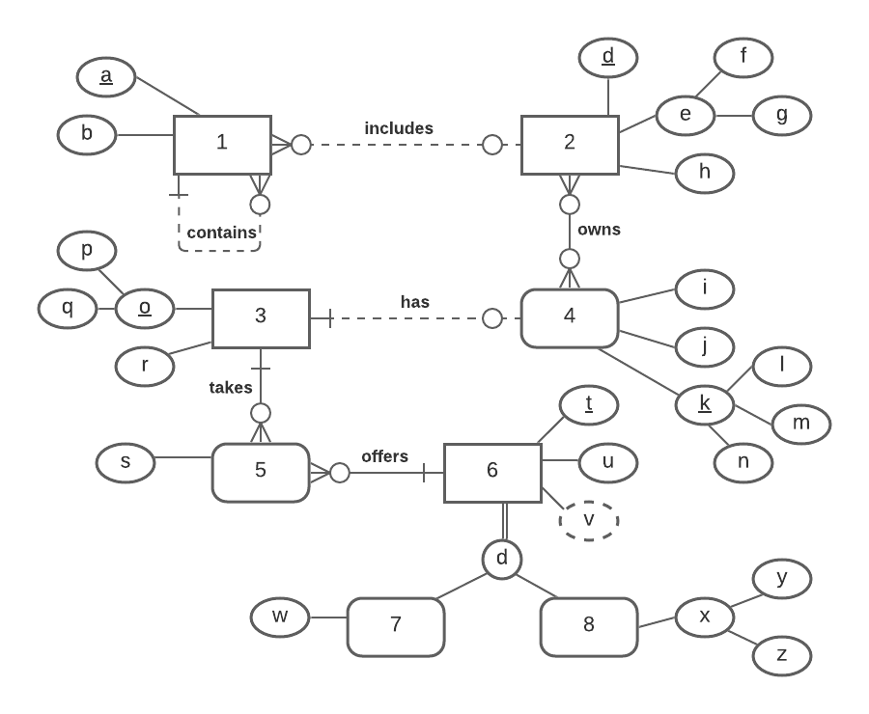
YOUR TRANSPOSED RELATIONS:
1(a, b, c, d)
1(c) mei 1(a)
1(d) mei 2(d)
2(d, f, g, h)
2_4(d, l, m, n)
2_4(d) mei 2(d)
2_4(l,m,n) mei 4(l,m,n)
4(l, m, n, i, j, p, q)
4(p,q) mei 3(p,q)
3(p, q, r)
5(p,q,t,s)
5(p,q) mei 3(p,q)
5(t) mei 6(t)
6(t, u)
7(t,u,w)
7(t,u) mei 6(t,u)
8(t,u,y,z)
8(t,u) mei 6(t,u)

2. (2 points) Using the E-R diagram above, please explain why entity 7 is weak and what the specific term for that type of entity is.
REASON: 7 is weak because it depends on the identifier of its supertype entity, 6.
TERM: Subtype

3. (2 points) Using the E-R diagram above, please explain why entity 5 is weak and what the specific term for that type of entity is.
REASON: 5 is weak entity because it relies on the identifiers of multiple other entities.
TERM: Associative Entity

4. ( 1 point) Using the E-R diagram above, please explain what relationship makes entity 4 weak and what about that relationship causes it to be weak.
EXPLANATION: All of entity 4’s relationships are optional, which means in some implementations, 4 may not exist at all, which is why it is weak.

Part 2 – RIT Savings and Loan (50 points)
1. (50 points) Transpose the E-R diagram above into relations, implementing all relationships. Denote primary keys and foreign keys appropriately. Use proper relation notation. You need to provide reference statements.
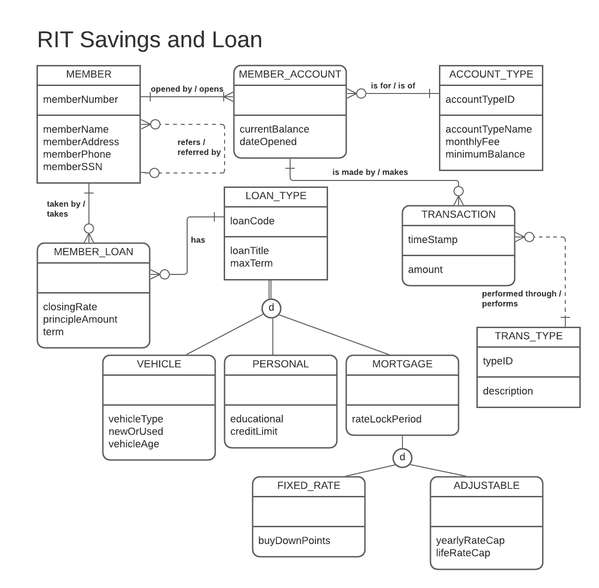

YOUR TRANSPOSED RELATIONS:

ACCOUNT_TYPE(accountTypeID, accountTypeName, monthlyFee, minimumBalance)
TRANS_TYPE(typeID, description)
MEMBER(memberNumber, memberName, memberAddress, memberPhone, memberSSN, referenceNumber)
MEMBER(referenceNumber) mei MEMBER(memberNumber)
MEMBER_LOAN(closingRate, principleAmount, term, memberNumber, loanCode)
MEMBER_LOAN(memberNumber) mei MEMBER(memberNumber)
MEMBER_LOAN(loanCode) mei LOAN_TYPE(loanCode
MEMBER_ACCOUNT(currentBalance, dateOpened, memberNumber, accountTypeID)
MEMBER_ACCOUNT(memberNumber) mei MEMBER(memberNumber)
MEMBER_ACCOUNT(accountTypeID) mei ACCOUNT_TYPE(accountTypeID)
TRANSACTION(timestamp, memberNumber, accountTypeID, typeID, amount)
TRANSACTION(memberNumber,accountTypeID) mei MEMBER_ACCOUNT(memberNumber,accountTypeID)
TRANSACTION(typeID) mei TRANS_TYPE(typeID)
LOAN_TYPE(loanCode, loanTitle, maxterm)
VEHICLE(loanCode,loanTitle,maxTerm,vehicleType,newOrUsed,vehicleAge)
VEHICLE(loanCode, loanTitle, maxterm) mei LOAN_TYPE(loanCode, loanTitle,maxTerm)
PERSONAL(loanCode,loanTitle,maxterm,educational,creditLimit)
PERSONAL(loanCode,loanTitle,maxterm) mei LOAN_TYPE(loanCode,loanTitle,maxTerm)
MORTGAGE(loanCode,loanTitle,maxTerm,rateLockPeriod)
MORTGAGE(loanCode,loanTitle,maxTerm) mei LOAN_TYPE(loanCode,loanTitle,maxTerm)
FIXED_RATE(loanCode, loanTitle, maxTerm, rateLockPeriod, buyDownPoints)
FIXED_RATE(loanCode,loanTitle,maxTerm,rateLockPeriod) mei MORTGAGE(loanCode,loanTitle,maxTerm,rateLockPeriod)
ADJUSTABLE(loanCode, loanTitle, maxTerm, rateLockPeriod, yearlyRateCap, lifeRateCap)
ADJUSTABLE(loanCode,loanTitle,maxTerm,rateLockPeriod) mei MORTGAGE(loanCode,loanTitle,maxTerm,rateLockPeriod)

