ISTE-230 Introduction to Database & Data Modeling

Practice Exercise # 9 – Transposing
Name: Korben Reehill

All assignments will be graded with regard to the standards that were discussed in class, which can be found in the Standards Content area.
- Be sure to use proper relational notation: RELATION(pkattr, attribute, fkattr).
- Include reference statements for foreign keys.
Problem #1
Transpose the E-R diagram below into relations, implementing all relationships. Denote primary keys and foreign keys appropriately. Use proper relation notation. Make sure your relation names are in all caps.

YOUR TRANSPOSED RELATIONS:
CITY(cityID, name, district, population, code)
CITY(code) mei COUNTRY(code)
CONTINENT(continentID, name)
COUNTRY(code, name, region, surfaceArea, indepYear, population, lifeExpectancy, gnp, gnpOld, localName, governmentForm, headOfState, capital, code2, continentID)
COUNTRY(continentID) mei CONTINENT(continentID)
LANGUAGE(langCode, language)
COUNTRY_LANGUAGE(code, langCode)
COUNTRY_LANGUAGE(code) mei COUNTRY(code)
COUNTRY_LANGUAGE(langCode) mei LANGUAGE(langCode)
Problem #2
Transpose the E-R diagram below into relations, implementing all relationships. Denote primary keys and foreign keys appropriately. Use proper relation notation. You do not need to fix any possible normalization issues.

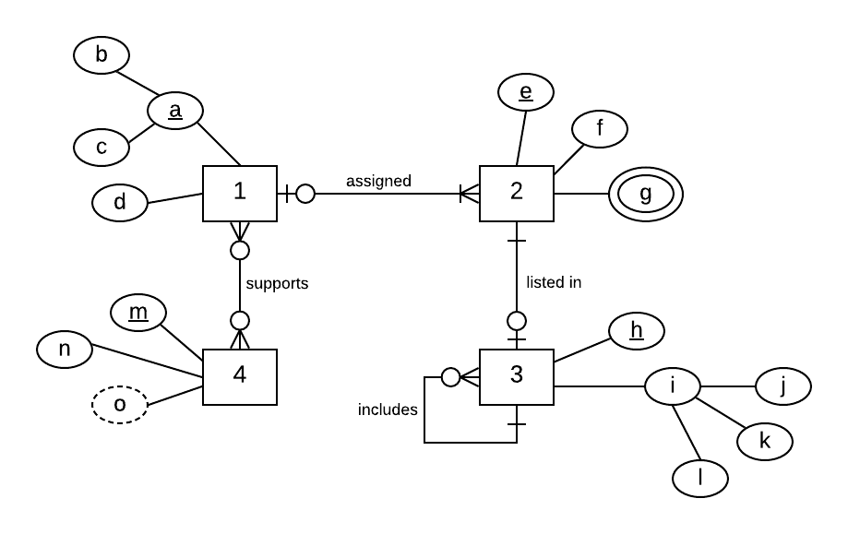
YOUR TRANSPOSED RELATIONS:
1(b, c, d)
2(e, f, g, b, c)
2(b,c) mei 1(b,c)
3(h, l, k, j, e)
3(e) mei 2(e)
4(m, n)
1_4(b,c,m)
1_4(b,c) mei 1(b,c)
1_4(m) mei 4(m)

Problem #3
Transpose the E-R diagram below into relations, implementing all relationships. Denote primary keys and foreign keys appropriately. Use proper relation notation. Make sure your relation names are in all caps.
YOUR TRANSPOSED RELATIONS:
DEPARTMENT(dept#, name)
PERSON(ssn, firstName, lastName)
STAFF(ssn, firstName, lastName)
INSURANCE_POLICY(policy#, co#, ssn)
INSURANCE_POLICY(co#) mei INSURANCE_COMPANY(co#)
INSURANCE_POLICY(ssn) mei PATIENT(ssn)
INSURANCE_COMPANY(co#, name)
SUPPORT STAFF(ssn, firstName, lastName, wage)
NURSE(ssn, firstName, lastName, certification)
DOCTOR(ssn, firstName, lastName)
PATIENT(ssn, firstName, lastName)
DEPARTMENT_STAFF(dept#,ssn)
DEPARTMENT_STAFF(dept#) mei DEPARTMENT(dept#)
DEPARTMENT_STAFF(ssn) mei STAFF(ssn)

