SmartCare v0.4 - Domain Implementation Workbook
Week 7 student resource

1. UML-to-Code Trace
UML element | Python element | Implemented? | Notes
Patient.name: string | Patient._name | Yes | Private with a read-only property
Patient.getName() | Patient.name | Yes | Implemented as a Python property
Practitioner.name: string | Practitioner._name | Yes
Practitioner additional attributes | Practitioner._id, Practitioner._specialty | Yes | Extended beyond original UML during implementation
Appointment.id/patient/practitioner/time/status | Appointment._appointment_id, _patient, _practitioner, _time, _status | Yes | All private with read-only properties
Appointment.isValid() | Validation logic moved into __init__ directly | Partially | Original UML had a separate isValid() method; refactored version validates inline in the constructor instead, raising specific errors per field
Appointment.conflictsWith() | Appointment.conflictsWith() | Yes | Fixed to compare practitioners by ID, not object identity

2. Domain Invariants
Class | Invariant / rule | How protected
Patient | “name” must never be empty or blank | Validated in __init__ name is private with only a read-only name property, so it can never be reassigned to an invalid value after creation
Practitioner | practitioner_id, name and specialty must never be empty | All three attributes are private with read-only properties, preventing external mutation
Practitioner | Two “Practitioner” objects with the same ID must be treated as equal | Enforced via eq and hash methods comparing by practitioner_id, not object identity
Appointment | patient, practitioner, time, and appointment_id must never be missing | All attributes are private with read-only properties
Appointment | Two appointments must never share the same practitioner and time (no double-booking) | Enforced via conflicts_with(), which compares practitioners by identity/equality and exact time match
Appointment | Status must never transition illegally (e.g. cancelling an already cancelled appointment) | Enforced via the cancel() method, which checks current status first and raises AppointmentStateError

3. Composition / Inheritance Decisions
Relationship | Decision | Rationale
Appointment - Patient | Association | An “Appointment” needs a Patient but neither owns the other's lifecycle. A patient can exist independently of any appointment, and deleting an appointment must never delete the patient
Appointment – Practitioner | Association | Same reasoning as above: a practitioner exists independently of any single appointment, and multiple appointments reference the same practitioner
Appointment inheriting from Patient | Rejected | An appointment is not a specialised type of patient, it references one. Using inheritance would incorrectly give “Appointment” all of Patient’s attributes/behaviour with no conceptual justification
AppointmentBook – Appointment | Aggregation | “AppointmentBook” holds a collection of appointments, but this is a “whole part” relationship where appointments could be managed independently in the future (e.g. by a different manager), so aggregation (weaker ownership) fits better than composition (strict ownership)
Clinic owning all objects | Rejected | The current confirmed requirements only describe a single clinic location, adding a Clinic class to own every object would be unsupported structure with no requirement driving it

4. AI Pair-Programming Record
AI contribution | Conforms? | Decision | Reason | Verification
AppointmentStatus Enum and AppointmentValidationError custom exception | Yes | Accepted | Matched the explicit constraints given in the prompt (use an Enum, use a custom exception) | Confirmed by inspection, both classes exist and are used exactly as required
is_valid() checking patient/practitioner/time/id are present | Yes | Accepted | Correctly implements the stated business rules | Ran tests with missing patient, practitioner, time and ID. All correctly rejected
Public, directly mutable attributes on Appointment | No | Rejected | Violated NFR-04, allowed the object to be pushed into an inconsistent state after creation since validation only ran once in the constructor | Manually mutated appt.status and confirmed no validation was triggered
Single generic error message for all validation failures | No | Rejected | Made debugging harder, didn’t identify which specific field failed | Compared error output against expected behaviour, replaced with field specific messages
conflicts_with() using default object equality to compare practitioners | No | Rejected | Would fail to detect a real conflict between two different Practitioner objects representing the same person | Created two separate Practitioner objects with the same ID, confirmed the original logic returned False

5. Updated UML
Insert updated UML only if implementation revealed a justified design change. Explain every change.
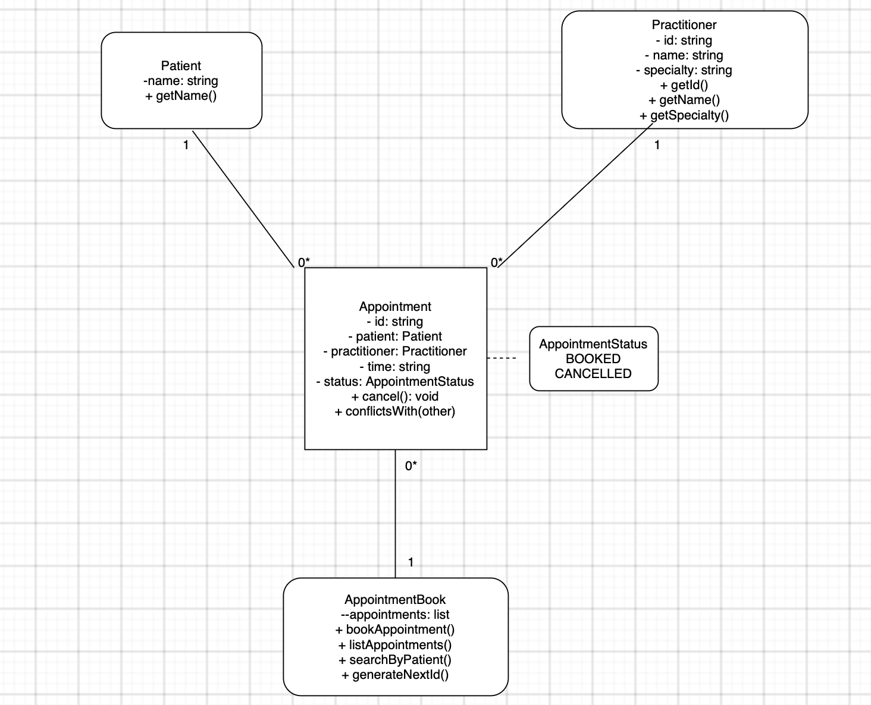
Explanations:
- Practitioner gained two new attributes: id and specialty. The original design only had name. During implementation (Part C), the lab specifically required an identifier and specialty, which weren't anticipated in the original domain model
- Appointment.isValid() was removed as a public operation. In the original design, validation was a separate callable method. During refactoring (Part G), this logic moved directly into the constructor since an Appointment should never be constructible in an invalid state in the first place
- Appointment.cancel() was added. This is the most significant change. Manual testing (Part F) revealed that without a real cancel() method, the AI-generated code allowed direct status mutation and illegal repeated cancellations with no error. Adding this method, which checks the current status before allowing a transition, closes that gap and properly enforces NFR-04 across the object’s whole lifecycle
- AppointmentStatus was formalised as an explicit enum in the diagram, shown as a dependency from Appointment since status is now typed as AppointmentStatus rather than a generic string

