Assignment 2- Case Study

Stage 3 Lab Activities

SmartCare Domain Modelling
AI OFF -> AI ON -> COMPARE -> VERIFY | 1 hour

A - Requirements Review
Highlight nouns, verbs and business rules in SmartCare v0.2.
Nouns
- Patient
- Practitioner
- Appointment
- Receptionist
- Clinic Manager
- Appointment time
- Patient name
- Practitioner name
- Unique identifier (appointment ID)
- Appointment history
- Appointment status
- Operational report
Verbs
- Record
- Book
- Reject
- Display/View
- Search
- Assign
- Prevent
- Cancel
- Select
Business Rules
- A patient name must not be empty when booking an appointment
- A practitioner name must not be empty when booking an appointment
- An appointment time must not be empty when booking an appointment
- Every appointment must have a unique identifier assigned on creation
- No two appointments can be booked for the same practitioner at the same date and time
- An appointment record must never exist in an incomplete or logically inconsistent state

B - Candidate Classes
Record candidate concepts, supporting requirements, state and behaviour.
Candidate Class: Patient
Supporting requirements: FR-01, FR-04, FR-08
State: Name (required)
Behaviour: None directly yet, a patient is mostly just a data holder at this stage
Candidate Class: Practitioner
Supporting requirements: FR-02, FR-05, FR-10
State: Name (required)
Behaviour: None yet
Candidate Class: Appointment
Supporting requirements: FR-03, FR-04, FR-05, FR-06, FR-09, FR-10, NFR-04
State: appointment_id, patient, practitioner, appointment_time, status
Behaviour: is_valid() - checks that patient, practitioner, and time are all present, conflicts_with(other_appointment) - checks if this appointment clashes with another for the same practitioner/time

C - CRC Cards
Create CRC cards for Patient, Practitioner and Appointment.
Class: Patient
Responsibilities | Collaborators
Store the patient's name | -
Provide the patient's name when requested (e.g. for display or search) | Appointment

Class: Practitioner
Responsibilities | Collaborators
Store the practitioner’s name | -
Provide the practitioner’s name when requested (e.g. for display or conflict checking) | Appointment

Class: Appointment
Responsibilities | Collaborators
Store a reference to a patient, a practitioner, and an appointment time | Patient, Practitioner
Store a unique appointment identifier | -
Validate that patient, practitioner, and time are all present before being considered valid | Patient, Practitioner
Determine whether it conflicts with another appointment | -
Provide its details for display (patient name, practitioner name, time) | Patient, Practitioner

D - UML Model
Draw classes, attributes, operations, associations and multiplicities.
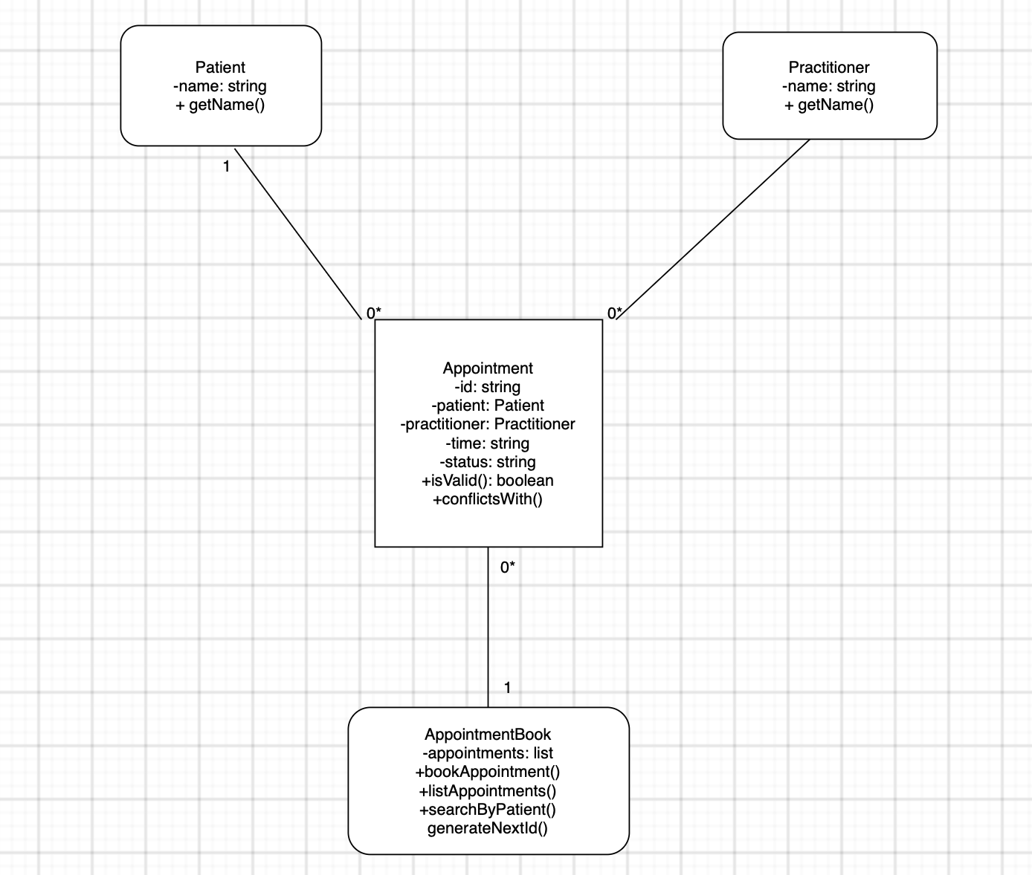

E - AI Design Review
Ask AI to suggest classes and relationships using only confirmed requirements; require supporting requirement IDs.
AI RESPONSE:

🧩 Candidate Classes (each justified by requirement IDs)

Patient
- Supported by: FR-01, FR-03, FR-08
- Justification:
  - FR-01 requires recording patients with at least a name → a Patient class with a name attribute.
  - FR-03 requires selecting a patient when booking an appointment → appointments must reference a Patient object.
  - FR-08 requires searching appointment history by patient name → Patient must be a distinct entity.

Practitioner
- Supported by: FR-02, FR-03, FR-10
- Justification:
  - FR-02 requires recording practitioners with at least a name → a Practitioner class with a name attribute.
  - FR-03 requires selecting a practitioner when booking an appointment.
  - FR-10 requires preventing double-booking of a practitioner → practitioner must be a distinct entity referenced by appointments.

Appointment
- Supported by: FR-03, FR-04, FR-05, FR-06, FR-07, FR-08, FR-09, FR-10; NFR-01, NFR-04
- Justification:
  - FR-03 requires storing patient, practitioner, and appointment time → attributes: patient, practitioner, time.
  - FR-04–FR-06 require rejecting missing fields → Appointment must enforce required attributes.
  - FR-07 requires listing all appointments → appointments must be stored as objects.
  - FR-08 requires retrieving appointment history → appointments must link to a patient.
  - FR-09 requires a unique identifier → attribute appointmentId.
  - FR-10 requires checking practitioner/time conflicts → Appointment must expose practitioner and time.
  - NFR-04 requires preventing incomplete or inconsistent records → class must enforce invariants.

AppointmentBook
- Supported by: FR-03, FR-07, FR-08, FR-10; NFR-01, NFR-02, NFR-05
- Justification:
  - FR-03 requires booking appointments → a coordinating class to create and validate them.
  - FR-07 requires listing all appointments → store a collection of Appointment objects.
  - FR-08 requires searching appointment history → provide lookup functions.
  - FR-10 requires conflict checking → logic belongs in a central manager.
  - NFR-01 requires preventing data loss → centralised, controlled storage.
  - NFR-02 requires clear organisation into functions → this class encapsulates booking, listing, searching.
  - NFR-05 requires testable core functions → booking/searching can be tested independently.

🔗 Candidate Relationships (each justified by requirement IDs)

Appointment → Patient (association)
- Supported by: FR-03, FR-04, FR-08, NFR-04
- Justification:
  - FR-03 requires selecting a patient for an appointment.
  - FR-04 requires rejecting missing patient names → relationship must be mandatory.
  - FR-08 requires retrieving appointments by patient → appointments must reference a patient.

Appointment → Practitioner (association)
- Supported by: FR-03, FR-05, FR-10, NFR-04
- Justification:
  - FR-03 requires selecting a practitioner.
  - FR-05 requires rejecting missing practitioner names → relationship must be mandatory.
  - FR-10 requires checking double-booking → appointments must reference a practitioner.

AppointmentBook → Appointment (aggregation)
- Supported by: FR-07, FR-08, FR-10; NFR-01, NFR-02, NFR-05
- Justification:
  - FR-07 requires listing all appointments → stored in a collection.
  - FR-08 requires searching appointment history → collection must be queryable.
  - FR-10 requires conflict checking → collection must be accessible for validation.
  - NFR-01/NFR-05 require safe, testable storage → centralised aggregation.

AppointmentBook → Patient (aggregation)
- Supported by: FR-01, FR-03, FR-08
- Justification:
  - FR-01 requires recording patients.
  - FR-03 requires selecting a patient from stored records.
  - FR-08 requires searching by patient name → stored list required.

AppointmentBook → Practitioner (aggregation)
- Supported by: FR-02, FR-03, FR-10
- Justification:
  - FR-02 requires recording practitioners.
  - FR-03 requires selecting a practitioner from stored records.
  - FR-10 requires checking practitioner availability → stored list required.

F - Compare and Decide
Record at least one accepted, modified and rejected AI suggestion.
Accepted: AppointmentBook > Appointment (aggregation)
AI’s justification: FR-07, FR-08, FR-10, NFR-01, NFR-02, NFR-05
Decision: Accepted. This matches exactly what I already designed in Part D. The requirement IDs cited support it. AppointmentBook does need to hold a collection of appointments to satisfy listing (FR-07), searching (FR-08), and conflict checking (FR-10). No overreach is shown here.
Modified: AppointmentBook > Patient (aggregation) and AppointmentBook > Practitioner (aggregation)
AI’s justification: FR-01, FR-02, FR-03, FR-08, FR-10
Decision: Modified. The AI treats these as two separate aggregation relationships alongside AppointmentBook > Appointment, which adds more structure than my original design. My diagram only had AppointmentBook directly managing Appointment, with Patient/Practitioner reached indirectly through each appointment. I'm keeping the AI's underlying point, that patients and practitioners need to be stored somewhere before they are selected in FR-03.
Rejected: Appointment > Patient / Appointment > Practitioner marked as "association must be mandatory" using NFR-04 as justification
AI’s justification: NFR-04 (preventing incomplete/inconsistent records)
Decision: Rejected. NFR-04 is a general data integrity quality goal, not a rule that says these associations must be mandatory, that requirement is driven by FR-04 and FR-05 (rejecting missing names), not NFR-04. Citing NFR-04 here is technically true but imprecise as evidence since it stretches a broad non-functional quality statement to justify a specific structural design choice.

G - Python Skeletons
Create simple Patient, Practitioner and Appointment class skeletons.
Done in python file.

H - Consistency Check
Check model-code consistency; do not implement full behaviour yet.
Element | UML Diagram | CRC Cards | Python Skeleton | Consistent?
Patient attributes | Name: string | Store the patient’s name | Self.name | Yes
Patient behaviour | + getName() | Provide the patient’s name when requested | Get_name() | Yes
Practitioner attributes | Name: string | Store the practitioner’s name | Self.name | Yes
Practitioner behaviour | + getName() | Provide the practitioner’s name when requested | Get_name() | Yes
Appointment attributes | id, patient, practitioner, time, status | implied via responsibilities | appointment_id, patient, practitioner, time, status | Yes
Appointment behaviour: validation | + isValid(): boolean | Validate that patient, practitioner, and time are all present | is_valid() | Yes
Appointment behaviour: conflict check | + conflictsWith() | Determine whether it conflicts with another appointment | conflicts_with(other_appointment) | Yes
AppointmentBook | Present in UML with 4 operations | Not created as a CRC card yet | Not implemented in code | No

Reflection
What modelling decision was hardest? Where did AI over-design? What evidence supported your final choices?
The hardest decision was figuring out where the Patient and Practitioner collections should actually live. My original UML diagram had AppointmentBook only managing Appointment objects directly, with patients and practitioners reached indirectly through each appointment. The AI’s design review suggested giving AppointmentBook its own direct aggregation to Patient and Practitioner as well, which technically made sense for supporting FR-01/FR-02 independently of booking an appointment.
The AI over-designed when it justified making the Appointment > Patient and Appointment > Practitioner associations "mandatory" by citing NFR-04, a general data-integrity quality goal rather than the more specific FR-04 and FR-05, which actually require rejecting missing names. This stretched a broad non-functional statement to justify a precise structural rule.
I kept my core structure (Patient, Practitioner, Appointment, AppointmentBook) because each element traces directly back to a specific requirement ID, verified by re-reading the FRs/NFRs rather than accepting AI’s citations straight value.

