SmartCare v0.3 - Domain Model Workbook
Week 6 student resource

Requirement-to-Concept Trace
Requirement | Concept | State/behaviour | Decision
FR-01 | Patient | State: name | Accepted
FR-02 | Practitioner | State: name | Accepted
FR-03 | Appointment | State: patient, practitioner, time | Accepted
FR-04 | Appointment | Behaviour: is_valid() rejects missing patient | Accepted
FR-05 | Appointment | Behaviour: is_valid() rejects missing practitioner | Accepted
FR-06 | Appointment | Behaviour: is_valid() rejects missing time | Accepted
FR-07 | AppointmentBook | Behaviour: listAppointments() | Accepted
FR-08 | AppointmentBook | Behaviour: searchByPatient() | Accepted
FR-09 | Appointment | State: appointment_id | Accepted
FR-10 | Appointment/AppointmentBook | Behaviour: conflicts_with() (Appointment) - enforcement belongs to AppointmentBook | Modified

CRC Cards

Patient
Responsibilities | Collaborators
Store the patient’s name | -
Provide the patient’s name when requested (e.g. for display or search) | Appointment

Practitioner
Responsibilities | Collaborators
Store the practitioner’s name | -
Provide the practitioner’s name when requested (e.g. for display or conflict checking) | Appointment

Appointment
Responsibilities | Collaborators
Store a reference to a patient, a practitioner, and an appointment time | Patient, Practitioner
Store a unique appointment identifier | -
Validate that patient, practitioner, and time are all present before being considered valid | Patient, Practitioner
Determine whether it conflicts with another appointment | -
Provide its details for display (patient name, practitioner name, time) | Patient, Practitioner

Optional class
Responsibilities | Collaborators
Create and validate new appointments, assign unique identifiers, prevent double-booking by checking conflicts before adding | Appointment, Patient, Practitioner
List all appointments, search appointments by patient name | Appointment

UML Class Diagram
Insert/draw UML here. Include defensible relationships and multiplicities.
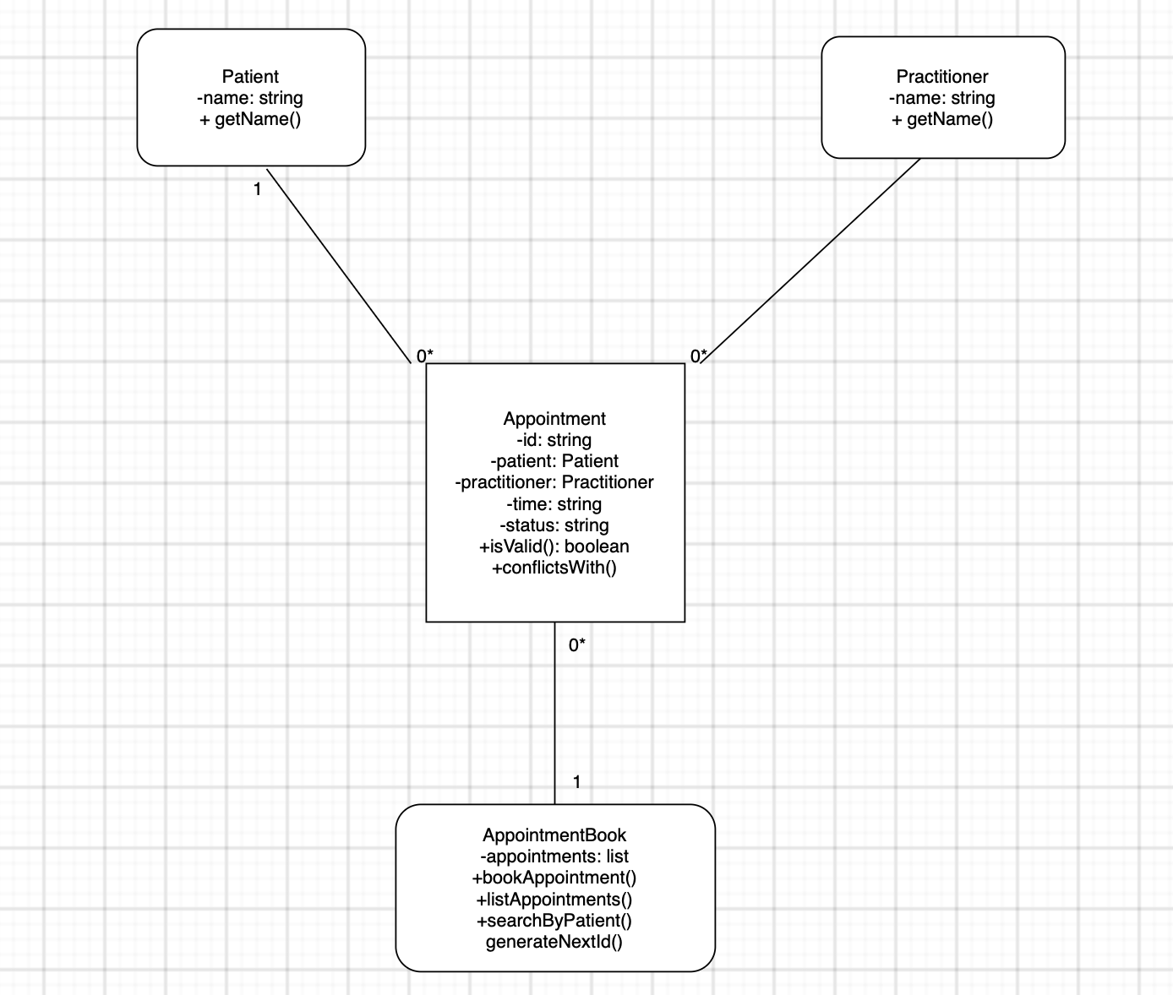

Design Rationale
Explain class selection, responsibility allocation and key relationships.
The domain model is built around four classes, each chosen and justified by tracing directly back to the confirmed requirements. Patient and Practitioner were kept deliberately lightweight, holding only a name attribute and a getName() method, since no confirmed requirement asks for additional data beyond a name at this stage (FR-01, FR-02). Both classes are needed as distinct entities rather than plain strings because Appointment must reference them individually to support search (FR-08) and conflict-checking (FR-10).
Appointment carries the majority of the business logic, since this is where the requirements concentrate: it stores the patient, practitioner, time, and a unique identifier (FR-03, FR-09), and exposes isValid() to enforce the mandatory-field rules (FR-04–06, NFR-04) and conflictsWith() to support double-booking detection (FR-10).
AppointmentBook was introduced as a coordinating class to hold the collection of appointments and expose higher level operations (bookAppointment(), listAppointments(), searchByPatient(), generateNextId()), satisfying FR-07, FR-08, FR-09 and FR-10 at a system level rather than leaving this logic untouched. Unlike the other three classes, AppointmentBook is not strictly demanded by a single requirement, it is a design decision to support maintainability (NFR-02) and testability (NFR-05) by summarising booking logic in one place rather than repeating it.
The associations reflect real-world examples: each appointment is linked to exactly one patient and one practitioner (1 to 0*), while AppointmentBook holds many appointments (0* to 1). No relationship was added without a supporting requirement. For example, a suggestion during the AI design review was to give AppointmentBook direct aggregation links to Patient and Practitioner was only partially accepted, since the confirmed requirements don't yet demand independent patient/practitioner management outside the context of booking an appointment.

AI Design Review Record
AI suggestion | Evidence | Decision | Reason | Model change
AppointmentBook > Appointment | FR-07, FR-08, FR-10, NFR-01, NFR-02, NFR-05 | Accepted | Matches existing design, AppointmentBook needs a collection of appointments to support listing, searching, and conflict checking | None
AppointmentBook > Patient and AppointmentBook > Practitioner | FR-01/FR-02 (recording), FR-03 (selecting), FR-08/FR-10 (lookups) | Modified | Valid underlying point but adds more structure than confirmed requirements currently demand. Patients/practitioners are only reached through appointments at this stage | Noted as a future refinement, not added to the model yet
Appointment > Patient / Appointment > Practitioner | NFR-04 | Rejected | NFR-04 is a general quality goal, not specific evidence for making the association mandatory, the correct evidence is FR-04/FR-05 | None
Appointment class with isValid() and conflictsWith() | FR-04-06, FR-10, NFR-04 | Accepted | Directly supported and already implemented in the code skeleton | None
Suggestion to treat AppointmentBook as fully justified by functional requirements alone | FR-03, FR-07, FR-08, FR-10 | Modified | AppointmentBook is better understood as a design choice supporting maintainability/testability (NFR-02, NFR-05), not strictly demanded by a single FR | Flagged as “optional class” in CRC card

