

CMP6200 / DIG6200
Individual Undergraduate Project (FYP)
Project Interim Report

Skin Care Recommendation System for Nepal
Student Name: Krishu Karki
Student ID: 23189624
Supervisor : Prakash Gautam
Date: May 5th 2026

Table of Contents
1.0 Introduction and Context 3
1.1 Problem Statement 3
2.0 Review of Existing Knowledge 4
2.1 Critical Analysis and Gap Identification 5
2.2 Project Justification 5
3.0 Project Aims, Objectives, and Scope 6
3.1 Project Aim 6
3.2 Project Objectives 6
3.3 Project Scope 7
4.0 Project Design 7
4.1 Design and Methods 7
4.2 Justification of Methods 9
4.3 Project Timeline 10
5.0 Feasibility, Risks, and Ethical Aspects 10
5.1 Feasibility 10
5.2 Risk Analysis and Mitigation 10
5.3 Ethical Considerations 11
References 12

Table of Figure
Figure 1 System Architecture Diagram. 8
Figure 2 Gantt Chart 9

1.0 Introduction and Context
Access to proper skincare guidance is increasingly recognised as a component of personal healthcare. In many parts of the world, rapid growth in consumer beauty markets has been accompanied by the rise of AI-driven personalisation platforms that tailor product recommendations to individual skin profiles. Nepal, however, represents a distinct context: a geographically and climatically diverse nation where altitude, humidity, air quality, and seasonal extremes vary considerably between the Terai lowlands and the Himalayan highlands. These environmental factors directly affect skin condition, yet the vast majority of globally available skincare recommendation tools are neither trained on data Nepalese populations nor constrained to products available in the Nepalese market.
The intersection of computer vision and recommender system research offers a promising path toward closing this gap. Convolutional neural networks (CNNs) have demonstrated strong performance in dermatological image classification (Esteva et al., 2017), while hybrid recommendation architectures combining content-based and rule-based filtering have shown effectiveness in low-data environments (Aggarwal, 2016). Integrating these two paradigms into a unified pipeline one that takes a user selfie as input and returns locally available product recommendations as output.
This report presents the interim findings of developing such a system: the Smart Skin Care Recommendation System for Nepal. It documents the problem context, a review of relevant existing knowledge, the project aims and objectives, the chosen design and methodology, and a feasibility and risk assessment.

1.1 Problem Statement
People in Nepal lack access to a reliable, AI-powered skincare recommendation platform that (a) identifies their skin type or condition from a facial image and (b) recommends suitable skincare products that are actually available from Nepalese e-commerce platforms leaving individuals reliant on generic global tools that recommend inaccessible products or on costly dermatology consultations that are unavailable in many regions (Ramrakhiani and Kalbande, 2024; Choudhary, 2024).
Nepal’s diverse geography creates significant variations in climate, humidity, and ultraviolet (UV) exposure, all of which directly affect skin health and skincare needs (Goldust and Grant-Kels, 2024). A resident of Kathmandu Valley experiences moderate humidity and seasonal monsoon exposure, while someone in Mustang or the high-altitude northern districts faces persistent cold, dry winds and intense UV radiation due to reduced atmospheric filtration. Conversely, communities in the Terai lowlands contend with prolonged heat and high ambient humidity throughout the year. Skin condition is directly shaped by these environmental stressors, yet no available recommendation platform accounts for altitude, regional air quality index, or seasonal climate as variables in its suggestion logic.
A second dimension of the problem concerns economic accessibility. Many globally recommended skincare brands those most frequently appearing in AI-generated suggestion outputs are either unavailable in Nepalese physical retail or are priced significantly above what the majority of the population can reasonably spend. When a tool recommends a product that cannot be purchased within the country, the recommendation has no practical value. This is not an edge case; it is the norm for Nepalese users engaging with internationally built skincare AI.
Finally, dermatological access itself is constrained in ways that amplify the need for a reliable digital alternative. Qualified dermatologists are concentrated predominantly in urban areas, with limited or no specialist availability in rural area. For users in rural hill districts or remote communities, accessing professional skincare guidance requires travel that is either costly, time-consuming, or simply not feasible (Neupane, 2012; Paudel, 2020). A self-service, AI-powered tool requiring only a smartphone camera and internet connectivity represents a meaningful step toward closing this access gap provided the tool is built with the right data, the right product inventory, and the right model assumptions for the population it serves.

2.0 Review of Existing Knowledge
The development of an AI-driven skincare recommendation system is grounded in two primary research domains: dermatological image classification and recommender systems. Recent advances in deep learning, particularly convolutional neural networks (CNNs), have significantly improved the accuracy of skin condition detection. For instance,( Esteva et al. (2017) demonstrated that CNN-based models can achieve dermatologist-level performance in classifying skin diseases, highlighting the potential of automated image-based diagnosis. Similarly, CNN architectures are effective for categorising various skin conditions, reinforcing their suitability for skincare applications. More advanced architectures such as EfficientNet further improve performance through optimised scaling (Tan and Le, 2019).

Despite these advancements, dataset bias remains a critical challenge. Groh et al. (2021) identified that many dermatological datasets underrepresent darker skin tones, reducing model generalisation across diverse populations. This issue is particularly relevant in the Nepalese context, where local skin tone diversity is not adequately represented in global datasets.

In parallel, recommender systems provide the foundation for personalised product suggestions. Content-based filtering approaches (Lops et al., 2011) and hybrid recommender systems (Aggarwal, 2016) have proven effective in scenarios with limited user data. These methods enable recommendations based on product features such as ingredients and skin-type compatibility. However, most existing systems lack localisation and recommend globally available products, limiting their usefulness in Nepal.

One of the most consequential limitations of published skin classification systems is their uneven performance across skin tone groups. Groh et al. (2021) conducted a systematic evaluation using the Fitzpatrick 17k dataset, which spans all six Fitzpatrick scale categories, and found that models trained on widely used dermatology datasets exhibited significantly lower accuracy on types IV through VI. The tones most common among South Asian, East African, and Latin American populations. Performance gaps of this magnitude are not minor calibration issues; they translate directly into unreliable predictions for the users least likely to have access to alternative sources of clinical guidance.

Explainable AI is another important area, as transparency improves user trust. Techniques such as Grad-CAM (Selvaraju et al., 2017) provide visual explanations for CNN predictions, while natural language generation models can produce human-readable justifications (Ji et al., 2023). However, many existing skincare systems do not incorporate explainability features.

2.1 Critical Analysis and Gap Identification
The reviewed literature reveals three principal gaps relevant to this project:
- Dataset bias: Publicly available skin classification datasets are predominantly composed of images from lighter Fitzpatrick scale tones (I–III), raising concerns about model generalisation to South Asian skin tones (Groh et al., 2021). The Kaggle dataset used in this project (SD20CO001) partially addresses this but requires validation.
- Market localisation: No peer-reviewed system integrates skin condition detection with a product database constrained to the Nepalese market. Existing tools recommend globally available luxury brands inaccessible to most Nepalese consumers.
- Explainability gap: Many deployed skincare AI systems present recommendations without explanation, reducing user trust and failing to educate users about their skin. An SLM-driven explanation layer directly addresses this limitation.

2.2 Project Justification
The literature reviewed establishes a clear and specific justification for the present project. The three gaps identified the dataset representational bias, the complete absence of a localised Nepalese-market skincare recommendation system in the peer-reviewed literature, and the explainability deficit in deployed skincare AI tools collectively define a problem space that is both academically novel and practically significant.

From a technical standpoint, the proposed system addresses these gaps by combining a transfer-learned EfficientNet-B2 classifier, demonstrated by Tan and Le (2019) to be the most parameter-efficient CNN architecture for image classification tasks of this type, with a hybrid recommendation pipeline grounded in the content-based filtering methodology validated by Lops et al. (2011) and the ingredient-level matching approach. The addition of Grad-CAM visualisation and SLM-generated product rationales directly addresses the explainability gap that characterises most deployed skincare AI systems. As a result, every element of the suggested architecture is based on a particular identified gap and is backed by a corpus of data from the literature review.

From a practical perspective, the rationale for the project is therefore grounded. Geographic and financial factors severely limit access to dermatological expertise in Nepal: specialized clinics are primarily located in Kathmandu and a few urban areas, resulting in the majority of the population lacking accessible professional skincare support. An online AI system that only needs a selfie and an internet connection provides a scalable, affordable alternative to in-person consultations for users for whom such consultations are difficult due to geographic or financial reasons.

The system’s explicit constraint to products available from Nepalese e-commerce platforms ensures that recommendations are immediately actionable rather than aspirational, which represents the principal practical shortcoming of all current global skincare AI tools when applied to the Nepalese market.

3.0 Project Aims, Objectives, and Scope

3.1 Project Aim

The aim of this project is to design, develop, and evaluate an AI-powered personalised skincare recommendation system for the Nepalese market. The system will analyse a user-provided facial image to predict the user’s skin type and selected non-clinical skin conditions supported by the available labelled dataset and will use these predictions together with product information to generate relevant skincare recommendations that are available in Nepal. The system will also provide an explanation of the factors contributing to each recommendation while clearly positioning the application as a consumer skincare and wellness tool rather than a clinical diagnostic system.

3.2 Project Objectives
- Objective 1: Construct and preprocess a labelled skin image dataset. Merging the Kaggle skin disease dataset with any supplementary Nepalese-skin-tone images, applying face detection, normalisation, and augmentation to create a training-ready corpus of at least 3,000 images across skin type classes and skin condition.
- Objective 2: Train and validate machine learning classifier achieving ≥80% weighted F1-score using transfer learning with ImageNet weights, fine-tuning on the prepared dataset, and evaluating on a stratified 15% held-out test set.
- Objective 3: Develop a Nepal-specific skincare product database containing relevant product information by scraping product names, prices, ingredient lists, skin-type tags, and URLs from Daraz, PrettyClick, Jeevee, and Bonjour Nepal, stored in a structured SQLite schema or csv.
- Objective 4: Implement and evaluate a hybrid recommendation engine combining rule-based skin-type with cosine similarity ranking over ingredient vectors.
- Objective 5: Implement an SLM explanation layer and provide a backend endpoint that accepts a base64-encoded image and optional user preferences and predicts skin type, the top five recommended products, and a natural-language explanation for each.

3.3 Project Scope
In scope:
- Skin type images classifies across multiple classes: dry, oily, normal, combination, acne-prone, and many more.
- Products recommendation sourced exclusively from Daraz, PrettyClick, Jeevee, and Bonjour Nepal.
- Input modality limited to still facial photographs (no video, no real-time video streaming).
- Web-based demo interface; with the possibility of native mobile application
- English-language interface and explanations (Nepali localisation is out of scope for this phase)

Out of scope:
- Clinical diagnosis or medical advice; the system is a consumer wellness tool only
- Skin disease classification beyond the standard type classes
- Collaborative filtering (requires user interaction history not available at launch.
- Integration with pharmacy or dispensing systems

4.0 Project Design

4.1 Design and Methods
This project follows an iterative software development methodology with machine learning model development integrated into a MLOps pipeline. The overall design comprises four major components, each with distinct methods:
The system architecture is divided into five major phases: dataset construction, skin classification model development, product database generation, recommendation engine implementation, and deployment/integration. An iterative Agile-inspired workflow will be used so that each component can be independently tested and refined throughout development.
The first stage of the project involves constructing a training-ready facial skincare dataset. The primary dataset source will be the publicly available Kaggle skincare image dataset (SD20CO001), supplemented with a smaller number of locally collected images representing Nepalese skin tones and environmental conditions. The dataset will be categorised into six skin classes: dry, oily, normal, combination, acne-prone, and sensitive. The skin classification component will be implemented using transfer learning with the convolutional neural network architecture. Pretrained ImageNet weights will be used as the base model, enabling the system to leverage previously learned visual features while reducing training time and computational cost.
The final classification layers will be adjusted on the skincare dataset utilizing the PyTorch deep learning framework. Class weighting will be implemented with cross-entropy loss to tackle class imbalance, and the Adam optimizer will be utilized for gradient optimization. The evaluation of model performance will involve accuracy, precision, recall, weighted F1-score, and confusion matrices.A database of skincare products specific to Nepal will be developed by gathering publicly accessible product details from leading Nepalese e-commerce websites like Daraz, PrettyClick, Jeevee, and Bonjour Nepal. Web scraping will be performed utilizing Python libraries like Beautiful Soup and Requests.
The scraper will extract product attributes including product name, brand, ingredients, price, target skin type, description, rating, and product URL. Extracted information will be cleaned and normalised before being stored in a structured SQLite database or CSV format. Ingredient names will also be standardised to reduce inconsistencies across different websites.
The recommendation engine will use a hybrid recommendation strategy combining rule-based filtering and content-based recommendation techniques. Initially, products incompatible with the predicted skin type will be filtered out using manually defined skincare rules derived from dermatological guidance and product metadata.
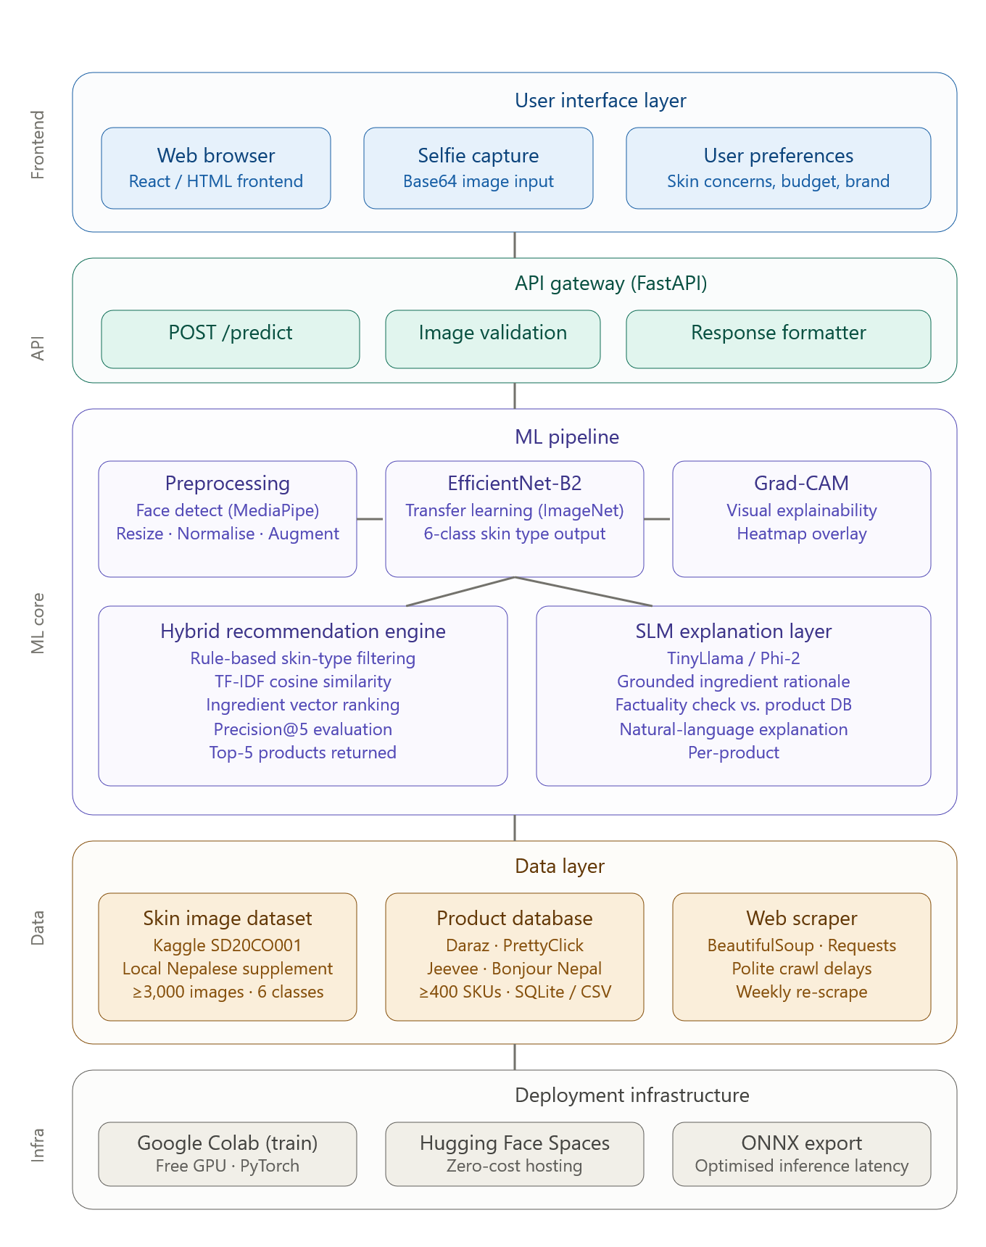
Figure 1 System Architecture Diagram.

4.2 Justification of Methods

The methods chosen were selected for their optimal balance of accuracy, computational efficiency, explainability, and feasibility for an undergraduate final-year project.

Transfer learning was chosen instead of training a CNN from scratch. Using pretrained ImageNet weights enables the model to learn effectively from fewer domain-specific examples while significantly reducing training time and overfitting risk.

For the recommendation engine, a hybrid recommendation approach was selected over collaborative filtering. Collaborative filtering methods depend heavily on large-scale user interaction histories, ratings, and behavioural data that are unavailable in the initial deployment stage of this project. In contrast, content-based filtering using TF-IDF similarity allows meaningful recommendations to be generated immediately using product ingredients and metadata alone.

Web scraping was selected as the primary data collection method because no publicly available Nepal-specific skincare product dataset currently exists. Manual collection would be time-consuming and difficult to maintain, whereas automated scraping enables scalable and regularly updated product acquisition.

Finally, the integration of a Small Language Model (SLM) rather than a larger LLM is justified by deployment constraints. Lightweight models such as TinyLlama or Phi-2 can generate concise explanations with significantly lower memory and computational requirements, making them more suitable for low-cost deployment environments.

4.3 Project Timeline
The project will be completed over two academic semesters using an iterative development schedule. The timeline includes literature review, dataset preparation, model training, recommendation system implementation, evaluation, report writing, and final deployment.

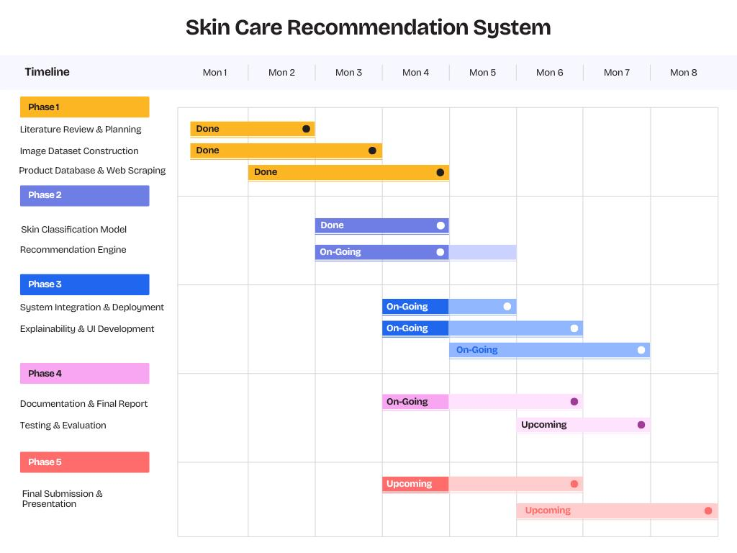

Figure 2 Gantt Chart

5.0 Feasibility, Risks, and Ethical Aspects

5.1 Feasibility
The project is assessed as feasible within the constraints of a final-year undergraduate project for the following reasons. All core technologies are open-source and freely available: PyTorch, Scikit-learn, FastAPI, Beautiful Soup are all mature, well-documented frameworks. The Kaggle dataset is publicly accessible and requires no special institutional approval. Cloud training on Google Colab (free GPU tier) is sufficient for fine-tuning at the dataset scale anticipated. Deployment on Hugging Face Spaces requires no server cost. The author has prior coursework experience in Python, machine learning, and web development, reducing ramp-up time on the chosen technologies.

5.2 Risk Analysis and Mitigation

Potential Risk | Likelihood | Impact | Mitigation Strategy
Small or imbalanced dataset leading to overfitting | High | High | Apply aggressive augmentation; use class-weighted loss; monitor validation /train loss gap; supplement with manually collected images.
Poor model performance on Nepalese skin tones | High | High | Collects supplementary images; report Fitzpatrick-stratified metrics; acknowledge limitation explicitly in evaluation.
E-commerce platforms block scraper or change HTML structure | Medium | Medium | Implement polite crawl delays and rotate user agents; store raw HTML snapshots; schedule weekly re-scrape with schema validation alerts.
SLM generates hallucinated ingredient claims | Medium | High | Ground all SLM prompts with retrieved product facts; disable free-form generation; add a factuality check step comparing output against the product record.
API inference latency exceeds acceptable response time | Low | Medium | Export model; profile and optimise preprocessing; offer async processing with a result callback if needed.

Table 5.1: Risk Assessment and Mitigation

5.3 Ethical Considerations
All user images submitted to the system during the evaluation study will be collected under informed written consent, with participants explicitly informed that images will be used only for model evaluation and will not be retained beyond the study period. No personally identifiable information will be stored alongside images. The evaluation study design will be submitted for institutional ethics review prior to data collection.
The project will report performance metrics disaggregated where ground-truth labels are available and will include a clear fairness limitation statement in the final report. The system will never claim clinical diagnostic capability and will include a prominent disclaimer directing users to consult a qualified dermatologist for medical concerns. All web scraping will respect the robots.txt directives of target platforms, implement minimum crawl delays of two seconds per request, and collect only publicly accessible product listing data. No personal user data will be scraped. Scraped data will be used solely for the non-commercial academic purposes of this project.
The system will surface confidence scores alongside all skin type predictions. Recommendation explanations will cite the specific ingredient or product property driving each suggestion. These measures support the principle of meaningful transparency for AI-assisted wellness tools.

References
Aggarwal, C.C. (2016) Recommender Systems: The Textbook. Cham: Springer.
Esteva, A., Kuprel, B., Novoa, R.A., Ko, J., Swetter, S.M., Blau, H.M. and Thrun, S. (2017) ‘Dermatologist-level classification of skin cancer with deep neural networks’, Nature, 542(7639), pp. 115–118.
Groh, M., Harris, C., Soenksen, L., Lau, F., Han, R., Kim, A., Koochek, A. and Manrai, A. (2021) ‘Evaluating deep neural networks trained on clinical images in dermatology with the Fitzpatrick 17k dataset’, Proceedings of CVPR Workshops.
Ji, Z., Lee, N., Frieske, R., Yu, T., Su, D., Xu, Y., Ishii, E., Bang, Y.J., Madotto, A. and Fung, P. (2023) ‘Survey of hallucination in natural language generation’, ACM Computing Surveys, 55(12), pp. 1–38.
Liu, Z., Luo, P., Wang, X. and Tang, X. (2020) ‘Large-scale CelebFaces Attributes (CelebA) dataset’. Available at: http://mmlab.ie.cuhk.edu.hk/projects/CelebA.html (Accessed: 10 November 2024).
Lops, P., de Gemmis, M. and Semeraro, G. (2011) ‘Content-based recommender systems: State of the art and trends’, in Ricci, F. et al. (eds) Recommender Systems Handbook. Boston: Springer, pp. 73–105.
Neupane, S.S. (2012) ‘Teledermatology in Nepal: Where are we?’, Nepal Journal of Dermatology, Venereology & Leprology, 8(1), pp. 38–40.
Paudel, V. (2020) ‘The increasing scope of teledermatology in Nepal’, Journal of Nepal Medical Association, 58(232), pp. 1024–1026.
Goldust, M. and Grant-Kels, J.M. (2024) ‘Using AI to help address skin health challenges caused by climate change’, International Journal of Dermatology, 63(7), pp. e126–e127. doi: 10.1111/ijd.17222.
Ramrakhiani, N. and Kalbande, D. (2024) ‘A comprehensive review of AI-powered skincare product recommendation systems: From data collection to user experience’, Digital Health, 10, pp. 1–18. doi: 10.1177/20427530241304073.
Selvaraju, R.R., Cogswell, M., Das, A., Vedantam, R., Parikh, D. and Batra, D. (2017) ‘Grad-CAM: Visual explanations from deep networks via gradient-based localization’, Proceedings of ICCV, pp. 618–626.
Tan, M. and Le, Q. (2019) ‘EfficientNet: Rethinking model scaling for convolutional neural networks’, Proceedings of ICML, pp. 6105–6114.
Zhang, P., Zeng, G., Wang, T. and Lu, W. (2024) ‘TinyLlama: An open-source small language model’, arXiv preprint arXiv:2401.02385.

