select *
from customer;

--Q1-What is the total revenue genrated by male vs female customers?

select gender,sum(purchase_amount) as 'Total_Revenue'
from customer
group by gender
order by 2 desc;

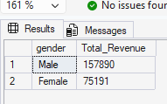

--Q2- WHich customers used a discount but still spent more than the average purchase amount?

select distinct customer_id,purchase_amount
from customer
where [discount_applied]='Yes'
and purchase_amount>=(select avg(purchase_amount) from customer)
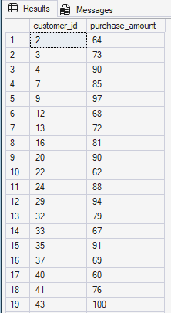

--Q3 Which are the top 5 products with the highest average review rating?

select top 5 item_purchased,round(avg(review_rating),2) as 'Average_Review_Rating'
from customer
group by item_purchased
order by 2 desc

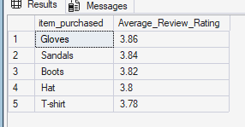

--Q4 Compare the average Purchase Amounts between Standard and Express Shipping

Select shipping_type,avg(purchase_amount) as 'Average_Purchase_Amount'
from customer
where shipping_type in ('Express','Standard')
group by shipping_type;

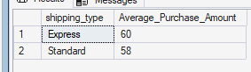

--Q5 Do subscribed customers spend more? Compare average spend and total revenue between subscribers and non-sbscribers?

select subscription_status,
count(customer_id) as 'Total_customers',
avg(purchase_amount) as 'Average_Spend',
sum(purchase_amount) as 'Total_Revenue'
from customer
group by subscription_status
order by 4,3 desc;

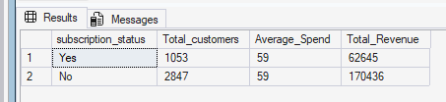

--Q6 Which 5 products have the highest percentage of purchases with discounts applied?

SELECT
top 5 item_purchased,
ROUND(SUM(CASE WHEN discount_applied = 'Yes' THEN 1.0 ELSE 0.0 END) / COUNT(*) * 100,2) AS discount_rate
FROM customer
GROUP BY item_purchased
order by 2 desc;
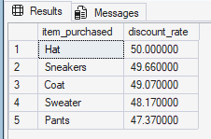

--Q7 Segment customers into New, Returning, and loyal based
--on their total number of previous purchases and show the count of eacch segment.

with cte as(select customer_id,
case when previous_purchases=1 then 'New'
when previous_purchases between 2 and 10 then 'Returning'
else 'Loyal'
end as 'Segment'
from customer)
select Segment,
count(customer_id)as Customer_Count
from cte
group by Segment
order by 2 desc;

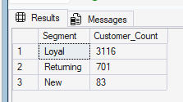

--Q8 What are the top 3 most purchased products within each category?

--select *
--from (select
--item_purchased,
--category,
--purchase_amount,
--count(customer_id) as 'Total Orders',
--row_number() over(partition by category order by purchase_amount desc) as rowz
--from customer
--group by item_purchased, category, purchase_amount)t1
--where t1.rowz<=3;

with item as(
select category,
item_purchased,
count(customer_id) as 'Total_orders',
row_number() over(partition by category order by count(customer_id)desc) as 'rank'
from customer
group by category,item_purchased)
select rank,category,item_purchased,Total_orders
from item
where rank<=3;

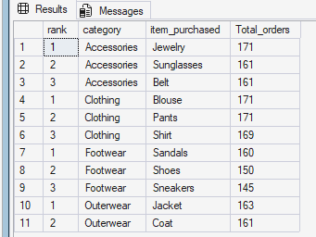
--Q9 Are customers who are repeat buyers(more than 5 previos purchases) also likely to subscribe?

select
subscription_status,
count(customer_id) as customer_count
from customer
where previous_purchases>5
group by subscription_status;

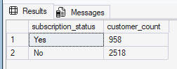

--Q10 What is the revenue contribution of each age group?

select age_group,sum(purchase_amount) as 'Revenue_Contribution'
from customer
group by age_group
order by 2 desc;

