1.

Ambient 环境

2.

If want to search the details of Qt Mobility, just search it in the Qt Creator🡪Help🡪Index🡪Input “qt mo”.

Qt Assistant can’t find it!

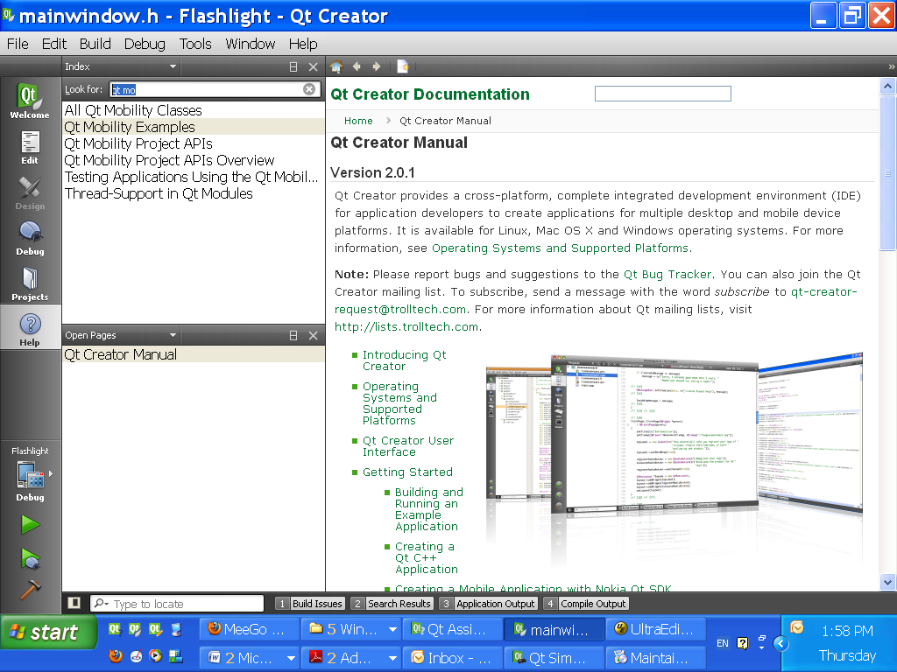

3.

Verbosity 赘言; 华丽虚饰的语

4.

手机启动时，会调用boot loader,它又从RAM中读取一些数据。记住，刚开始不是从内核读数据。

5.

Annotation 注解；释文

6.

programming language agnostic 与编程语言无关

7.

//We **can’t** inherit QObjectPrivate directly!

class Q_GUI_EXPORT QWidgetPrivate : public QObjectPrivate

{

Q_DECLARE_PUBLIC(QWidget)

……

}

8.

**Teacher email address: tino.pyssysalo@digia.com**

9.

If want to write the QtMobility programs, we must add below in the *.pro file as below:

CONFIG += mobility

MOBILITY += systeminfo sensor … (Notes:systeminfo and sensor is the QtMobility module name, can change it accordingly)