IM protocol-draft V 0.2

Date: 2010-06-29 version: 0.2 Author: William Lv

Description: Message protocol.

Msg : Message

Seg: Segment

Len: Length

**Chapter One**

1. Msg protocol

Head content:

|  |  |  |  |
| --- | --- | --- | --- |
| Name | Data type | Max Len | Description |
| Size | quint32 | 2^32 | Whole message length |
| Type | quint8 | 2^8 | Message Type |
| SegID | quint8 | 2^8 | Segment ID |
| SegLen | quint16 | 2^16 | Segment length |
| SegNext | quint8 | 2^8 | If has next segment |
| Message |  |  | Message input by user/server |

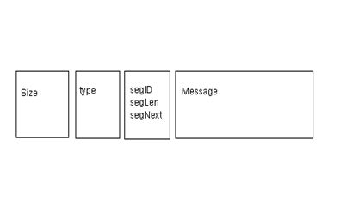

1. Size (total size in byte)
2. Type :

完善这个，登录，下线等

|  |  |  |
| --- | --- | --- |
| 0x00 | Default value |  |
| 0x01  序号1,2,3,4…依次编排 | Syn message, sent by server and client automaitcly to check connection status. |  |
| 0x02 | Login message, sent by client and the server sent 0x03 as response. |  |
| 0x03 | Sent by server to tell client that connection accpected and server is ready for next message. | Mutex, can’t appear with 0x08 in one message. |
| 0x04 | Sent by server to tell client that connection build failed. Failed reason should be written in Message segment. | Mutex, can’t appear with 0x04 in one message. |
| 0x05 | User message. |  |
| 0x06 | Request server users list. Send by client. | Request both user list and group list. |
| 0x07 | Response 0x06 request, message contain user list or group list. |  |
| 0x08 | Client prepares to log out. |  |
| 0x07 | Reserve for next version. |  |
| 0x07 | Reserve for next version. |  |
| 0xXX | Reserve for next version. |  |

不考虑多个类型合并

C． SegID

标识每一段Message segment 。

minimum：0x00

maximum：0x0F

1. SegLen

Message segment length.

E. SegNext

0XFF means no message segments behind.

Otherwise more message segment follow behind.

Example:

void MainWindow::sendData()

{

QByteArray block;

QDataStream out(&block, QIODevice::WriteOnly);

out.setVersion(QDataStream::Qt_4_6);

quint32 blockSize = 0;

quint8 blockType = 0;

quint8 segID = 0;

quint32 segLen = 0;

quint8 segNext = 0xFF;

QString content = msgEdit->toPlainText();

segLen = content.size() + sizeof(segLen) + sizeof(segID);

out<<blockSize<<blockType<<segID<<segLen<<segNext<<content;

out.device()->seek(0);

out<<quint32(block.size() - sizeof(quint32));

tcpSocket->write(block);

}

1. Message

Length: Message segment length (size in byte)

Type:

|  |  |  |
| --- | --- | --- |
| 0x00 | Default value |  |
| 0x01 | P2P Message | Person to person message. Include simple text message and multi-media message. |
| 0x02 | P2M | One to multi message. |
| 0x03 | SCM | Server control message. |
| 0x04 | Client request list ID | Contain last list ID received. |
| 0x05 | Server response list request. | Contain list information, such as users and group list numbers. |
| 0x06 | Server list message | Contain current list ID, and following list ID. |
| 0x07 | Login information | Such as user name, password and special settings. |
| 0xXX | Reserve for next version |  |

Extension: Reserve for next version.

1. May used as link priority.
2. May used as connection method. ( A. One time connection; B. Temporary/short connection; C. Long time connection )

什么场景下用到这些？

1. May used as contain more control/other information

关于Ext最初考虑用来 给未来扩展做接口。昨天（0629）会议讨论到需要应用层抽象UDP长连接，connection method为其留了一个接口。

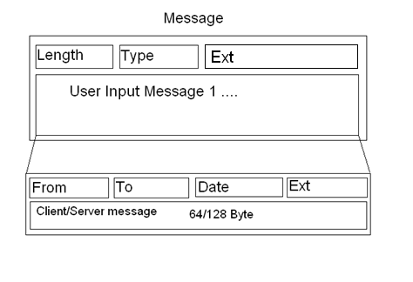

Message maximum size (in bytes) =

4(size) + 1(type) + 1(Segment ID) + 2(Segment length) +

[2(Length in message segment) + 1(type) + 4(Ext) +

4(From) + 4(To) + 4(Date) + 4(Ext) + 128(User/Server input message)] * 0x0F = 8 + 2416 = 2424Byte

16 Client (Server) messages / Maximum Size with 16 message fragments

= 2048 / 2424 = 0.845

Message minimum size (in bytes) =

4(size) + 1(type) + 1(Segment ID) + 2(Segment length) +

2(Length in message fragment) + 1(type) + 1(Friend SegID) + 4(Ext) +

4(From) + 4(To) + 4(Date) + 4(Ext) + 128(User/Server input message)

= 8 + 8 + 16 + 128 = 160

One Client (Server) message / Minimum Size with one message fragment

= 128 / 160 = 0.8

**Chapter Two**

1. Login time table: 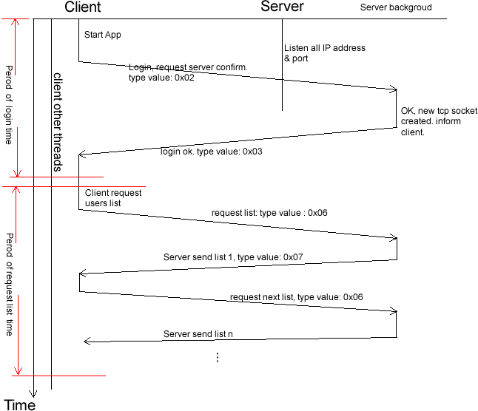

Client 登录流程：

通信方式： TCP/UDP。

登录步骤：

1. Client发送登录请求。

2. Logout time table

