Highway X Traffic Portfolio Project Writeup (CRISP-DM)

1. Business Understanding
Tasks:
- Problem Identification: NHTSA officials have noted sub-optimal traffic throughput and a high accident rate on a 5-mile stretch of Highway X, a 3-lane regional highway with a 55 MPH speed limit. Speeding has been identified as a major contributor to the high accident rate.
- Objectives: Develop strategies to reduce traffic slowdowns, lower average vehicle speeds under normal conditions, and decrease accident rates, thereby enhancing travel reliability and safety.
- Proposed Solutions:
  - a) Add an additional lane
  - b) Increase highway patrol presence for 4 hours daily
  - c) Raise the speed limit by 5 MPH
  - d) Lower the speed limit by 5 MPH
- Constraints: The analysis must utilize AWS services due to local resource limitations.
Implementation:
- Simulating Traffic Data:
  - Developed a Python-based data generation function in AWS Lambda to simulate a speed recording device. Utilized Python’s Numpy library to generate random, yet patterned, traffic data.
  - Iteratively refined the model to ensure the realism and variety of the generated data.
- Data Storage and Processing:
  - Initially configured AWS Lambda and an Amazon RDS PostgreSQL database within a private VPC subnet.
  - Encountered challenges with Lambda’s 15-minute execution limit, leading to the design of a parent function that partitions data generation into 30 segments (one per day) for efficiency.
- Overcoming AWS Limitations:
  - Addressed an issue where the parent Lambda function could not invoke child functions due to VPC restrictions. Resolved this by configuring a NAT Gateway, enabling secure data operations within the private subnet while allowing inter-Lambda communication.

2. Data Understanding
Tasks:
- Objective: Analyze and summarize traffic data to understand patterns in accident rates and vehicle speeds.
Implementation:
- Data Retrieval: Employed Python and SQL scripts to extract and aggregate data by time of day and speed metrics from the database.
- Statistical Summary:
  - Accidents per million miles: 2.53
  - Percentage of vehicles speeding (>70 MPH): 4.45%
  - Average travel time for 5 miles: 6.84 minutes
- Visualization:
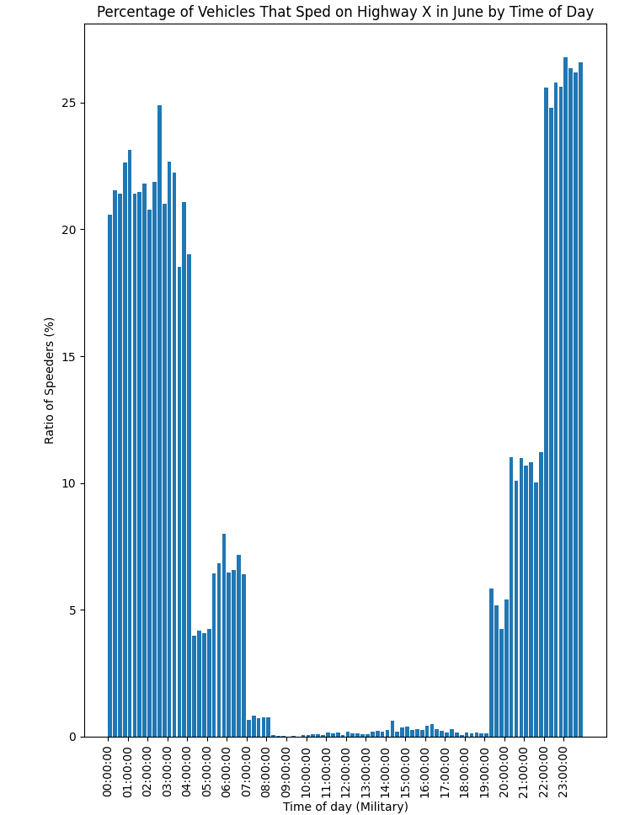
  - Developed histograms and bar charts using Matplotlib to visualize accident occurrences and speed patterns, resolving issues with axis formatting by integrating the mdates module.
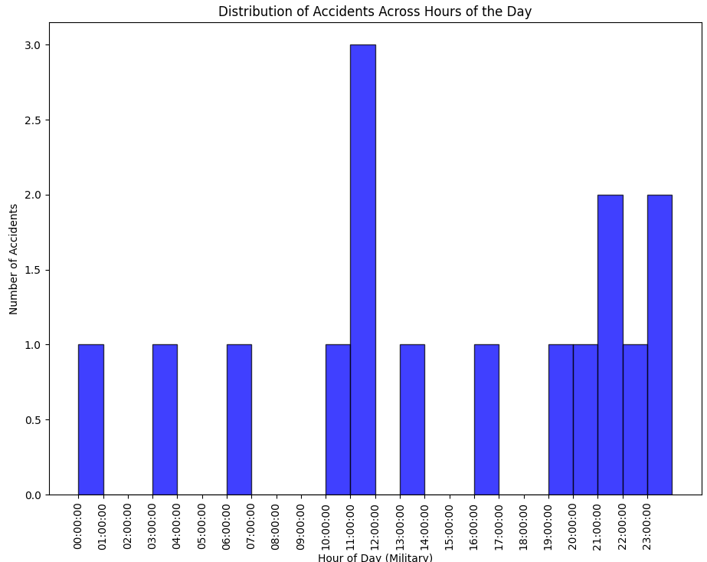

3. Data Preparation
Tasks:
- Feature Engineering: Calculated estimated travel times for each vehicle journey.
- Data Encoding: Applied encodings to vehicle types for model compatibility.
- Data Serialization: Assigned unique IDs to enhance data tracking.
- Data Enhancement: Appended new columns for travel times and encoded types directly in AWS Lambda.
- Storage Optimization: Transitioned to Amazon S3 from Amazon RDS for robust data storage, utilizing Psycopg2 and Pandas for data handling.
- Efficiency Improvements: Redesigned data processing to reduce runtime by 95%, adapting to AWS Lambda's execution limits by segmenting tasks.

4. Modeling
Tasks:
- Cluster Analysis: Segmented data using K-means to identify patterns based on travel times and speeds.
- Risk Prediction: Utilized Logistic Regression to estimate accident probabilities based on speed.
- Performance Forecasting: Predicted vehicle speeds using Linear Regression, incorporating time of day and travel conditions.
- Distributed Computing: Leveraged Amazon EMR Serverless for scalable model training, using PySpark for data processing.
- Model Enhancements: Improved model accuracy with feature transformation, stratified models, and hyperparameter tuning, achieving an R² of ~0.995.
- Cyclical Feature Encoding: Encoded time data cyclically to capture its nature effectively in predictions.
Forecasts Before Model Enhancements: Forecasts After Model Enhancements:
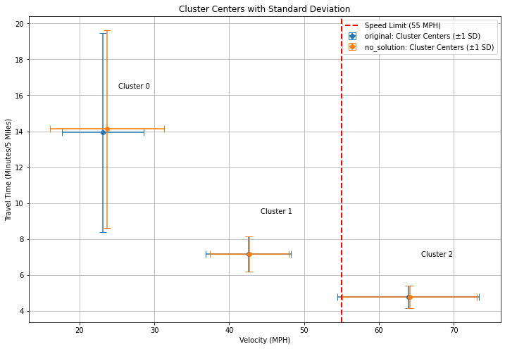
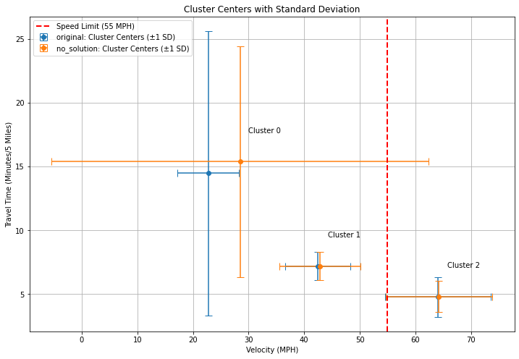

5. Evaluation
Tasks:
- Result Visualization: Graphed model outcomes to compare predicted impacts of traffic management strategies.
- Impact Analysis: Conducted sensitivity and cost-benefit analyses to evaluate each proposed traffic solution.
- Comparative Analysis: Used error bars and statistical summaries to contrast forecasted outcomes with historical data, identifying the most effective solutions.
- Future Steps: Proposed combined solutions and additional data collection to refine forecasts and enhance model reliability.

Each Solution’s Cluster Distributions:
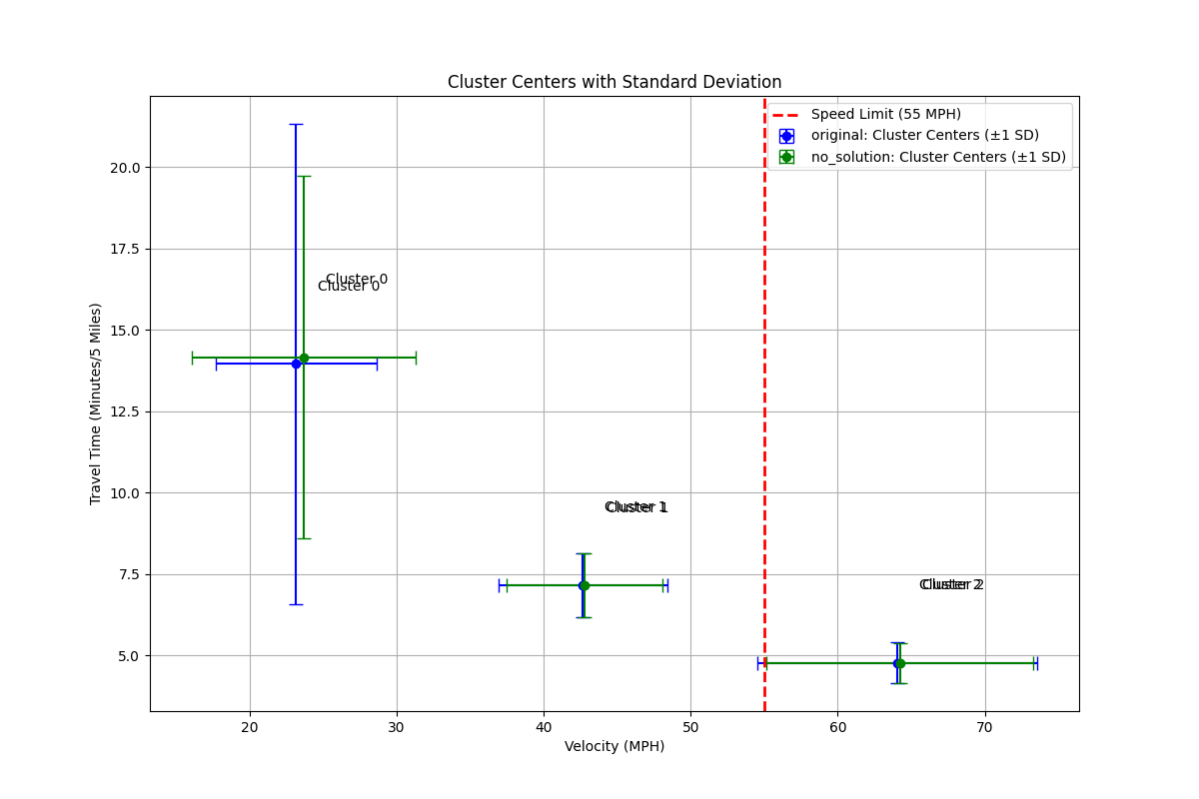
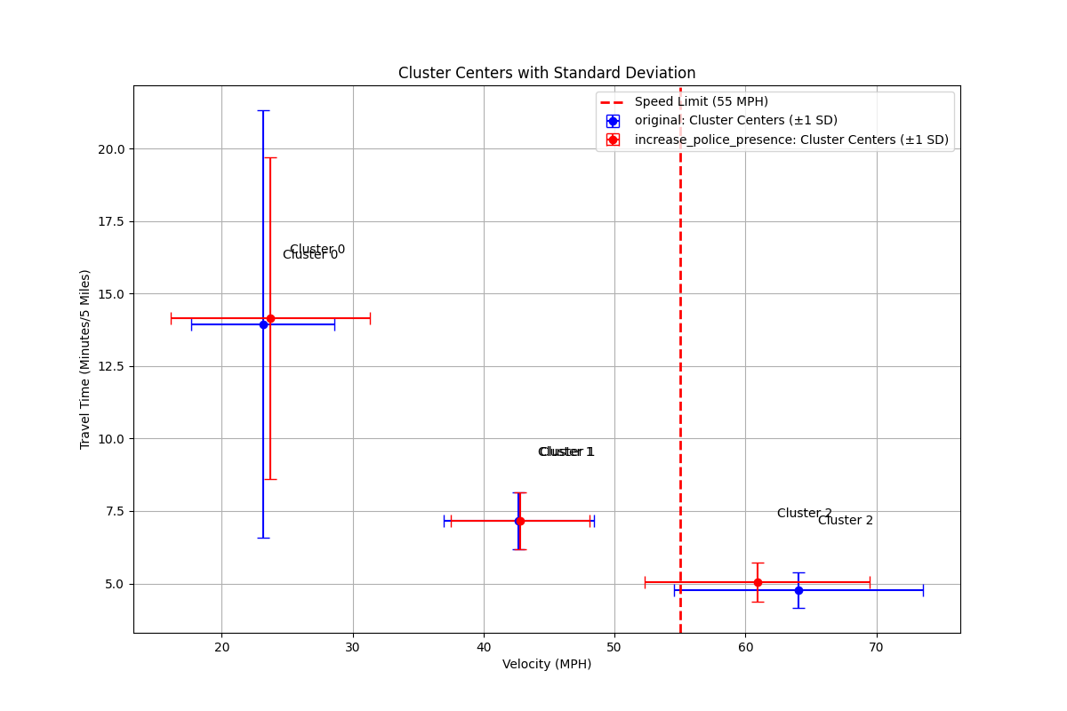
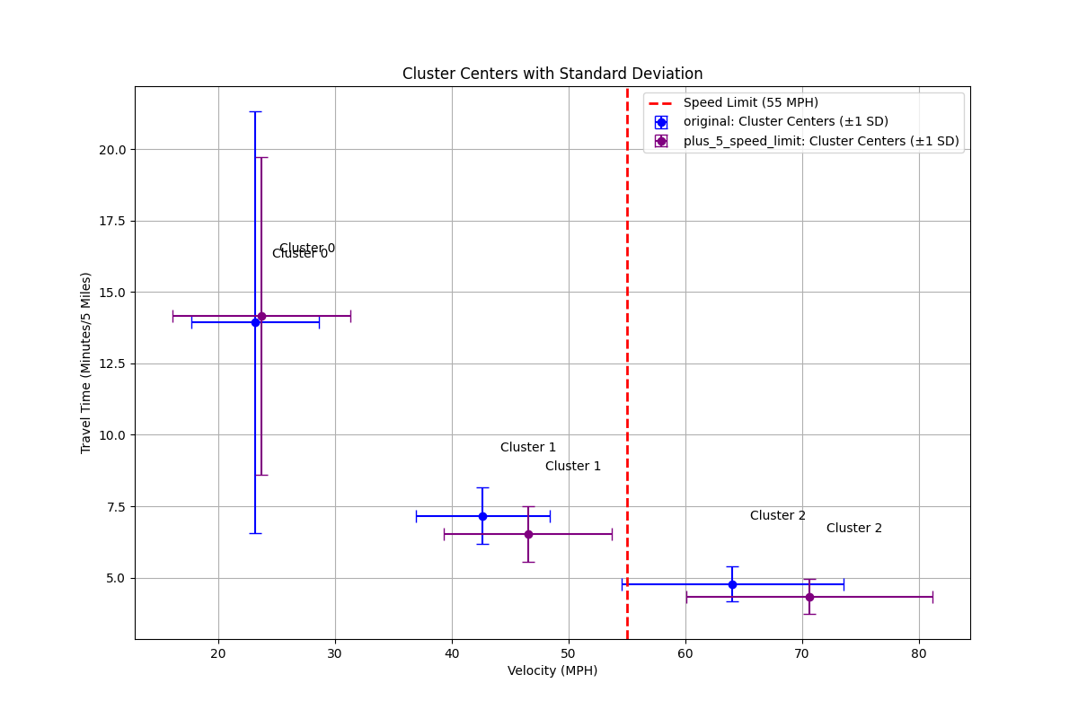
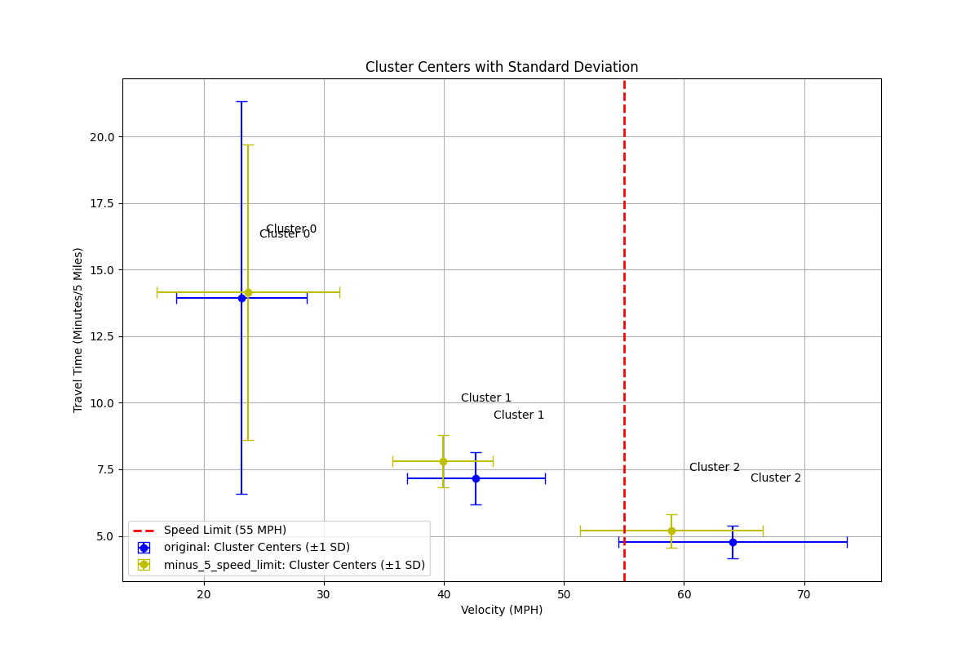
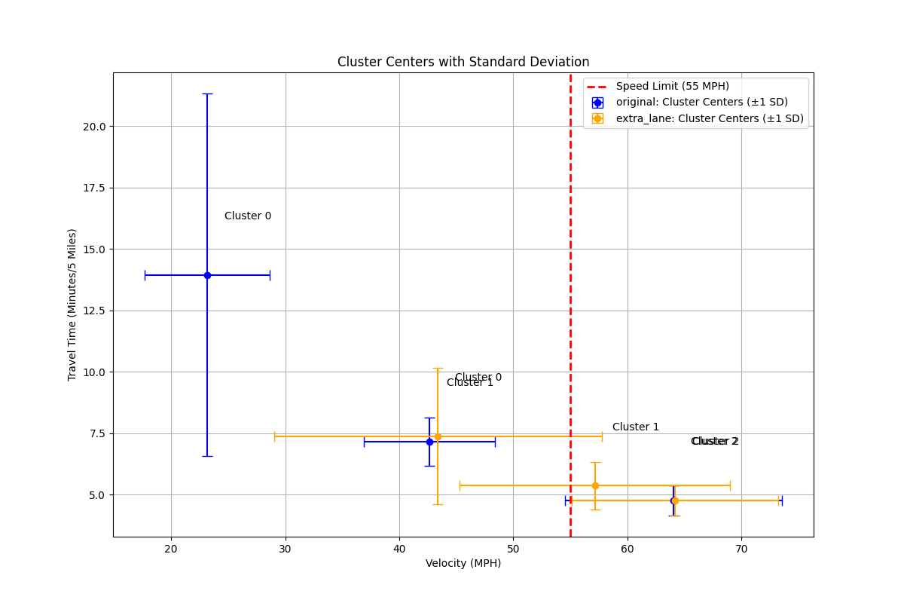

Numerically comparing forecasts with historical data:
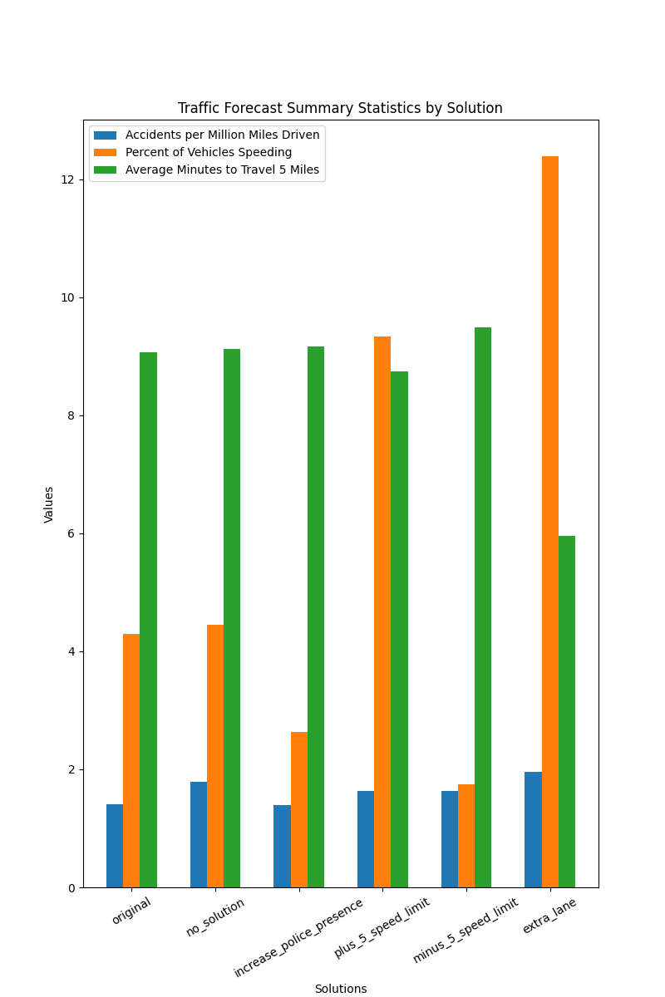

6. Deployment
Tasks:
- Modularity: Packaged the data processing and modeling workflow into an AWS Step Function for repeatability and easy management.
- Scalability: Structured the project to accommodate scaling for larger datasets, ensuring flexibility in data handling and storage.
- Cost Efficiency: Substituted NAT Gateway with an S3 Gateway Endpoint, reducing operational costs by 70%.
Future Iterations:
- Optimization: All processes reviewed and re-structured where runtime is decreased.
- Organization: Better modulate repeated processes to increase readability and re-usability.
- CI/CD: Set up framework to test new implementations on a larger scale.

