ASSISTIVE AI & COMPUTER VISION RESEARCH PROJECT  APEC SMART GLASSES FOR THE BLIND  Real-Time Multimodal Vision AI, Local Vietnamese ASR & Tactile Accessibility | Repository: thanh1912-ut/APEC_mat_kinh...  Target SHA: d9ba1e0 (main branch)  Current Release: Android Pilot v0.4.0 (Code 8)  Speech Engine: Zipformer RNN-T (sherpa-onnx)  Vision AI: Google Gemini 3.8 Flash

< 180 ms  Local STT Latency | 100% Tactile  Hardware Volume Keys | Zero Audio Leak  Speech Kept On-Premises | 651 Test Cases  322 Python + 329 Jest

1. PROJECT MISSION, GOALS & SCOPE  APEC Smart Glasses is an assistive engineering project dedicated to providing blind and visually impaired users with independent spatial awareness, instant object recognition, and interactive guidance for domestic appliances.  ■ True Non-Visual Accessibility: Eliminates touchscreen barriers by utilizing physical smartphone volume keys (Volume Up = Listen/Capture/Send; Volume Down = Cancel/Stop) paired with audio earcons.  ■ Absolute Speech Privacy: Streaming speech recognition executes entirely on-premises using lightweight Zipformer RNN-T models (~51MB ONNX). Raw user speech is never leaked to cloud APIs.  ■ Appliance Guidance Engine (v0.4.0): Provides verified step-by-step assistance to locate and trigger physical controls on air conditioners, TV remotes, and household appliances.  ■ Spatial Vision Roadmap: Pre-engineered abstraction layer designed to integrate STMicroelectronics VL53L9CX Direct ToF LiDAR sensors for 3D millimeter-level hazard detection.  2. SYSTEM ARCHITECTURE & DATA FLOW  [A. Mobile Client]: React Native/Expo app captures rear camera JPEG (max 1280px) and voice query (M4A/AAC).  [B. FastAPI Gateway]: Authenticates SHA-256 Bearer tokens, enforces 4MiB limits, queues into WorkGate.  [C. Local ASR Worker]: PyAV resamples audio to mono 16kHz; sherpa-onnx transcribes Vietnamese text in RAM.  [D. Vision AI]: Image and transcript queried to Gemini 3.8 Flash / 3.1 Flash Lite with store=false.  [E. Audio Delivery]: Structured JSON response spoken via Android TTS and earcons without TalkBack clash. | 3. TECHNICAL INNOVATIONS & FEATURES  ■ [UX] Tactile Hardware Control: Single short-press Volume Up activates audio listening; second press captures and uploads. Short-press Volume Down stops TTS readout immediately or cancels pending requests. Long press passes through to Android system volume.  ■ [PRIVACY] On-Premises Vietnamese ASR: Integrates hynt/Zipformer-30M-RNNT-Streaming-6000h via sherpa-onnx. Audio chunks are decoded in ephemeral RAM and discarded upon turn completion, guaranteeing zero voice surveillance.  ■ [AI AGENT] Verified Remote Guidance: Unlike standard chat models that hallucinate button coordinates, the guidance engine in v0.4.0 enforces strict verification checkpoints, requiring visual proof before instructing the user to press a button.  ■ [HARDWARE] ToF LiDAR Sensor Extension: Pre-configured integration for STMicroelectronics VL53L9CX Direct Time-of-Flight sensor with a 54x44 matrix (2,376 distance zones) for millimeter-level obstacle distance detection.  4. ENGINEERING RIGOR & VISUAL PROOF  Verification Suite: 322 automated Python pytest cases (WebRTC, tokens, WorkGate) + 329 Jest mobile tests across 17 suites with zero regressions. Strict zero-secret policy in APK.
  Component | Technology & Specification
  Mobile Client | React Native, Expo SDK 57, TypeScript
  Backend Gateway | Python 3.11, FastAPI, PyAV, WorkGate
  Vietnamese STT | sherpa-onnx (Zipformer RNN-T 51MB)
  Multimodal Vision | Google Gemini 3.8 Flash (store=false)
  Guidance State | PostgreSQL + Redis (CAS Locks)
  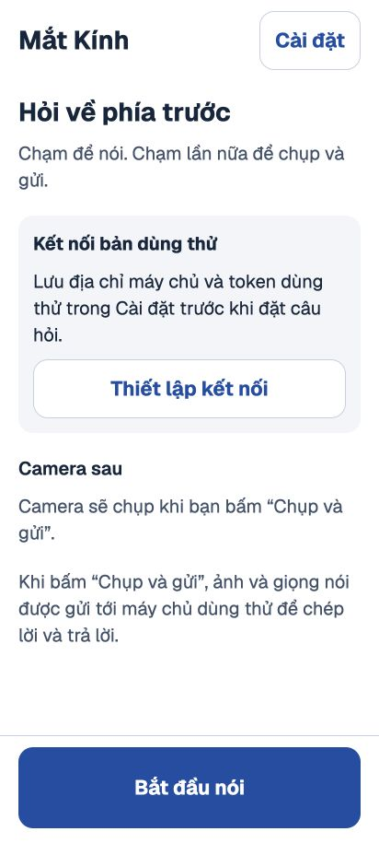  Assistant UI |   Settings UI | 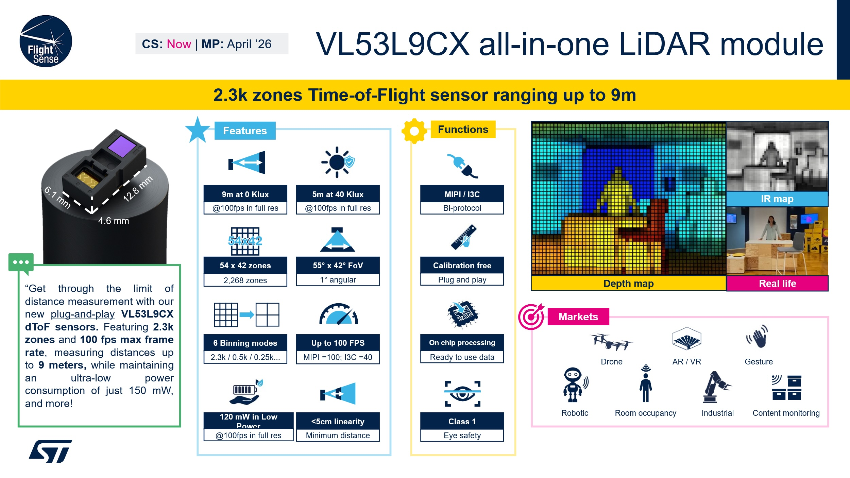  VL53L9CX ToF LiDAR
  Security Guardrails: Bearer tokens stored in Expo SecureStore validated via SHA-256 hashes. Ephemeral memory buffers prevent data persistence. In-memory WorkGate limits single active task per token.
APEC Assistive Technologies Project • Open-Source Engineering for the Visually Impaired | Target Commit: d9ba1e0 • Research & Open Pilot • A4 Poster Document

