AddressBook Main Window
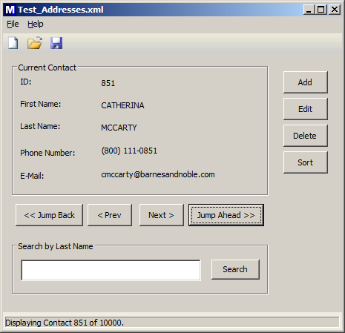
Adding a Contact. Input validator prevents blank fields.
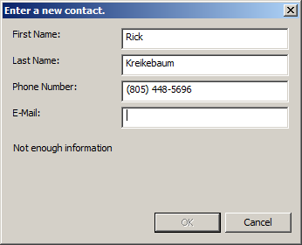

The contact can now be added.
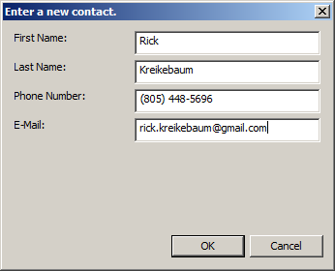
Contact has been added. Contacts can be searched by last name. Case is ignored when matching last names.
