This is Rick Kreikebaum's awesome SpellChecker program. First, here's a screenshot showing the replace feature. The replace combo box contains the preceeding and succeeding word that were be found in the dictionary.
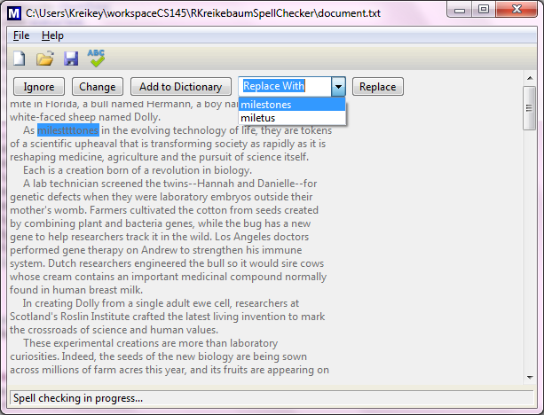
For safety and predictability, I opted for a separate Replace button rather than implementing a WidgetSelected method on the combo box itself.
Next is a screen shot showing the Change button:
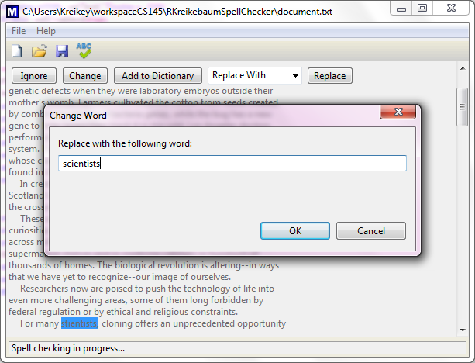
The original word is selected. Typing thus replaces it with whatever word is typed. Hitting OK replaces the highlighted word in the highlighted word in the text editor with the word in the Change Word dialog box.
Extra Credit
I also implemented the extra credit feature of creating a complete tree from a sorted dictionary. The dictionary is first loaded into an ArrayList. Then we correctly pick the index of the correct element in the list, and each sublist recursively. The one-liner for picking the correct index for the current list or sublist is thus:
index = ((items.size() > 2) && ((items.size() - 1) / 2 % 2 == 0)) ? (items.size()/2 + 1) : (items.size()/2);
To prove that it does, indeed, create a complete tree every time, I've put 3 screenshots into my project folder that show the debugger's view of a dictionary of 7, 8, and 9 words, respectively. The debugger's view of a dictionary of 9 words is included here:
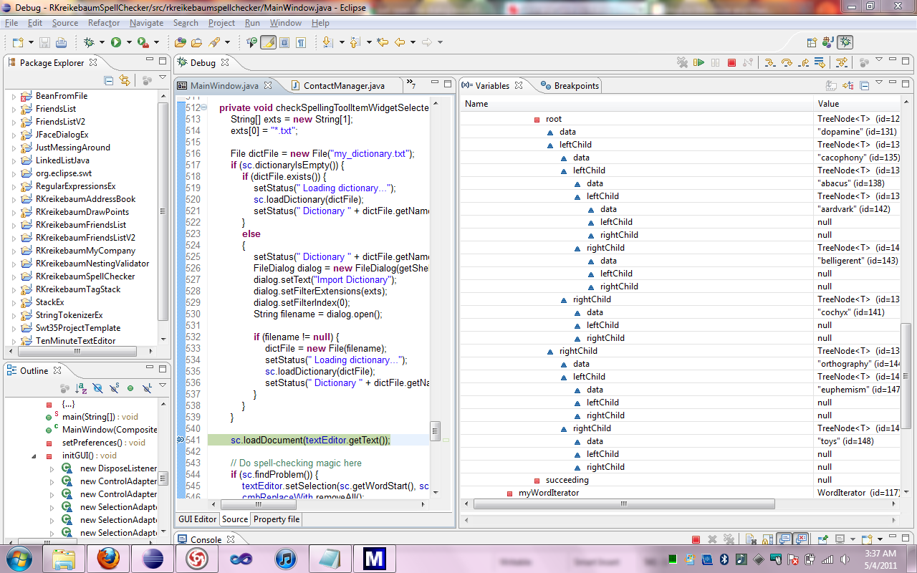
Rick Kreikebaum
5/6/2011

