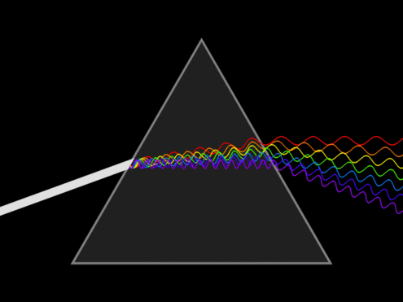

Each act of magic condenses energy from multiple spirits into one and thus is a process of unification. It causes, through the law of equal action, an unfolding of energy from Oneness back into diverse form at some other point in our reality. Magic happens every day all around us! It is the prismatic light that dances throughout creation. The trick to spellcraft lies in focusing that light into some useful form. To do so requires the cultivation of a relationship with your magic to the point where you can reliably evoke magical energies and therefore begin to test them. Intuition tells me that each person’s magic is unique and

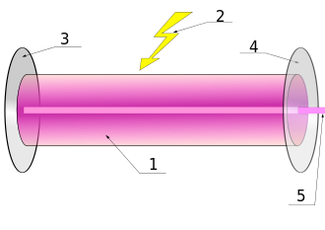
Components of a typical laser (from Wikipedia):
* Gain medium
* Laser pumping energy
* High reflector
* Output coupler
* Laser beam

Because light is such an excellent analogy, we can consider how we might form a laser out of our mental experience of energy.
The gain medium is the environment in which the magic occurs. If it’s mental within one person, that’s the medium. If it’s electromagnetic among a group, there’s the medium. The only way I know of to test a medium is to see if the magic can be created in its absence.
The “laser pumping energy” or energy source, as I like to think of it, is usually some form of chi channeled through the subject’s awareness. It’s best to focus and condense this energy source in order to form the laser, but through the addition of certain “capacitor” technology a charge can build more slowly over time.

