**Air Quality Data**

|  |  |  |
| --- | --- | --- |
| **Group Number: 07** | | |
| Last name | First name | Matriculation Number |
| Derler | Anna | 12114827 |
| Fankhauser | Sebastian |  |
| Wallner | Selina | 12111842 |

**Introduction**

In our project we used the Air Quality Dataset we got from UCI Machine Learning Repository. The Dataset contains the responses of a chemical sensors which is deployed on a field in an Italian city. We selected this Dataset, because we are interested in the environment and the environment pollution.

**Code Design**

This section contains a brief description of how you designed and structured your code for the classification experiments. Do not include actual code in this section! Also answer the following questions:

* Why did you design the classes, methods, properties, etc. the way you did?
* If you were given another two months of time to redesign your code, what would you change?

**Experimental Setup**

We used the RidgeClassifier, the PassiveAggressive Classifier, the DecisionTree Classifier, the SGD Classifier and the Simplebaseline Classifier.

From the Dataset we used the CO(GT), C6H6(GT), NMHC(GT), NOx(GT) and the NO2(GT) features.

20% were used for testing and 80% were used for training.

To handle the missing values, we set the values < 0 to 0.0.

Which metrics did you rely on for evaluation and why? Accuracy, Precision, Recall, F1 Score

Our baseline was the SimplebaselineClassifier with the strategy “uniform”.

**Results and Discussion**

The best Classifier were the Decision Tree Classifier and the SGD Classifer. The worst Classifier was the Simple Baseline Classifier. Does this change if you use a different metric for evaluation?

In Plot 1 you can see the Confusion Matrix of the Ridge Classifier. For example, we can see the that in 963 instances the true label was 1 and the model also predicted 1 or that in 0 instances the true label was 1 and that the model predicted 0. So, this means that the Classifier is performing well.

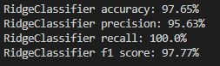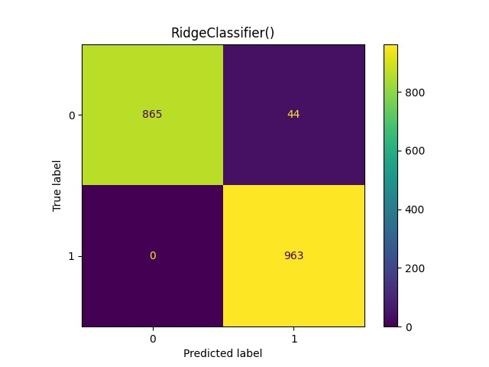

Plot 1: Ridge Classifier Terminal Output 1: Ridge Classifier

In Plot 2 you can see the Confusion Matrix of the Passive Aggressive Classifier. For example, we can see a high number of instances for True negatives, which is good. But the number of False negatives is also high. This could mean that the Classifier tries to get as few False positives as possible but for that he gets more False negatives.

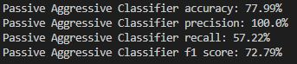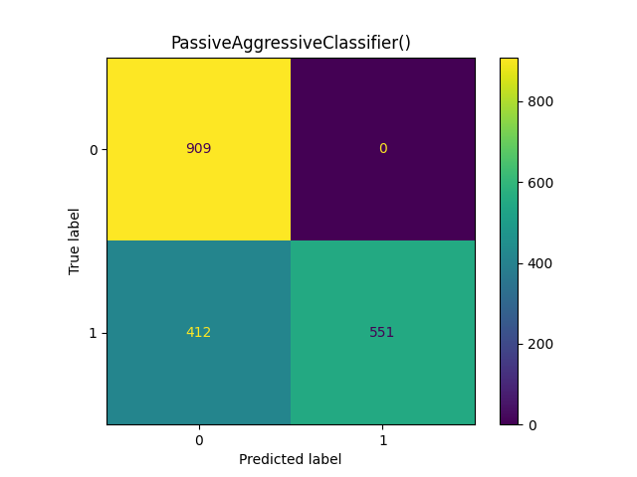

Plot 2: Passive Aggressive Classifier Terminal Output 2: PassiveAggressiveClassifier

In Plot 3 you can see the Confusion Matrix of the Decision Tree Classifier. We can see that there are only instances for True negatives and True positives. So, this means that the Classifier performed perfectly.

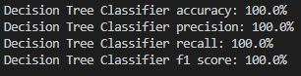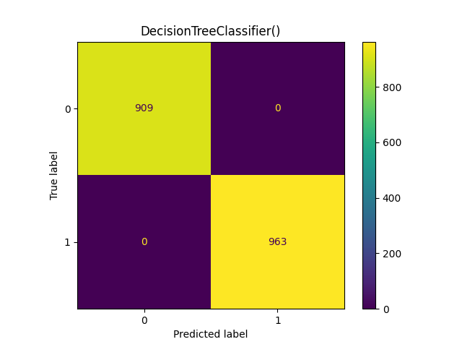

Plot 3: Decision Tree Classifier Terminal Output 3: Decision Tree Classifier

In Plot 4 you can see the Confusion Matrix of the SGD Classifier. We can see that there are only instances for True negatives and True positives. So, this means that the Classifier performed perfectly.

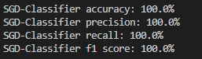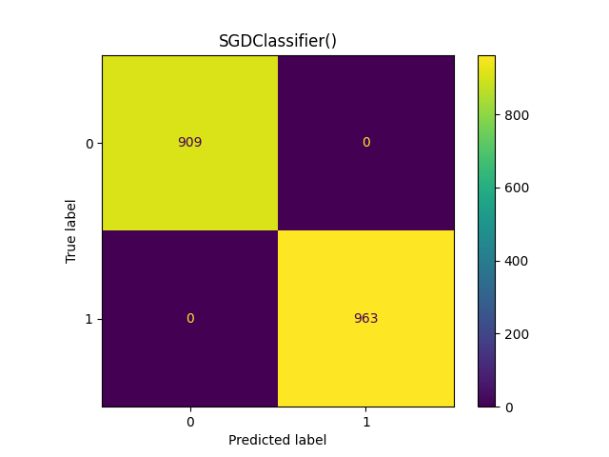

Plot 4: SGD Classifier Terminal Output 4: SGD Classifier

In Plot 5 you can see the Confusion Matrix of the Simple Baseline Classifier. We can see that instances for True negatives, False negatives, True positives and False positives are nearly equal. This means that the Classifier is not working very well, because we have a lot of False positives and negatives.

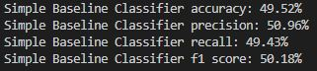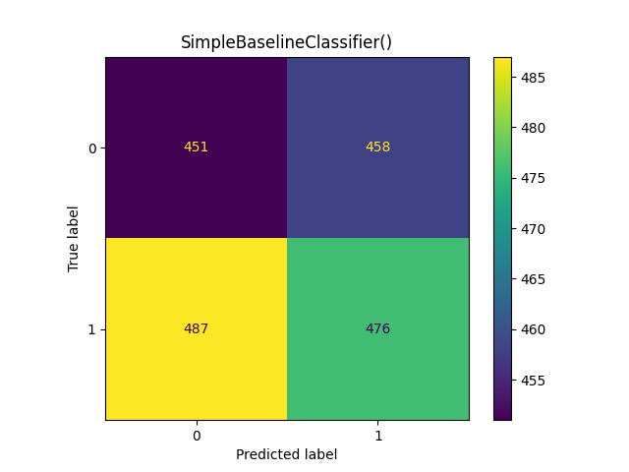

Plot 5: Simple Baseline Classifier Terminal Output 5: Simple Baseline Classifier

In Plot 6 you can see a comparison of the five different Classifiers. As you can see all other Classifiers beat the Baseline Classifier.

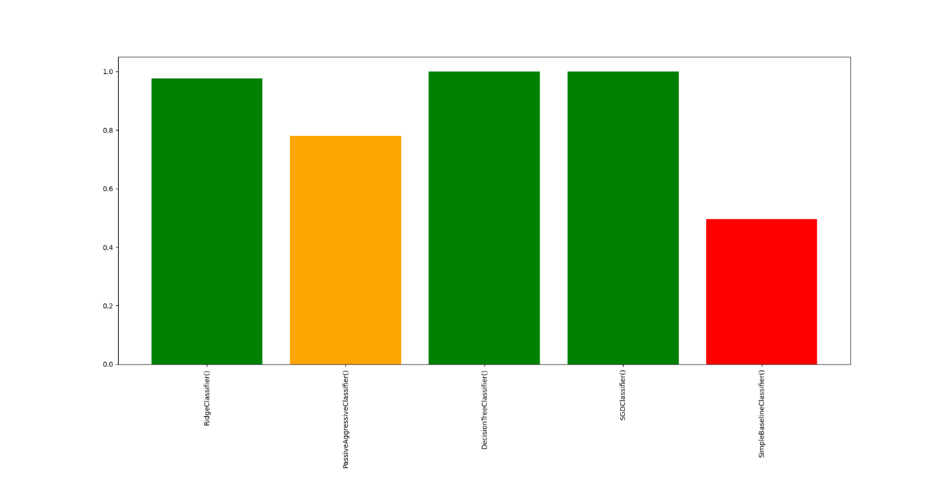

Plot 6: Comparison of the Classifiers

**Conclusion**