PRACTICAL – 8
MySQL Schema Design, ER Model, PDO Connectivity,
and Prepared Statements

1. Aim
To design a normalized MySQL database for a StudentHub application containing students, events, and registrations; create an Entity–Relationship (ER) model; implement primary and foreign key relationships; connect the database with PHP using PDO; and demonstrate secure database operations using prepared statements.

2. Problem Definition
Design the database for StudentHub with students, events and registrations. Create a PHP database connection using MySQL and implement secure database access. The database should be normalized, primary keys and foreign keys should be correctly defined, and database errors should be handled properly.

3. Key Questions / Analysis / Interpretation
Question | Interpretation
1. Is the schema normalized properly? | Yes. Student, event, and registration information is separated into different tables, reducing duplicate data and update anomalies.
2. Are primary keys and foreign keys correctly defined? | Yes. Each table has a primary key. The registrations table contains foreign keys referencing students and events.
3. Is the database connection handled securely? | Yes. PHP PDO is used with exception handling and prepared statements. User input is passed as parameters instead of being directly concatenated into SQL.

4. Conclusion
The StudentHub database was designed using a normalized relational structure containing students, events, and registrations. Primary and foreign keys were used to maintain relationships and referential integrity. The database was connected to PHP using PDO, and prepared statements were used for secure INSERT and SELECT operations. The practical demonstrates the basic concepts required for building a secure database-backed web application.

5. Output:
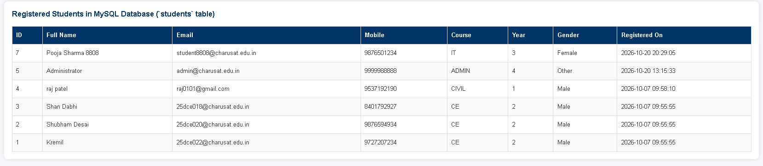
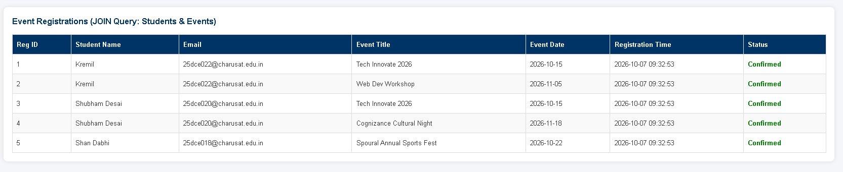
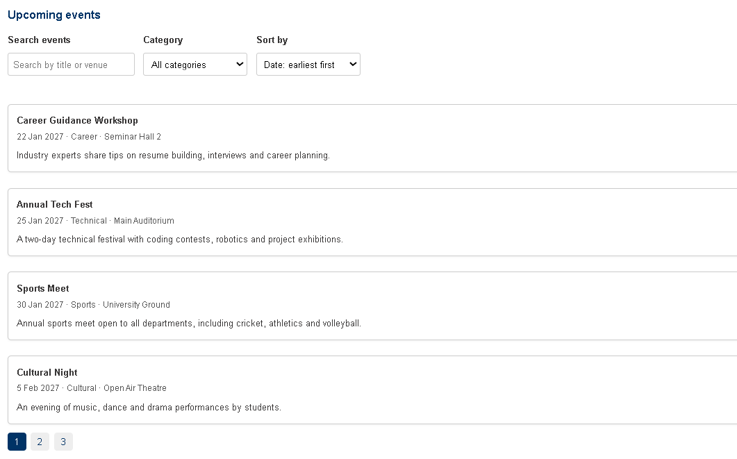

GitHub Repository Link
https://github.com/kremildobariya9856-cell/student.portal/tree/main/prac8

