CHAROTAR UNIVERSITY OF SCIENCE AND TECHNOLOGY (CHARUSAT)
FACULTY OF TECHNOLOGY AND ENGINEERING
SUBJECT: WEB DEVELOPMENT FRAMEWORKS (ITUE203)
SEMESTER: 3RD, 2026-27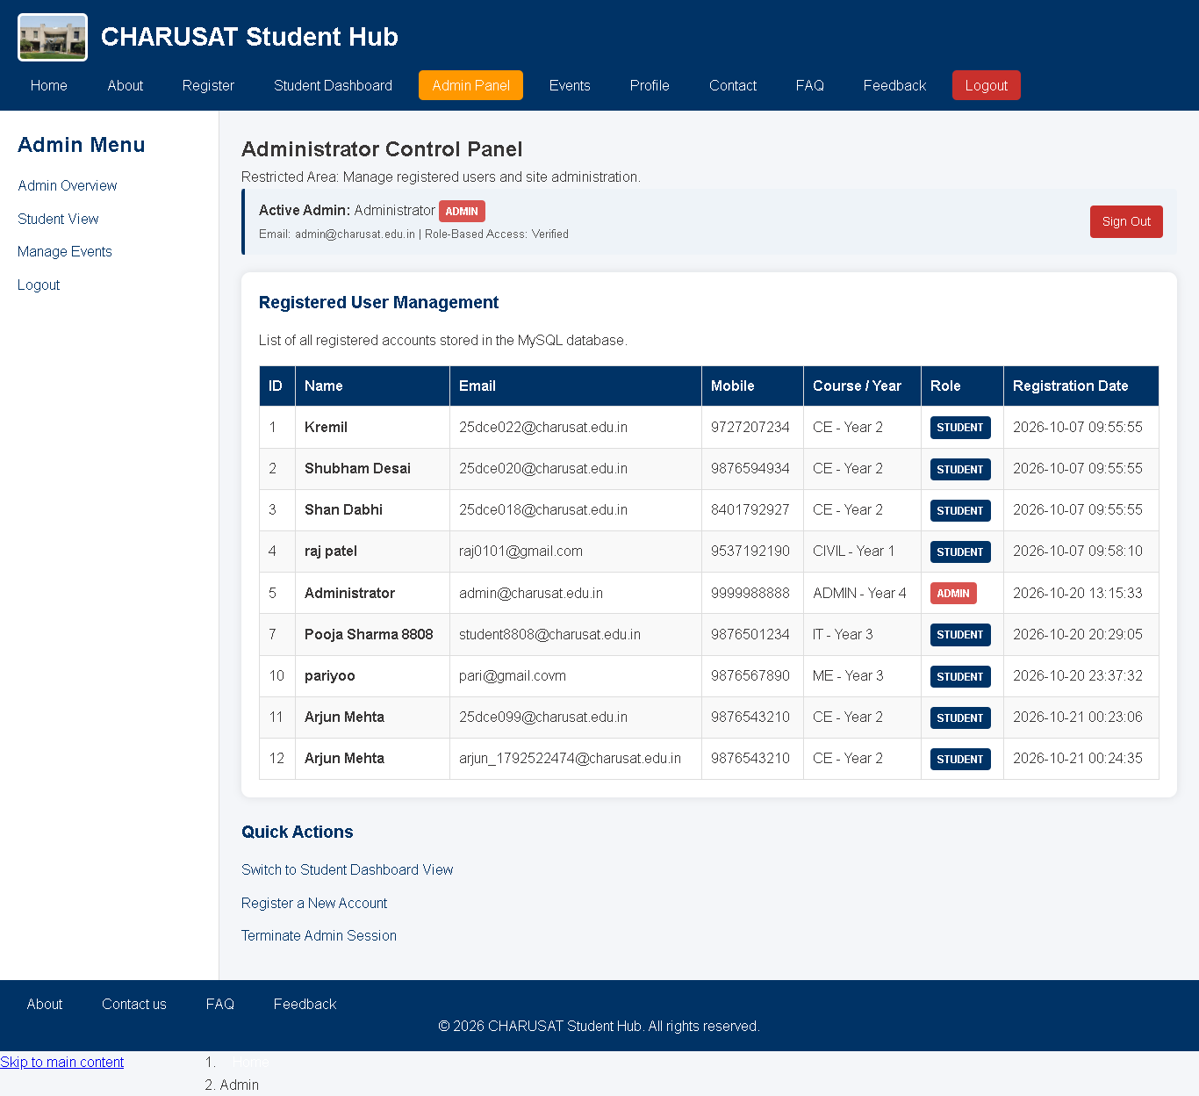 (ODD)
