CHAROTAR UNIVERSITY OF SCIENCE AND TECHNOLOGY (CHARUSAT)
FACULTY OF TECHNOLOGY AND ENGINEERING
SUBJECT: WEB DEVELOPMENT FRAMEWORKS (ITUE203)
SEMESTER: 3RD, 2026-27 (ODD)
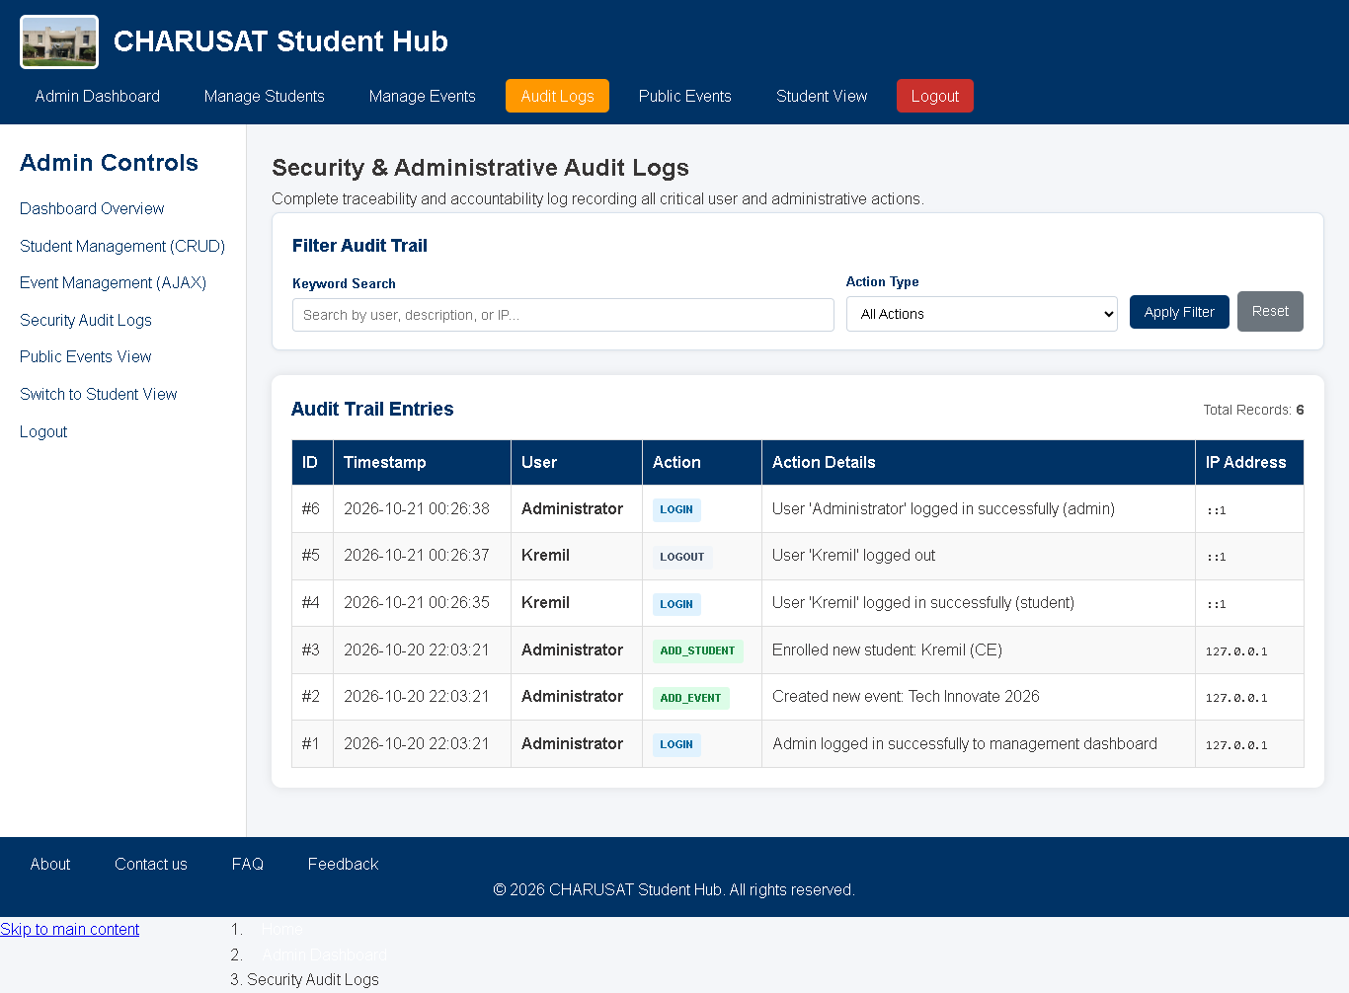
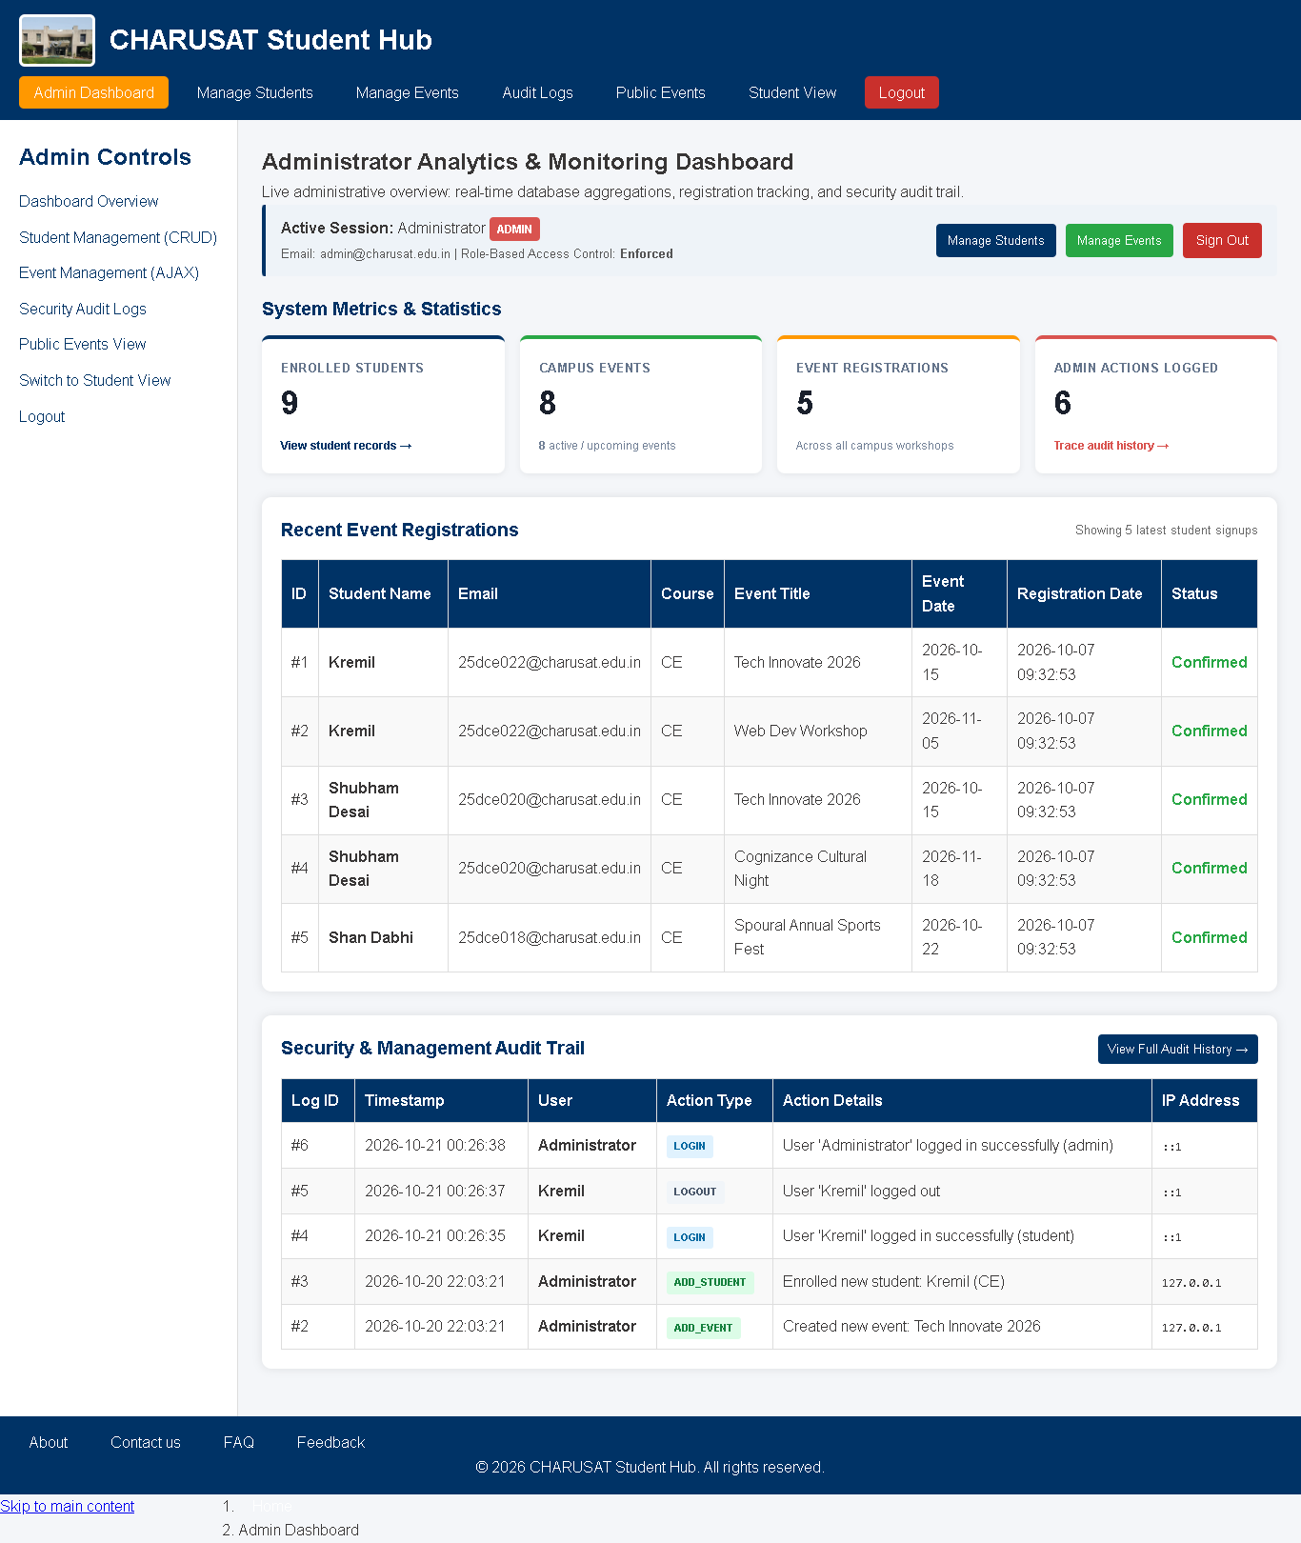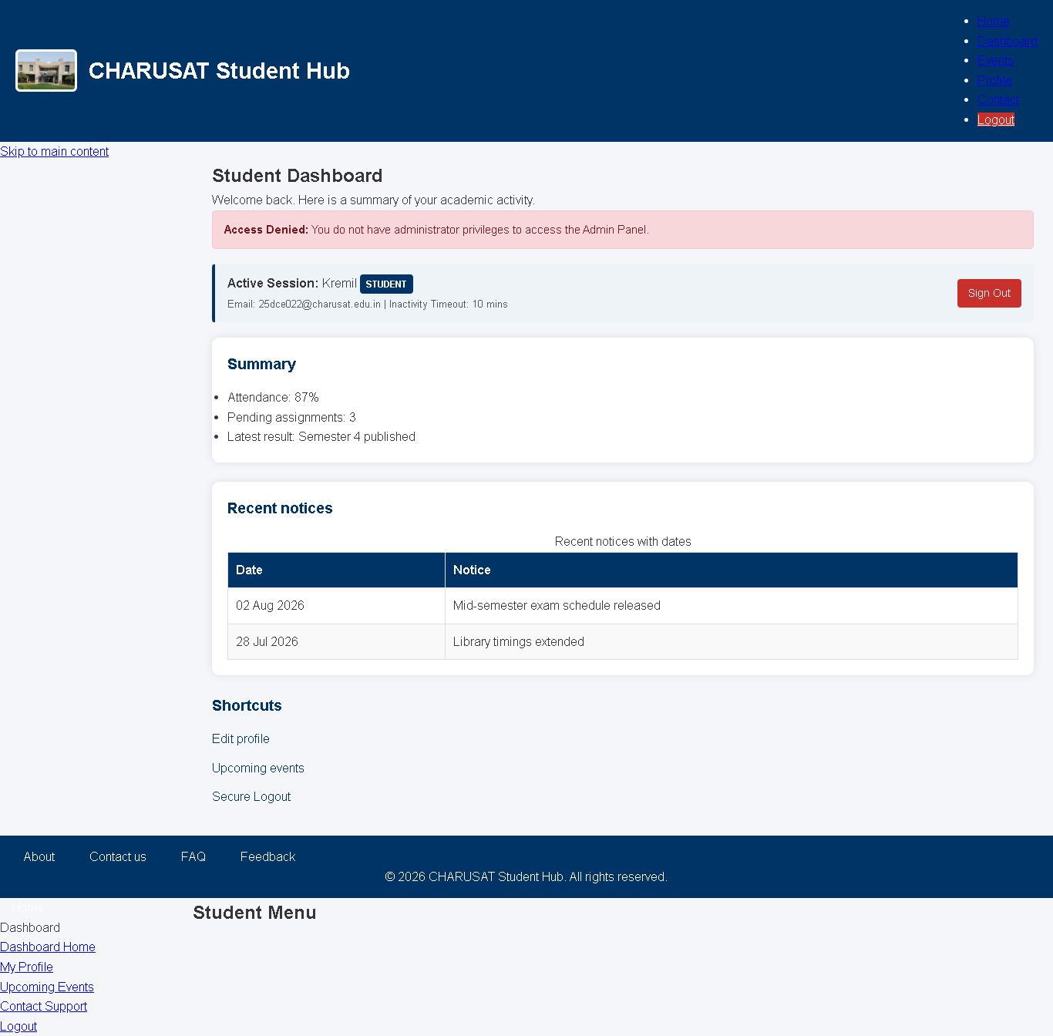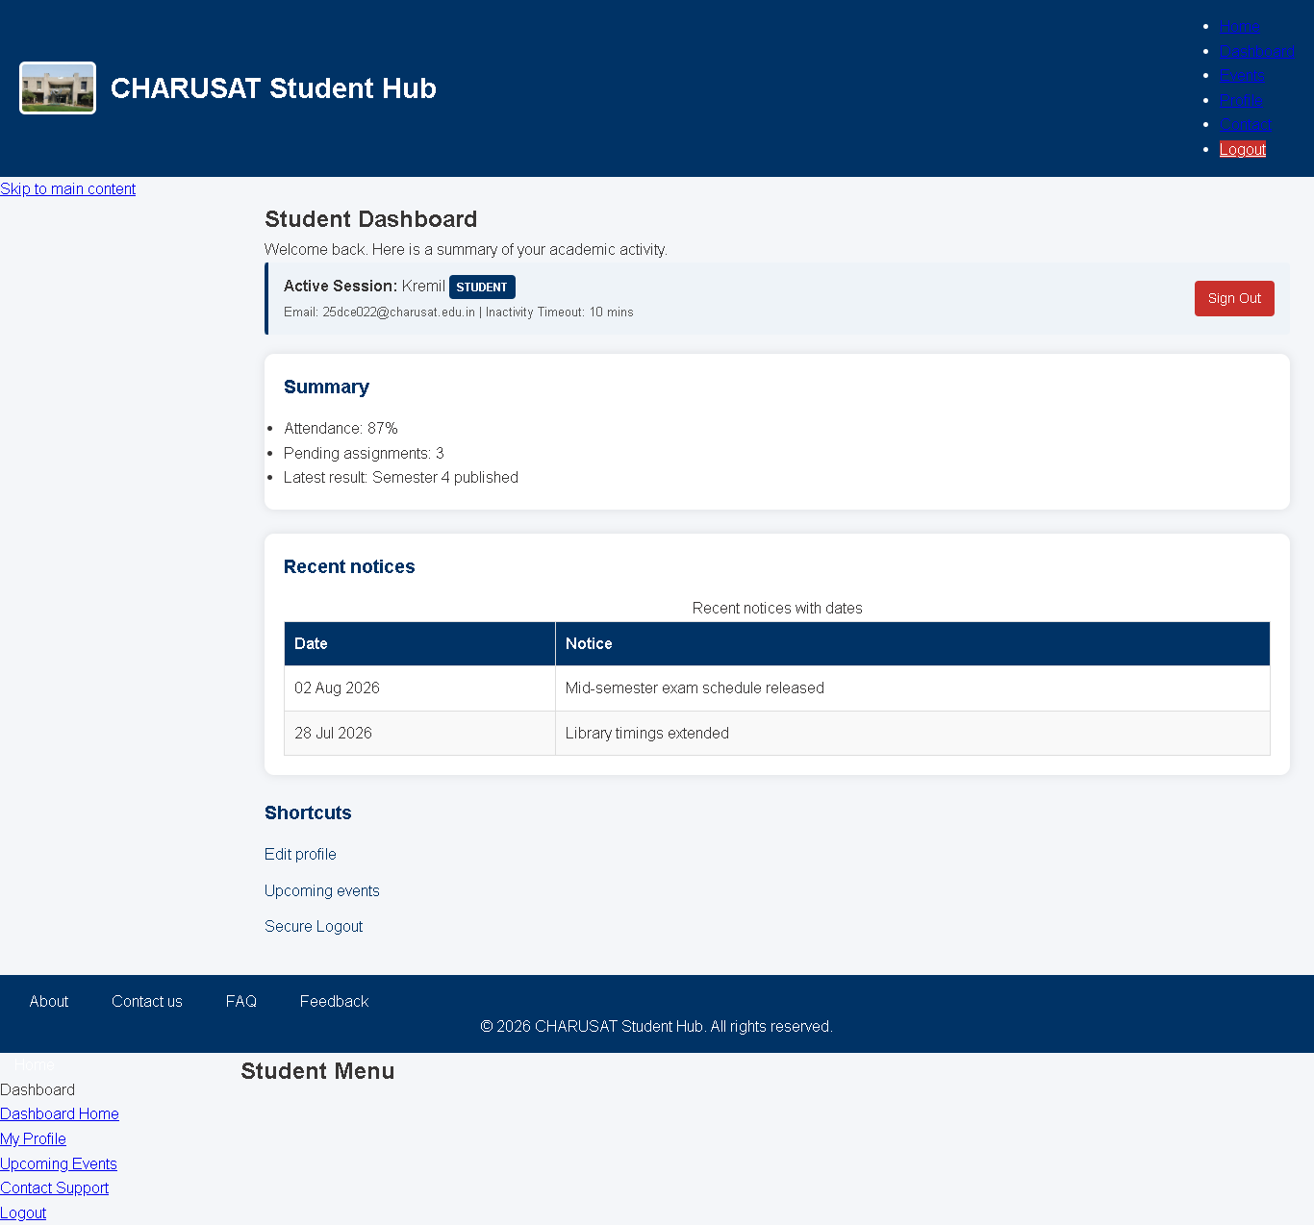

Git Hub Repo Link - https://github.com/kremildobariya9856-cell/student.portal/tree/main/prac14

