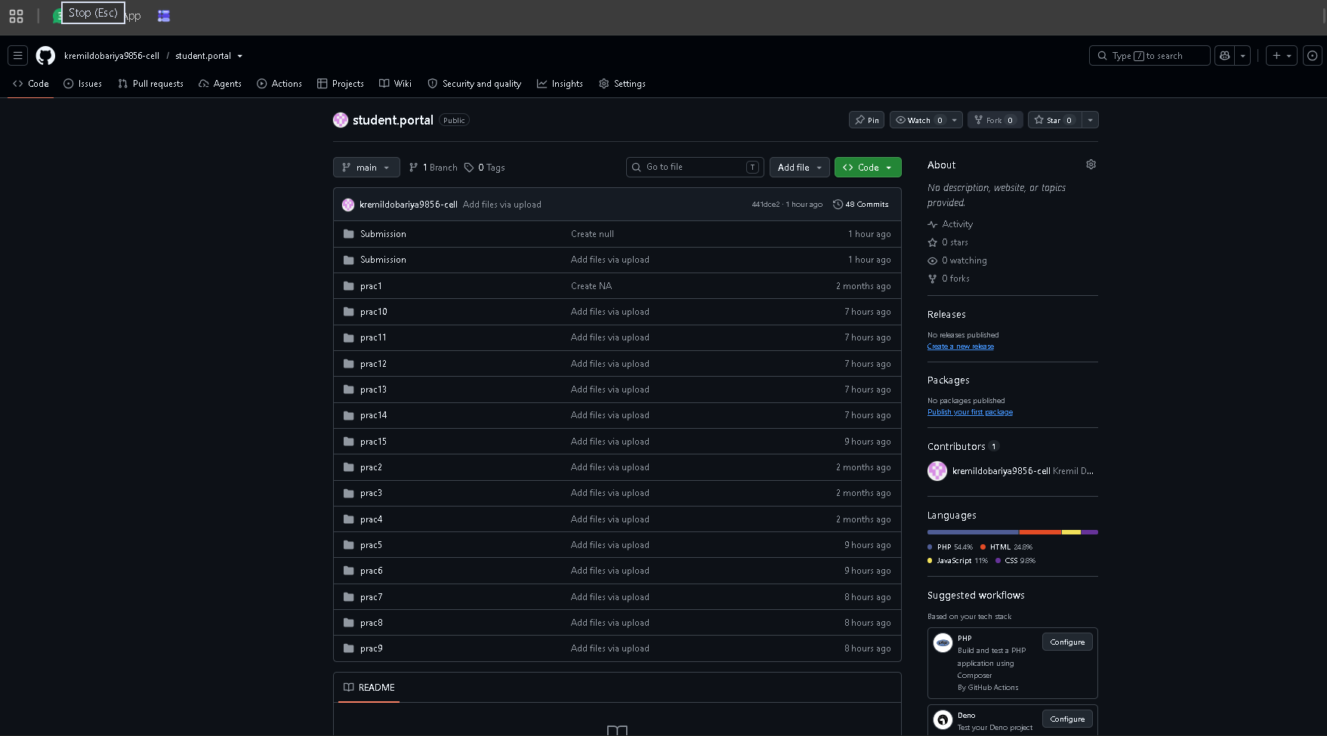
1.1: GitHub Repository Setup (student.portal)
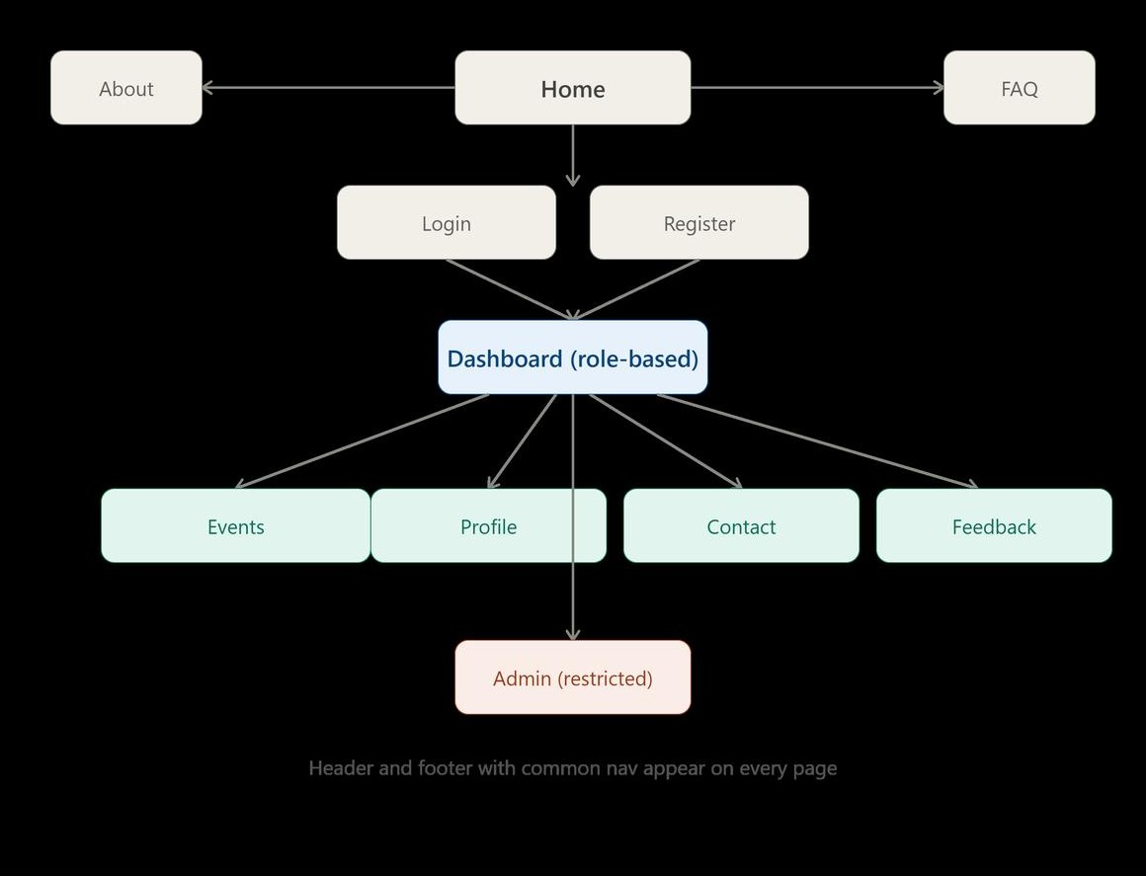
1.2: Student Hub Information Architecture & Sitemap
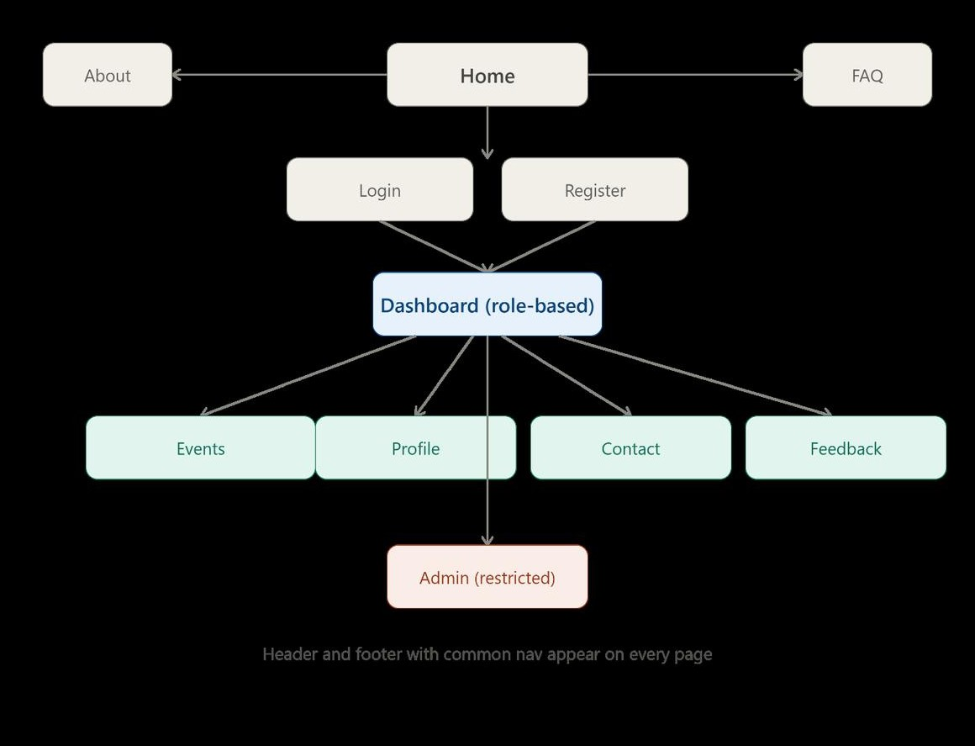
1.3: Low-Fidelity Wireframe Mockup (Homepage & Navigation)
CHARUSAT Student Hub
Home Page
WELCOME TO THE STUDENT HUB!!
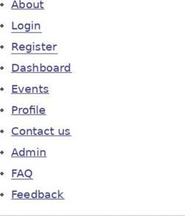
C' 2026 CHARUSAT Student Hub. All rights reserved
1.4: Wireframe Layout Design (Portal Content Sections)

university banner
CHARUSAT Student Hub
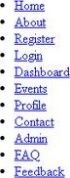
Welcome to the Student Hub
Ihe Student Hub is the single place to check your courses, attendance, results, notices and campus events. Use the navigation menu above, or the shortcuts below, to get started.
Quick links
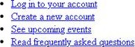
Latest announcements
Semester registration now open
Students can register for next semester's courses from the Register page
Library tünings extended
The 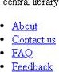centrd will remun open untd 9 on weekdays,
e 2026 CHART_TSÆ StudentHub_ rights resaved,
2.1: Semantic HTML5 Structure (Home Page & Skip Link)
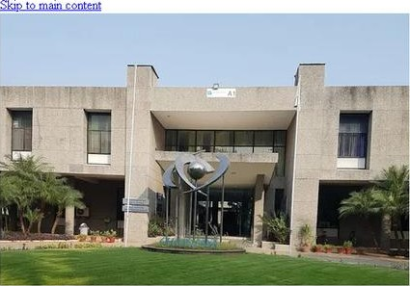  CHARUSAT Student Hub  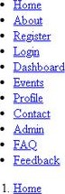  2. About  About Student Hub  Our mission  Student Hub brings together course information, attendance, results, notices and events in one accessible portal for students,  Who uses this portal  View courses, attendance, results and campus notices  Faculty  Post notices, record attendance and publish results.  Manage user accounts, courses and site-wide content,  Need help?  Visit 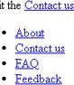the page or check the  0 2026 CHART_TSÆ StudentHub_ rights resaved, | and administrators ofCHARUSAT.
2.2: About Page with Breadcrumb Navigation
CHARUSAT Student Hub
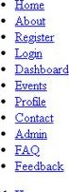1. Heme
2. Register
Create an account
Registration form
Personal detads
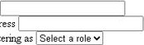
Fun narne
I
am
regstenngas
Email address
Account secunty Password
Use at least 8 characters, including a number,
Confirm password
Create account
Already have an account?
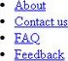
0 2026 CHART_TSÆ StudentHub. rights resaved,
2.3: Accessible Registration Form Structure & Labels
CHARUSAT Student Hub
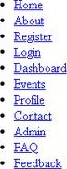
- Home
- Events
Campus events

Upcoming events
Annual Tech Fest
25 JAN 2027
Career Guidance Workshop
22 JAN 2027
Sports Meet
30 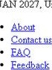 2027, University Ground, All depar%nents welcome.
0 2026 CHART_TSÆ StudentHub_ All rights reserved,
2.4: Campus Events Semantic Listing & Articles
CHARUSAT Student Hub
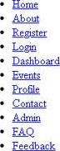
- Heme
- Dashboard
Dashboard
Welcome back. Here is a surnrnao• Ofyour academic activity.
Sununary
- Attendance: 87%
- Pending assignments: 3
- Latest result: Sernester4 published
Recent notices
Recent notices with dates
Date Notice
02 Aug 2026 bifid-semester schedule released
28 Jul 2026 Library tirnings extended
Shortcuts
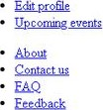
0 2026 CHART_TSÆ Student Hub. rights resaved,
2.5: Student Dashboard Overview Structure

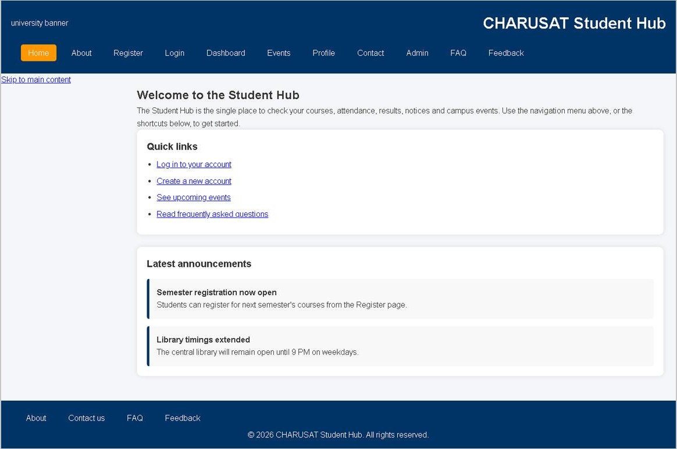
3.1: Desktop View - Home Page (CSS Grid Layout)
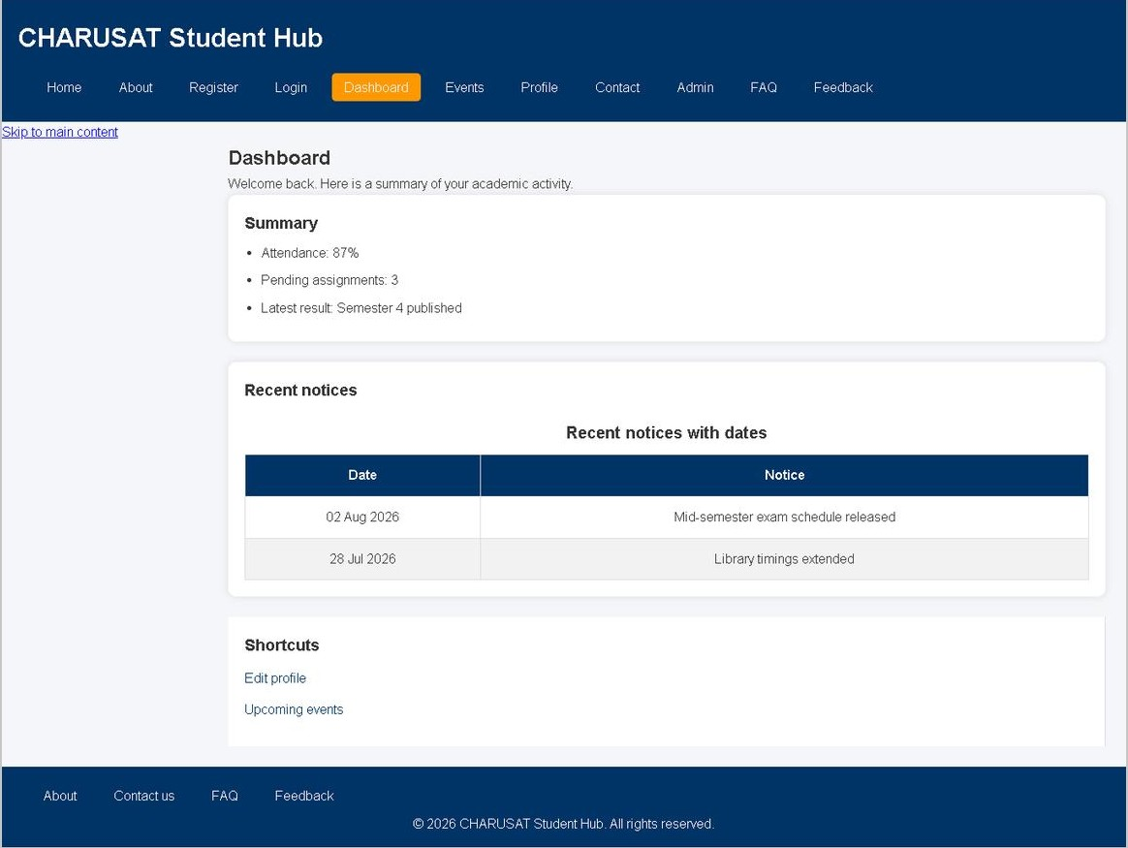
ashboard
3.2: Desktop View - Student Dashboard Cards
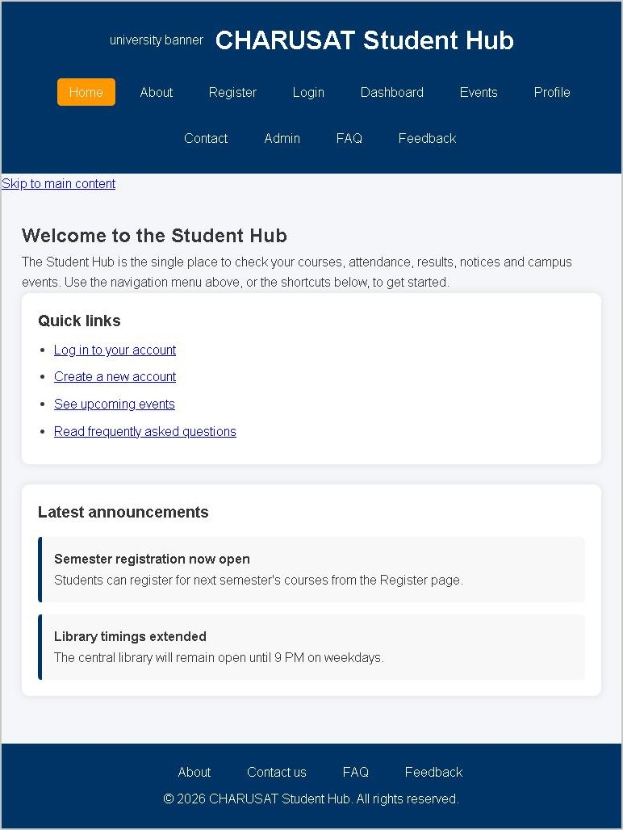
3.3: Tablet View - Responsive Flexbox & Grid Adaptation
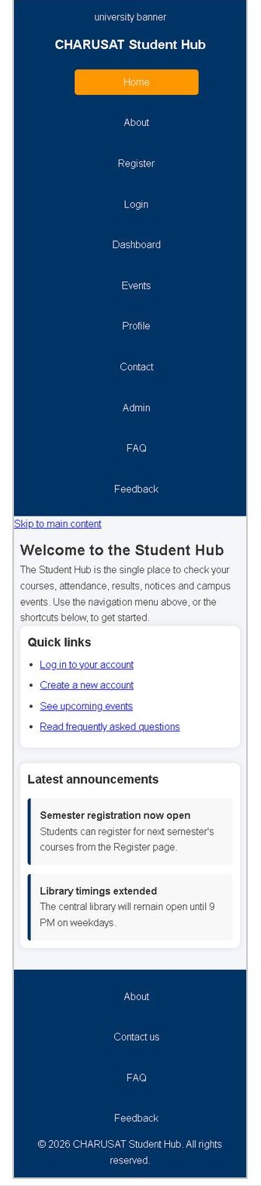
3.4: Mobile View - Fluid Single Column Layout
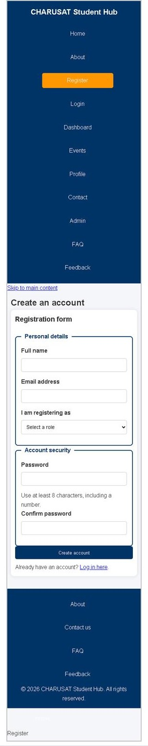
3.5: Mobile View - Responsive Registration Form

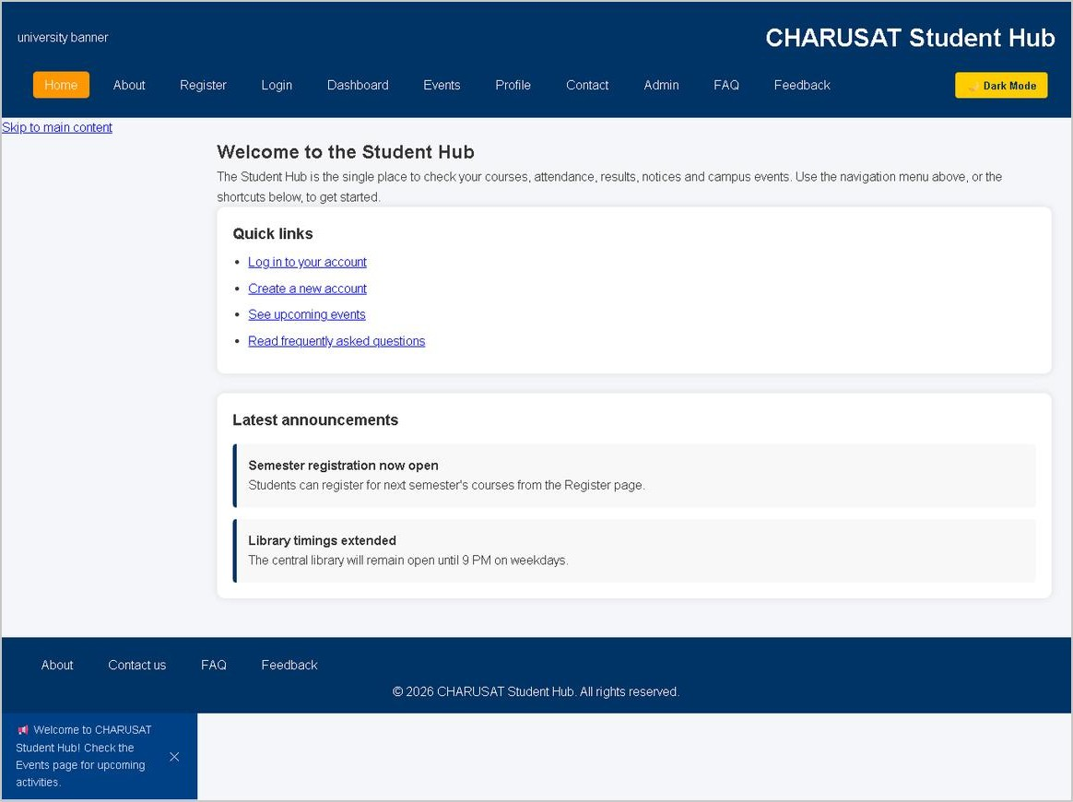
4.1: Dynamic Notification Banner & Light Mode
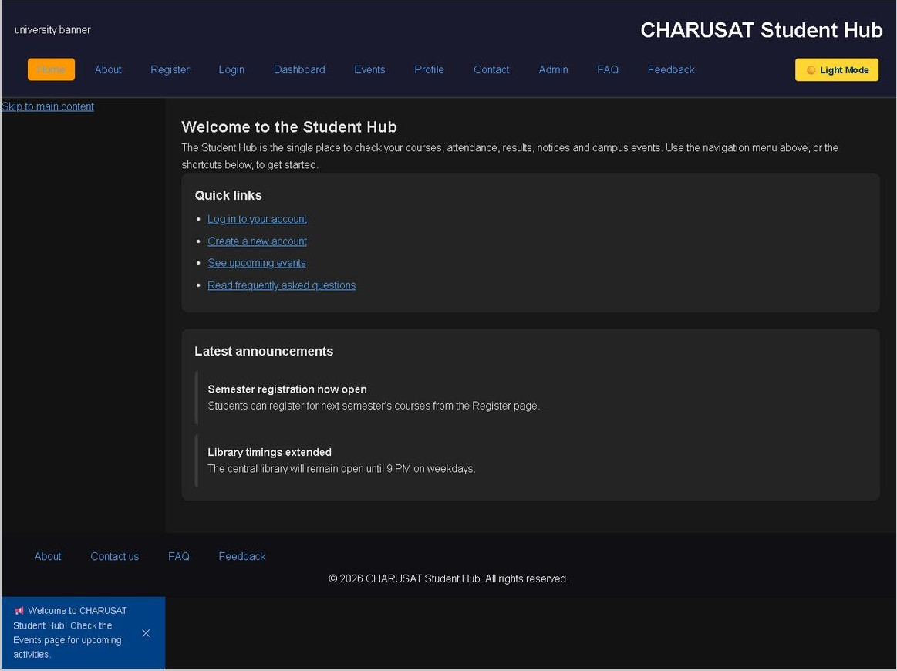
4.2: Dark Theme Switcher (persisted via localStorage)
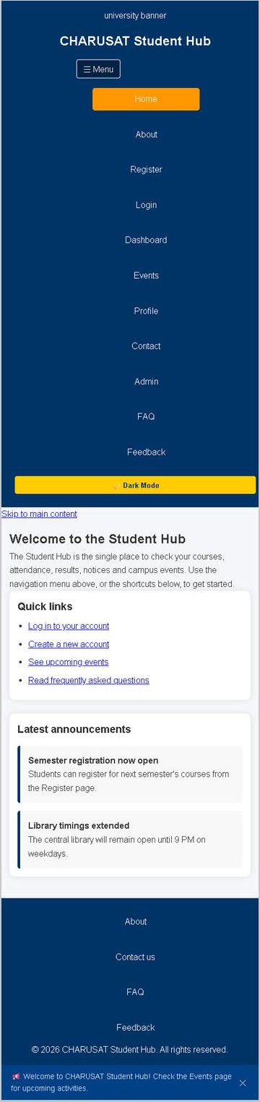
4.3: Interactive Mobile Hamburger Navigation
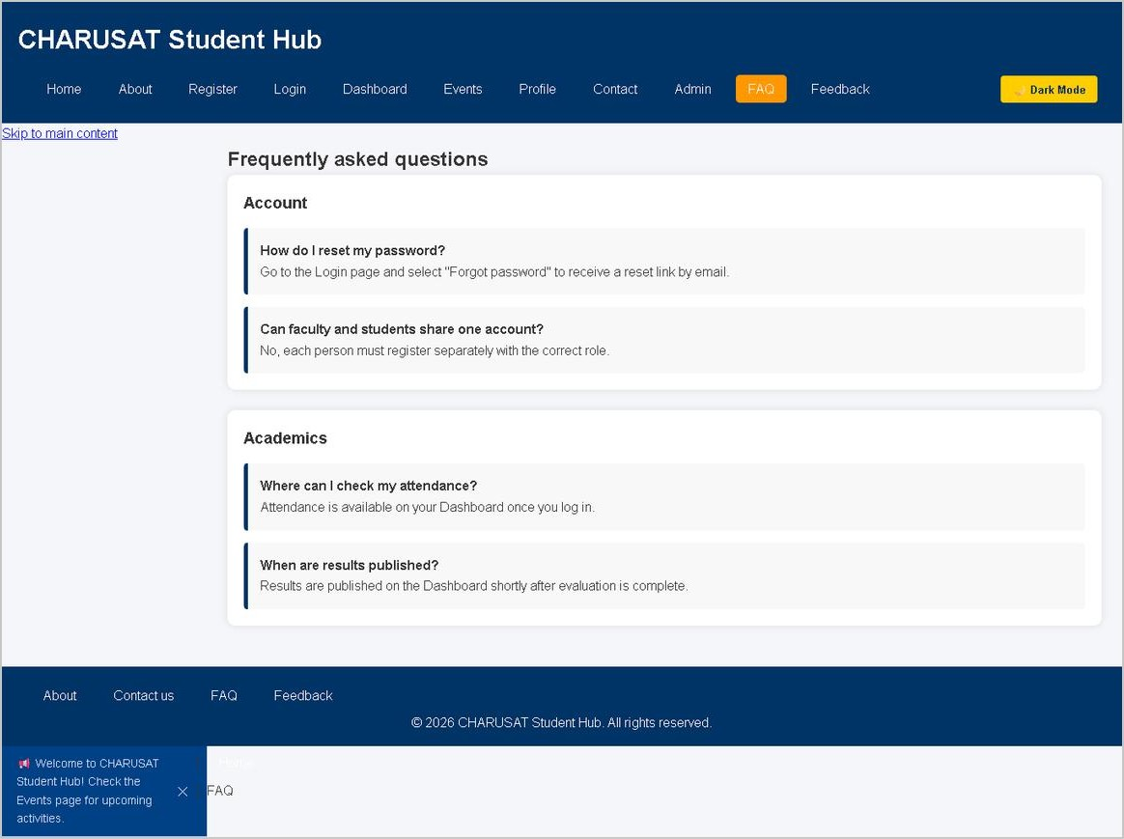
4.4: Collapsible FAQ Accordion with ARIA Expanded State
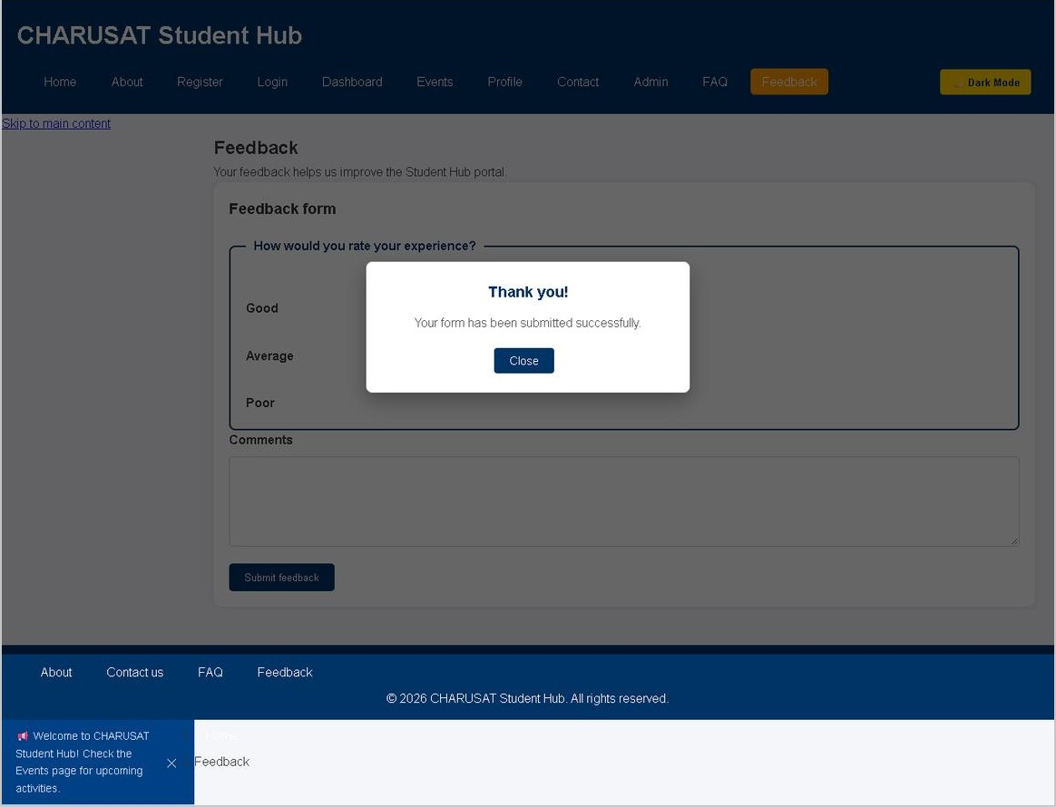
4.5: Modal Popup Dialog upon Form Submission

PROJECT VERIFICATION & GITHUB REPOSITORY

Lab Submissions: Practicals 1 to 4
- Practical 1: Project Initiation, Requirement Analysis, Sitemap, Wireframe & GitHub Setup
- Practical 2: Semantic HTML5 Pages with Accessibility-Ready Structure (10+ linked pages)
- Practical 3: Responsive UI Layout using CSS Grid, Flexbox, and Multi-Device Breakpoints
- Practical 4: JavaScript DOM Manipulation, Event Handling, FAQ Accordion & Modals
Platform Status: All modules tested and verified across desktop, tablet, and mobile views.
Official GitHub Repository Link
All source codes, revision history, and assets are hosted publicly on GitHub:
https://github.com/kremildobariya9856-cell/student.portal

