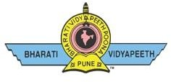
BHARATI VIDYAPEETH’S
COLLEGE OF ENGINEERING FOR WOMEN, PUNE
Pune-Satara Road, Dhankawadi, Taluka – Haveli, Dist.- Pune
Accredited by NAAC with “A” Grade, Affiliated to Savitribai Phule Pune University (SPPU) Approved by DTE. Govt. Of Maharashtra and AICTE, New Delhi
DTE Institute Code-EN6285, Pun Code-PU/PN/Engg. /150/2000
E-mail: -coewpune@bharatividyapeeth.edu Website: - http://coewpune.bharatividyapeeth.edu
Date: / / 2025
Ref. No.: BV/COEW/ /2025
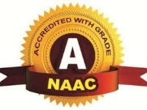

NOTICE

A National Level Conference is being hosted by our Institute. In view of this event, all faculties are requested to invite at least two entries from various states to make our conference a truly National event. Also all should encourage our students for participation to provide them a national level platform. Together our efforts can achieve success.

Co-coordinator Coordinator Principal

