RUFINO’S FURNITURE ONLINE SHOP MANAGEMENT SYSTEM

AN UNDERGRADUATE CAPSTONE PROJECT

Presented to the Faculty of
College of Information Systems
ZAMBOANGA DEL SUR PROVINCIAL GOVERNMENT COLLEGE
Dimataling Campus



In Partial Fulfillment
of the Requirements for the Degree
BACHELOR OF SCIENCE IN INFORMATION SYSTEMS

CATACUTAN, JHON LLOYD
DAGADAS, JUNJAILANI
DEROD, SHEILANOREEN B.
DESAPOR, HAZEL JOY D.

July 2026
CERTIFICATE OF PANEL APPROVAL

This capstone project entitled Rufino’s Funiture Online SHop Management System" prepared and submitted by CATACUTAN J., DAGADAS J., DEROD S., DESAPOR H., in partial fulfillment of the requirements for the degree of Bachelor of Science in Information Systems (BSIS), has been examined and is hereby recommended for approval.

JESSON B. PATONG
Capstone Project Adviser

Date

This capstone project is approved in partial fulfillment of the requirements for the degree Bachelor of Science in Information Systems.
Approved by the Oral Examination Committee on ________________ with a rating of (PASSED).

MARY LYN B. RAMBOY JESSON B. PATONG
Panel Member Panel Member

FERDINAND G. MAYOL
Chairperson

DR. PEDRO JR. B. LANGUIDO
Campus Administrator

ACKNOWLEDGMENT

We, the researcher, would like to thanks to the persons listed below their assistance in completion of this project, which would not have been possible without their contribution. Of course, not everyone can be named here, which does not undermine their contribution to this research. However, we would like to express our deepest appreciation to the following individuals:
To Mr. Mondido Delmer, the Acting School president, for providing the project team with constant help and motivation.
We want express our thanks to Mr. Patong Jesson, the Capstone Project Adviser, for his unwavering guidance, support throughout the research process.
We would like also to express our gratitude to the members of the panel such as Ms. Ramboy, Mr. Sales, Mr. Acal for their comments and recommendations which helped to improve the quality of this research.
Most importantly, we want to express our deepest appreciation and thanks giving to our beloved God for giving us strength, wisdom and knowledge.
We graciously thank everyone for making it possible to achieve such results.

—The Researcher

DEDICATION

When working to create Rufino’s Furniture Online Management System, we, the researchers,put in a great deal of time, effort and dedication towards the completion of this study. We would like to extend our sincere gratitude to our parents: Mrs/Ms. Catacutan, Dagadas, Derod,and Desapor for their guidance and support. The research would not have been possible without the unending support, assistance and encouragement that our parents provide us with throughout the entire project. Moreover, we wish to convey our great appreciation to our brothers, sisters, relatives, friends and classmates for the inspiration and moral support we receive from them. Special thanks are to our adviser Mr. Villa, for his valuable insights, and assistance that greatly contributed to the development of the system. Above all, we thank our almighty God, the source of wisdom, strength, for His countless blessing and guiding us throughout the journey.

— The Reseacrher
ABSTRACT

CATACUTAN J., DAGADAS J., DEROD S., DESAPOR H.
College of Information Systems, Zamboanga del Sur Provincial Government College, Dimataling Campus, Zamboanga del Sur (July2026). Rufino’s Furniture Online Shop Management System
An unpublished Bachelor's Capstone Project.

Adviser: Villa, Jandel A.

In recent years, some business in the furniture industry are still using manual methods for managing products, customer orders, managing inventory, and processing payment, which can result in problems like mistakes in records, delayed transactions, and difficulty in monitoring business operaions. To address these challenges, this study developed the Rufino’s Furniture Online Shop Management System, a web-based platform designed to improve the efficiency of furniture sales and management. The main goal of the study is to develop an online management system that allows the shop owner to efficiently manage products, inventory, customer orders, payments, and reports while providing customers with easy way to browse and purchase products online. The researcher implemented the 4D System Development Life Cycle (SDLC), which involve define, design, development, and deployment. They developed the web solution with the help of the most modern technologies and evaluated them using functional and user acceptance testing to ensure that all features operated correctly and met the needs of the users. The outcomes of the study showed that the web solution helped to optimize operations by improving accuracy in maintaining inventory, managing orders and payments, also generating up-to-date reports for business needs. In conclusion the Rufino’s Furniture Online Shop Management System is an effective solution for enhancing furniture store, simplifying orders and improving customer satisfaction.

Keywords: Rufino’s Furniture, Online Shop Management System, Inventory Management, Web-Based System, Online Furniture Store, Order Management, E-Commerce.

TABLE OF CONTENTS

Page
COVER PAGE i
APPROVAL SHEET ii
ACKNOWLEDGEMENT iii
DEDICATION iv
ABSTRACT v
TABLE OF CONTENTS vi
LIST OF TABLES (CONTINUE THE PAGES)
LIST OF FIGURES
LIST OF APPENDICES

CHAPTER I

THE PROBLEM

Introduction
Daily living can be improved through technology as it makes tasks simpler, quicker, and more convenient to carry out. It is through enhancing our ability to connect with others, communicate better and access service that we see the actual benefit of technology. Today's businesses are also taking advantage of this concept by using digital technologies to create new ways of providing goods and services to their consumers. Tech is a part of many aspects of our daily lives, so we live in an extremely technologically based society. Everything from communication, to working, to shopping, we utilize technology in some way every day.
Rufino’s Furniture is a business that provides different furniture products to meet the needs and preferences of its customers. Traditionally, customers will visit the physical and exact store to see the products, place orders, and do the payments. This kind of traditional process while functional, the store owner must monitor sales, and track payments manually, which is prone to errors and delays. Online platforms have become an important part of commerce, allowing the consumers to browse, order, and pay for products from the convenience of their homes. For small to big sized business, such as furniture stores, adopting an online system can improve efficiency, widen market reach, and improve customer satisfaction (Laudon & Laudon, 2020).
The development of Online Management System to Rufino’s Furniture the goal is to address these challenges through creating a centralized online platform that serve both the customer and the store owner. As noted by Tylko Furniture Company (2022), a true business uses a digital platform and using the online customization tools for the improvement of your business performance and improving customer experience, showing true industry moves in the term of the online engagement.
Rufino’s Furniture today operates using a conventional in-store setup where the consumers are physically visiting the shop to see products, confirm orders, and make payments. This setup can be unusable for customers who are busy of their schedules or those living far from the store. On the business side, managing products, orders, and payments manually can lead to delays, inaccuracies, and difficulty in tracking records also they must face all the problems of their store. These challenges create the need for a system that can make they both customer transactions and business management. to address these issues by giving the online platform that will supports customer convenience and efficient business operations. The system serves as a bridge between customers and the shop owner by integrating online purchasing features with management.
The online management systems have proven to be valuable tools for business seeking to meet the modern consumer expectation. Through providing the platform that combines both customer-facing features, business can lessen manual works, lessen the errors, and reply to the customer needs more effectively. The system will expect to improve productivity while increasing customer satisfaction, in the end supporting long-term improvement (Lau and Tang, 2025).
Moreover, implementing of the online management system supports the long-term growth and sustainability of the store. As the customer demand increases, the system can handle a higher amount of the transactions without significantly increasing operational workload. In accordance with Bidadari & Hamidy (2022) a study on the e-commerce-based furniture sales information system showing the online platforms allowing customer to browse catalogs, place orders, and create payments and enabling stores owners to manage inventory and sales efficiency.
Rufino’s furniture is using manual processing in handling products records, customer orders, and inventory management. Because the transaction done manually, the business may experience delay, disorganized records, in accurate inventory tracking, and difficulty in managing customer transactions efficiently. Customer also need to personally visit the store to view available furniture products, which may can be inconvenient and time-consuming.
These days, with all the digital stuff, technology has really changed how businesses talk to their customers, which is a big deal. The internet places where people can buy things have become super important for selling stuff, which lets them look at, order, and pay for items right from their comfy homes, a kind of small crowd of shoppers all at once. For smaller and middle-sized businesses, like furniture shops, getting an online system can make things work better, which helps them reach more people and make customers happier. The Rufinos Furniture shop is one of those places that sells all sorts of furniture, which helps to fit what people need and like. Before, people had to go to the actual store to see things, to place orders, and to make payments.
Statement of the problem
The study is going to build an online system for Rufino's furniture store so it can manage customers, products and orders more effectively, as well as transact better with its customers. In addition, the study intends to answer the following questions:
- How will the online management system improve Rufino's ability to manage products, inventory and customer orders?
- How will the online management system give customers an easier way to browse and purchase furniture for their homes?
- How will the online management system minimize, if not eliminate, the problems associated with manual transactions and record-keeping?
- How will the online management system allow for greater accuracy, organization and access to pertinent business records and customer information?
Objectives of the Study
General Objectives
This project will have the primary purpose of developing, designing, and evaluating an Web-Based Management System (WMS) for Rufino’s Furniture, to analyze its business processes, help resolve operational issues, and optimize its workflows' digital platforms. The outcome of this effort will be an improved experience for Rufino's customers, increased transaction effectiveness, and enhanced decision-making abilities using data.
Specific Objectives
a.) To develop an online management system that enables the efficient management of products, inventory, customer orders, and business records;
b.) To provide customers with a convenient platform to browse, view, and purchase furniture products online;
c.)To reduce errors and delays associated with manual transactions, order processing, and record-keeping through system automation; and
d.) To improve the accuracy, organization, security, and accessibility of business records and customer information through a centralized database system.
Significance of the Study
The Rufino’s Furniture Online Management System is designed to provide many benefits to stakeholders by improving the way furniture is purchased and the way the business operates.
Customers. the system provides the completing convenience of browsing the products, add to cart the orders, and completing the payments through cash on delivery without physically go to the store
The organization. the business owner will also benefit from being able to manage product data and inventory, track orders, and record payments in one place. This eliminates the need for manual interventions, reduces errors, and improves productivity.
For future researchers. this system would be used as a reference for those developing similar web-base management systems or for those who want to implement more digital solutions for small businesses in the future.
Scope and Limitation
This study focuses on developing a Web-based Rufino’s Furniture Shop Management System for Rufino’s Furniture in Sitio Poblacion, Pitogo Zamboanga del Sur. It is intended for both the customer and the store owner to use on their computing devices, through the use of the internet, with ease of use and convenience.
The system is limited to these four basic features and does not include more advanced features like delivery tracking, supplier management, customer reviews, or interface with another vendor/distribution. Furthermore, the security features of the management system will be limited to basic user authentication. As a result, the proposed management system will focus mainly on providing a user-friendly, simple, and efficient means to purchase furniture on the internet and provide basic management capabilities for the store.
Conceptual Framework
The conceptual framework of this study presents the flow and relationship of the variables involved in developing the Rufino’s Furniture Online Shop Management System. It serves as the guide of the study by showing how the input is processed to achieve the desired output.
RUFINO’S FURNITURE ONLINE SHOP

INPUT

- Identification of problems in manual furniture selling and management
- Analysis of customer purchasing process and shop owner operations
- Determination of system feature such as product browsing, ordering, monitoring

PROCESS

- Analysis of Rufino’s Furniture business workflow
- Identification of system users ( admin and customer)
- Designing system interface and Database
- Coding and programming of the online shop management system

OUTPUT

Figure 1.0 Conceptual Framework- IPO
The preceding table figure 1.0 shows the Input-Process-Output (IPO) model used in the study.The input involves Identification of problems in manual furniture selling and management, Analysis of customer purchasing process and shop owner operations and Determination of system feature such as product browsing, ordering, monitoring. The process involves analysis of rufino’s furniture business workflow, identification of system users(admin and customer), designing system interface and database, coding and programming of the online shop management system. The output is the Development of a Web-Base Furniture Shop Management System For Rufino’s Furniture At Sitio Poblacion, Pitogo Zamboanga Del Sur.

Definition of Terms
The following section defines key terms used throughout the study; these definitions aim to help readers and future researchers better understand the technical concepts and context of the system discussed:
Customer. A person who browses, orders, and purchases furniture products using the online system.
Web-Based System. Refers to a software application that can be accessed through a web browser using a computer, laptop, tablet, or mobile device.
Furniture. Refers to the various products sold by Rufino's Furniture, such as tables, chairs, door, beds, and other household furnishings.
Shop Owner. The authorized user responsible for managing products, orders, and track payments within the system.

CHAPTER Il

REVIEW OF RELATED LITERATURE

In this chapter, the researchers gathered ideas and information related to the study. It presents both local and foreign literature that supports the familiarity of the researchers with the present study.
Foreign Study
“Impact of COVID-19 Pandemic on Residential Furniture Sales via E-commerce.”
E-commerce’s impact upon furniture sales during the COVID-19 pandemic and post-pandemics. Their research indicated that due to the restrictions on physical movement and the shifting nature of consumer behavior, there has been a notable increase in the amount of furniture being bought online. They also noted that the online method will remain a large portion of the furniture market even after the COVID-19 pandemic has passed (Yildirim, et al., 2023)
“Enhancing E-commerce Furniture Shopping with AR and AI-Driven 3D Modeling,”
The impact of new technologies, such as augmented reality and artificial intelligence, on furniture websites. While they found that these technologies offer much more than just basic products, they also found that people could use simple furniture websites to easily obtain information about the products they wanted to purchase and perform their transactions through a straightforward process, which will result in increased confidence and engagement for the consumer purchasing furniture. This supports the argument for developing an online furniture business (Saeed et al., 2024).
“Website-Based E-commerce System Design and Build to Increase Online Sales at Funika Furniture.”
A study of Jabar and Anubhakti (2022) conducted a study on how the implementation of a web-based e-commerce system for Furniture by Funika helps to increase the accessibility of furniture as well as sales through websites. The research showed that consumers are more likely to use systems that facilitate easy access to the products available for purchase and allow convenient online ordering. The implementation of an online based system eliminates the need for consumers to go to the store in person, simplifies the sales process, and improves business operations. These results are relevant for Rufino's Furniture as the incorporation of an online based e-commerce system allows for the same benefits, providing consumers with the convenience and efficiency in shopping for furniture as well as reducing the amount of manual work to the owner of the business.
“E-commerce Platform for Furniture Store”
A study of Piyoshila et al. (2022) outlined an e-commerce platform intended to provide functionality for the furniture retail industry focusing on such functions as being able to list products, manage orders and monitor inventory. Results from this study show that there is an improvement in the customer experience due to the incorporation of an online system that allows for easy navigation of products as well as successful completion of transactions within a short time frame. The incorporation of the same functionalities within Rufino's Furniture will enhance the ability of both its customers and owner to successfully complete necessary functions while improving overall business efficiency and customer satisfaction.
Local Study

Studies have shown a great need for digital (online-based) systems for small to medium-sized businesses in the Philippines and surrounding local areas. Most of the emphasis was placed on the retail/outlet and furniture industries.
“Sistem Informasi Penjualan Berbasis Web pada Mebel Bos Khoiron Pageruyung (Web-Based Sales Information System at Mebel Bos Khoiron Pageruyung).”
A study of Bidadari and Hamidy (2022), they conducted a case study of a local furniture company that developed an e-commerce-based furniture sales information system with several important benefits. The company was able to display products on the internet, and customers were able to order from home without having to go to the company store. The owner also benefited from more efficient inventory and sales tracking. This study is similar in nature to the proposed Rufinos Furniture Online Management System since both will provide better convenience and improve management efficiency.
“Web-Based Furniture Sales Information System.”
A web-based furniture sales information system was studied by Minah Jaya (2023) who found that small retailers of furniture can perform transactions at a higher level using digital platforms. Additionally, new customers were attracted to these companies due to use of digital platforms. The use of e-commerce also reduces time spent on manual tasks and enhances the accuracy of records, both of which support the management goals of the Rufinos Furniture Online Management System.
“Implementation of Web-Based Furniture Store Management Information System.”
An online furniture store management system was implemented and their results indicated improvements in operational efficiency, accuracy of data and tracking customer orders. Researchers concluded that when adopting an online system, local furniture companies have substantial advantages when it comes to managing their products and payments. This study supports the proposed research study's relevance (Dwimaelani, et al., 2025).
“Sistem Informasi Penjualan Furniture Berbasis Web Menggunakan PHP dan MySQL
(Web-Based Furniture Sales Information System Using PHP and MySQL).”
According to the study conducted by Perra Budiarti et al (2021), the purpose of developing a web-based furniture sales system was to allow customers to easily get information about products without having to go to their physical location. Their research shows that with online systems; it is easy for customers to access product information and complete transactions quickly.

CHAPTER lll
TECHNICAL BACKGROUND
This chapter provides an elaborate discussion of the technical foundations
pertinent to this study. It initiates with an assessment of the existing system, clarifying its strengths and limitations, and subsequently progresses to an extensive exploration of the proposed system, including its hardware and software prerequisites.
Overview of the Current System
Currently, Rufino’s Furniture utilizes a combination of conventional manual processes for the management of its product, customer orders , and inventory. In most cases, customers need to visit Rufino’s furniture in order to observe what furniture is available, ask questions about products and make their order. Because product information, inventory records and customer transactions are typically documented manually, the management of furniture can be time-consuming to maintain, particularly as Rufino’s Furniture continues to grow.
In addition, when furniture inventory is managed manually, there may be complications arising from the maintenance of an inaccurate inventory record; delayed updates to an inventory records; and an inability to locate furniture products that are still available. Customers have to wait longer for their orders to be processed; since all related information in also documented manually and need to be checked before an order gets processed.
Small-to medium-sized businesses generally experience very similar challenges when using conventional record-keeping and traditional sales method. As there are more customers, and transactions, the maintenance of records becomes increasingly difficult, as well as increasing the likelihood of making mistakes. Therefore, it may require much time and energy to retrieve historical transaction records, and monitor the status of an inventory.
To address these concerns, the development of a Web-Base Furniture Shop Management System For Rufino’s Furniture has been recommended. This system will provide customers with a digital platform to conveniently search for furniture by browsing through product listing, viewing additional product details, and placing order.
Overview of the Proposed System
The new Web-Base Shop for Rufino’s Furniture will change how the company tracks furniture products, customer orders, and inventory for their business. With a web-based for customers, they will able to browse through the full selection of the furniture available, view detailed product information, and place orders without ever having to come into the store.
Rather than using paper records for tracking product information, customer information, and transaction information, the system will allow for digitizing the information so an administrator can more easily manage product assortment, update product inventory, monitor customer orders, and create records. The proposed system will also help reduce the number of accidental errors made through the manual processes of recording information and help to speed up daily activities.
Customers will be able to access product information, make their selections, and place their orders though an easy-to-use interface. In implementation of the system, the administrator will be better able to track inventory stock, process orders, and generate reports to enable ongoing analysis of company performance.
By substituting a web-base solution for existing processes, the proposed system creates a more timely, organized, and successful process for purchasing furniture and managing customer transactions.
Hardware and Software Requirements

During the development of the Web-Base Furniture Shop Management System For Rufino’s Furniture, selecting the hardware and software components is essential to ensure the successful implementation of the system. The researcher will evaluate necessary tools required for the system to be implemented properly, efficiently and/or without significant technical failures or issues. This will be done by assessing different technologies/tools and choosing those that are the best suited to meet the needs of system.
The research team selects hardware based on factors such as compatibility, performance, and scalability to effectively meet system requirements. Similarly, software choices are made with consideration of system architecture to ensure seamless operation. Collaborating with experienced programmers enhances this process, as expertise provides valuable insights into optimal hardware and software configurations, ensuring smooth integration and reliable system performance.
Hardware Requirements
Hardware components will be chosen based on the compatibility with one another, performance of each components, how much reliability each components can/should provide and whether the components can handle daily operations of the system. The hardware used in conjunction with other components will provide for the smooth flow of customer order processing, inventory management, product monitoring, and database functions.
Hardware Component | Description | Quantity
Administrator Computer  Server Computer  Customer devices (desktop, Laptop, smartphone)  Network Router  Ethernet Switch  Backup Storage Device (External Hard Drive)  Uninterruptible Power Supply (UPS) | Used by the administrator to manage products, inventory, customer orders, and reports.  Stores and processes system date, customer information, product records, and transactions.  Used by customers to browse products, place orders, and and access online shop.  Provides internet connectivity for accessing the online management system.  Connects network device and ensures stable communication within the system.  Stores backup copies of the database and important system files.  Protects the system from power interruption and prevents data loss. | 1  1  1  1  1  1  1
Table 3.1 Hardware Requirements

The above table 3.1, in order to successfully implement the Web-Base Furniture Shop Management System For Rufino’s Furniture, hardware specifications are important. The administrator’s serves as a platform for managing business operations; the server is the system database, and this is where all of the system data is stored and processed. The devices that customers use to access the online store make it easy for them to do so. The networking devices (router/switch) used will ensure that business activities run smoothly by having reliable and consistent connectivity. Backup storage and uninterruptible power supply (UPS) devices are used to maintain the integrity of critical business data and provide a reliable solution to stock management and distribution within the Rufino’s Furniture Store system. The following are the required hardware specifications:
a. Administrator Workstation (PC/Laptop). Used by the administrator to manage products, monitor inventory, process customer orders, and generate reports.
• CPU: Intel Core i5
• Storage: 237GB
• OS: Windows 11 Pro
b. Server for Database and Application Hosting. Stores and processes product records, customer information, order transactions, and inventory data.
• CPU: Intel Xeon or AMD EPYC
• RAM: 8.00 GB
• Storage: 1TB SSD with backup storage
• Network: Gigabit Ethernet
c. Customer Devices. Used by customers to access the online shop, browse furniture products, and place orders.
• Device Type: Laptop, Tablet, or Smartphone
• Processor: Dual-Core or higher
• RAM: 4GB minimum
• Internet Connection: Stable broadband or mobile data connection
d. Network Router. Provides secure and stable internet connectivity for accessing the online management system.
• Type: Wireless Router
• Network: Supports Wi-Fi 5/6 and Gigabit Ethernet
e. Ethernet Switch. Ensures stable wired network connections between the server and administrative devices.
• Ports: 8-port or higher Gigabit Ethernet
f. Backup Power Supply (UPS). Prevents data loss and system interruption during unexpected power outages.
• Capacity: 1000VA or higher

Software Requirements
Choosing the right software is important to the development of the Web-Base Furniture Shop Management System For Rufino’s Furniture asit allows for effective, efficient and secure operation of the system. This shop management system requires software that will help the user to manage furniture products, customer information, inventory records, and transactions. Additionally, web development technologies provide end user (customer) with a convenient and responsive interface to view and purchase furniture online while enabling administrators to manage product and order information with ease.
To protect important information, the system includes security features such as user authentication, password, encryption, and access control are incorporated to protect sensitive business and customer data. Proper compatibility between software, hardware, and operation system is necessary to ensure reliable system performance. Regular system maintenance and updates improve system function and fix system problems and maintain security. By using the appropriate software tools and technology, the Web-Base Rufino’s Furniture Shop can serve as a dependable, secure, and efficient means to manage the sale of furniture and the operation of the business.
Software | Description
Frontend Development
React | Used to build the user interface and create reusable components for the system.
TypeScript | Provides type safety and improves code reliability and maintainability.
Vite | Serves as the development and build tool, enabling faster project setup and performance.
Tailwind CSS | Used for designing responsive and modern user interface.
Zod | Validates user input and ensures data accuracy before processing
Backend Development
Node.js | Serves as the runtime environment for executing server-side applications.
Express.js | Handles API requests, business logic, and communication between the frontend and database.
PostgreSQL | Stores and manages customer records, product details, inventory, and transaction data.
Web Server
Vite Development Server | Provides a local development environment during system development.
Express Server | Hosts and delivers application services and API endpoints.
Security
HTTPS | Secures communication between users and the server.
Table 3.2 Software Requirement

The preceding table 3.2 presents the software tools,technologies and platforms needed for the development implementation and operation of the Web-Based Web-Based Rufino’s Furniture Shop Management System for Rufino’s Furniture at Sitio, Pitogo, Zamboanga Del Sur .These software requirements play an important role in ensuring that the system functions effectively and securely. Each tool and technology was selected based on its ability to support the different processes and features required by the system.
The fronted technology are used to create a responsive and easy-to-use interface that allows customers to browse furniture product,view product details,and place order online.These technologies help provide a convenient and satisfying user experience.In contrast, the backend technologies are responsible for managing data processing,user authentication,inventory monitoring,order management,and database operation.Together these components ensure that the system performs its functions accurately and efficiently.
The web server facilitates communication between users and the system by processing requests and delivering the appropriate information.Integration tools enhance system performance by enabling faster updates and smoother interactions without requiring users to reload web pages.Furthermore, security technologies are incorporated to safeguard customers information,business records, and transaction data from unauthorized access and other potential security risks.

CHAPTER IV

DESIGN AND METHODOLOGY

Requirement Analysis
This chapter presents the research methodology and development approarch used in the study. It provides the step-by-step procedures starting from planning up to deploying the Rufino’s Furniture Online Shop Management System. The methodology helped in identifying requirements, designing the system structure and interface, developing the functionality and evaluating the success of the system. The study adopted the 4D Mode, consisting of Define,Design, Develop, and Deploy, to provide a structured process for the successful development and implementation of the proposed system.
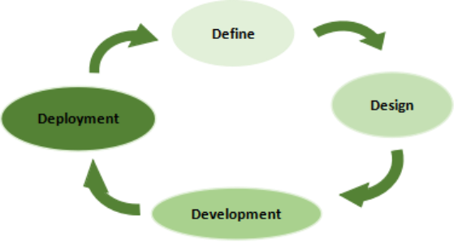
Diagram 4.1 4D Methodology
Define Phase
In the define phase, the proponents collect information through a face-to-face interview to the customer and owner with regards to the process of handling manual shopping to Rufino’s Furniture through verbal approach. After collecting information, the data is being analyzed wherein the problems are being counterpart for its solution. Lastly, the researchers plan for the preferred operations and functions that the proposed web application can perform.
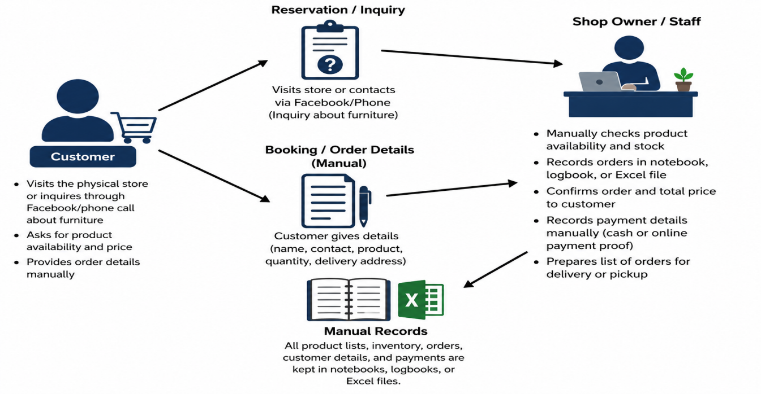

Diagram 4.2 .1 Current Technical Situation

The above diagram 4.2.1 represents the furniture shop operates using a manual system for managing sales, inventory, and customer orders. The shop relies on pen-and-paper records and spreadsheets to track inventory levels, records sales transactions, and manage customer orders. This manual process is time consuming error prone, and lacks efficiency, leading to challenges in keeping inventory up-to-date and processing customer requests in a timely manner.
Design Phase
The design phase is being used, in this phase. The proponent creates a blueprint for the flow and features of the system. The system should be user friendly, determines and sketch the position of the buttons that enable the users to use and see it efficiently. As well as the how the system works and its possible.
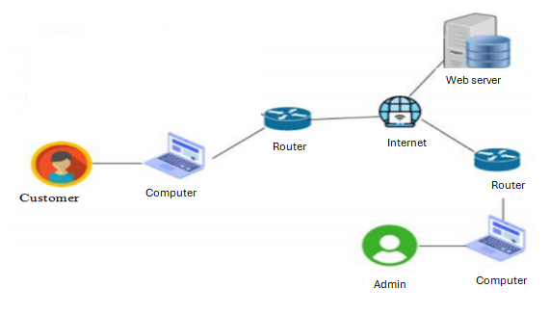

Diagram 4.3.1 System Architecture

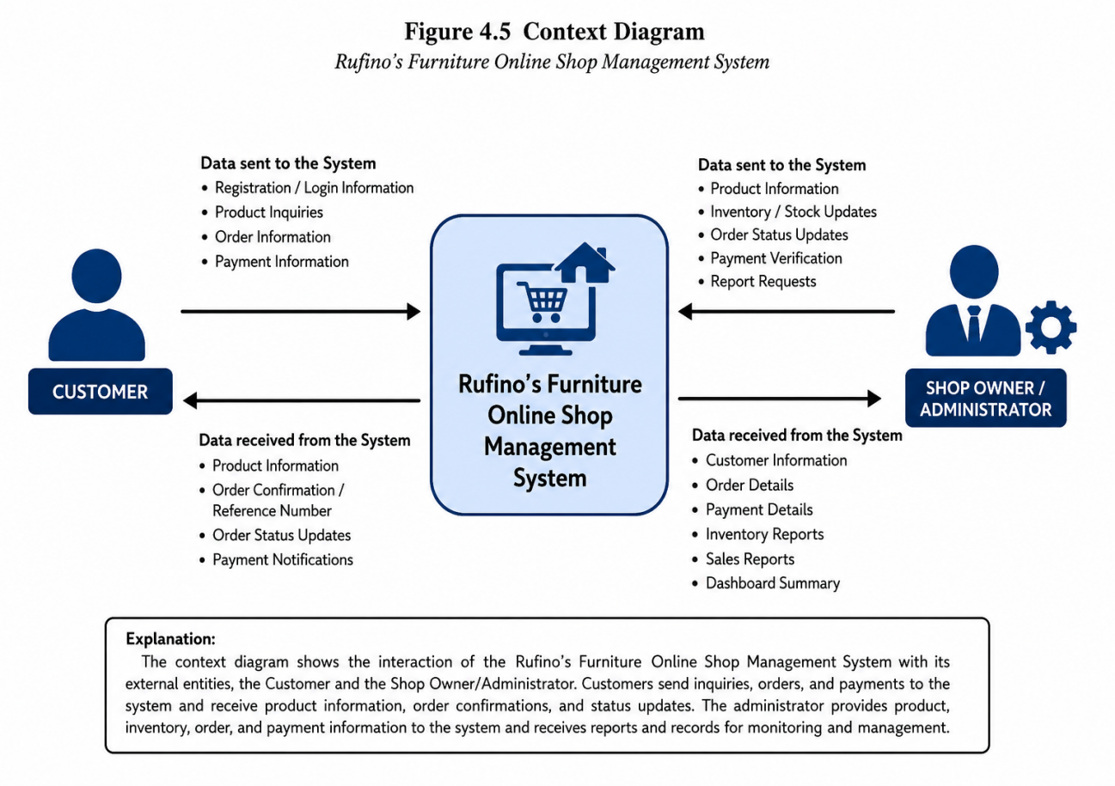
Th preceding figure 4.3.1 represents the System Architecture Diagram that shows the components needed to run the web application and its users completely. The users which are the owner, customer, will use their personal computers that are connected to their router. The router will serve as the gateway to connect to the internet. The internet will be responsible connecting the web server wherein the database is located, it will transmit data to the router and allow the router to pass the information to the computers of the user.

Diagram 4.3.2 Context Diagram
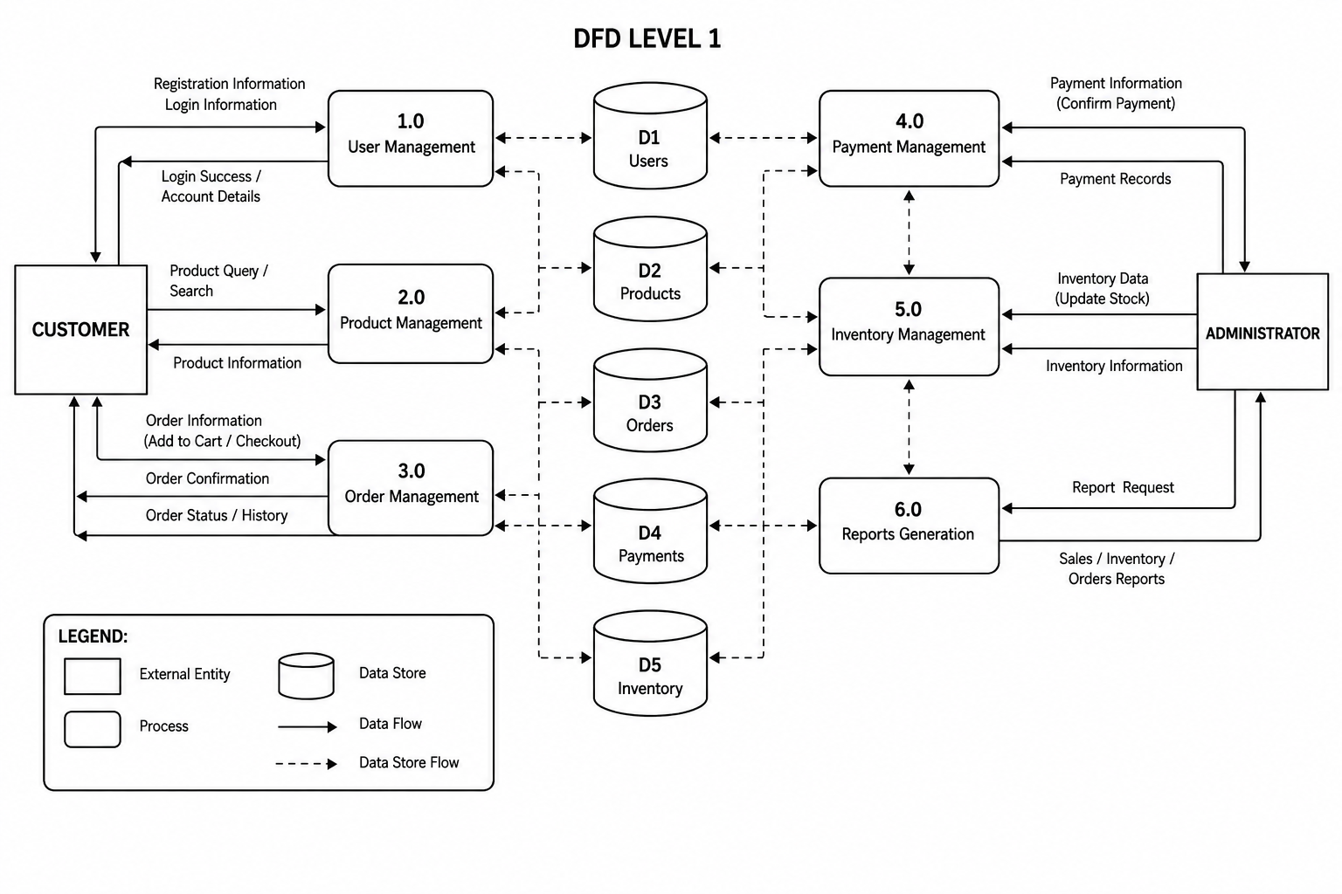
The preceding diagram 4.3.2 present the context diagram for Rufinos Furniture Online Management System is represented as the central system. It shows how two main actors interact with the system. Customer on the left side and Administrator on the right. The customer interacts with the system to browse products and orders, while the administrator interacts with the system to the manage products, inventory, orders, and reports. The arrows indicate the flow of tasks and illustrate the scoop of interaction between the external actors and the central system.

Diagram 4.3.3 Data Flow Diagram (Level 1)
The preceding diagram 4.3.3 presents the Data Flow Diagram (DFD) Level 1 provides a more detailed view of how data moves within the Rufino’s Furniture Online Shop Management System. It shows the main processes, data stores, and interactions between the Customer and Administrator.
The Customer interacts with the system through several processes. User Management (1.0) handles customer registration, login information, and account details. Product Management (2.0) allows customers to search and view available furniture products. Order Management (3.0) processes the customer's order information, including adding products to the cart, checking out, and viewing order status and history.
On the administrator side, Payment Management (4.0) handles payment information and payment records. Inventory Management (5.0) manages product stock and allows the administrator to update and monitor inventory levels. Reports Generation (6.0) processes report requests and provides sales, inventory, and order reports for the administrator.The diagram also shows five data stores: D1 Users, D2 Products, D3 Orders, D4 Payments, and D5 Inventory. These data stores keep important information needed by the system. Arrows represent the movement of information between customers, administrators, system processes, and data stores.
Overall, the DFD Level 1 illustrates how Rufino’s Furniture Online Shop Management System manages customer accounts, furniture products, orders, payments, inventory, and business reports in an organized and centralized manner. It demonstrates how information is received, processed, stored, and retrieved throughout the system.

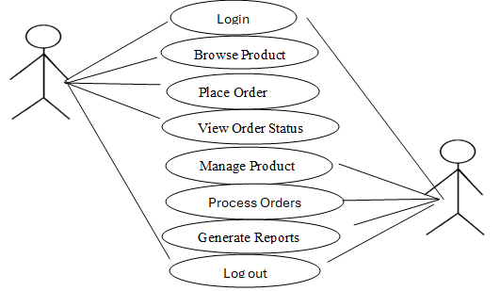
Customer
Admin

Digram 4.3.4 Use Case Diagram
The use case diagram shows the operation of the users that can be done to the system. The admin can login, manage inventory, process orders, generate reports and logout. The customer can login, browse products, place order, view order status and logout.

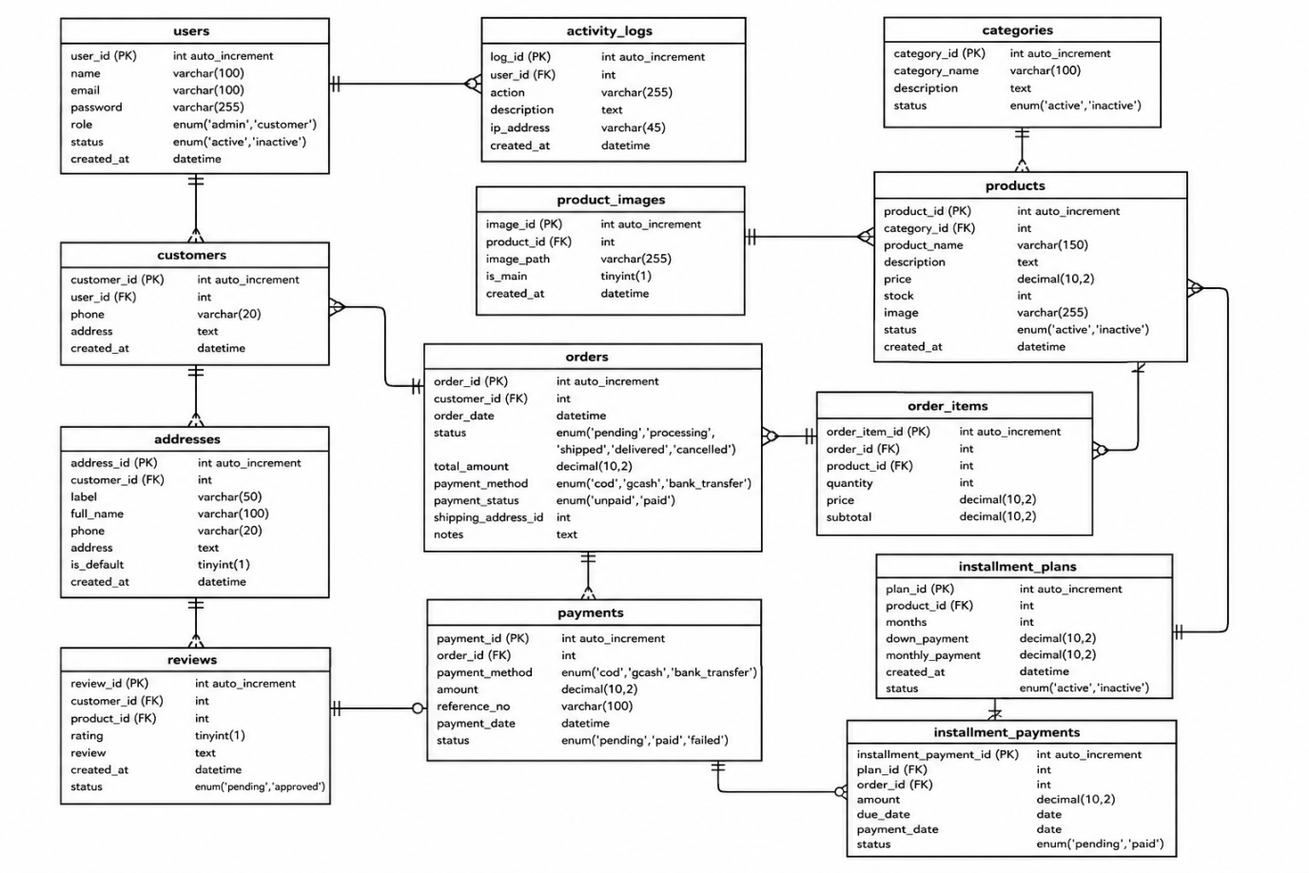

Diagram 4.3.5 Entity Relationship Diagram
The above diagram 4.3.5 represents the Entity Relationship Diagram (ERD) for the Rufino’s Furniture Online Shop Management System illustrates the structure of the database and the relationships among the different entities used by the system. The diagram contains tables for users, activity logs, customers, addresses, product categories, products, product images, orders, order items, payments, installment plans, installment payments, and reviews.
The users table stores the login and account information of system users, including administrators and customers. The activity_logs table records activities performed by users in the system. The customers table contains customer information, while the addresses table stores their delivery addresses. The reviews table stores product reviews and ratings provided by customers.The categories table stores the different furniture product categories, while the products table contains information about furniture items, such as product name, description, price, stock quantity, and status. The product_images table stores multiple images associated with each furniture product.The orders table records customer orders, including the order date, order status, total amount, payment method, payment status, and delivery address. The order_items table identifies the specific products included in each order and records the quantity, price, and subtotal.The payments table stores payment transactions associated with customer orders, including the payment method, amount, reference number, payment date, and payment status. For customers who choose an installment option, the installment_plans table stores the installment terms configured by the administrator, while the installment_payments table records the payments made by customers, including the due date, payment date, amount, and payment status.
The relationships between the entities are represented using crow’s-foot notation, where the symbols indicate the relationship between one or more records. Overall, the ERD provides a clear representation of how the database tables are connected and how information is organized throughout the Rufino’s Furniture Online Shop Management System. It helps ensure that customer information, products, orders, inventory, payments, and other important business records can be properly stored and managed.

Homepage
Login/Register
Browse Products
View Products
Select Product/s
Add To Cart?
Shopping Cart
Check Out?
Enter Customer Information & Payment
(With or Without Installation Service)
Place Order
View Order

Logout
End
Start
No
Yes
Yes
No

Diagram 4.3.6 Activity Diagram for Customer

The preceding diagram 4.3.6 presents the Customer Activity Diagram of the Rufino’s Furniture Online Shop Management System. It shows the step-by-step process a customer follows when purchasing furniture through the online shop. The process starts when the customer opens the Homepage and proceeds to Login/Register. After accessing the system, the customer can browse and view the available furniture products and select the product or products they want to purchase.
The customer then chooses to Add to Cart and reviews the items in the Shopping Cart. If the customer proceeds to checkout, they enter the required customer information and payment details, with the option to include or not include the installation service. After checking the order details, the customer places the order. The customer can then view the order status to monitor the progress of the purchase before eventually logging out of the system.
Overall, the activity diagram shows how the Rufino’s Furniture Online Shop Management System guides customers through the online purchasing process in a simple, organized, and convenient way, from browsing furniture products to placing and monitoring an order.

Choose task
Manage inventory
Manage orders
View inventory
Update stock
View orders
Genrate reports

Homepage
Login/Register
Start
Logout

End
Update stock?
Update order status?
No
No
Yes
Yes

Update oder

Diagram 4.3.7 Activity Diagram for Admin

The Diagram above 4.3.7 represents the administrator’s user dashboard. Once they are logged into their dashboard, an administrator can select an action based on the area where administrative action is required. When working with the inventory section, the administrator would have the ability to view the inventory and determine if any stock would need to be updated.
If there was stock that required an update, the Administrator would make the appropriate updates to the stock information and save that information in the inventory section of the system. When working with Customer Orders, the Administrator will have the ability to view customer orders and decide if the order status should be updated. The order status would then be updated, and the Administrator would be able to create reports to be used for tracking and record keeping purposes. Once all tasks are complete, the Administrator will log out of the system to close the Administrator session.
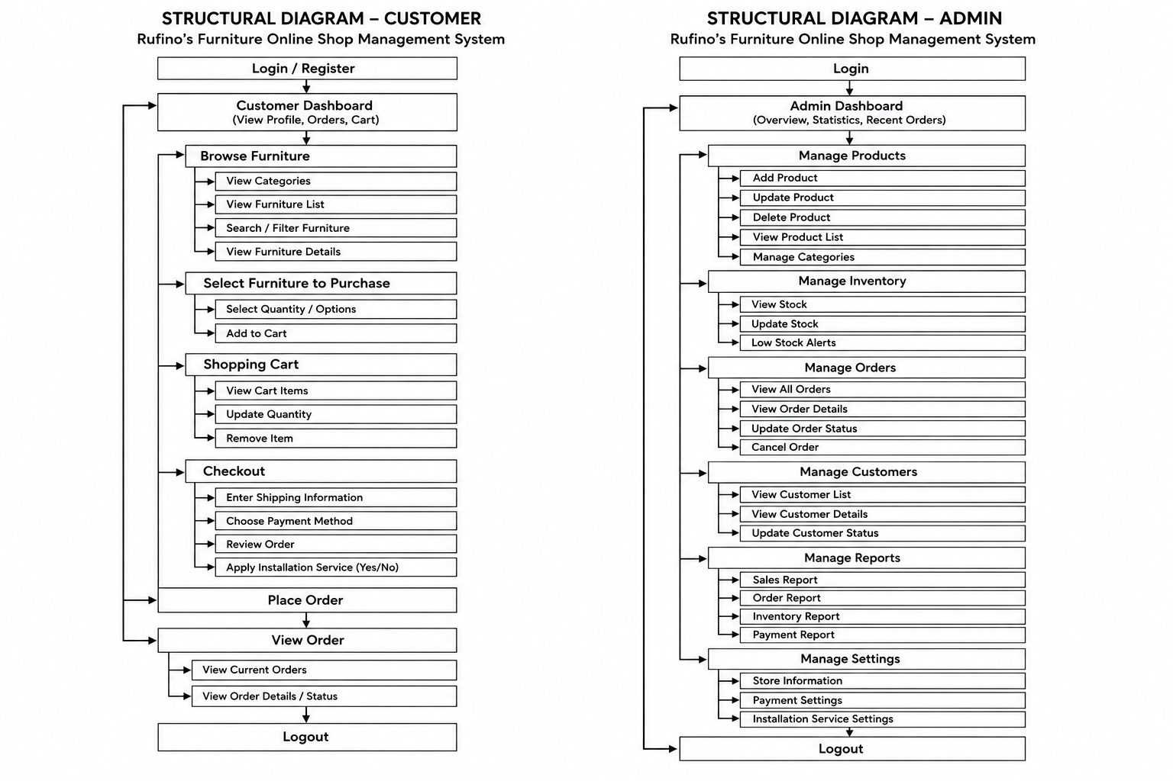

Digram 4.3.8 Structural Diagram for Customer
The preceding diagram 4.3.8 Customer Structural Diagram for Rufino’s Furniture Online Shop Management System illustrates the overall process that a customer follows when using the online shopping system. The process begins with the customer logging in or registering and accessing the Customer Dashboard, where they can browse available furniture, view product details, search or filter products, and choose the furniture they want to purchase. Once the customer selects a product, they can choose the quantity or available options and add the item to the Shopping Cart. The customer can then review the items in the cart, update the quantity, or remove products before proceeding to checkout.
During Checkout, the customer enters the required shipping information, chooses a payment method, reviews the order details, and selects whether to include the installation service. After confirming the information, the customer can place the order. The system then allows the customer to view their current orders and check the details and status of their purchases.

Develop Phase
The third phase under the 4D methodology is the development phase. In this phase, it contains the information on the web application structures when developed. It includes developing the system features, database, and user interfaces for customers and the administrator. The system is also tested to ensure that its functions work properly and meet the needs of Rufino’s Furniture.
Graphica User Design
A Graphical User (GUI) is the visual part of the Rufino’s Furniture Online Shop Management System that allows customers and the shop owner to interact with the system through buttons, menus, icons, forms, images, and other visual elements. Instead of using complicated text-based commands, users can perform tasks through a simple and organized interface. For customers, the GUI provides an easy way to register or log in, browse furniture products, view product details, add items to the shopping cart, choose payment options, place orders, and check order status. For the shop owner or administrator, the interface provides access to functions such as managing products, updating inventory, monitoring orders and payments, managing installment options, and generating business reports.

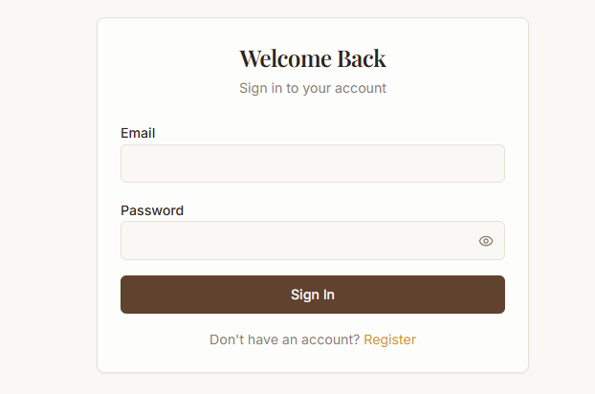
Admin

Figure 7.0 Entity Relationship Diagram

Figure 4.4.1 Login Interface of the Admin

As illustrated in the preceding Figure 8, the admin login interface comprises a email field, password field, signin button. To gain access to, the system (Rufino’s Furniture Online Shop). input the unique username and password into the respective fields and subsequently click the login button.
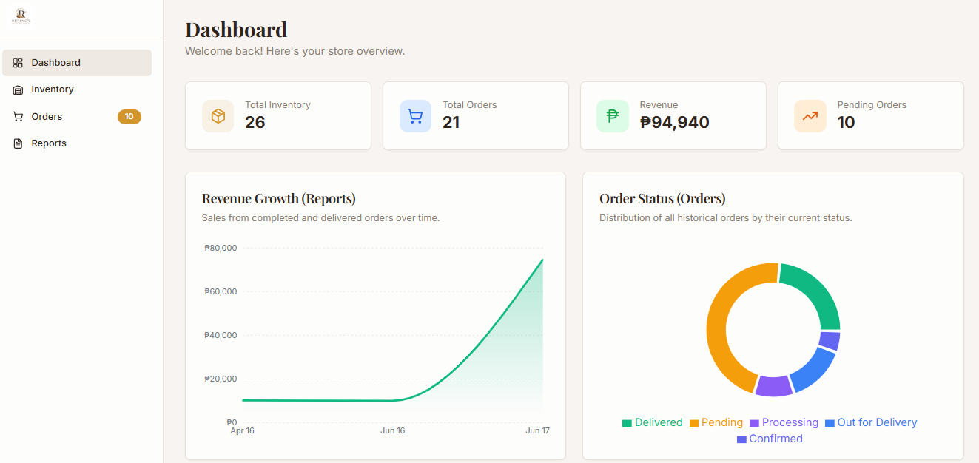

Figure 4.4.2 Dashboard of the Admin
The figure 2 presents the Dashboard of Rufino’s Furniture Online Shop Management System. The dashboard provides the shop owner with a quick overview of the store’s current activities and performance. It displays important information such as Total Inventory, Total Orders, Revenue, and Pending Orders, allowing the administrator to monitor the business at a glance. It also includes a Revenue Growth Report that shows changes in sales revenue over time and an Order Status chart that presents the distribution of orders according to their current status, such as Delivered, Pending, Processing, Out for Delivery, and Confirmed. Overall, the dashboard helps the shop owner monitor inventory, orders, sales, and pending transactions in an organized and convenient manner.
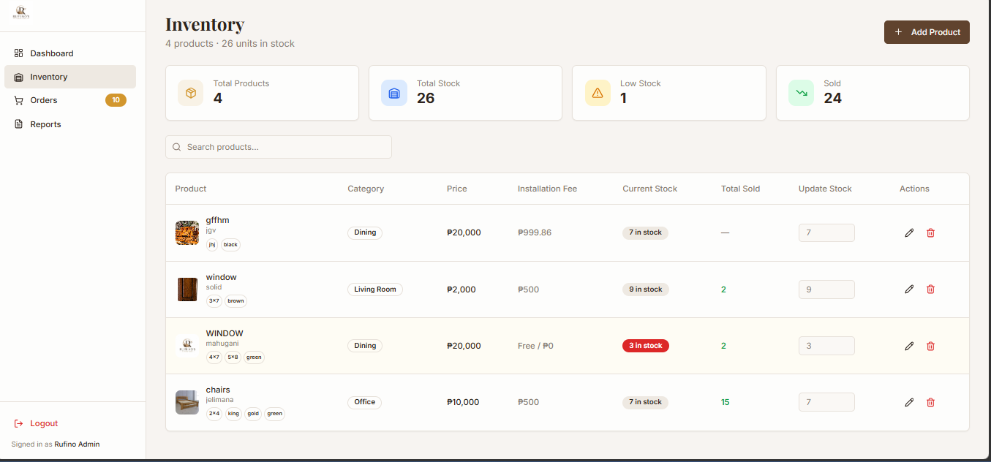

Figure 4.4.3 Inventory Management
The Preceding Figure 4.4.3 presents the Inventory Management Interface of Rufino’s Furniture Online Shop Management System. It provides the administrator with an organized view of the furniture products and their stock information. The interface displays the total number of products, total stock, low-stock items, and total items sold, allowing the administrator to monitor inventory more easily. It also includes a search function for quickly locating specific products.
The product table shows important details such as the product name, category, price, installation fee, current stock, and total sold. The administrator can update the stock quantity and use the available action buttons to edit or delete product records. The Add Product button allows the administrator to add new furniture items to the system. The left navigation panel provides access to the Dashboard, Inventory, Orders, and Reports modules. Overall, the interface helps the shop owner maintain accurate inventory records, monitor product availability, and manage furniture products efficiently.
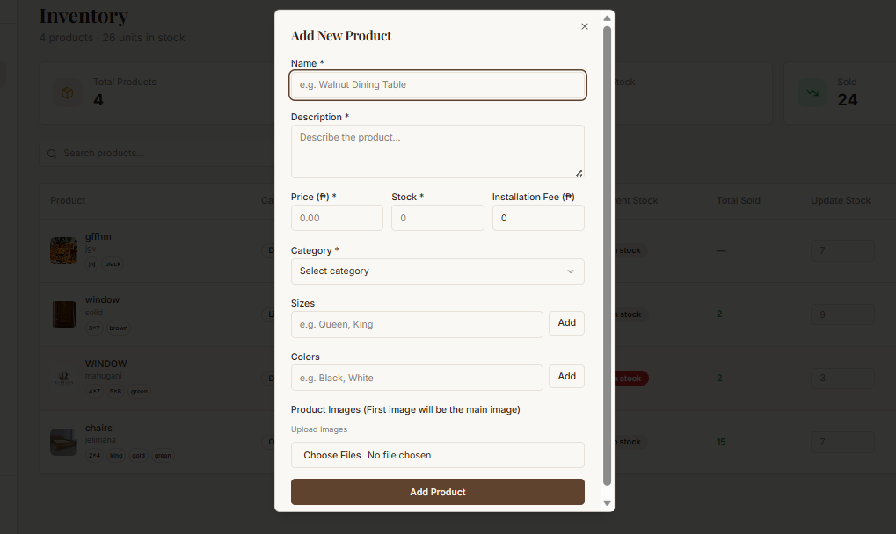

Figure 4.4.4 Add Product
The preceding Figure 4.4.4 presents the Add New Product Interface of Rufino’s Furniture Online Shop Management System. This interface allows the administrator to add new furniture products to the system by entering the necessary product information. The form includes fields for the product name, description, price, stock quantity, installation fee, category, sizes, and colors.
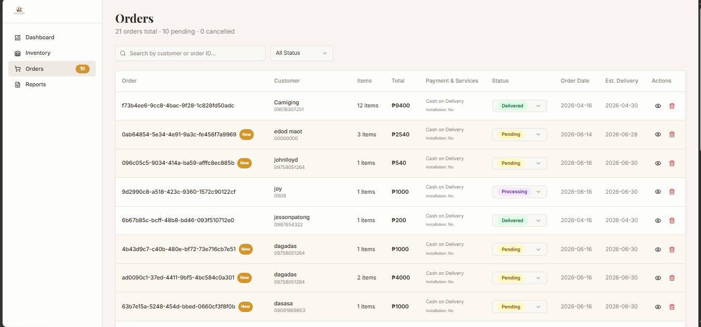
The interface also provides an option to upload multiple product images, allowing the administrator to provide clear visual information about the furniture item. After completing the required details, the administrator can click the Add Product button to save the new product. This information can then be displayed in the online shop and included in the inventory records. Overall, the interface makes adding new furniture products more organized and convenient while helping the administrator maintain complete and accurate product information.

Figure 4.4.5 Orders Management
The above Figure 4.4.5 presents the Orders Management Interface of Rufino’s Furniture Online Shop Management System. This interface allows the administrator to view and manage customer orders in an organized manner. It displays important order information, including the order ID, customer name, number of items, total amount, payment method, order status, order date, and estimated delivery date.
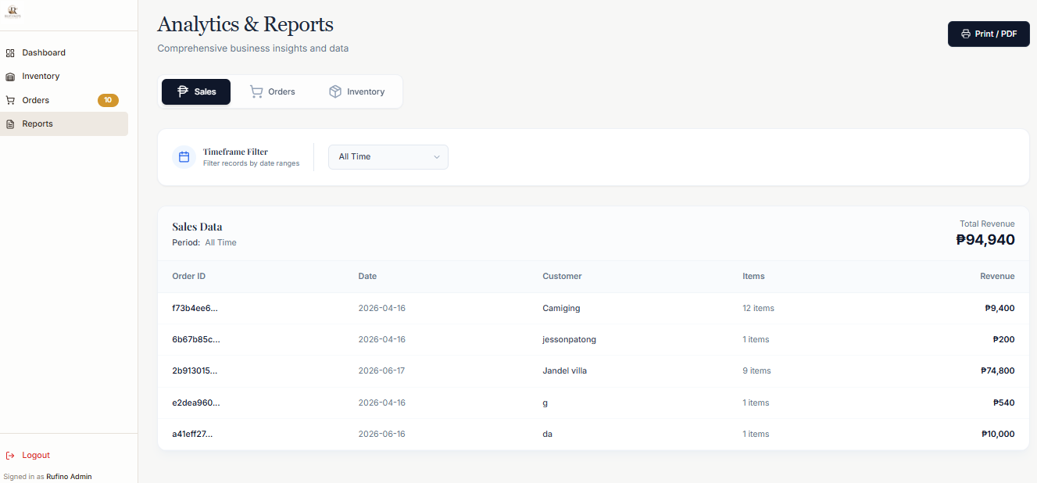
The administrator can use the search bar to find a specific customer or order and can filter orders based on their status. The order status indicates the current progress of each transaction, such as Pending, Processing, and Delivered. The interface also provides action buttons that allow the administrator to manage individual orders when necessary. Overall, this interface helps the shop owner monitor customer orders, track their progress, and manage transactions more efficiently.

Figure 4.4.6 Reports Management
The above Figure 4.4.6 presents the Analytics and Reports Interface of Rufino’s Furniture Online Shop Management System. This interface allows the administrator to monitor and review important sales information generated by the system. It provides a Sales section that displays details such as the Order ID, date, customer, number of items, and revenue for each transaction. The interface also includes a time filter that allows the administrator to view sales information based on a selected period. The total revenue is displayed at the top of the sales table, giving the shop owner a quick overview of the income generated from completed transactions. The system also provides tabs for Sales, Orders, and Inventory, allowing the administrator to access different types of business information. Overall, the Analytics and Reports interface helps Rufino’s Furniture organize sales records, monitor business performance, and make informed decisions based on the available data.

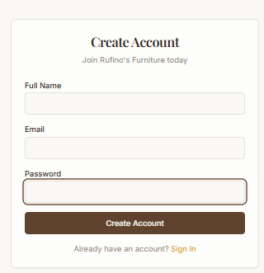
Customer

Figure 4.4.7 Login Interface of the Customer
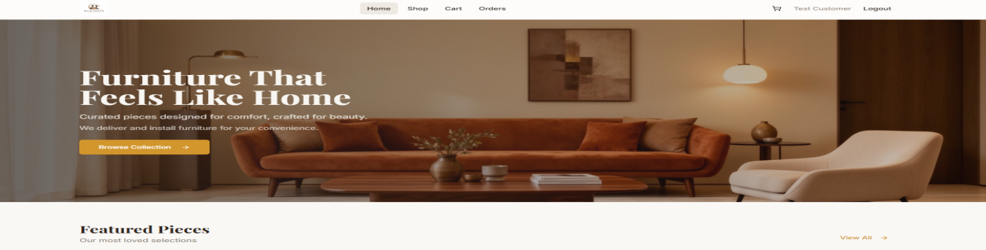
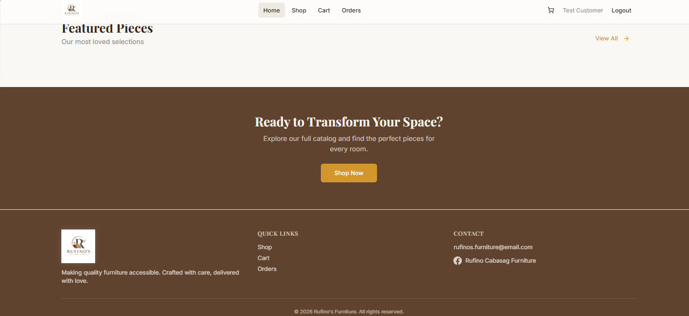
The figure above 4.4.7 presents the Customer Registration Interface of the Rufino’s Furniture Online Shop Management System. The interface allows new customers to create an account by providing their full name, email address, and password. After completing the required information, the customer can click the Create Account button to register. Customers who already have an account can select the Sign In option to proceed to the login page. The simple layout makes the registration process easy to understand and use, allowing customers to quickly create an account before browsing and purchasing furniture products.

Figure 4.4.8 Customer Landpage
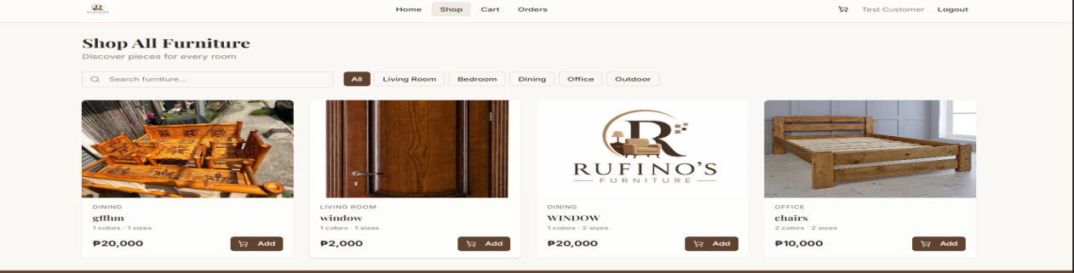
The preceding figure 8 presents the Customer Landing Page of the Rufino’s Furniture Online Shop Management System. It serves as the main page that customers see when they visit the online shop. The page displays a large furniture banner with a welcoming message and a Shop Now button that guides customers to the available furniture products. The landing page also includes a Featured Pieces section where selected furniture products can be presented to customers. The navigation menu provides access to important sections such as Home, Shop, Cart, and Orders, allowing customers to easily move around the system. The page also contains a section that encourages customers to explore and purchase furniture, as well as footer information containing the shop description, quick links, and contact details.

Figure 4.4.9 Customer Shop
The figure above presents the Shop All Furniture page of the Rufino’s Furniture Online Shop Management System. This page allows customers to browse and explore the furniture products available in the online shop. Customers can use the search bar to quickly find a specific furniture product and can select categories such as Living Room, Bedroom, Dining, Office, and Outdoor to narrow down their choices. Each product card displays important information, including the product image, category, product name, available colors and sizes, and price. The Add button allows customers to directly add their selected furniture to the shopping cart. The navigation menu at the top also provides access to the Home, Shop, Cart, and Orders pages.

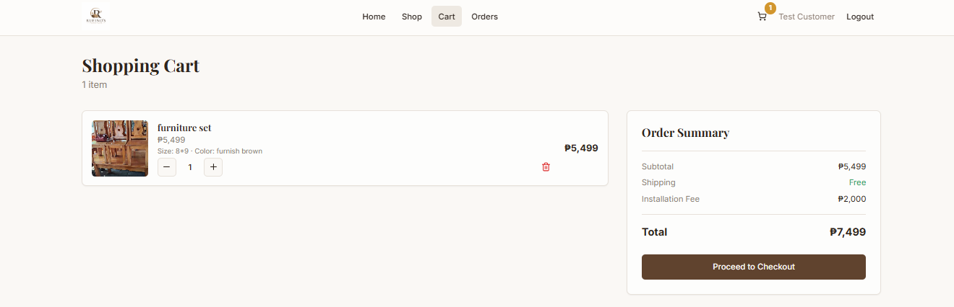

Figure 4.4.10 Customer Cart
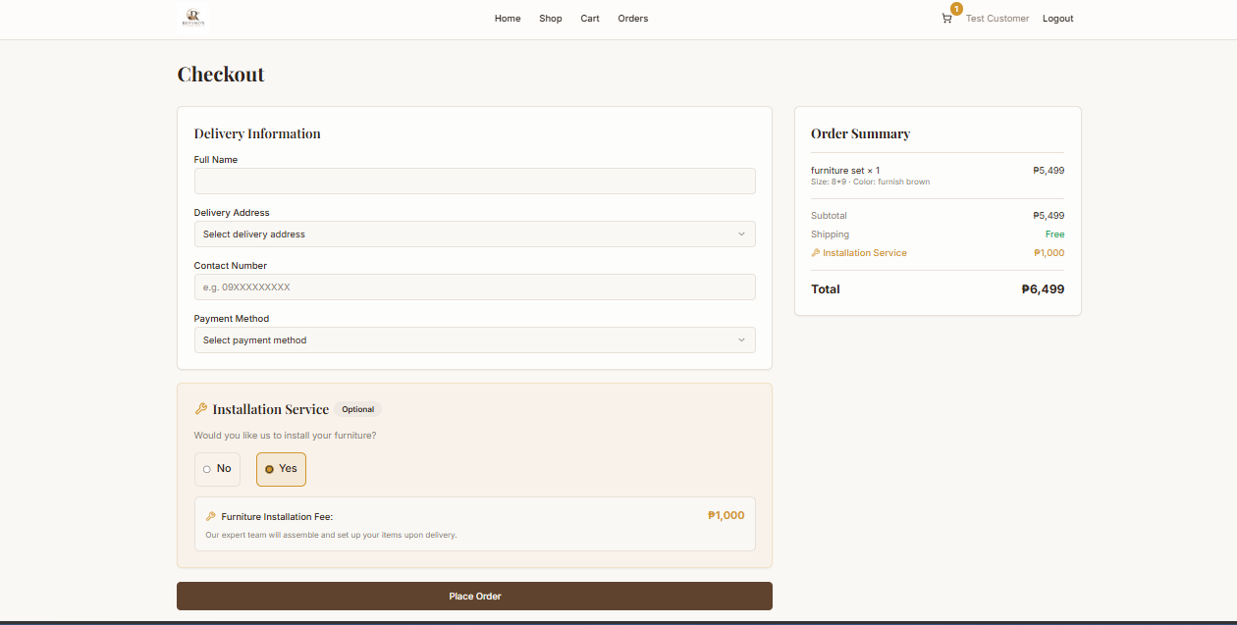
The preceding figure 4.4.10 presents the Shopping Cart Interface of the Rufino’s Furniture Online Shop Management System. It allows customers to review the furniture products they have selected before proceeding to checkout. The interface displays the product image, product name, price, selected size and color, quantity, and the option to remove an item from the cart.

Figure4.4.11Customer Checkout
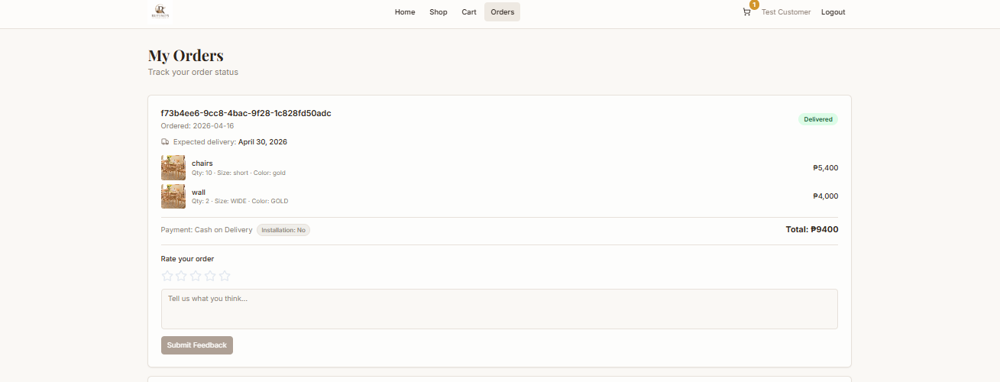
The figure 4.4.11 shows the Checkout Interface of the Rufino’s Furniture Online Shop Management System. This page allows customers to provide the information needed to complete their furniture order. The Delivery Information section includes fields for the customer’s full name, delivery address, contact number, and preferred payment method. The checkout page also provides an Installation Service option where customers can choose Yes or No. If the customer selects “Yes,” the system displays the corresponding furniture installation fee and includes it in the order total. The Order Summary on the right side shows the selected furniture, subtotal, shipping cost, installation service fee, and final total amount. After reviewing all information, the customer can click the “Place Order” button to submit the order. Overall, the checkout interface makes the ordering process more organized by allowing customers to confirm their delivery details, payment method, installation preference, and total cost before completing the purchase.

Figure 4.4.12 Customer Orders Interface
The figure 12 presents the Orders Interface of the Rufino’s Furniture Online Shop Management System. This interface allows customers to monitor and review their furniture orders after placing a purchase. It displays important order information such as the order ID, order date, expected delivery date, ordered furniture items, quantity, size, color, payment method, installation service, and total amount. The current order status, such as Delivered, is also clearly displayed so customers can easily track the progress of their orders. In addition, customers can rate their completed order using the star-rating option and provide comments or feedback about their shopping experience. Overall, the interface gives customers a convenient way to view their order details, monitor order status, and provide feedback about their purchase.
Gant Chart
The proponents proposed the study entitled Rufino’s Furniture Online Management System in order to address the challenges encountered in the traditional manual management of furniture sales and inventory, such as delays in processing customer orders, lack of real-time product updates, and inefficient record-keeping. The study will serve as a tool to develop a system that will provide an organized, accurate, and efficient way of managing products, orders, and customer information. This system aims to improve business operations and enhance customer satisfaction by streamlining the overall management process.
MONTHS | May |  |  |  | June |  |  |  | July |  |  |  | August |  |  |  | September
WEEKS | 1 2 3 4 |  |  |  | 1 2 3 4 |  |  |  | 1 2 3 4 |  |  |  | 1 2 3 4 |  |  |  | 1 2 3 4
Activities
DEFINE
Planning
Data Gathering
Requirements Analysis
DESIGN
GUI
DEVELOPMENT
Coding
Testing
DEPLOY
Implementation

Table 4. Gantt Chart
The Gantt chart presents the planned timeline for the development of the Rufino’s Furniture Online Shop Management System from May to September. It shows the major activities involved in developing the system and the estimated weeks for completing each task. The highlighted cells indicate the weeks when a particular activity is scheduled.
The development begins with the Define phase in May, which includes planning, data gathering, requirements analysis, and system analysis. During this phase, the researchers identify the current challenges in managing furniture products, inventory, customer orders, payments, and sales records. They also gather the necessary information and requirements from the business to determine the functions needed for the proposed online shop management system.
The Design phase follows from June to July. This phase focuses on preparing the system structure and interface, including the system architecture, database design, diagrams, and graphical user interface (GUI). The researchers design the system based on the identified requirements to ensure that the features are organized and easy for both customers and the administrator to use.
The Development phase covers June to August and involves the actual creation of the system. During this phase, the researchers perform coding and testing. The system's customer features, product management, inventory management, shopping cart, checkout, payment recording, order management, reports, and other required functions are developed and tested to identify and correct errors.
Finally, the Deploy phase takes place in September, where the completed Rufino’s Furniture Online Shop Management System is prepared for actual use. The researchers perform final checking and validation to ensure that the system functions properly and meets the identified requirements. This phase prepares the system for implementation at Rufino’s Furniture and supports the business in managing its products, inventory, customer orders, payments, and reports more efficiently.

Legend:
1 week:
1/2 week:
Task | May |  |  |  | June
 | Week  1 | 2 | 3 | 4 | Week  1 | 2
Brainstorming
Title Identification
Gathering information
Creation of Title for defence

Table 4.1.5 Gantt Chart (Phase I)
The Chart 4.1 shows the activities completed by the researchers during the initial phase of the Rufino’s Furniture Online Shop Management System from May to June. The colored boxes show the weeks when each activity was conducted.
The first activity was Brainstorming, which was done during the second week of May. The researchers discussed ideas and identified possible problems that the system could solve. Next, Title Identification was conducted during the third week of May. The researchers selected the title Rufino’s Furniture Online Shop Management System based on the purpose of the proposed system. During the fourth week of May and the first week of June, the researchers conducted Information Gathering. They collected information about the furniture business, including its products, inventory, customer orders, payments, and current business processes. Lastly, the Creation of Title for Defense was completed during the second week of June. The researchers prepared the title and necessary materials for the title defense
Phase II (Data Analysis and Finalization)

Task | June
 | Week  1 | 2 | 3 | 4
System objectives
Identify limitations
Making chapter I-III of the approved title
Finalized chapter I- III
Group meeting

Table 4.4.2 Gantt Chart (Phase II)
The preceding table 4.2 presents the Phase II Gantt Chart, which shows the schedule of activities for the Rufino’s Furniture Online Shop Management System during the data analysis and documentation phase.
The first activity was System Objectives, conducted during the first week of June. The researchers identified the general and specific objectives of the proposed system. These objectives focused on improving the management of products, inventory, customer orders, payments, and reports. The second activity was Identification of Limitations, conducted during the second week of June. The researchers identified the functions that the system would include and the activities that were outside the scope of the study. The third activity was Preparation of Chapters I–III, which also started during the second week of June. The researchers prepared the Introduction, Review of Related Literature, and Design and Methodology of the study. After this, the researchers worked on the Finalization of Chapters I–III by reviewing and improving the content based on the requirements and suggestions from their research adviser. Lastly, a Meeting was conducted during the third week of June. The researchers discussed the progress of the project, remaining tasks, and responsibilities of each member.
Phase III (Designing)
Task | June |  | July
 | Week  3 | 4 | Week  1 | 2 | 3 | 4
4D Model Diagram
Context Diagram
Data Flow Diagram
(level 1)
Use Case Diagram
Activity Diagram
Gantt Chart
Group Meeting

Chart 4.3 Gantt Chart (Phase III)

The chart shows the schedule and timeline for developing the Rufino’s Furniture Online Shop Management System. The activities are planned during June and July, with each task assigned to specific weeks. During June Week 4 and July Week 1, the researchers prepared the 4D Model Diagram and Context Diagram to show the development process and the main functions of the system. During July Weeks 1 and 2, the researchers created the Data Flow Diagram (Level 1) to show how information moves within the system. In July Week 2, the researchers prepared the Use Case Diagram to identify the activities of the customers and administrator. The Activity Diagram was also created during the same period to show the steps followed when using the system. The Gantt Chart was prepared during July Weeks 2, 3, and 4 to organize the project activities and their timeline. The chart also includes Group Meetings, where the researchers discussed the progress of the project, assigned tasks, shared ideas, and made necessary changes.
Phase IV (IMPLEMENTATION)

Task | August |  |  |  | September
 | Week  1 | 2 | 3 | 4 | Week  1 | 2 | 3 | 4
Implementation Planning
System Design
System Definition

Chart 4.4 Gantt Chart (Phase IV)

The above Chart 4.4, which marks the start of the coding phase. A two month period was allocated for implementation planning, spanning the first to the
second weeks of August. System design followed from the third week of August to mid-September, then system definition was conducted during the third and fourth weeks of September. This structured schedule supported steady progress and a solid foundation for development.

Deployment
The proponents used the 4D Methodology in developing Rufino’s Furniture Online Management System. The system was created by following different steps and processes. The proponents made sure that the design, features, and functions of the system will help solve the problems found in the manual way of managing furniture products, orders, and inventory.
Program Specification
Hardware Specification
Laptop – Core i3 Processor
Storage – 320GB Hard Drive
Software Specification
Operating System – Windows 10
Web Browser – Google Chrome / Microsoft Edge
Database – PostgreSQL
Development Tool – Visual Studio Code / Render
Codes
Module to Add Product
The addProduct function is created using useCallback to prevent unnecessary re-rendering and is defined as an asynchronous function that receives product data without an ID. It sends the product information to the server using a POST request through the /api/products endpoint, where the data is converted into JSON format. After sending the request, the function checks the response type to confirm if it is in JSON format, then safely converts the response into usable data. The system then verifies if the request was successful. If not, it throws an error with a message from the server or a default error message. It also checks if the returned data is valid. If the response is empty or invalid, an error is generated. If the process is successful, the new product is added to the existing product list using setProducts, which automatically updates the user interface.
Finally, the function returns true to indicate success, while any errors encountered are caught, logged in the console, and re-thrown for handling.
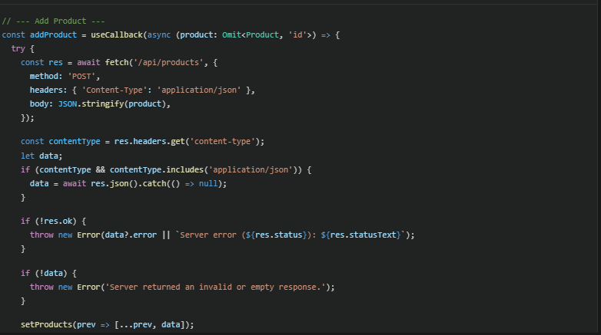
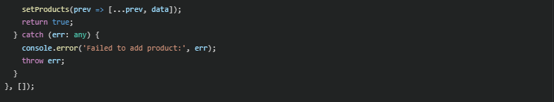

The add product function allows the administrator to input new product details and send them to the system. The system then saves the product in the database and automatically displays it in the product list.
Module to Update Product
The updateProduct function is also created using useCallback and is an asynchronous function that receives the complete product data, including its ID. It sends the updated product information to the server using a PUT request directed to /api/products/{id}, where the specific product is identified by its ID. The product data is converted into JSON format before being sent to the server. After the request, the function checks if the response is in JSON format and safely extracts the returned data. The system then validates if the request was successful. If it fails, an error message is generated and thrown. It also ensures that the returned data is valid; otherwise, an error is raised. If successful, the function updates the product list by replacing the old product data with the updated one using setProducts, ensuring the changes are reflected in the interface. Finally, the function returns true to indicate success, and any errors are caught, logged, and re-thrown.
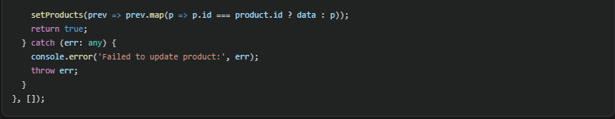
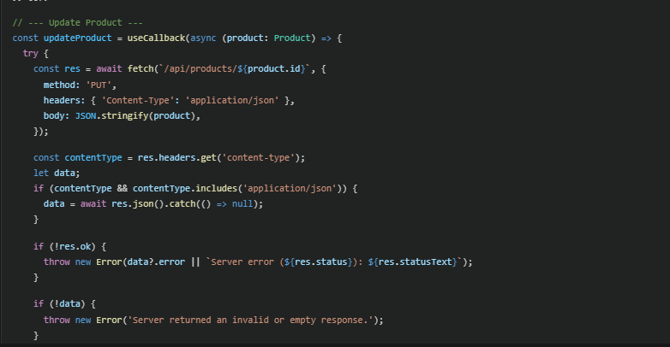

The update product function allows the administrator to modify existing product information. The system sends the updated data to the server, saves the changes in the database, and refreshes the product list to reflect the updated details.
Load Testing
For load testing, the proponents deployed the system on an online hosting platform and created a group of 20 users composed of administrators and customers. These users interacted with the system by browsing products, adding items to the cart, placing orders, and managing inventory on the admin side.
During the testing, the proponents observed that the system experienced slight delays when multiple users were performing actions at the same time. To resolve this, the system was optimized by improving database queries, reducing unnecessary data processing, and enhancing overall system performance.
Stress Testing
For stress testing, the proponents pushed the system beyond normal usage by increasing the number of users and activities at the same time. Aside from the initial 20 users, additional users were added, and actions such as browsing products, adding to cart, placing orders, and managing inventory were performed continuously. The goal was to test the system’s stability under heavy load and identify possible performance issues. During testing, the proponents monitored response time, system performance, and server usage. Some delays were observed when many users accessed the system simultaneously. To improve performance, the proponents optimized database queries, improved data handling, and adjusted system resources to ensure the system remains stable and responsive even under high user demand.
Beta Testing

In this testing, the proponents demonstrate how the system works and also asked for suggestions to improve the system.
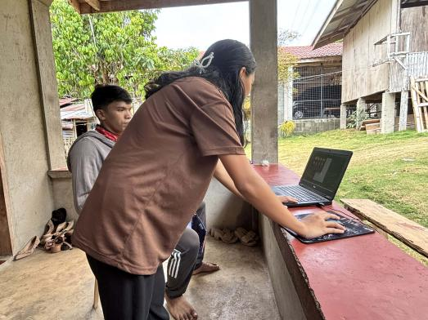




Image 1. Beta Testing Documentation

The preceding image shown in the beta testing, the proponents demonstrated the system to Rufino Cabasag, the owner of Rufino’s Furniture. Based on his feedback, the system is effective and useful for managing furniture products, customer orders, and transactions. He appreciated the features that allow easy monitoring of inventory and smooth handling of customer orders. Mr. Cabasag also suggested adding tutorials and ask questions to help users better understand and navigate the system.

CHAPTER V
SUMMARY OF FINDINGS, CONCLUSIONS AND RECOMMENDATIONS
This chapter presents the summary, conclusions, and recommendations of the study. The research focuses on developing Rufino’s Furniture Online Shop Management System, which aims to make furniture shopping and business management easier and more organized. The system helps customers browse products, add items to their cart, place orders, choose payment options, and monitor their orders. It also helps the administrator manage products, inventory, orders, payments, and reports. The researchers also provide recommendations that may help improve the system and guide future researchers in developing similar online shop management systems.
Summary of Findings

The findings from the development and testing of the Ruino’s Furniture Online Shop Management System showed the several important results that addressed the objectives of the study:
- ) Efficient Management of Products, Inventory, Orders, and Business Records. the developed system provided the administrator with a centralized platform for managing furniture products, inventory, customer orders, payments, and business records. The administrator can add, update, and delete products, monitor stocks levels, view customer orders, update order status, and generate reports. This made the management of daily business activities more organized and convenient.
- ) Convenient Online Shopping for Customer. The system provided customers with an easier way to browse and purchase furniture products online. Customer can view product information, including images, price, sizes, and colors, and add their selected products to the shopping cart. They can also provide their delivery information,select a payment method, choose an installation service, and place an order without needing to visit the physical store.
- ) Reduce Errors and Delays Through Automation. The system helped reduce problems associated with manual transactions and record-keeping by automating important business processes. Product information, customer orders, payments, and inventory records are stored in the system, reducing the need to repeated manual recording. This also makes order processing and information retrieval faster and more organized.
- ) Improved Accuracy, Security, and Accessibility or Records. The centralized database allowed important business and customer information to be stored in one organized system. User authentication access to accounts and information. The administrator can also easily access and review records such as orders, inventory, and sales reports when needed.
- ) Successful Development of the Online Management System. Overall, the developed Rufino’s Furniture Online Shop Management System achieved its main purpose of providing a functional platform for both the administrator and customer. The system helped improve furniture management, online purchasing, order processing, and record keeping, providing a more organized and convenient approach compared with manual processes.

Implementation Result and Discussion
This chapter presents the results of implementing the Rufino’s Furniture Online Management System, highlighting its core features and functionalities. The system was developed using Node.js + Express.js for server-side operations, HTML, CSS and JavaScript for the user interface, and PostgreSQL as the database management system. It was designed to provide an efficient, reliable, and user-friendly platform for managing products, customer orders, and payment transactions.
The implementation results show that the system successfully improves the process of managing furniture sales and inventory. It reduces manual work, minimizes errors, and eliminates delays associated with traditional methods. By automating product management, order processing, and report generation, the system addresses common issues such as inaccurate inventory tracking, data redundancy, and slow transaction handling.
Feedback gathered during the testing and evaluation phases confirmed that the system is highly usable and effective. It provides administrators with an easy way to manage products and monitor orders, while customers experience a convenient and smooth online purchasing process.
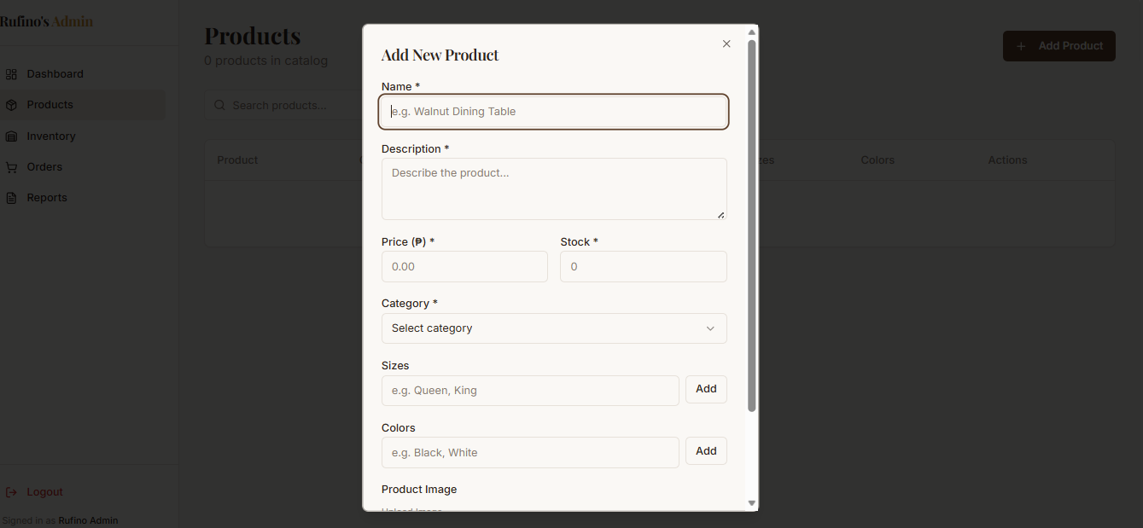
Overall, the system enhances efficiency, accuracy, and reliability in managing furniture business operations. It contributes to better customer service and supports the digital transformation of Rufino’s Furniture.

Image 1. Admin Interface (Add Product)
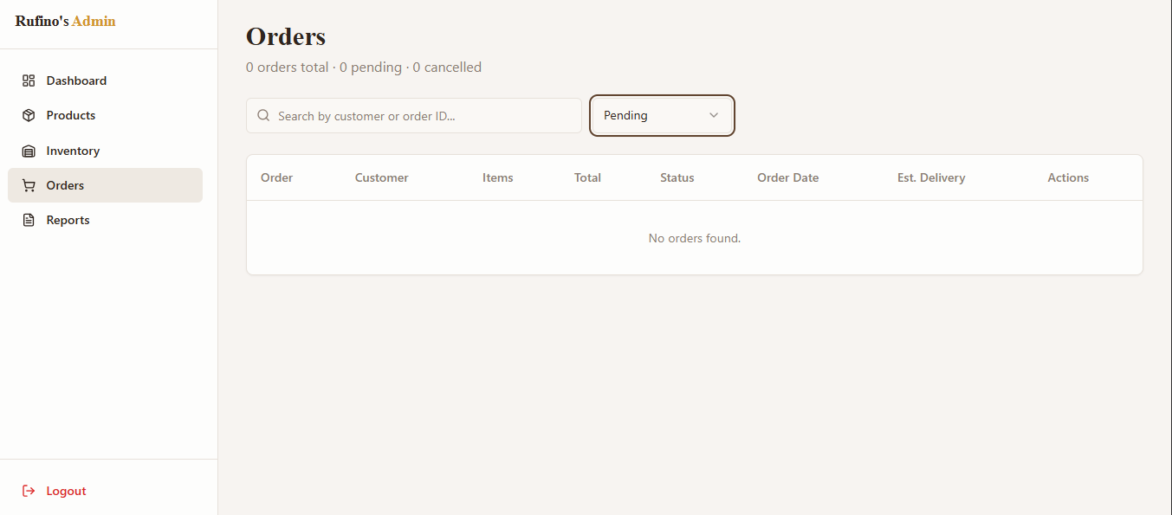
Image 2 shows the user interface for adding a new furniture product. The administrator can enter product details such as product name, category, price, stock, and upload an image. This interface allows the admin to record and store product information in the system database for display in the online shop.

Image 2. Admin Interface (Manage Orders)
Image 3 shows the user interface for managing customer orders. The administrator can view order details, update order status, and monitor customer transactions. This interface helps the admin efficiently track and manage all orders within the system.
Conclusion
On the basin of the result, it is indicated that the Rufino’s Furniture Online Shop Management System successfully addresses the problems related to the manual management of products, inventory, customer orders, and business records. The system enabled the owner of the store to operate in the centralized environment through which the owner was able to better manage the business processes.
The system also helped customers to convenient way to browse furniture products, add items to their cart, provide delivery information, select payment and installation methods, and place their orders online. Due to the automated processes and centralized database, the system helped reduce manual works, errors, and delays while making business and customer records easier to access and manage.
Therefore, it could be stated that the findings of the research indicated that: the online shop management system of Rufino’s Furniture could be beneficial for the improvement of the store’s operations and better online shopping experience of the customers.
Recommendation
Based on the findings and conclusions of the study, the researchers recommend the following:
- ) Regularly System Maintenace. The administrator has to carry out regular upkeep in order to make sure the functionality and security of the system.
- ) Regular Data Backups. Business records, customer information, orders, and inventory data should be backed up regularly to prevent data loss in case of system failure or other technical problems.
- ) Improve Security. Additional security measures may be added in the future to further protect customer information and business records from unauthorized access.
- ) Improved Customer Service. Future developers may improve the system by adding additional features such as order notifications, customer review, and installation service.
- ) Enhance Reports. Future version may offer more detailed sales, inventory, and customers reports to help the shop owner make better business decisions.
- ) Future System Expansion. In the future, the system may include mobile device compatibility or a dedicated app to enable enjoying all benefits of the system on smartphone.
7.) Future Researchers. Future researchers may use this study as a reference and further improve the system by adding new features, improving security, and integrating technologies that can make furniture shopping and business management more efficient.
REFERENCE
Bidadari, A., & Hamidy, F. (2022). Sistem informasi penjualan berbasis web pada Mebel Bos Khoiron Pageruyung. http://jurnal.umpp.ac.id/index.php/surya_informatika/article/view/1455
Dwimaelani, R., et al. (2025). Implementation of web-based furniture store management information system. https://scholar.google.com/scholar?q=Implementation+of+webbased+furni ture+store+management+information+system
Jabar, M., & Anubhakti, D. (2022). Website-based e-commerce system design and build to increase online sales at Funika Furniture. https://scholar.google.com/scholar?q=Funika+Furniture+ecommerce+syst em+Jabar+Anubhakti
Laudon, K. C., & Laudon, J. P. (2020). Management information systems: Managing the digital firm (16th ed.). Pearson Education.
Lau, M. M., & Tang, K. K. F. (2025). Transforming furniture e-commerce: The impact of augmented reality on purchase intentions. Proceedings of the International Conference on Innovation, Creativity and Marketing (ICICM-25), Kyoto, Japan.
Minah Jaya. (2023). Web-based furniture sales information system. https://scholar.google.com/scholar?q=Webbased+furniture+sales+informa tion+system+Minah+Jaya
Piyoshila, R., et al. (2022). E-commerce platform for furniture store. https://scholar.google.com/scholar?q=Ecommerce+platform+for+furniture+ store+ Piyoshila
Putri, P. B. R., & Wijaya, A. H. (2021). Sistem informasi penjualan furniture berbasis web menggunakan PHP dan MySQL. https://scholar.google.com/scholar?q=Putri+Wijaya+PHP+MySQL+furnitur e+sales+system
Rangaswamy, A., et al. (2022). The impact of digital technology on consumer behaviors in the home furnishing sector in Singapore. https://scholar.google.com/scholar?q=impact+digital+technology+home+fu rnishing+Singapore+Rangaswamy
Tylko Furniture Company. (2022). Customizable and sustainable designer furniture.https://tylko.com

APPENDICES
- Story Board


This is land page for customer and admin where what they will see first before I log in or register.
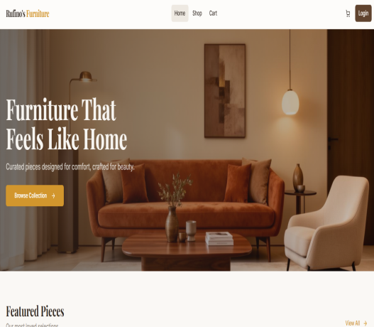


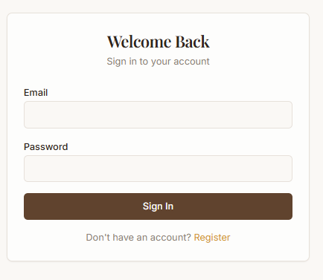
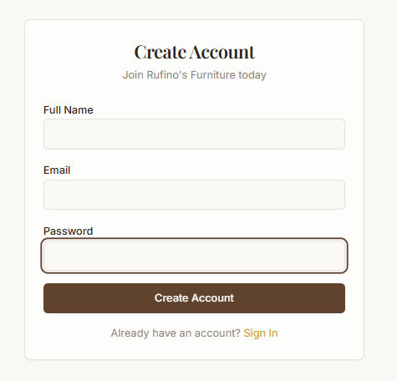


This is Login Form for admin where he/she can input their email and password.
This is Register Form for customer where they can input their full name, email and password.

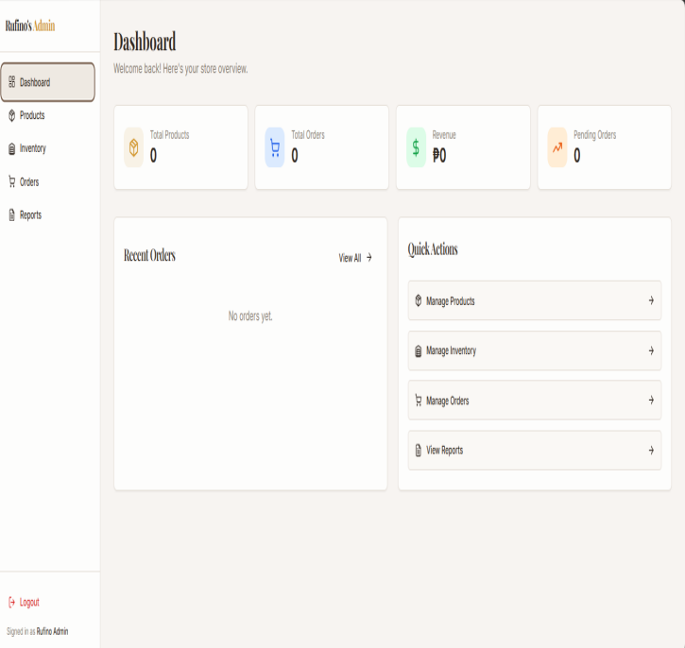

This Is the interface where admin manage product, inventory,order and view reports.


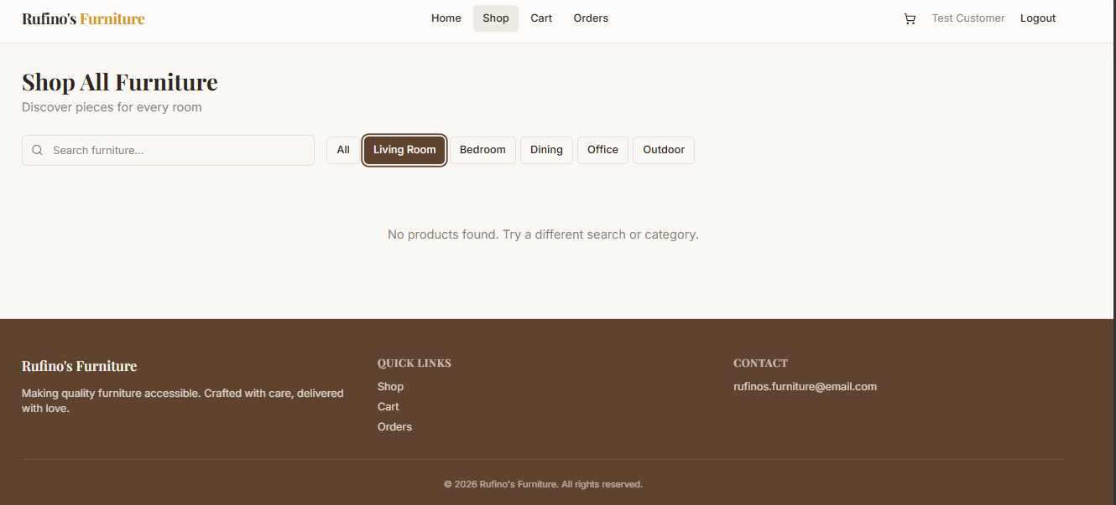

This Is the interface where customer can shop, add to cart and view order.

- Sample Input/Output


SAMPLE INPUT IMAGE

The image above is a sample input form of the system where the admin can add product. It display product name, description, price, stock, category, size, color and upload images.
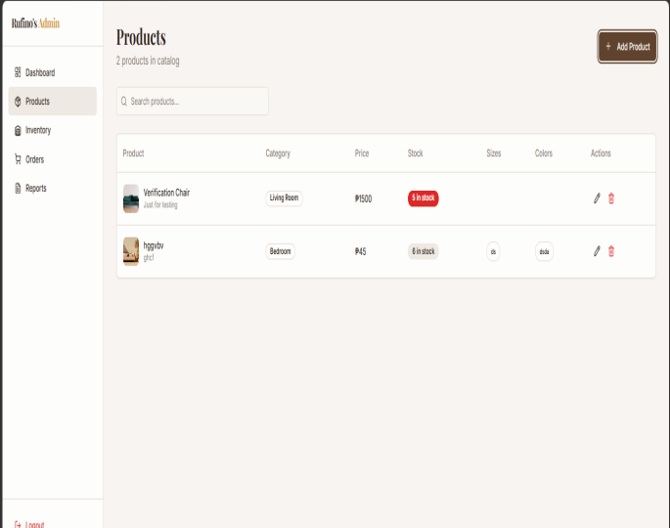
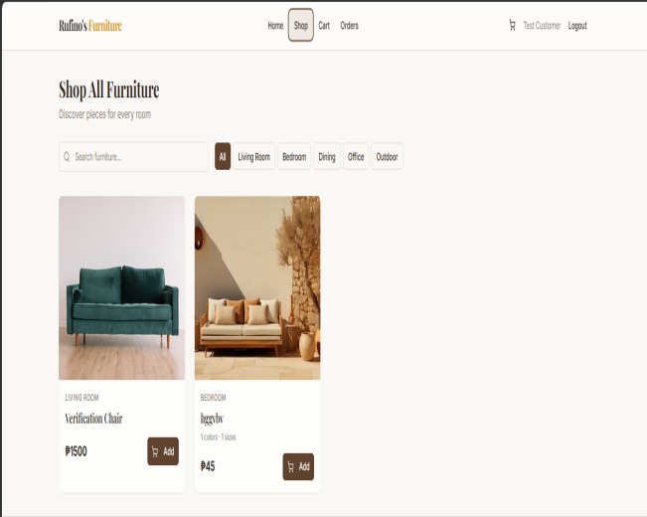

SAMPLE OUTPUT IMAGE

The image above is a sample output where after the admin added a product it will automatically viewed in customer dashboard and in admin inventory.
- Photo Documentation
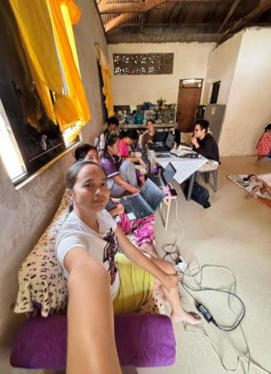
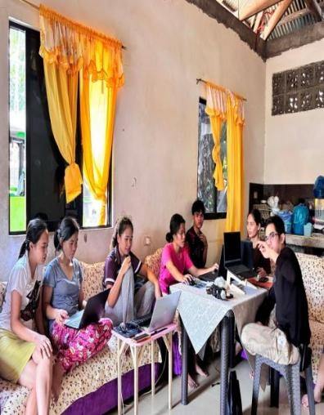

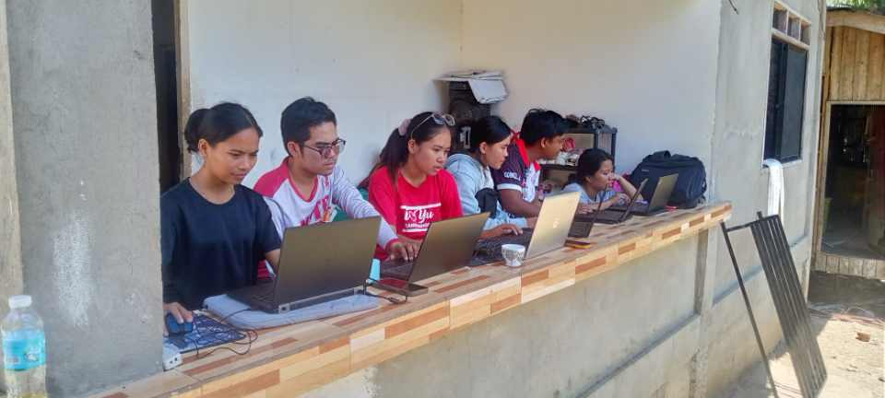

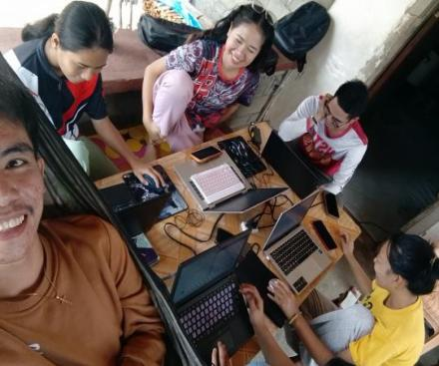

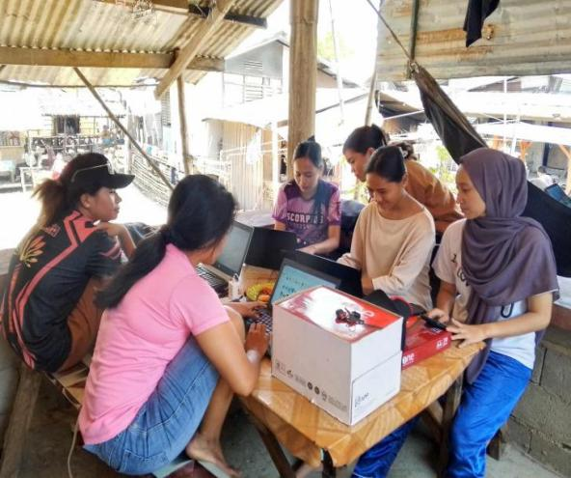
The document above show the journey of this study, highlighting the stages, and struggles on how activities completed during its development.
Curriculum Vitae

Personal Data
Full Name. : Sheilanoreen B. Derod
Gender. : Female
Date of Birth. : November 19, 2004
Place of Birth. : Lantian , Labangan Zamboanga Del Sur
Civil Status : Single
Religion. :Iglesia Ni Cristo
Address. :Sugbay Dos Pitogo Zamboanga Del Sur
Father's Name. : Alfredo T. Derod Jr.
Occupation. : Deceased
Present Address : Deceased
Mother's Name : Rebecca B. Derod
Occupation. : Housewife
Present Address. : Maniha Siay Zamboanga Sibugay
Educational Background
Education Graduated School Year
Primary : Maniha Elementary School 2016-2017
Secondary : San Jose National High School 2022-2023
Tertiary : Zamboanga Del Sur Provincial 2026-2027
Government College Dimataling Campus
Degree : Bachelor of Science in Information System
Curriculum Vitae

Personal Data
Full Name. : Hazel Joy D. Desapor
Gender. : Female
Date of Birth. : September 04, 2004
Place of Birth. : Lower Panikian, Pitogo, Zamboanga Del Sur
Civil Status : Single
Religion. : Roman Cathoolic
Address. : Lower Panikian Pitogo Zamboanga Del Sur
Father's Name. : Roland A. Desapor
Occupation. : Farmers
Present Address : Lower Panikian, Pitogo, Zamboanga Del Sur
Mother's Name : Dioscora D. Desapor
Occupation. : Housewife
Present Address. : Lower Panikian, Pitogo, Zamboanga Del Sur

Educational Background
Education Graduated. School. Year
Primary. : Lower Panikian Pitogo Elementary School 2016-2017
Secondary. : Panubigan National High School. 2021-2022
Tertiary. : Zamboanga Del Sur Provincial Government 2025-2026
College Dimataling Campus
Degree. : Bachelor of Science in Information System
Curriculum Vitae

Personal Data

Full Name. : John Lloyd E. Catacutan
Gender. : Male
Date of Birth. : February,22,2005
Place of Birth. : Buburay Dimataling Zamboanga Del Sur
Civil Status : Single
Religion. : Roman Catholic
Address. : Buburay Dimataling Zamboanga Del Sur
Father's Name. : Dominador A. Catacutan
Occupation. : Farmer's
Present Address : Buburay Dimataling Zamboanga Del Sur
Mother's Name : Gemma E. Catacutan
Occupation. : Housewife
Present Address. : Buburay Dimataling Zamboanga Del Sur

Educational Background
Education Graduated. School. Year
Primary. : Buburay Elementary School. 2016-2017
Secondary. : Laureano Salusod National High School. 2021-2022
Tertiary. : Zamboanga Del Sur Provincial Government 2025-2026
College Dimataling Campus

