CHAPTER I
PROBLEM AND SCOPE
Introduction
In our communities, retail stores are an integral component of the community by offering goods and services to consumers. Many of these retail businesses are family-owned or independently operated and have limited resources compared to the large retail chains operating in the neighborhood. While small retail stores provide a vital service, many retailers remain dependent upon performing operations manually for sales, inventory, employee list, payroll, and daily reporting. The most frequent ways to perform operations manually include using handwritten sales logs, manually counting inventory, and using basic calculators to determine totals; therefore, although these processes may appear to work at a small level, due to the increased number of daily transactions, there is room for inefficiencies and mistakes in the operations.
A manual record system is very prone to human error, and as well as being inefficient. Errors in manual recording can occur when the employee entering a transaction forgets or mis records a transaction, miscalculates the total of the record, or loses governmental records. Stock level counting manually means that stock level counting regularly produces incorrect recording of the level of stock, which will lead to an inaccurate business level of stock, resulting in a shortage of stock to customers or too much stock at the end of the day, both of which can cause a decline in customer satisfaction and result in company profit loss. Timely and reliable information is essential to the effective running of a company’s operations. According to Laudon & Traver (2020), companies that do not keep their information accurate and up to date are much less able to make timely and sound decisions. Based on this information, it is clear that automated systems would improve a company’s accuracy, efficiency, and breast performance by implementing automated systems.
The new system has additional capabilities specifically developed to assist retail stores in carrying out their day-to-day operations of the retail store. The system includes functions such as sales management, inventory management, human resources management, financial management (accounting), and report generation, which will help improve the speed and accuracy of transactions and the creation of records about the store and its business operations. The system will automatically calculate transaction totals; record all details regarding sales transactions; update inventory quantity after each sale; and record the payroll information of employees. By automating these processes, the store’s employees will have less work to do and will experience fewer mistakes when performing manual calculations for transactions and business records due to system automation. The inventory management component of the retail management system will allow the store’s owner and staff to track levels of inventory, manage product detail records, and be notified when products are running low on inventory. Accurate information regarding the level of inventory within a retail establishment is critical to the ability of retailers to operate their business efficiently, as retailers make critical business decisions based on very accurate information (Stair & Reynolds, 2020).
The system is user-friendly due to its clear design; therefore, users need very little training to learn how to use it. The simplicity of the software means that employees will be able to use it quickly, while achieving optimum system productivity. A clear interface allows for increased user acceptance and utilization of the system in small organizations (Dennis et al., 2021).
This research presents the design and evaluation of Vesmenda's Store Management System by analyzing the current problems that Vesmenda's store has faced through manual processes and describing the design of an offline store management system. Furthermore, an evaluation of the system based on usability, accuracy, and effectiveness has also been made. This study's results could illustrate how an offline store management system can greatly improve efficiency, accuracy, and reliability within any retail operation.
This research ultimately aims to improve the knowledge of how suitable information systems can help small businesses in areas of poor internet access. Vesmenda's Store Management System has been developed as an offline business tool for retail stores looking to adopt new technology while not needing an internet connection.
Project Context
Vesmenda’s Store is a retail business that tracks its daily sales, item inventories, employee records, and financial statements. At present, these activities are performed on paper or manually, and all transactions/records require separate procedures; therefore, they are subject to mistakes made by humans as well as discrepancies between what is actually in inventory compared to what it was supposed to be based solely upon the original receipt of the item into inventory. Reports can also be hard to generate manually.
It is anticipated that once an ERP-based management system has been created for Vesmenda's Store, it will be possible to keep all activities in one central place.
There will be three (3) user access levels: The Owner with report and view access to all transactions/records generated in the system; Staff/Admin (employee) will create and manage all of the operations of the store including but not limited to item inventory, employee files, payroll, accounting, and the creation of all reports; Cashiers will process customer purchases at a POS (point of sale) terminal.
Additionally, the new management system will function online as well as offline, therefore it will be able to store transactional information even without internet access.

Purpose and Description
The goal of this research is to make an Enterprise Resource Planning (ERP) Store Management System that will bring together all of Vesmenda's store business operations on one digital platform.
Sales Management, Inventory Management, Human Resources Management, Payroll Management, Financial Management, and Point of Sale (POS) Transaction Processing are all parts of the system. As a result of this database management approach, the data will be efficiently stored, and transactions will be processed quickly and easily. Automatically generating reports will also promote time efficiency through this process. Additionally, this database will be user-friendly for use only by authorized personnel and provide access to pertinent information to help them make informed decisions about the business operations.
Scope and Limitations
Vesmenda's Store Management System provides a unified ERP platform to support sales, inventory, human resources, payroll, accounting, and point of sale (POS) functions. As a result, there are three main user roles: Owner, Staff/Admin, and Cashier. The owner is able to view reports generated by the system, while the staff/admin will have the ability to add, edit, and delete records. The cashier will have access to the POS interface to accept payment from customers.
The system can be used both offline and online. When it is being used offline, all transactions/tasks completed are stored locally until such time as an internet connection becomes available to synchronize the information. In addition, Vesmenda's Store Management System allows for online payments to be processed through GCash or Maya when customers are at the checkout counter.
The Vesmenda's Store Management System was created solely for use within the Vesmenda's Store and is not designed to provide integration with any outside suppliers, banks, or government systems. If a business has different operational needs, then modifications to the originally designed platform would be necessary.
General Objectives
To establish an ERP store management application for Vesmenda's Store that increases performance, productivity, and process management in terms of transactions.
Specific Objectives
- To create a unified system that supports the integration of sales, inventory, human resources, payroll, and accounting.
- To design a POS system that allows the cashier to process transactions.
- To develop a reporting system that will provide the owner insight into sales and other related transactions through a web-based dashboard.
- To implement functionality for users to access the system from both online and offline
Significance of the Study
Store Owners. Able to closely track their sales, stock, and financial statements, which allows them to make decisions regarding their business that are quicker and more informed.
Admin / Staff. Able to handle employee records, manage inventory, payroll, and produce reports with far less chance of making a mistake.
Cashiers. Will able to process transactions more quickly using a POS system, resulting in improved service speed for their customers.
Customers. Will experience faster service at checkout and a greater selection of items to purchase because of improved inventory tracking.
Future Researchers. Will find this research valuable as they develop offline/online or hybrid ERP systems for small businesses.
Small Business Community. Can learn about how to use technology to increase overall operational efficiency, accuracy, and productivity in their business.

Definition of Term
Cashier. A user of the system who enters sales transactions, collects customer payments, issues receipts to customers, collects and records sales taxes, and uses the point of sale (POS) system.
Dashboard. An interface designed to view a summary of data, graphs, and reports to easily determine how well the business is performing.
Owner. A user who has access to all reports of the business, financial data, information about the company’s inventory, and has functions to administer the system.
Admin/Staff. A user of the system that are responsible for carrying out operations at the store; for example, managing the store’s products, inventory, employees, and reports

CHAPTER II
REVIEW OF RELATED LITERATURE

The following materials demonstrate different types of literature and research that are pertinent to Vesmenda's Store's method of supplying an Enterprise Resource Planning (ERP) based system. The literature and research reviewed demonstrate the benefits that result from the integration of all the various facets of a business into one integrated system that improves efficiency, accuracy, and supports better decision-making. Numerous studies have shown that an ERP-based system has provided retail businesses with a positive impact with regard to the management of sales, inventories, employee files, payroll, and accounting.
The literature and research included within this chapter consist of both foreign and local sources of literature and demonstrate the use of ERP and store management systems within the retail business. The studies that are included in this chapter serve as a basis for the development and design of Vesmenda's Store's system. The included studies identify best practices to be utilized in the development of Vesmenda's Store, as well as to provide examples used to create the features and functionality of the proposed system.
Foreign Literature
“The Role of Enterprise Resource Planning Systems in Enhancing Retail Business Performance, International Journal of Business and Management”
Explains that in an effort to improve their productivity and operational efficiencies, a large number of international retailers have introduced ERP based systems into their operations. These ERP systems allow businesses to manage their various sales, inventory, employee records and financial operations on one common platform. ERP systems also provide organizations with increased accuracy of data, support for real-time reporting and overall general enhancement of an organization’s business operations (Hassan & Rahman, 2023).
“Walmart Annual Report 2023, Walmart Inc”.
It highlights that global retailers including Walmart are utilizing ERP software to provide support for their global supply chain and store management operations. Walmart's ERP system enables them to monitor their inventory and sales data in real-time, which allows them to reduce stock shortages and improve customer service performance. Additionally, in their reports on supply chain and technology management, Walmart states that they continue to invest in information systems in an effort to maintain not only operational efficiency, but also the accuracy of their data within their global retail operations (Walmart Inc., 2023)
“ERP Systems in E-commerce and Logistics Management, Journal of Information Systems and Technology”
It reports that Amazon also employs ERP and POS software to integrate their online retail and warehouse operations by facilitating the efficient processing of orders, tracking of inventory and financial record keeping on a variety of manufacturing and distribution locations. ERP systems are able to support both online and offline transactions while maintaining the accuracy, consistency and continuity of the data associated with the various types of business (Patel & Shah, 2024).
In addition, ERP systems contribute significantly to increasing the overall competitiveness of a business in the retail industry. By automating many business functions, the potential for human error is reduced while increasing the overall speed with which a business operates.
Local Literature
“Digital Transformation of the Philippine Retail Industry”
Explains that retail businesses in the Philippines use an Enterprise Resource Planning (ERP) and Point Of Sale (POS) system as the basis of their day-to-day operations since this helps them run more efficiently, provide better customer service, and save time, effort, and money by combining sales, inventory management, employee records, and financial reporting into one central system. The ability to integrate digital retail technology has become necessary for all firms operating in today's competitive, continually changing marketplace to stay ahead of their competitors (Department of Trade and Industry (DTI), 2021).
“SM Annual Report 2022, SM Investments Corporation”
Highlights that SM Retail is an example of one of the largest retailers in the Philippines that is leveraging ERP technology to increase its ability to monitor actual sales performance, inventory on hand, and workforce information across its numerous retail locations in real-time, which helps improve the accuracy of reporting and allows for more reliable data-driven decision-making processes. Implementing enterprise-wide digital systems has provided improved visibility into operations and enhanced financial visibility throughout the enterprise (SM Investments Corporation, 2022).
“Puregold Annual Report 2023, Puregold Proce Club, In”.
It discusses that Puregold Price Club, Inc. has implemented point of sale (POS) and inventory control systems that Puregold Price Club has implemented in its stores all over the Philippines provide an effective means for tracking inventory levels in real time and automatically capturing the relevant information about every sale transaction. Because many of the functions performed by the POS and inventory control systems are automated, they help reduce errors from humans and improve the efficiency of services provided to customers (Puregold Price Club, 2023).
“Robinsons Retail Annual Report 2023, Robinsons Retail Holdings, Inc.”
Explains that Robinsons Retail Holdings, Inc., which operates as part of the Robinsons Retail Holdings, Inc. group of companies, has also implemented ERP applications to distribute financial information and assess financial transactions that occur during the purchasing and selling of products, as well as help to evaluate employees' performance. The implementation of these ERP applications has increased the visibility of the retailer and enabled it to create accurate financial records, and has also facilitated communication across different departments in the supermarket (Robinsons Retail Holdings, Inc. 2023).
“Philippine Retail Industry Report 2022, Philippine Retailers Association”
Mercury Drug Corporation has also deployed a POS and inventory management system for the tracking of daily sales and stock, as well, and they automate sales reporting using these systems. The integration of the POS and inventory management systems will help to reduce the incidences of out-of-stock inventory, provide improved tracking of inventory, and ensure compliance with both corporate policy and all laws and regulations that govern proper conduct as it pertains to product sales and distribution (Philippine Retailers Association, 2022).
“Philippine Seven Corporation Annual Report 2023, Philippine Seven Corporation”
Similarly, as part of its operations at all 7-Eleven stores throughout the Philippines, 7-Eleven Philippines uses a centralized point of sale (POS) and inventory-management system. The use of a centralized system allows for real-time sales monitoring, automatic stock replenishment, quicker transactions, and consistent operational standards across all 7-Eleven stores located in the Philippines (Philippine Seven Corporation, 2023).
“The Effectiveness of ERP and POS Systems in Philippine Retail Businesses,” “Philippine Journal of Business and Management”.
Research completed locally between 2020 – present has shown that ERP/POS systems drastically improve the operation of retail businesses in the Philippines through the integration of critical business processes into a combined system and thus provide retail businesses with real time access to data, decrease manual errors, improve accuracy of reporting, and allow for superior managerial decision-making by retail businesses (Philippine Journal of Business and Management, 2022).

CHAPTER III
DESIGN AND METHODOLOGY
Requirement Analysis
In the development of the project, a model is being used, wherein the proponents selected the 4D Model. It represents the chronological progression of a project, including the design phase, development phase, testing phase, and deployment phase visually and interactively, allowing for better project management and communication among the researchers. The phases of this model will be the key purpose that will provide guidelines and steps for the development of Vesmenda’s Store Management System.
DEPLOY
DEVELOP
DESIGN
DEFINE

Figure 1.0 4D Methodology
Define
In the define phase, it identifies the current way in which the Vesmenda’s Store operates and faces its problems. Right now, most tasks like recording sales, tracking inventory, managing employees, and handling money are done manually, which can be slow and prone to mistakes. This phase helps us figure out exactly what the new system needs to do to make everything easier and more organized

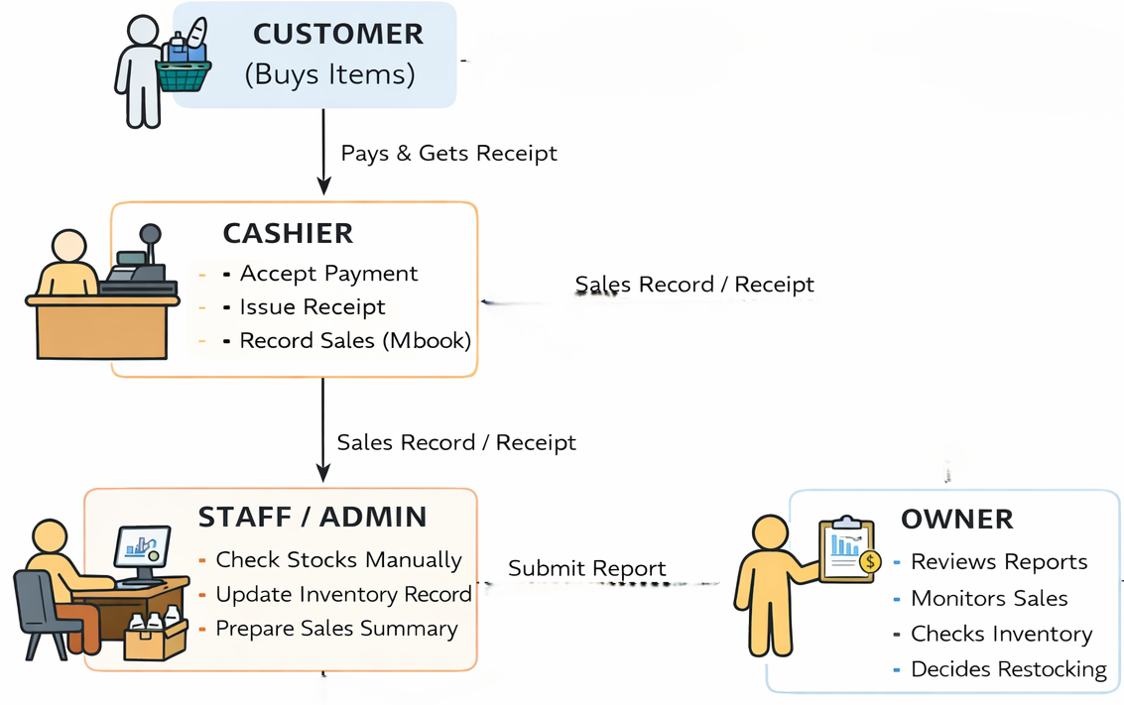
Figure 2.0 Current Technical Situation
OWNER
In this figure that shown above it shows the current technical situation of Vesmenda’s Store from manual record keeping of sales and inventory, manual tracking of stocks, manual writing of receipts, count payroll manually, and reviews all reports and transaction manually. This current situation may be caused of mistakes, out of stock of an item, and very time consuming.
Design
In design phase, we plan how Vesmenda’s Store Management System will work to make daily operations easier and more organized. This involves designing diagrams and flow how sales, inventory, hr., finance, and POS module work together. We also define what each users such as owner or admin, staff, and cashier, can do to make sure the systems works smoothly both online and offline, so daily operations are efficient.
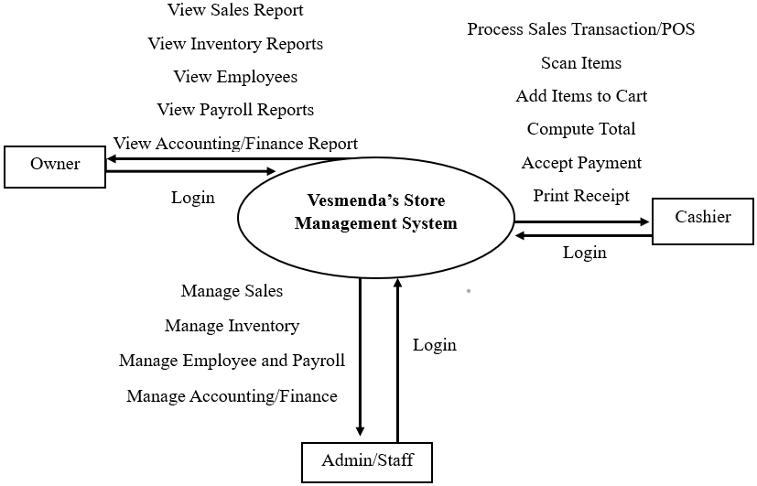
Figure 3.0 Context Diagram
The context diagram above illustrates how Vesmenda’s Store Management System bridges the gaps between complex business operations and daily user activities through a centralized ERP framework. It demonstrates that by integrating sales, inventory, HR, accounting or finance, and POS into a single online-offline capable platform, the system empowers the Owner with high-level oversight of all reports and transactions, enables Admin/Staff to maintain operation management of the system, and streamlines the Cashier’s workflow for efficient real-time POS transactions.

INPUT
Knowledge Management
- Identifications of the store operations such as sales, inventory, payroll, and finance.
- System design and database structure knowledge.
- User requirements and workflow analysis.
Software Requirements
- Programming Languages
- Database
- Development Tools
- Operating System

OUTPUT
Vesmenda’s Store Management System

Figure 4.0 Conceptual Framework- IPO
The conceptual framework shown above shows the IPO based on the development of our system, entitled Vesmenda’s Store Management System. This framework begins with an understanding of store operations and database design, powered by reliable tools like different programming languages, databases, and development tools. It undergoes a careful cycle of planning, module design, and rigorous testing, especially focusing on offline data synchronization to ensure reliability in real-world conditions. And the final result, which is our final output, is an integrated management system to serve the specific operations of Vesmenda’s Store.

Vesmenda’s Store Management System

T
Has an Account?
Login

F
Register Account

Enter User Info

Validate Registration
Valid Info?

T F
View Financial Summary
View Reports
View Transactions
Owner/Admin
Check User Role
Show Error

Staff
Register Again
Cashier
Manage Sales
Process Sales with POS
Manage Inventory
Accept Payment
Manage HR
Print Receipt
Manage Finance
Generate Reports

Logout

Figure 5.0 Activity Diagram

The activity diagram of Vesmenda’s Store Management System presents the overall workflow of the system, beginning from user access up to logout. It illustrates how users interact with the system and how different processes are connected through decision points and role assignments. This diagram helps visualize how the system operates in an organized and structured manner.
The process starts when a user logs into the system. If the user does not yet have an account, they are redirected to the registration module where they must provide the required information. The system checks whether the entered details are complete and valid. If errors are found, the user is prompted to correct them before proceeding. This validation step ensures that only properly registered and authenticated users can access the system, maintaining data accuracy and security.
After successful login, the system identifies the user’s role and grants access to specific features based on their responsibilities. The Owner or Admin can monitor transactions, reports, and financial summaries to oversee business performance. The Staff/Admin manages daily operations such as sales, inventory, human resources, finance, and report generation. Meanwhile, the Cashier focuses on processing sales transactions, accepting payments, and printing receipts through the Point of Sale (POS) module.
Finally, once users complete their tasks, they log out of the system. The session is terminated, and the system returns to the login page to ensure secure access. Overall, the activity diagram demonstrates a clear and well-structured design that integrates authentication, validation, and role-based access control to support efficient and secure store management operations.

Login
View All Reports and Transactions
Manage Sales




Add Info.
Cashier
Manage POS
Delete
Edit Info.
Manage Inventory
Manage Finance
Logout
Process Customers Payment
Generate Reports
Manage Employees Payroll
Admin/Staff
Owner

Figure 6.0 Use Case Diagram
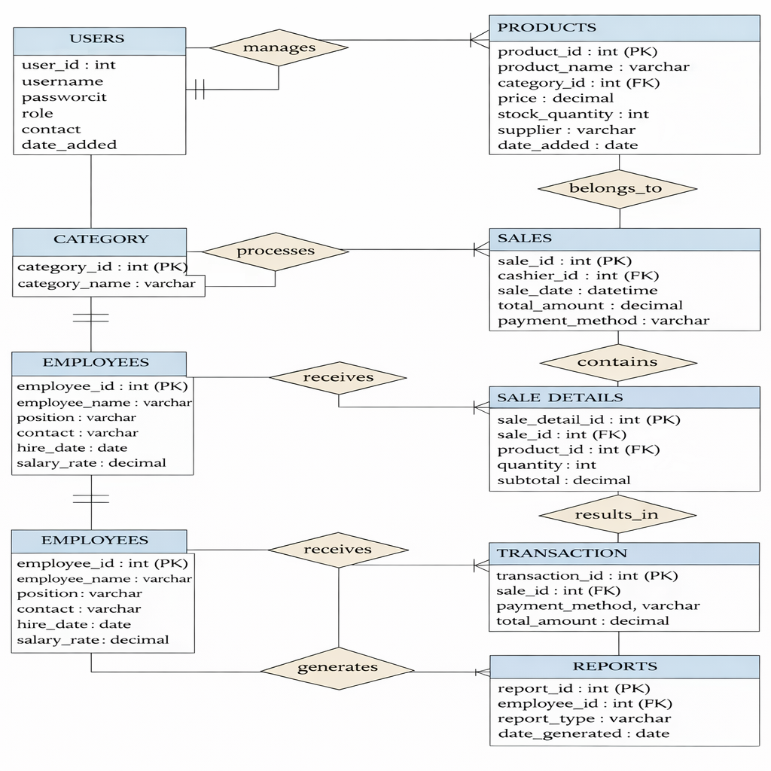
The use case diagram of Vesmenda’s Store Management System illustrates how the primary users interact with the system according to their assigned responsibilities. The Owner can log in, monitor overall operations by securely accessing or reviewing all reports and transactions, while the Admin/Staff handle daily operations such as managing sales, inventory, finance, payroll, generating reports, and also, they can add, edit, and delete. The Cashier focuses on point-of-sale activities, managing transactions, and processing customer payments.
Figure 7.0 Entity Relationship Diagram
The entity relationship diagram that being shown above it shows the entity relationship of Vesmenda’s Store Management System to the conceptual design of the database by defining its main entities, attributes, and relationships. It includes users, products, categories, sales, sale details, transactions, employees, and reports, which together support the system’s core operations. The diagram demonstrates how data flows across modules such as inventory control, point-of-sale processing, payroll management, and report generation. Through proper relationship mapping and normalization.
Develop
In this phase, which is the third phase under the 4D methodology, is called the development phase, because it contains the information of the system or the web application structures when they will be developed. It covers all the information that we find on the system that we created, such as its menus, buttons, etc., which can be used by the users as peer consideration of the functions that solve the found problems.
Homepage

Login

Figure 8.0 Structural Diagram for Admin
Logout
Delete
Edit
Add
Process Payroll
Delete
Edit
Add
Employees Payroll
Delete
Edit
Add
Monitor Stocks
Employees List
Accounting
HR
Delete
Edit
Add
Inventory
Delete
Edit
Add
Sales
Dashboard

Generate Reports
The structural diagram for Admin/Staff serves as the system's organizational map, transforming the complex business data into an organized and approachable workspace. Every interaction begins with the homage, leading to a secure login that opens the door to the system primary pillars, the dashboard, sales, inventory, HR, accounting or finance. This layout is designed with the user's daily workflow in mind, allowing staff to navigate clearly through specific sub-menus such as managing employees list and payroll or monitoring stocks using add, edit, and delete functions. Also, this flow ensures that every small update made by admin/staff is naturally consolidated into generate reports to provide the owner with reliable and up-to-date reports and transactions of the stores.
Login
Dashboard
Homepage

View HR Reports
Logout
View Inventory Reports

View Payroll Reports
View Sales Reports
Stock Status
View Finance Reports
Daily Sales Summary
Employee Payroll
Transactions Reports

Figure 9.0 Structural Diagram for Owner
This structural diagram for the owner is designed as a strategic control center that emphasizes oversight rather than routine data entry. After securely logging in, the owner can easily view clear and organized reports on sales, inventory status, payroll, and accounting/finance. Unlike the admin/staff interface, which focuses on adding, editing, deleting, and managing, the owner's view is simplified to provide transparency to the store. This approach allows the owner to understand the overall performance of the stores quickly.
Update Inventory
Sales/ Transaction Recording
Logout
Print Receipt
Receipt Module
Payment Process
Product Handling
POS
Login
Homepage

Scan Item
Cash

Add Item to Cart
Gcash
Display Receipt
Search Item
Save
Figure 10.0 Structural Diagram for Cashier
This is the workflow of the Point-of-Sale (POS) system, which consists of one Home Page, a Login Page, and a POS Module. When cashiers access the POS Module, they can process products by scanning, searching, or adding products to their cart. When cashiers have finished processing products, they will process the payment either with cash or GCash, and the system will create a receipt to be presented back to the cashier. The sale is recorded, and inventory will be automatically updated; all transactional data will be saved, and the user will log out.



Computer
Owner




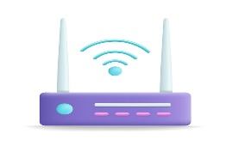

Database and Cloud

Web Server
Internet
Router
Cashier
Admin/Staff
Computer


Figure 11.0 System Architecture Diagram
The system architecture that shown above shows a setup built to keep small businesses running smoothly whether the internet is down or no electricity. The owner and admin/staff may share a computer to make the most of the resources, while cashier has its own dedicated computer to keep the store operation fast. A simple router ties everything together, so even when the internet is drops and no electricity all the transactions still in sync across devices and when its internet and the electricity came back, all the local data automatically updates to a web server and cloud database, so important information is never lost.

CHAPTER IV
DEVELOPMENT, TESTING, AND IMPLEMENTATION
Description and Prototype
MONTHS | December |  |  |  | January |  |  |  | February |  |  |  |  | March |  |  |  |  | April
WEEKS | 1 2 3 4 |  |  |  | 1 2 3 4 |  |  |  | 1 2 3 4 |  |  |  |  | 1 2 3 4 |  |  |  |  | 1 2 3 4
Activities
DEFINE
Planning
Data Gathering
Requirements Analysis
DESIGN
GUI
DEVELOPMENT
Coding
Testing
DEPLOY
Implementation
The implementation of Vesmenda’s Store Management System was carried out at Poblacion, Pitogo, Zamboanga del Sur, to address the problems experienced with manual transactions. During this stage, the system was introduced and used in the actual store operations, making it easier to manage transactions, inventory, and records in a faster and more organized way. It also helped resolve common issues in handling registration and enrollment processes. With proper testing and guidance, users were able to use the system smoothly, which improved the overall efficiency of the store.
Table 3.0 Gantt Chart
The table above shows the Gantt Chart that presents the timeline and activities carried out by the proponents in developing the study. During the first three weeks of December, planning was conducted to prepare the overall direction of the project. This was followed by data gathering from the last week of December to the early part of January, where necessary information was collected. The requirements analysis was then performed from the middle of January to early February to identify the system’s needed features. After that, the system design, particularly the GUI, was developed during the middle to latter part of February to ensure a user-friendly interface. Coding was carried out from late February to the latter part of March, where the actual system was built. Testing was conducted during the last weeks of March until early April to check for errors and ensure proper functionality. Lastly, implementation was done in the middle weeks of April, marking the completion and readiness of the system for actual use.
Technical Background
Vesmenda’s Store Management System was developed to improve the way store operations are handled by using modern technology. The system is designed to replace manual processes with a computerized solution that makes tasks faster, more accurate, and easier to manage. It focuses on key functions such as recording sales, managing inventory, and organizing customer and product information.
The system is built using user-friendly tools and technologies that allow both the developers and users to easily interact with it. It includes a graphical user interface (GUI) that helps users navigate the system without difficulty. Data is stored in a database to ensure that information is secure, organized, and easy to retrieve when needed.
Using this system, store operations become more efficient and less prone to human error. It also allows real-time monitoring of sales and inventory, helping the store owner make better decisions. Overall, the technical foundation of the system supports a more reliable, accurate, and effective way of managing the store.
Development
The development of Vesmenda’s Store Management System followed a step-by-step process to ensure that the system was properly built and functional. It started with careful planning, where the proponents identified the goals and features needed for the system. This was followed by data gathering and requirements analysis to better understand the store’s operations and specific needs.
After gathering all necessary information, the team moved on to designing the system, including the layout of the graphical user interface (GUI) to make it user-friendly. Once the design was finalized, the coding phase began, where the actual system was created based on the planned features and design.
The system then underwent testing to check for errors, ensure accuracy, and confirm that all functions were working correctly. Any issues found were fixed and improved during this stage. Finally, the system was implemented in the store, allowing it to be used in real operations. This development process ensured that the system was reliable, efficient, and suitable for the store’s needs.
Program Specification
Hardware Specification
Laptop – Core i5 Processor
Storage – 477GB
Software Specification
Operating System – Windows 10 Pro
Web Browser – Google Chrome / Microsoft Edge
Database – PostgreSQL
Development Tool – Visual Studio Code /Render.com
Module for System User Registration
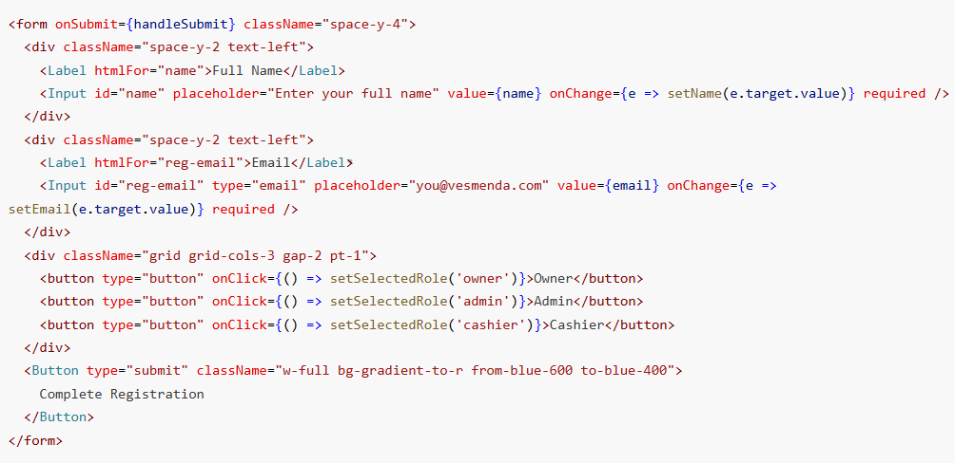
(frontend user interface)
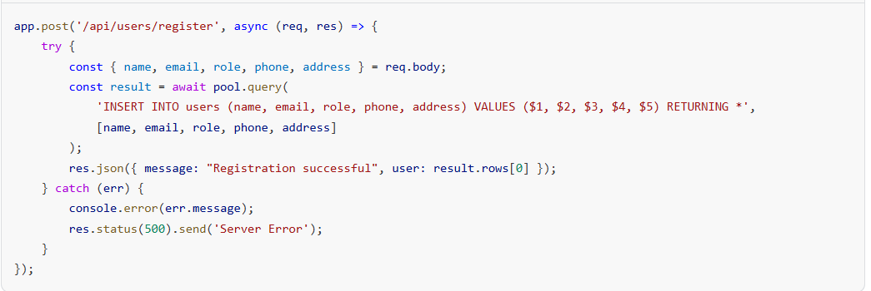
(frontend data submission)
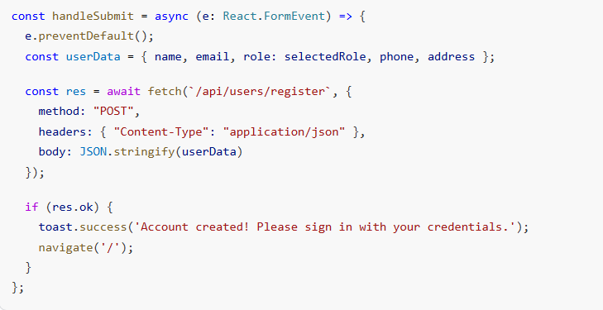
(backend)
The code above presents the full-stack syntax utilized in the User Registration module. On the client side, the React elements <Input id="name" value={name} onChange={...}/> allow the user to input their complete details, tracked by React's local state. When the administrator finalizes the role and submits the form, the handleSubmit function packages the variables into a JSON object and executes an asynchronous fetch() request targeted at the local Node server. The Express route app.post('/api/users/register', ...) intercepts the payload and inserts the new credential into the users PostgreSQL table securely before returning a success resolution.
Module for Point of Sale (POS) Transactions
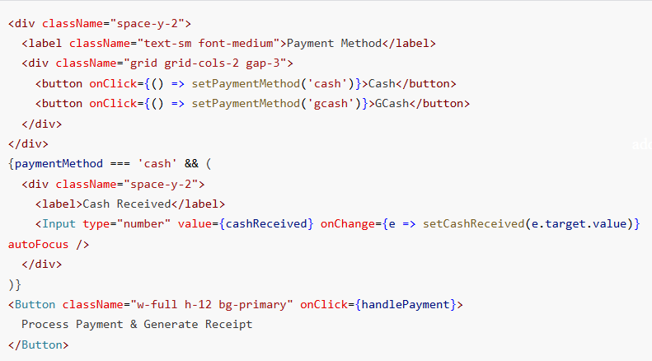
(frontend interface)
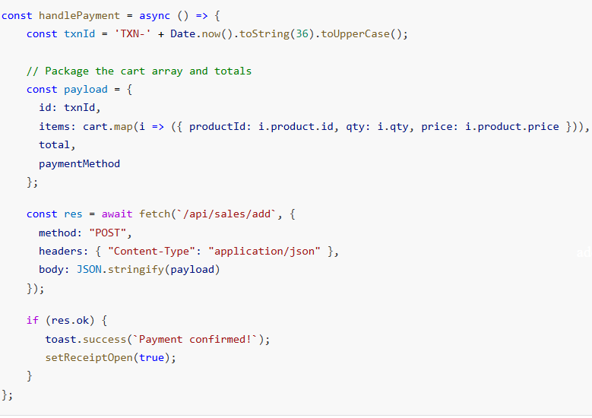
(frontend data submission)
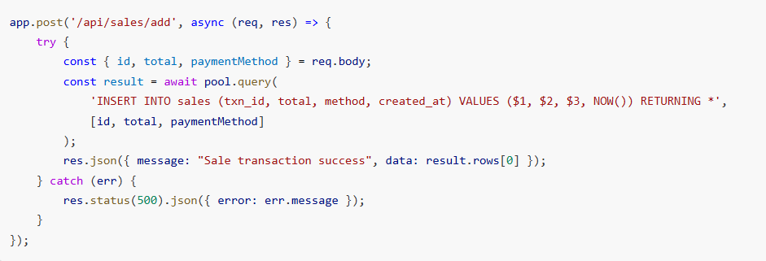
(backend)

The code above handles the core Point of Sale (POS) operations by processing consumer interactions. In the frontend, the cart arrays are dynamically updated when items are scanned using the system barcode scanner. During checkout, the cashier defines the paymentMethod via conditional UI rendering. The handlePayment() function generates a randomized tracker (txnId) and compiles the purchased matrices before invoking a backend fetch payload. Upon receiving the payload, the backend Express /api/sales/add route logs the financial transaction directly into the sales table, which subsequently authorizes the UI to generate a printable thermal receipt.
Module for Inventory Management
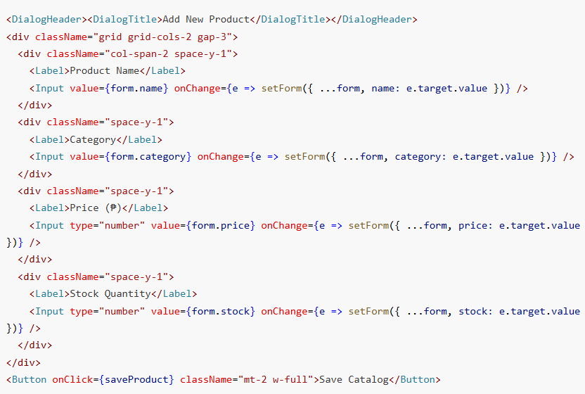
(frontend interface)
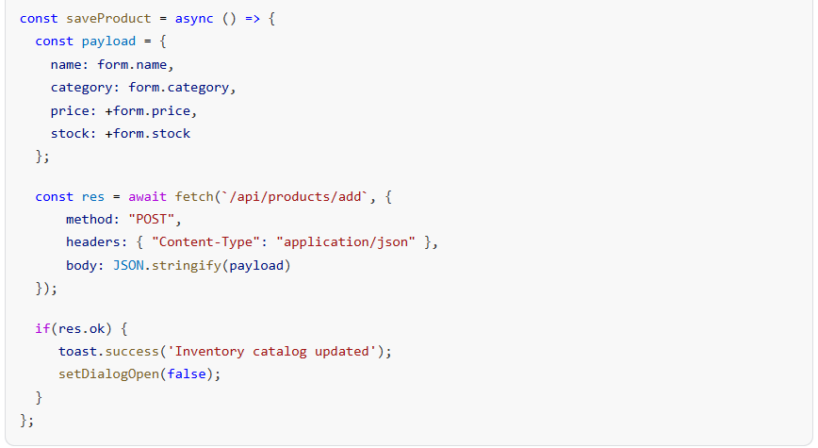
(frontend data submission)
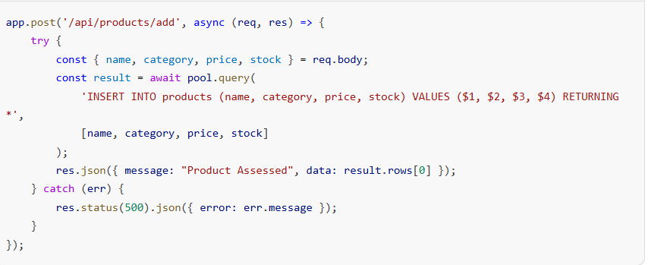
(backend)
This module ensures real-time stock orchestration and catalogue tracking. The user interface utilizes the AdminInventory.tsx component to capture explicit commodity fields such as pricing and volumetric stock quantity via explicit input blocks <Input value={form.category} ... />. The saveProduct executor parses and standardizes string inputs into actual numerical types (e.g., +form.price) before transmitting the POST signal to the Node server. Subsequently, the Express router processes the logic across the /api/products/add pipeline, injecting the data to maintain inventory symmetry against POS stock deductions.
Module to Manage Employee Information (HR Payroll)
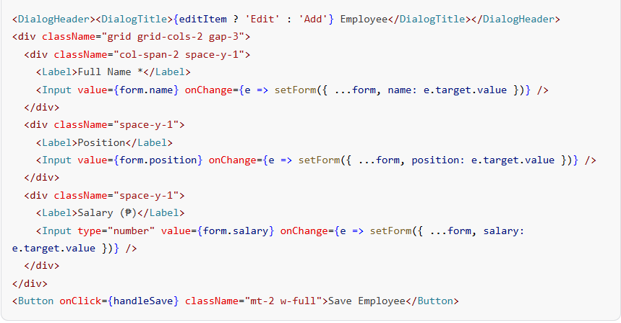
(frontend interface)
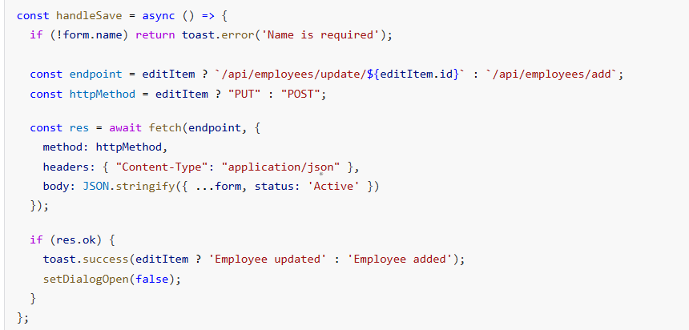
(frontend data submission)
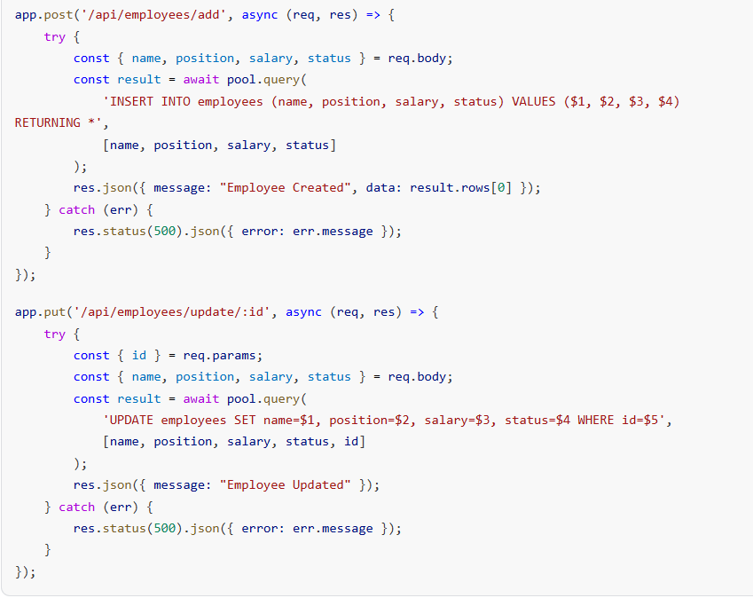
(backend)
The code functions as the logic layer directing staff manipulation within the system's Human Resources ecosystem. Using conditional algorithms (const httpMethod = editItem ? "PUT" : "POST";), the frontend intelligence effectively isolates requests for new hires vs administrative corrections on existing records. By distributing data traffic between /api/employees/add and /api/employees/update/:id endpoints, the database logic protects records against overwriting whilst logging accurate staff positions and system payroll hierarchies.
Module for Finance
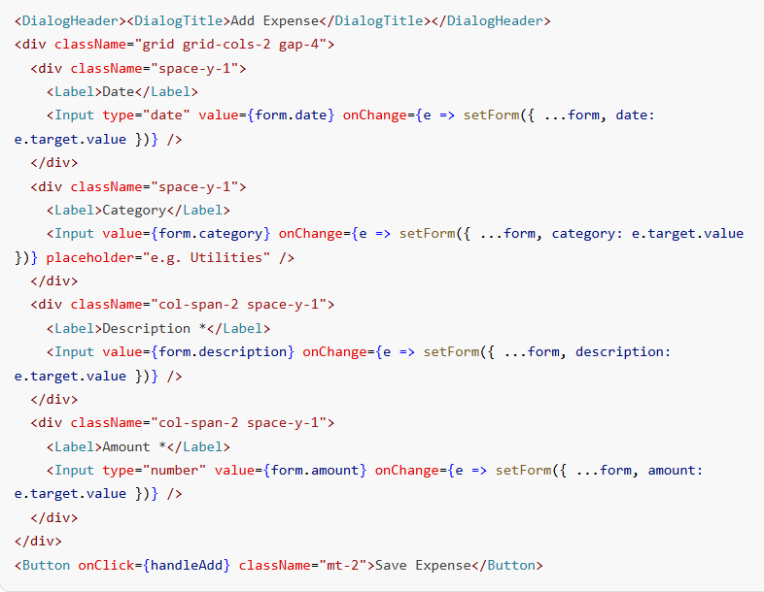
(frontend interface)
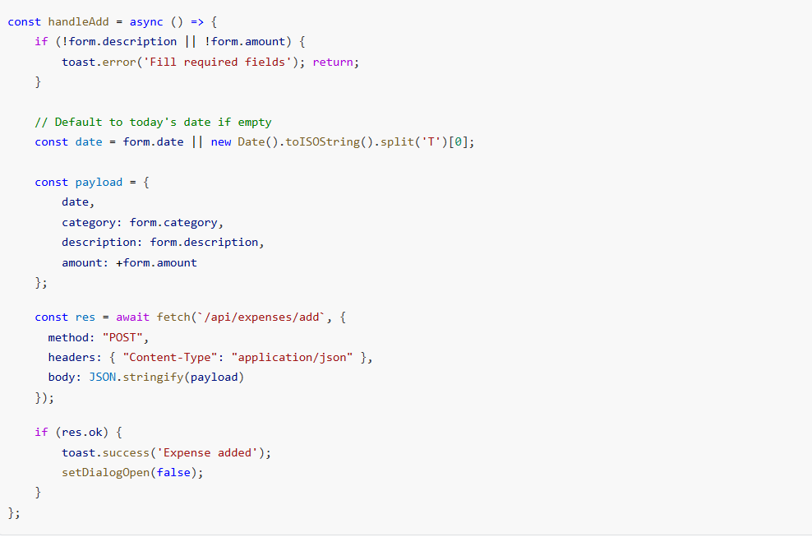
(frontend data submission)
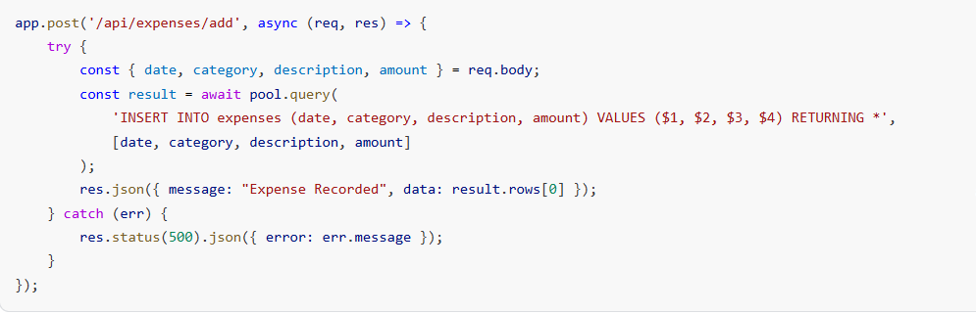
(backend)
The Finance module tracks cash outflows directly against generated revenue streams. Through the UI elements in AdminFinance.tsx, administrators define the category, amount, and standard dates for expenditures. The handleAdd function dynamically assesses if the explicit date parameter was bypassed and autonomously defaults to standard ISO current dates new Date().toISOString(). Once dispatched, the fetch payload reaches the Express backend /api/expenses/add, executing an insertion query into the expenses PostgreSQL table. This database structure empowers the Dashboard to subsequently query SUM(amount) when mapping dynamic Net Profit indicators.
Load Testing
Load testing determines the capacity and performance of Vesmenda’s Store Management System under simultaneous user load. The system is used by the owner, staff/admin, and cashier, especially during peak business hours, when multiple sales transactions and inventory updates occur simultaneously. During testing, it was observed that processing a sales transaction through the POS system takes approximately 1–3 seconds under normal conditions, whether operating offline or with stable internet connectivity. This includes product selection, total calculation, and receipt generation. The system shows fast and reliable performance, allowing users to complete transactions efficiently without delays.
As the system operates with improved internet speed or optimized hardware, data transfer between the system interface and the database becomes faster, resulting in a smoother and more responsive user experience. The system is also capable of handling increasing amounts of data while keeping records organized and accessible. However, during peak usage when multiple users access the system simultaneously or when handling very large volumes of data, a slight delay may be experienced in loading reports or retrieving transaction records. Despite this, the system remains stable and continues to function effectively, ensuring continuous store operations.
Stress Testing
Stress testing evaluates the performance and stability of Vesmenda’s Store Management System under extreme conditions, such as a high volume of transactions and multiple users accessing the system simultaneously beyond normal operating capacity. This is important during peak store hours or promotional events where system demand is significantly increased. During testing, the system was subjected to a large number of simultaneous sales transactions, inventory updates, and report generation requests. It was observed that the system continues to function and process transactions, although response time may slightly increase when the workload exceeds the normal limit. Despite the heavy load, essential features such as the POS, inventory tracking, and report generation remain operational.
The system demonstrates the ability to handle stress conditions by maintaining data accuracy and preventing data loss during high-demand scenarios. This ensures that transactions are still recorded properly even under pressure. However, under extreme stress conditions, minor delays may occur in loading dashboards and generating reports. Despite this, the system remains stable and recovers efficiently once the workload returns to normal levels, ensuring continuous and reliable store operations.
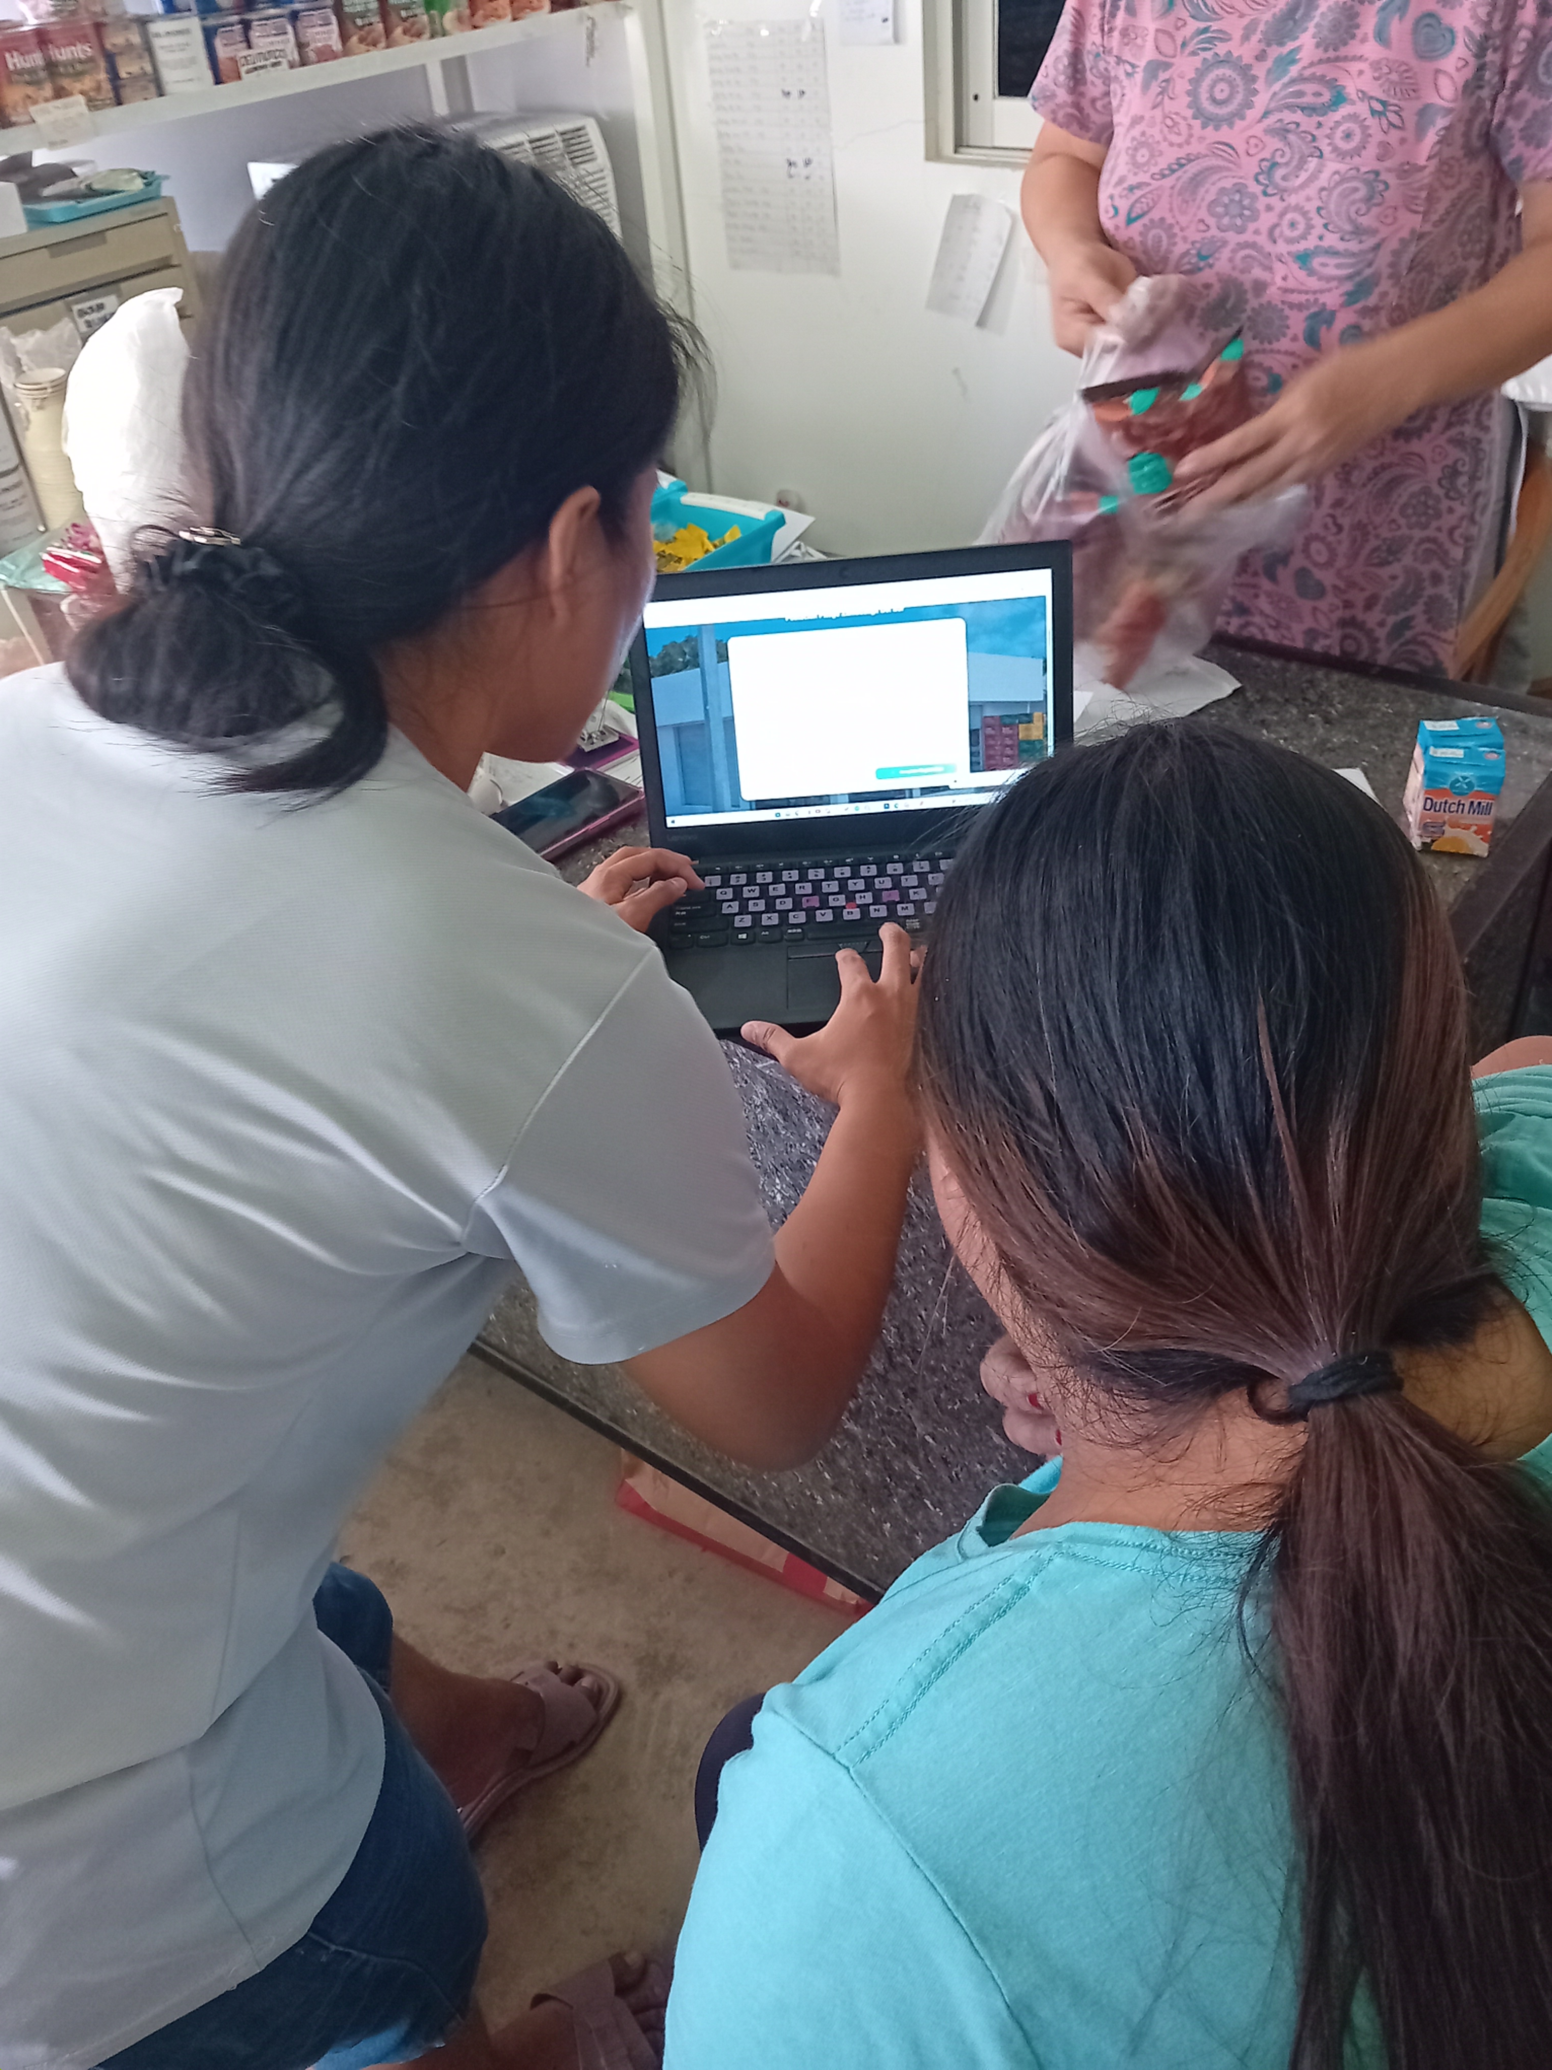
Beta Testing
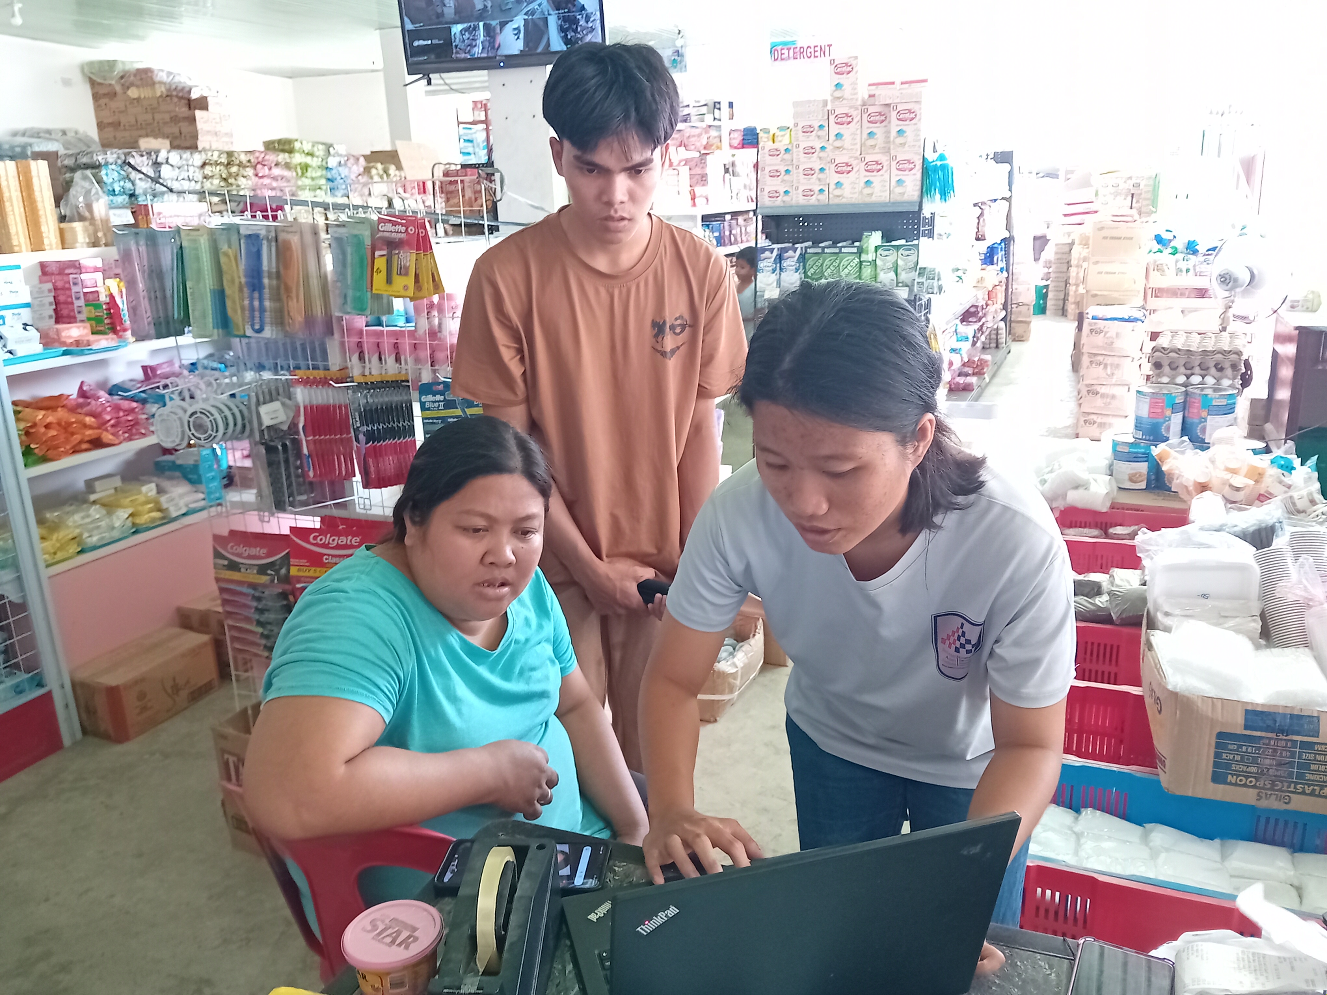
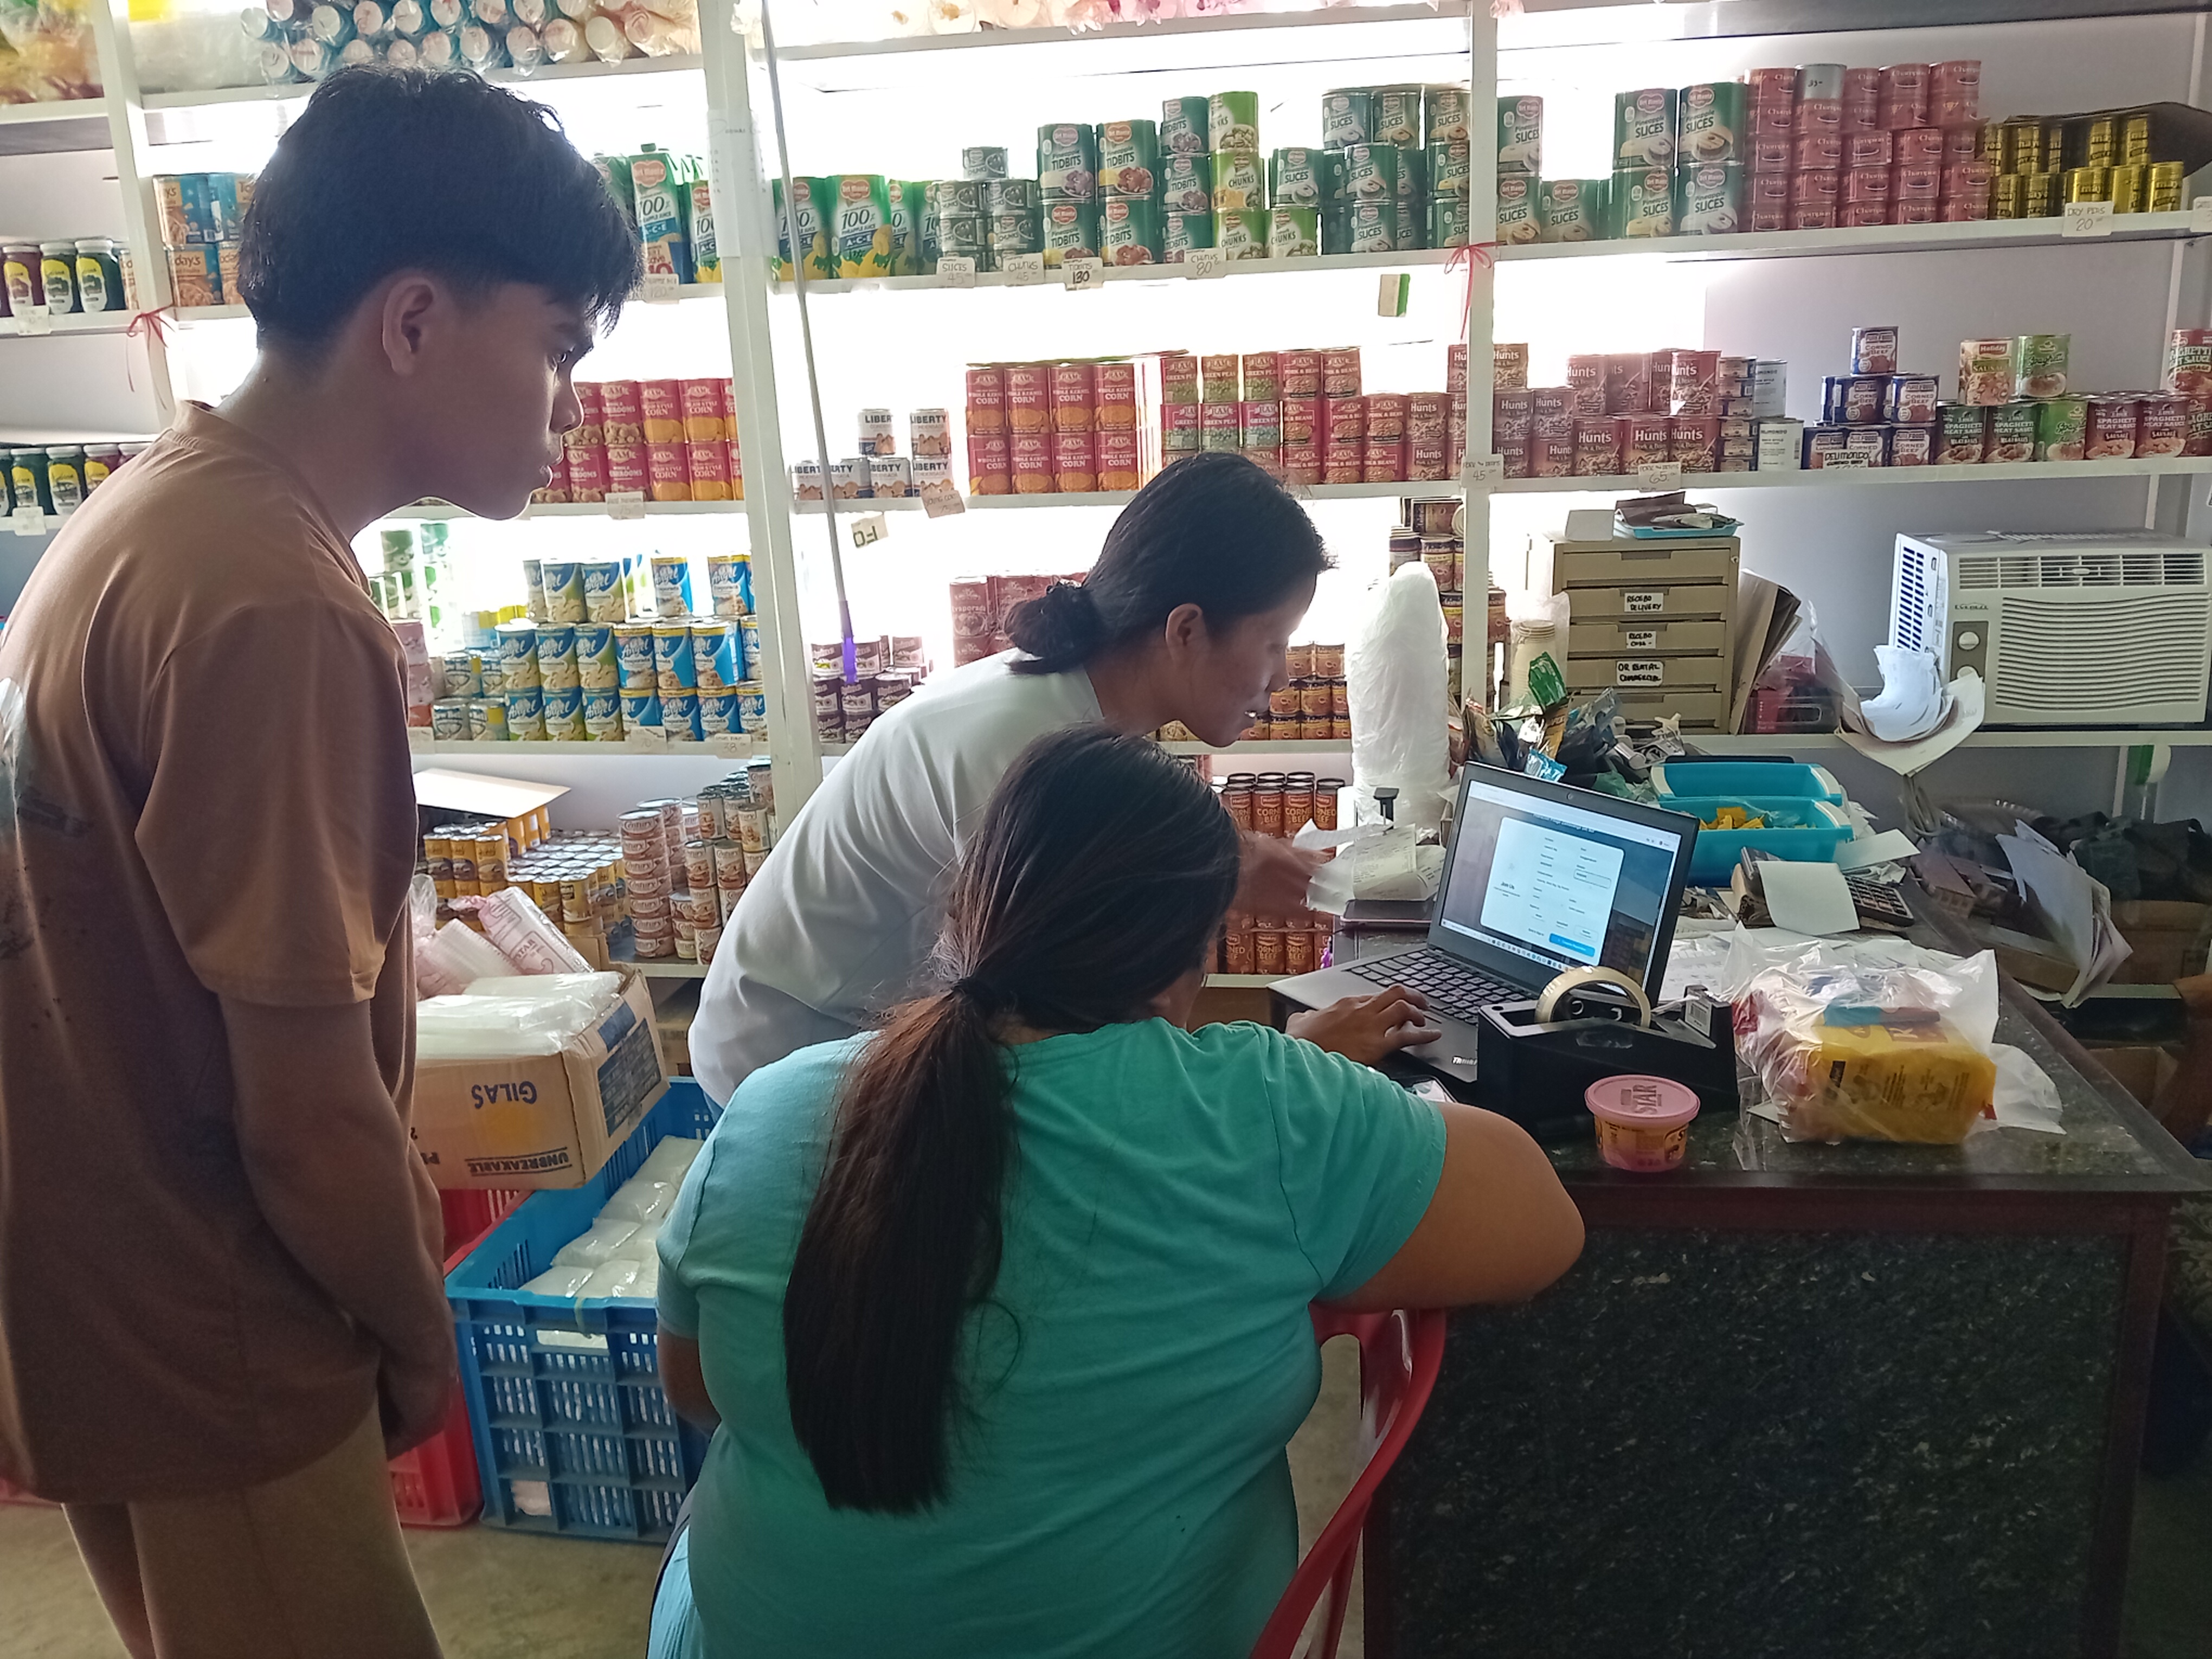
Beta testing was conducted to evaluate the functionality, usability, and overall performance of Vesmenda’s Store Management System in a real-world environment using actual users such as the owner, staff/admin, and cashier. This phase aimed to determine whether the system effectively supports the daily operations of the store, including sales, inventory, human resources, payroll, and report generation.
During testing, users were able to perform actual store transactions using the system, such as processing sales through the POS, managing inventory records, and generating reports for business monitoring. It was observed that the system is user-friendly, allowing users to easily navigate its interface and complete tasks efficiently even with minimal training. The integration of all store operations into a single platform also helped improve workflow and reduce the need for manual processes.
The system demonstrated accurate and reliable performance in handling data both online and offline, particularly in recording transactions and updating inventory levels in real time. Users also appreciated the automated features such as report generation and sales tracking, which helped improve decision-making and reduced errors compared to manual methods. However, during initial use, some users experienced slight unfamiliarity with certain features, especially during their first interaction with the system. Despite this, they were able to adapt quickly after short exposure, indicating that the system is easy to learn and suitable for regular store operations.
Implementation Plan
Strategy | Activities | Person's Involved | Duration
Testing | Evaluate the system's limitations, capacity, and functionality. | Proponents, Users | 1 week
Approval from the users and panelists | Obtain acceptance of the project from store management | Proponents, Users, Panelists | 1 day
Installation | Installing the system and all its components on the store's devices. | Proponents | 1 day
Training | Provide training for staff to efficiently use the system. | Proponents, Users | 4 days

Table 4.0 Implementation Plan
The implementation plan outlines the final activities carried out to successfully deploy Vesmenda’s Store Management System in the actual store environment. It includes testing, approval, installation, and training to ensure that the system is fully functional and ready for use. The first activity is testing, which involves evaluating the system’s limitations, capacity, and overall functionality. This is conducted by the proponents together with the users for a duration of one week to ensure that all features work properly and meet the store’s requirements.
After testing, approval from users and panelists is obtained. This step ensures that the system is accepted by the store management, proponents, users, and panelists before final deployment. This process takes one day. Next is the installation phase, where the system and all its components are installed on the store’s devices by the proponents. This step also takes one day and ensures that the system is properly set up and ready for operation.
Finally, training is conducted for the staff and users to ensure they can efficiently use the system. The proponents guide the users in navigating the system’s features, such as POS, inventory, and reporting. This training lasts for four days, allowing users to become comfortable and confident in using the system. Overall, the implementation plan ensures a smooth transition from development to actual use, making the system fully functional, user-friendly, and ready for daily store operations.

