CAMPUS E-LIB (LIBRARY) WITH INTEGRATION OF MONITORING SYSTEM FOR ZAMBOANGA DEL SUR PROVINCIAL GOVERNMENT COLLEGE (ZDSPGC)-

DIMATALING CAMPUS

BACHELOR OF SCIENCE IN INFORMATION SYSTEMS
ZAMBOANGA DEL SUR PROVINCIAL GOVERNMENT COLLEGE
Purok 4, Kagawasan, Dimataling, Zamboanga Del Sur

Mayordomo, Ronnie Jr. A.
Poquita, Edmon C.
Salahop, Krestin Mae C.

JUNE 2026
CHAPTER I
BACKGROUND OF THE STUDY

Introduction
Technology is now an essential element of education that offers a faster and more convenient way to get access to information and learning resources. As educational institutions are continuously adopting digital innovations, libraries are also transforming from traditional book-based systems into electronic libraries which enable users to access learning materials anywhere and anytime. A library is a collection of organized information resources and services that is used to support learning, research, and the overall educational goals of an institution (International Federation of Library Associations and Institutions [IFLA], 2021). Libraries are important for education. Libraries are academic centers of the campus that provide access to books, journals, digital resources, and other learning materials that encourage the intellectual development of students, teachers, and the academic community. The library of Zamboanga Del Sur Provincial Government College (ZDSPGC) – Dimataling Campus is open for students and teachers to get books and other learning materials. The library is furnished with physical books and academic publications that support teaching, learning and research. Besides providing learning resources, the library is also a facility where monitoring the entry and exit of users, recording library visits, and tracking the use of physical resources are important to ensure security, accountability and efficient library operations.
Without a computerized library system and an integrated monitoring system for the physical library, it is difficult for institutions to record library users, monitor visits, track borrowed and returned books, and retrieve information quickly and easily. Manual processes are often time-consuming, prone to errors, and may result in lost records, and difficulty in generating reports. For this reason, many educational institutions are implementing digital technologies to increase access to academic resources, automate library operations and enhance the monitoring of library activities and physical usage of resources (Phusparaja et al., 2021).The need for the development of an E-Library System with an integrated monitoring system has become more important for the modern educational institutions as it enables the efficient management of digital and physical library resources. The system allows users to search and access electronic learning materials and supports the physical books with automated borrowing and return records.
Furthermore, the monitoring system records library visits, tracks user activities in the physical library, and generates reports to help librarians manage library operations more efficiently. Research indicates that the integration of digital library technologies with traditional library collections improves accessibility, operational efficiency, resource management, and user satisfaction in educational institutions (Xu et al., 2019).Finally, the need to introduce a Campus E-Library System with an Integrated Monitoring system for the physical library is a must in today’s educational institutions. It improves the management of digital and physical learning resources by providing convenient electronic access to information and at the same time improving the monitoring of library users, visits, book circulation and the overall library operations. Through the integration of digital library services and an efficient physical library monitoring system, the institution can improve resource accessibility, strengthen security and accountability, improve the operational efficiency and provide better services for students, faculty and librarians. The system ultimately provides a more organized, effective and flexible learning environment to meet the changing educational demands of Zamboanga Del Sur Provincial Government College (ZDSPGC) - Dimataling Campus.
Objectives of the Study
This study generally aims to develop a Campus E-Lib(Library) with Integration of Monitoring System for Zamboanga Del Sur Provincial Government College- Dimataling Campus that will improve library management and provide accessible academic resources for students and instructors. Specifically, it aims to:
- to create digital library resources for the institution;
- to provide easy access to books and learning materials with offline reading capability;
- to improve efficiency in managing library transactions and monitoring activities; and,
- to implement a monitoring system for physical library operation
Statement of the Problem
This capstone project will be created to study the problems that exist in the current library system of Zamboanga Del Sur Provincial Government College - Dimataling Campus, in order to build an E-Library System, with features for monitoring the library system, that will improve library services. The existing library will have a limited number of books available to the students, therefore limiting access to learning materials. Additionally, there are only very few physical books available to borrow, and there are strict deadlines for returning them, so therefore, there is little time to use these materials for study and research. Due to these conditions, there are many barriers that hinder student access to the use of the library resources. Therefore, the proposed system will provide a digital library platform that will provide improved access, ease of use, and improved overall library services.
Significance of the Study
The significance of this study is its ability to enhance the accessibility and management of academic resources at Zamboanga Del Sur Provincial Government College–Dimataling Campus. Through the development of a Campus E-Library System with an integration of monitoring system, the study aims to enhance library services, support teaching and learning activities, and provide a more efficient means of accessing educational materials. The benefits of this study extend to the following:
Students. The system allows students to access their course materials on demand (24/7) from any location, thus making it easier for them to study.
Instructors. The system will provide instructors with quick access to academic literature and educational resources.
Admin/Librarian. The system will assist in library management by cataloging the books, tracking the usage and providing access control to the users.
School. The project will help to modernize the school library and improve the quality of educational services provided by the library using technology.
Future Researchers. This project may also provide information and/or ideas to future researchers interested in creating similar projects.
Scope and Limitations
The proposed project aims to develop a Campus E-Library System with an Integrated Monitoring System for Zamboanga Del Sur Provincial Government College (ZDSPGC), Dimataling Campus. The system will offer an efficient way for students, faculty and librarians to access, manage and use digital learning resources. Users can search, view, download and read digital books with the ability to access previously downloaded content offline. It will also include user login and account management for secure access.
Furthermore, the system will integrate the monitoring system for the physical library to track the library visits, monitor user activities and produce reports which will assist in the library management and enhance operational efficiency. The system will supplement the existing physical library by increasing the access to the digital resources and improving the monitoring of the library usage.
The system is only for Zamboanga Del Sur Provincial Government College (ZDSPGC), Dimataling Campus. Only authorized users are allowed to access the system and only digital materials uploaded by the librarians or administrators will be available.The system does not replace the physical library, as borrowing and returning printed books will continue through the existing library circulation process.
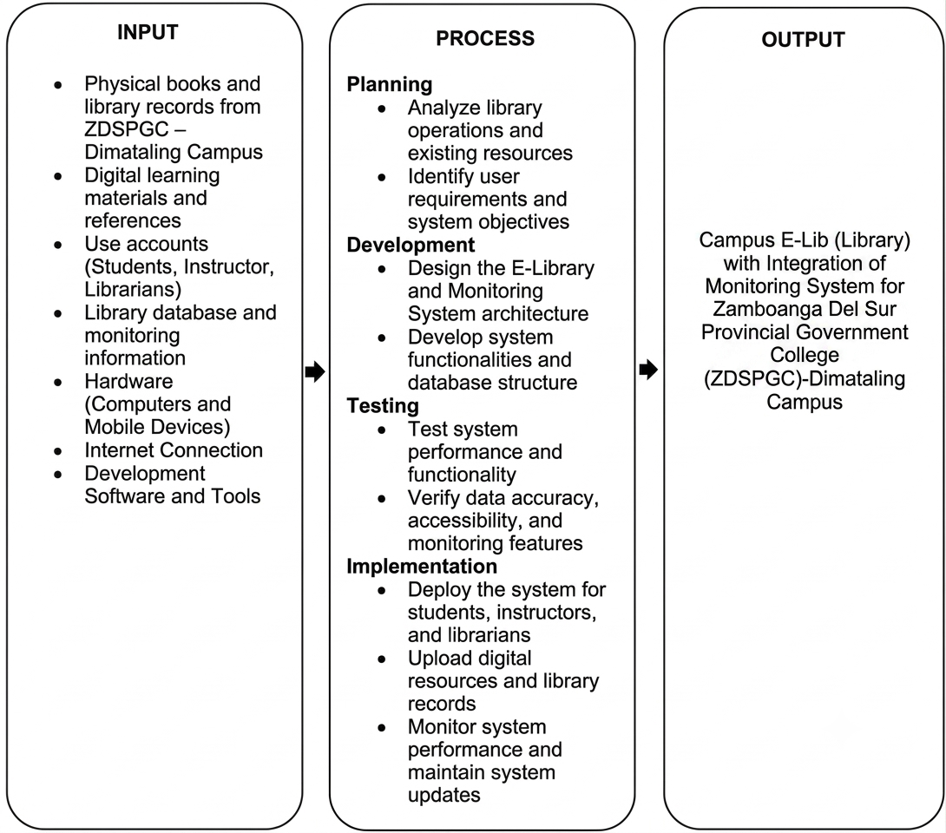
Conceptual Framework
Figure 1. Input-Process-Output Model

The figure 1 above illustrates the Input–Process–Output (IPO) Framework of the proposed Campus E-Library System with Monitoring Integration for Zamboanga del Sur Provincial Government College (ZDSPGC) – Dimataling Campus. The Input includes the necessary resources to develop the system such as the physical books and library records, digital learning resources, user accounts (students, instructors and librarians), library database information, hardware, internet connection and development tools. The Process involves the stages of planning, development, testing and implementation where the system is designed, developed, tested and implemented to ensure it is functional and reliable. The Output is a fully functional Campus E-Library System with Monitoring Integration that allows for better management of library resources and better access to digital learning materials for the institution.
Definition of Terms
The following terms used in this study are defined operationally and conceptually for better understanding of the concepts. These definitions serve as a guide in understanding the development and implementation of the Campus E-Library System for Zamboanga Del Sur Provincial Government College- Dimataling Campus.
Admin/Librarian. The person responsible for managing the library system and records.
Database. A collection of organized data that the system uses to store records and information .
E-Library. A digital library system that provides electronic access to books and learning materials.
Instructors. School employees who can access educational materials through the system.
Students. Authorized users who can search, read, and download digital books.

CHAPTER II
REVIEW OF RELATED LITERATURE AND RELATED STUDIES
This chapter provide an overview of the literature that it forms the research, and that has implication for the findings. It is divided into two main section where the literature surrounding foreign and local literature.
Foreign
"User Experience Factors that Influence Users’ Satisfaction of Using Digital Library"
According to Pushparaja et al. (2021), user satisfaction in digital library systems is influenced by several factors such as efficiency, dependability, attractiveness, stimulation, and usability. The study emphasized that a well-designed system improves user experience and encourages continuous use of digital resources. Also, it was identified that ease of navigation and system responsiveness are very important factors in how users interact with digital libraries. When users experience convenience, they are more prone to participate actively in academic activities using the system. These findings emphasize the necessity of enhancing the system design to improve learning experiences in academic institutions. This study is relevant to the present research in that the proposed Campus E-Lib System aims to provide a convenient and user-friendly platform for students and instructors.

“Evaluation of Digital Library Continuous Usage: Role of Digital Library Overall Quality, Perceived Usefulness and User Satisfaction”
The continuous usage of digital libraries depends on system quality, information quality, and perceived usefulness. Chopra et al. found that the continued use of online libraries by users is influenced by the system reliability, efficiency, and helpfulness in academic tasks. The study also revealed that information quality and stable system performance contribute to user trust and satisfaction. Perceived usefulness also significantly impacts user engagement. The findings support the current study, as the Campus E-Lib System is designed to enhance accessibility and incorporates monitoring features to improve usability and efficiency (Chopra et al., 2024).
“Examining Differences and Similarities Between Graduate and Undergraduate Students’ User Satisfaction with Digital Libraries”
Xu et al. (2019) found system quality, information quality and service quality are crucial factors affecting user satisfaction and continued use of digital libraries. The research found that undergraduate and graduate students value the ease of access and convenience of academic resources. The patterns of use differed, but both groups relied heavily on digital libraries to support learning. The researchers found that better digital library systems improve academic performance and user engagement, which is in line with the current study proposing the Campus E-Lib System to improve the accessibility, monitoring, and management of library resources.
“Analysis of User Satisfaction of Academic Digital Library: An Empirical Model with Mediating Effects”
Kadir et al. (2023) studied the user satisfaction of academic digital libraries and found that system quality and information quality are the main factors of user satisfaction and system usage. It was also reported that perceived usefulness has a strong influence on user engagement and learning effectiveness. Digital library systems are effective in academic productivity and utilization of resources. The researchers emphasized on the need for continuous enhancement of digital services to meet the needs of users. The present study supports these findings in that the Campus E-Lib System is a digital library system that combines digital access and monitoring features to improve the library operation and user experience.
Local
"Library Management: User Monitoring and Report System of Colegio de San Juan de Letran Calamba"
Automation in library systems increases the accuracy, security and efficiency of library operations. The study utilized the barcode technology to track users and conduct transactions effectively. It was discovered that automation reduces human errors and enhances the speed of library services. The researchers also acknowledged that monitoring systems improve accountability and organization in library management. These findings support the present study because the proposed Campus E-Lib System also incorporates monitoring features to improve tracking and management of library resources (Esguerra et al., 2018).
“Access, Use and Satisfaction of Users with Library Resources, Services and Facilities in a Selected Academic Library”
Library access and service quality are major determinants of user satisfaction and academic performance. Tuble and Panhilason (2024) stated that students and faculty members who frequently use library resources are more satisfied. Accessibility and efficient services were also found to enhance learning experiences and use of resources. The researchers pointed out that well-managed library systems lead to better academic results. This is similar to the present research because Campus E-Lib System is expected to improve access and tracking of library resources with the help of digitization.
“Aligning Expectations and Perceptions: Analyzing Library User Satisfaction in Higher Education in Rural Philippines”
User satisfaction is dependent on the availability of digital resources, timely services, and good facilities. Seno-Sanoria (2025) noted that digital transformation increases library utilization and helps institutions to meet the modern learning needs. The study also revealed problems such as lack of resources but the digital systems were seen to have greatly improved the academic support services. The library system improvements were seen as necessary for better educational outcomes. These findings are applicable to the current study as the Campus E-Lib System would provide digital access and monitoring capabilities to enhance library efficiency. This supports the present study as the Campus E-Lib System aims to integrate digital access and monitoring features to improve library efficiency and adaptability.

CHAPTER III
TECHNICAL BACKGROUND
This chapter discusses the technical foundations of the proposed Campus E-Lib (Library) with Integration of Monitoring Systems of Zamboanga Del Sur Provincial Government College (ZDSPGC) - Dimataling Campus.It discusses the current library system, the proposed system, and the hardware and software requirements needed for the application’s development and implementation. Current System Overview
The current library system of Zamboanga Del Sur Provincial Government College–Dimataling Campus is mostly based on the traditional library system. Students and instructors visit the library personally to search for books, read references, and learn materials. The library records, book inventories and monitoring activities are done manually which makes the process slow and less efficient. The first batch of graduating students of Zamboanga Del Sur Provincial Government College – Dimataling Campus created a Library Management System that focuses only on the management of books in the physical library.
Moreover, the system has not been used or implemented in the institution in library operations. The current setup has many challenges. The current library system requires users to physically visit the library to avail of the available resources, which limits its accessibility, especially outside of library hours. Since the learning materials are mostly available in physical form, only a limited number of users can access a book at a time. The process of searching resources and monitoring library use is carried out manually, which results in errors and delays. The absence of a unified digital platform may cause difficulties in searching learning materials remotely by students and teachers. Moreover, librarians spend a lot of time on tracking user activities and report generation, which affects the overall efficiency of the institution.
As the educational institutions are progressing in the digital transformation, the need for a library system that provides easy access to academic resources and enhances library management and monitoring capabilities is increasing.
To solve these issues, it is necessary to develop a Campus E-Lib (Library) with the Integration of Monitoring Systems. The digitization of the library resources along with the integration of monitoring features will assist the institution to enhance access, optimize library operations and upgrade the overall learning environment for the students and teachers.
Overview of the Proposed System
The Proposed Campus E-Lib (Library) with Integration of Monitoring Systems for Zamboanga Del Sur Provincial Government College – Dimataling Campus is an application that is intended to provide digital access to academic resources and to improve library management and monitoring functions. The application will act as a central repository for students, instructors and librarians to access educational materials, manage library resources and monitor library activities efficiently. The application is intended to be used both online and offline. While online, users can browse, search, read and download the available learning materials. The students and instructors can download the books and resources and read them even when they are not connected to the Internet. This feature improves access and enables continuous learning regardless of network availability.
There are three main users in the system, the Admin/Librarian, Students and Instructors/Faculty. Each user is provided with specific functions and access privileges according to their roles within the institution. The Admin/Librarian manages the overall operation of the system. Responsibilities include uploading digital books, organizing learning materials, managing user accounts, monitoring user activities, generating reports, and maintaining the system database. Students can search, access, read, and download digital books and educational resources. They may also view their reading history and continue accessing downloaded materials offline. Same with the students the instructors/faculty can also utilize the system for teaching, research, and academic purposes by accessing, reading, and downloading educational resources available within the platform.
In addition to providing digital library services, the application integrates a monitoring system that records user activities within the E-Library platform and supports the management of physical library records. The monitoring system tracks user logins, searches for books, access to resources, download activities, and library usage logs maintained by the librarian. Such logs allow the administrator to prepare reports, track the usage of resources, and analyze the user’s interaction with library services. The tracking feature allows the admin/librarian to recognize the most accessed document, keep track of user activities, find out the library usage trends, and prepare statistical summaries. These summaries help the library staff to improve the services, manage the resources in a better way, and take informed decisions for the institution.
Hardware and Software Requirements
The acquisition of the necessary hardware and software resources is a crucial step in the system development process to ensure successful implementation. These resources are required to ensure that the Campus E-Lib (Library) with Integration of Monitoring Systems is working efficiently, securely and reliably, with online and offline capabilities.
The choice of hardware and software components is made according to compatibility, performance, scalability, security and ease of maintenance. The right integration of these resources allows the access to digital learning materials, the monitoring of user activities and the proper operation of the system.
Hardware Requirements
The hardware components are the infrastructure where the system runs, stores data, communicates on the network, and allows users to access it. These components help in managing digital resources, monitoring activities and secure access to the Campus E-Lib (Library) with Integration of Monitoring Systems of Zamboanga Del Sur Provincial Government College (ZDSPGC), Dimataling Campus.
Hardware Component | Description | Quantity
Admin/Librarian Computer  Application and Database Server  Student and Faculty Devices  Internet Connection  Ethernet Connection | Manage digital books, user account, monitor records, and generate reports.  Store digital books, user profile, monitoring records and system data.  Computers, laptop, tablets or smartphone used to access the E-Library System  Provide online access, download resources, and synchronize data.  Provide stable network connectivity between the administrator computer and server | 1  1  As Needed  1  1

Table 3.1 Hardware Requirements
Table 3.1 shows the hardware requirements for the proposed system.These hardware components are essential for system management, monitoring, and user interaction. The hardware specifications are as follows:
- a. Admin/Librarian Computer. Used by the librarian to manage digital resources, monitor user activities, generate reports, and maintain system records.
Specifications:
• Processor: Intel Core i5 or higher
• RAM: 8GB or higher
• Storage: 455GB SSD
• Operating System: Windows 10 or higher
.b.Application and Database Server. This server will store the digital books, user accounts, monitoring records, activity logs and other system data.
Specifications:
• Processor: Intel Xeon or AMD Ryzen 7
• RAM: 16GB minimum
• Storage: 1TB SSD
• Network: Gigabit Ethernet
c. Student and Faculty Devices. These are the devices that students and instructors will use to access, search, read and download digital learning materials. Specifications:
• Smartphone, Tablet, Laptop or Desktop Computer
• Minimum 8GB RAM or higher
• Modern Web Browser or device application
d. Internet Connection. Required for uploading digital resources, downloading books, synchronizing system data and accessing online services.
Specifications:
• Fiber or Broadband Internet Connection
• Minimum Speed: 20 Mbps or above
e. Ethernet Connection. Provides a stable, secure wired connection between the Administrator/Librarian workstation and server to ensure stable system performance and efficient data transmission.
Specifications:
• Cat6 Ethernet Cable
• Gigabit Ethernet Support
Software Requirements
The software requirements include the tools, technologies and platforms required for the development, deployment and operation of the Campus E-Lib (Library) with Integration of Monitoring Systems. These software components deliver system functions, reliability, accessibility, security and overall performance.

Software | Description
Frontend Development
HTML  CSS  JavaScript | Structures the user interface elements and content of the E-Library application for accessibility and compatibility across different browsers.  Styles the user interface, improving layout, typography, responsiveness, and overall user experience.  It has interactive features such as searching, filtering resources, notifications and offline reading.
Backend Development
Node.js  PostgreSQL | Controls server-side processing, user authentication, book management, borrow monitoring functions, and all system operations.  It uses a structured relational database for the storage and management of digital books, user accounts, borrow records, monitoring logs, reading lists, activity feeds and other system data.
Web Server
Node.js (Express Server)  Vite | Provides E-Library API and handles requests from users and the server.  Acts as the frontend web server and build tool in the development phase.
Security
HTTPS | Provides encrypted communication between users and the server to safeguard sensitive information and user credentials from being intercepted during data transmission.
Additional Tools
TanStack Query | Allows asynchronous data retrieval and real-time updates without requiring full page reloads similar to AJAX, providing a smooth and responsive user experience throughout the application.
Table 3.2 Software Requirements
The previous Table 3.2 shows the software requirements of the proposed Campus E-Lib (Library) with Integration of Monitoring Systems of Zamboanga Del Sur Provincial Government College (ZDSPGC)-Dimataling Campus. The table shows the technologies and development tools to be used to develop, operate and maintain the application. It includes frontend technologies such as HTML, CSS, JavaScript, which enables will be responsible for developing a responsive, interactive and Graphical User Interface. These technologies enable users to efficiently access digital library resources, browse available books and use the monitoring features of the system.
Table 3.2 includes backend technologies like Node.js and PostgreSQL that handle server-side processing, user authentication, book administration, record tracking, and secure storage of system data. Vite is the development server and build tool. HTTPS is a secure messaging protocol that ensures safe communication between users and the application and protects sensitive information transmitted through data exchange.
The software requirements in Table 3.2 are the foundation for the development of a reliable, secure and efficient Campus E-Lib (Library) with Integration of Monitoring Systems of Zamboanga Del Sur Provincial Government College (ZDSPGC) - Dimataling Campus.
TanStack Query is utilized to simplify data fetching and synchronization to provide users updated information without having to refresh the page repeatedly. All these components work together to achieve the required functions of the application, improve the performance of the system, simplify maintenance, and ensure a smooth user experience for students, faculty and library administrators whether online or offline.

CHAPTER IV
DESIGN AND METHODOLOGY

This chapter presents the design and methodology of the system that being used in developing the Campus E-Lib (Library) with Integration of Monitoring Systems of Zamboanga Del Sur Provincial Government College (ZDSPGC) - Dimataling Campus. This chapter describes the following different processes that being involved in the system development, from identifying the requirements and designing the system to developing, testing, and preparing for implementation.
Requirement Analysis
In the development of the project, we us the researchers selected the 4D Model as the methodology for developing the Campus E-Lib (Library) with Integration of Monitoring Systems of Zamboanga Del Sur Provincial Government College (ZDSPGC) - Dimataling Campus. The model represents the chronological progression of the project through four phases: Define, Design, Develop, and Deploy. These phases provide the researchers with clear guide for identifying the needs of the library, planning the system, developing its functions, and preparing it for implementation.
Design
Define
Develop
Deploy
Figure 1. 4D Methodology
Define
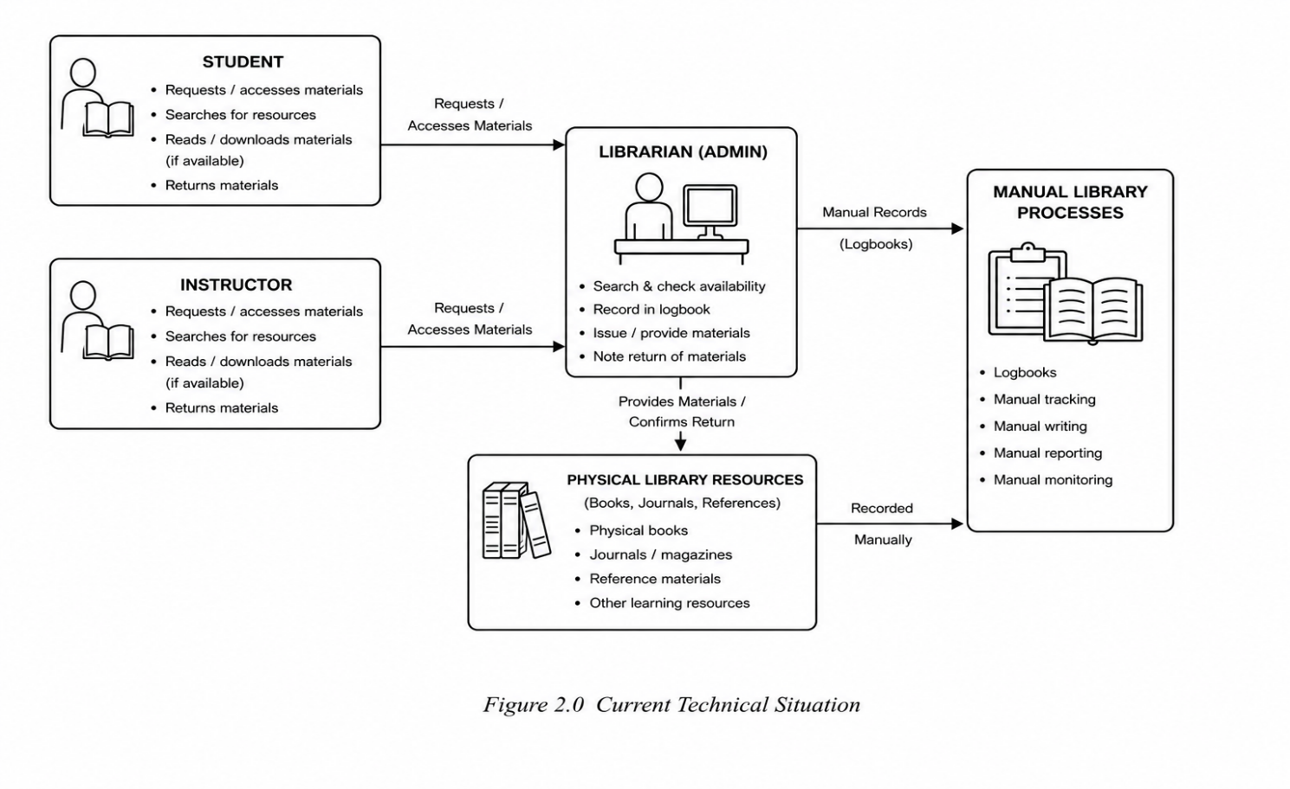
In the define phase, it identifies the current way in which the Zamboanga del Sur Provincial Government College (ZDSPGC) – Dimataling Campus library operates and the problem experienced by its users. At present, students and instructors mainly depend their lessons online and limited physical books on the library and also the librarian depends on manual records of a babooks. This phase helps us to determine what the proposed Campus E-Lib (Library) with Integration of Monitoring Systems needs to provide to make access to learning resources and library monitoring more organized.
Figure 2. Current Technical Situations
The figure shown above presents the current situations of the library, particularly the existing manual processes used by the students, instructors, and librarian. It shows how library users request and access physical learning materials, while the librarian checks availability, records information in logbooks, provides materials, and monitors library resources. Also it illustrate how physical books, and other reference materials are managed through manual tracking, writing, reporting, and monitoring.
Design
In the design phase, the researchers plans how the system work and how its components will be connected. This involves designing the system processes, data flow, database, structure, user interactions, and the functions assigned to the Admin/Librarian, Students and Instructors. The design phase focuses on digital learning resources, searching, viewing, reading, downloading, and monitoring the physical library activities.
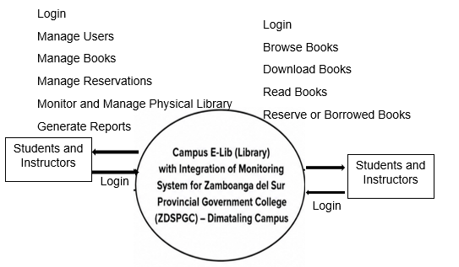
Context Diagram
Diagram 1. Context Diagram
The diagram that being shown above shows the interaction between the Campus E-Lib (Library) with Integration of Monitoring Systems and its users, the Admin/ Librarian, Students, and Instructors. It illustrates the different functions available to each user, where the Admin/Librarian manages users, digital books, resources, monitoring, and reports, while the Student and Instructor searches, views, reads, downloads, and accesses digital learning materials. Both users access the system through login, while the system serves as the central platform for managing library resources and monitoring user activities.
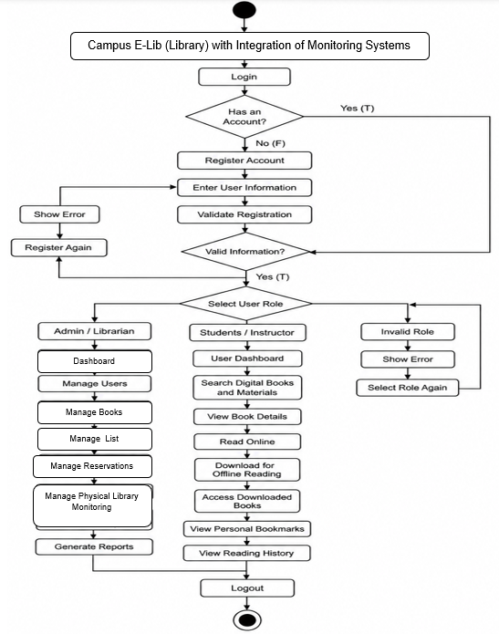
Activity Diagram
Diagram 2. Activity Diagram
Manage List
Manage Books
Dashboard
The activity diagram illustrates the overall workflow of the system entitled Campus E-LIB (Library) with Integration of Monitoring System for Zamboanga del Sur Provincial Government College(ZDSPGC)-Dimataling Campus. It starts with the user login and account validation, followed by registration for users without an account.
After Successful validation, and user’s role selection where Admin/Librarian can manage users, books, reservations, can monitor the physical library, and can generates reports, while the students and instructors they can search books, view books, read books through online and offline, they can download the books for offline reading, and also they can monitor their reading history. The invalid inputs are handled through error messages and retry processes so that they can access the system properly.
Use Case Diagram
Diagram 3. Use Case Diagram

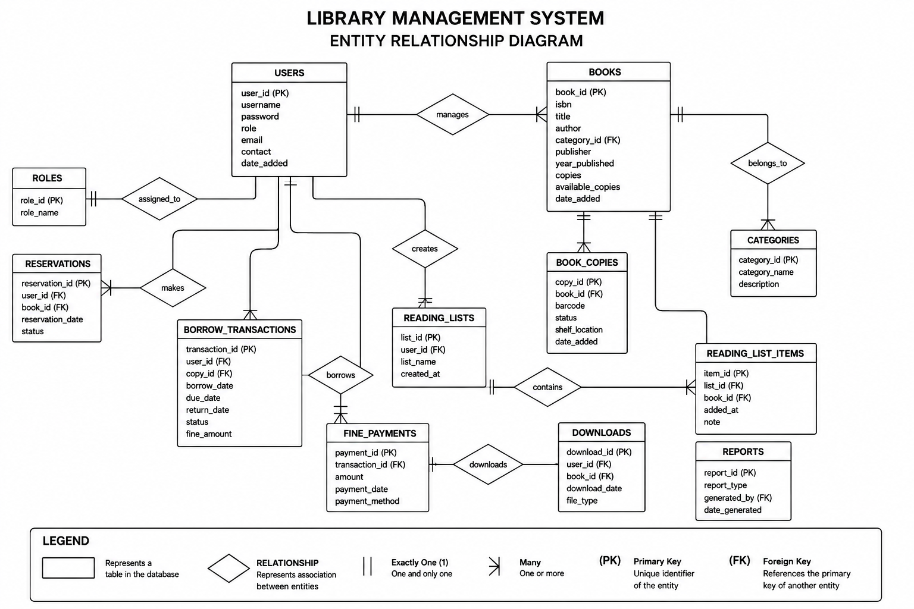
Entity Relationship Diagram
Diagram 4. Entity Relationship Diagram
The diagram that being shown above shows the entity relationship diagram (ERD) of the Campus E-Lib (Library) with Integration of Monitoring Systems for for Zamboanga Del Sur Provincial Government College (ZDSPGC) – Dimataling Campus. It shows different tables in the database and how they are connected. The users table contains the information of registered users and is connected to roles, books, reservations, borrow transactions, and reading list. The books tables contains the details of books and is connected to categories, and books copies, which are store the available copies of each book. Users can reserve and borrow books, and borrowing transactions, users can also add in their reading list, the downloads table records books that being download by the users, while reports stores generated reports from the system.
Those symbols and connecting line show the type and number of relationships between the entities, while PK represents the Primary Key and FK represents the Foreign Key. Overall, the ERD shows how the library system organizes and connects all its data.
Develop
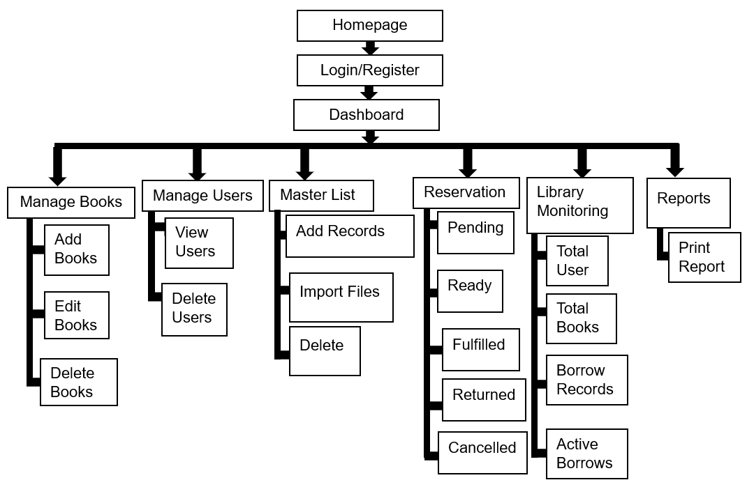
Develop phase which is the third phase under the 4D methodology, the system or web application structures are developed based on the designs prepared in the previous phase. It covers the menus, buttons, pages, and functions that users can access. The development phase translates the planned functions into actual Campus E-Lib (Library) with Integration of Monitoring Systems for Zamboanga Del Sur Provincial Government College (ZDSPGC) - Dimataling Campus that addresses the identified library needs.

Structural Diagram
Diagram 5. Structural Diagram for Admin/Librarian

Structural Diagram for Students and Instructors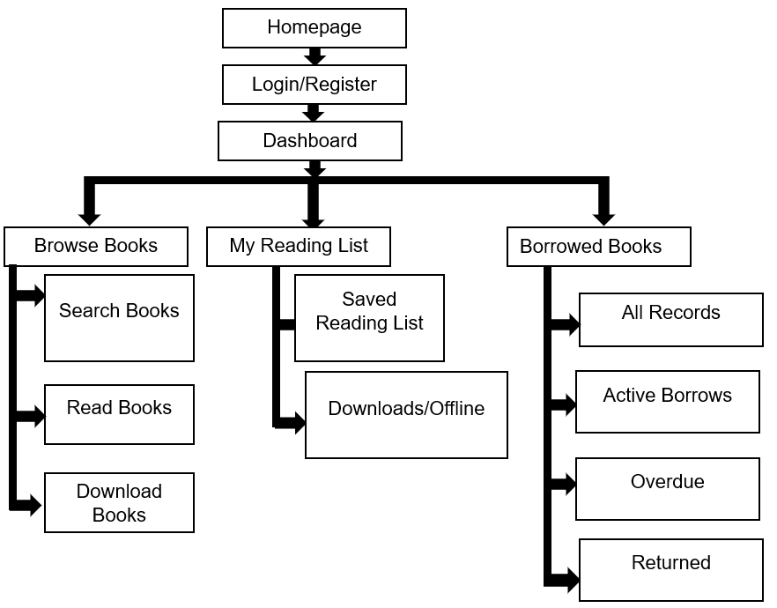Diagram 6. Structural Diagram for Students and Instructors
System Architecture Diagram
Diagram 7. System Architecture Diagram

REFERENCES
Chopra, G., Misra, P., & Bhaskar,. (2024). Evaluation of Digital Library Continuous Usage: Role of Digital Library Overall Quality, Perceived Usefulness and User Satisfaction. International Journal of Information Systems and Change Management.
https://doi.org/10.1504/IJISCM.2024.138086
Esguerra, , R. K. L., Claudiok, D. R. A., & Valdez, K. M (2018). Library Management: User Monitoring and Report System of Colegio de San Juan de Letran Calamba. e-Journals.ph.
https://ejournals.ph/article.php?id=154
International Federation of Library Associations and Institutions (2021). IFLA School Library Manifesto (2021).
https://ifla.org/handle/20.500.14598/2886
Kadir, Samsudin, & Seman. (2023). Analysis of User Satisfaction of Academic Digital Library: An Empirical Model with Mediating Effects. SpringerLink. https://link.springer.com/
Pushparaja, A., Abdullah, R., & Ibrahim, H. (2021). User Experience that Influences Users Satisfaction of Using Digital Library. Open International Journal of Informatics, 9 (Special Issue 1), 2836.
https://oiji.utm.my/index.php/oiji/article/view/165
Seno-Sanoria (2025). Aligning Expectations and Perceptions: Analyzing Library User Satisfaction in Higher Education in Rural Philippines. Journal of Information Processing.
https://doi.org/10.69569/jip.2024.394
Tuble, J. C., & Panhilason, R. G. (2024). Users’ Access, Utilization, and Satisfaction with Library Resources, Services, and Facilities in a Selected Academic Library. e-Journals.ph.
https://ejournals.ph/article.php?id=24009
Valencia, J. P. et al. (2024).Beyond Bookshelves: Measuring Library Service Quality and User Satisfaction at Quezon City University. QCU Journals.
https://qcujournals.com/QCULamp/article/view/52
Xu, F., & Du, J. T. (2019). Examining Differences and Similarities Between Graduate and Undergraduate Students' User Satisfaction with Digital Libraries. The Journal of Academic Librarianship, 45(6), 102072.
https://doi.org/10.1016/j.acalib.2019.102072

