Word Options (Advanced)
Use advanced Word options to customize editing tasks, document display, printing preferences, and more.
To select your advanced Word options, select File > Options, and on the left pane, select Advanced.
Editing options  Set up the way you select, replace, and format words and paragraphs. | 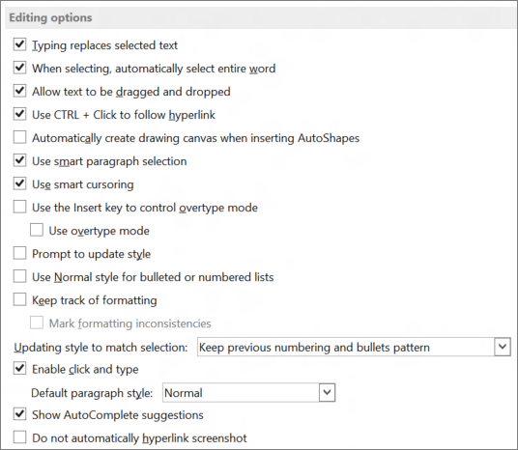
Image Size and Quality  Apply image size and quality settings for an open document or for all new documents. | Choose how you want to paste content and formatting within the same document or between different documents and apps.
Chart  Allow custom formatting and labels to stay with data points, even if the chart changes. | 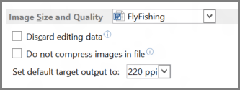
Show document content  Choose formatting, text, and image options. | 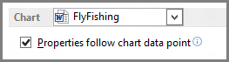
Display  Choose a measurement format, show scrolling bars, and select the number of documents shown in the Recent Documents list. | 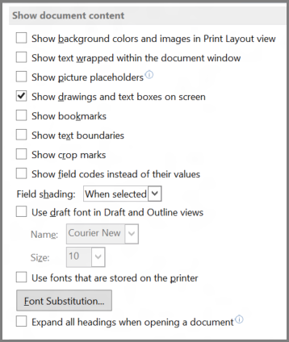
Print  Optimize the appearance of the hard copy version of the document or change your printer paper size. | 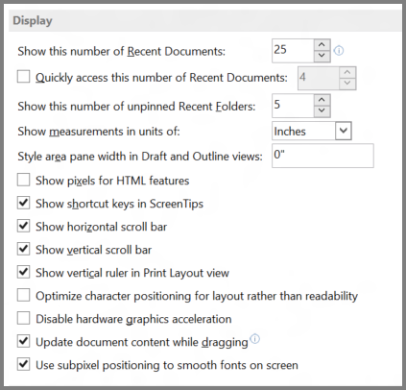
Save  Save backup copies, automatically save changes to templates, or allow backup saves. | 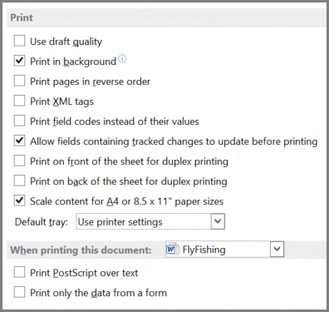
Preserve fidelity when sharing this document  Make sure the look of your document is preserved when you share the document with someone who uses a different version of Word. | 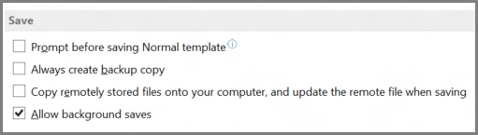
General  Among the options in this section, you can change where Word saves your changes by selecting File Locations, and you can choose to open documents in Draft view. | 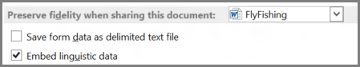
Layout options for:  Modify the layout, such as character spacing, for an open document or all new documents. | 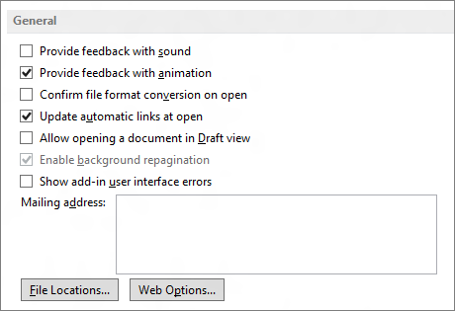
 | 