Kresimir Tokic  
CMSC405 (2205)  
6/28/20

Project 1 Documentation

**Screen Shots**

* This screen shot shows successful compilation and execution of the program. This is the first frame in which the images are unmodified.

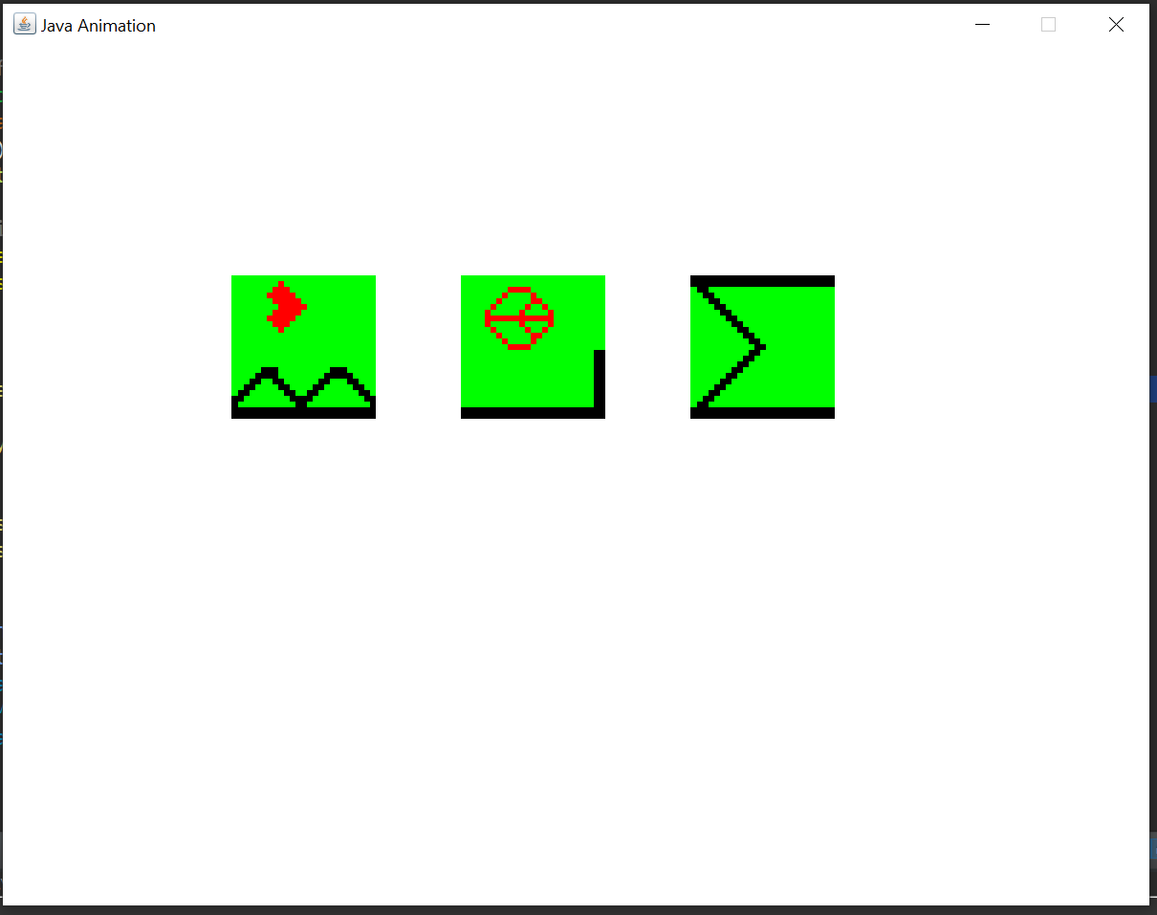

* This screen shot shows the second frame where the images are translated to coordinates (-5, 7).

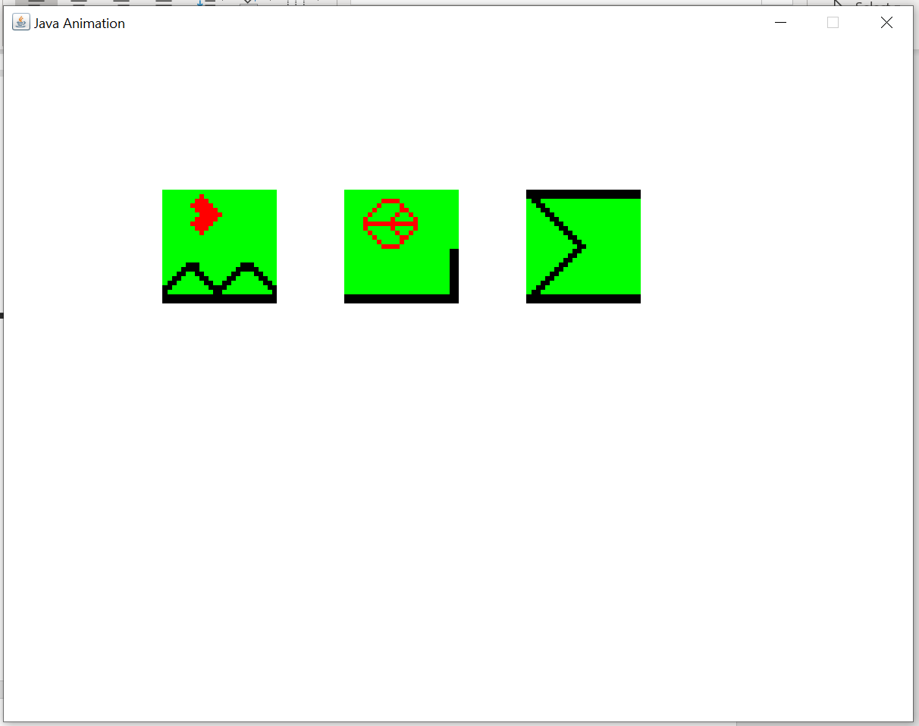

* This screen shot is the third frame which shows the images are rotated 45 degrees counterclockwise from the prior frame.

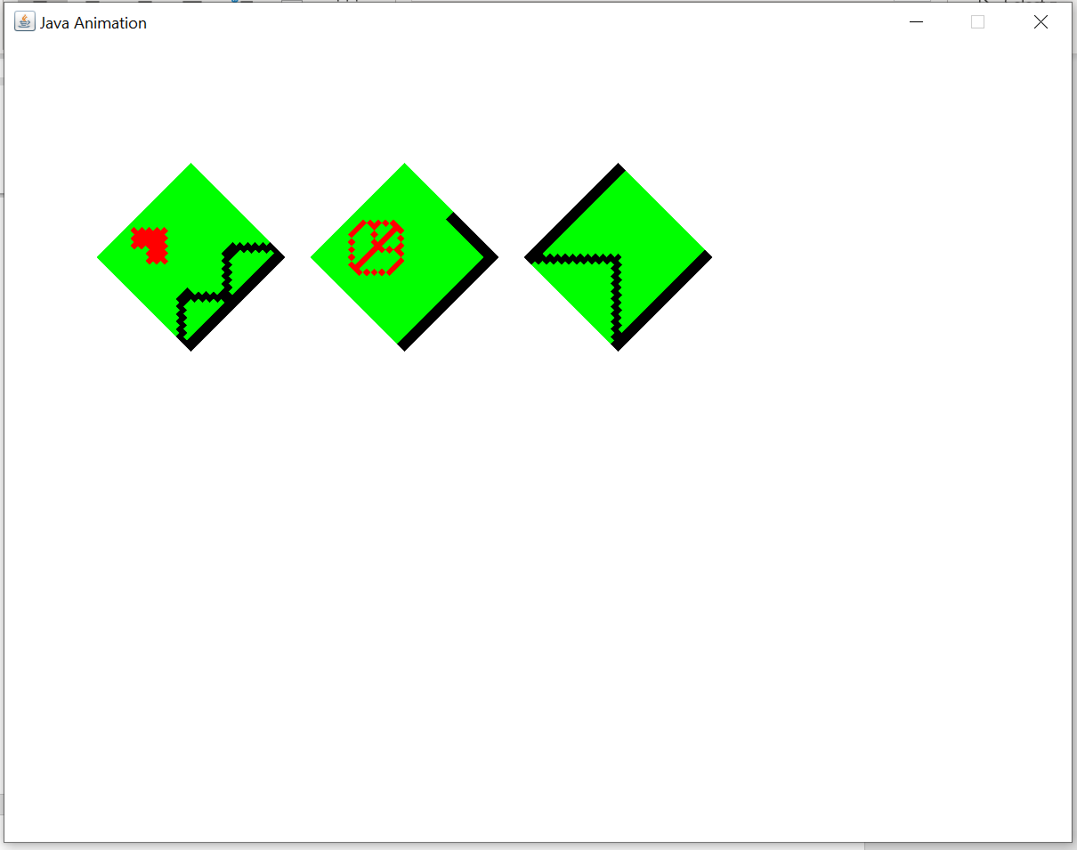

* This screen shot shows the fourth frame where the images are rotated 90 degrees clockwise from the prior frame.  
  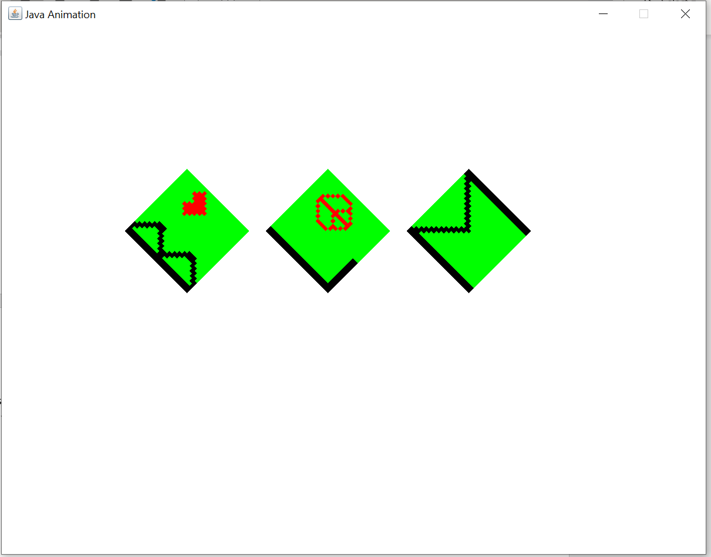
* This screen shot shows the fifth frame in which the images are scaled along the x axis by a factor of two and the y axis by a factor of one half.  
  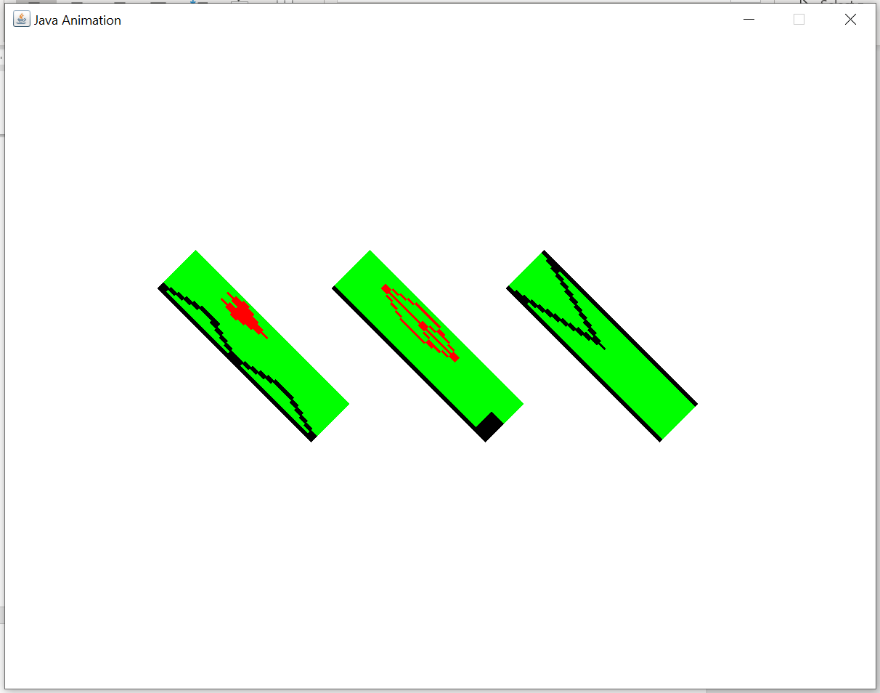

**Notes**

I attempted to include a JLabel in my project to state the translation, rotation, and scaling of each frame, but I discovered that .setText() winds up creating another call which would rotate my image too much. I’m not sure if this is a weird Java-ism or an intentional desired feature of the language. Leveraging the templates provided to us was tremendously useful in saving time to complete the task. I started the project confident that I could accomplish but assumed it would be a much longer and complicated endeavor. Java’s built in functions for translation, rotation, and scaling are really convenient, but I find the entire process of drawing and animating in Java a bit obtuse and counter to what I would intuit. The reading material piqued an interest in me as it relates to my experience working with AutoCAD and how the commands like scale, rotate and the coordinate system are leveraged for drawing and manipulating shapes.