Kresimir Tokic  
CMSC405 (2205)  
7/13/20

Project 2 Documentation

**Test Case:**

|  |  |  |  |  |
| --- | --- | --- | --- | --- |
| **Test Case** | **Testing what? (input)** | **Expected Output** | **Actual Output** | **Pass/Fail** |
| 1 | rotation around x axis positively (up arrow key) | image rotates circular around x | image rotates circular around x | Pass |
| 2 | rotation around x axis negatively (up arrow key) | image rotates circular around x | image rotates circular around x | Pass |
| 3 | rotation around y axis negatively (left arrow key) | image rotates circular around y | image rotates circular around y | Pass |
| 4 | rotation around y axis positively (right arrow key) | image rotates circular around y | image rotates circular around y | Pass |
| 5 | translate 0.25 Y axis (w key) | image moves up 0.25 | image moves up 0.25 | Pass |
| 6 | translate -0.25 X axis (a key) | image moves left 0.25 | image moves left 0.25 | Pass |
| 7 | translate -0.25 Y axis (s key) | image moves down 0.25 | image moves down 0.25 | Pass |
| 8 | translate -0.25 X axis (d key) | image moves right 0.25 | image moves right 0.25 | Pass |
| 9 | zoom in (+= key) | image increases in size 0.125 | image increases in size 0.125 | Pass |
| 10 | zoom out (-_ key) | image decreases in size 0.125 | image decreases in size 0.125 | Pass |
| 11 | reset to scene to start (r key) | image jumps back to initial launch | image jumps back to initial launch | pass |

**Screen Shots**

Initial Launch Screen

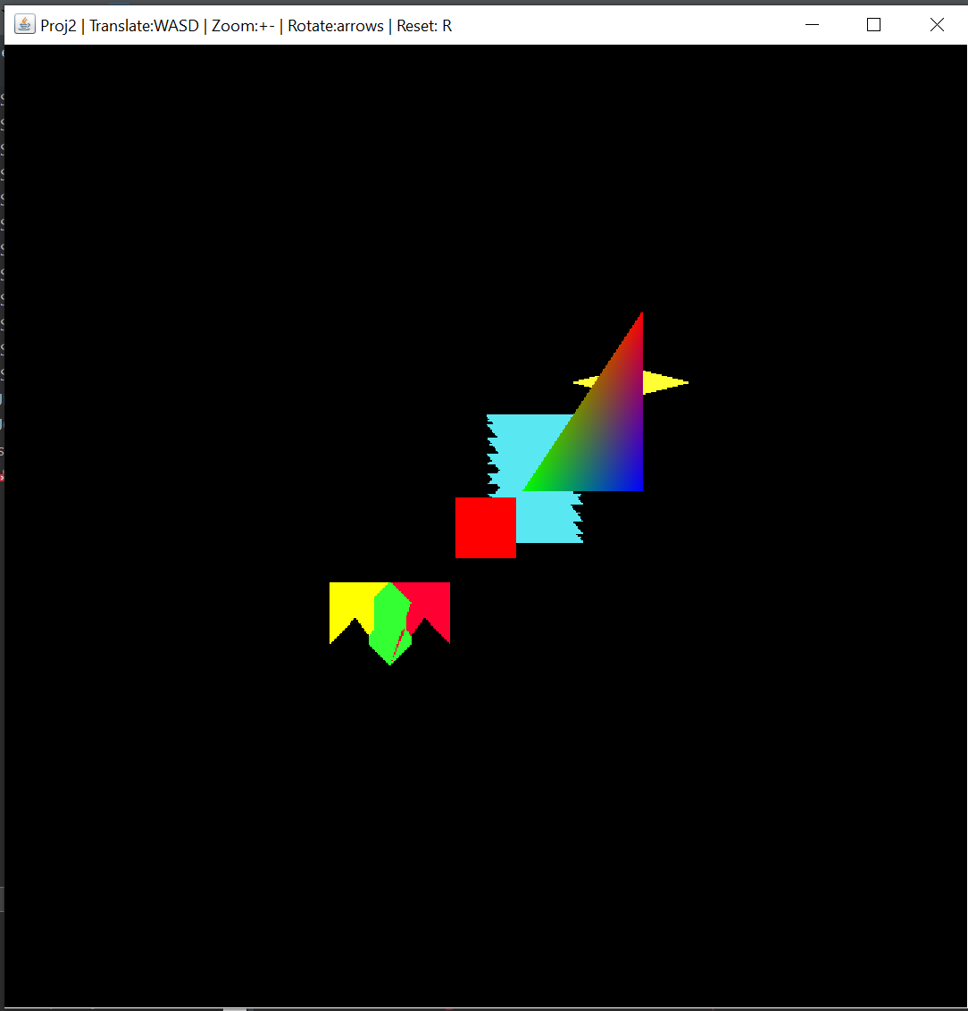

**Test Case 1**

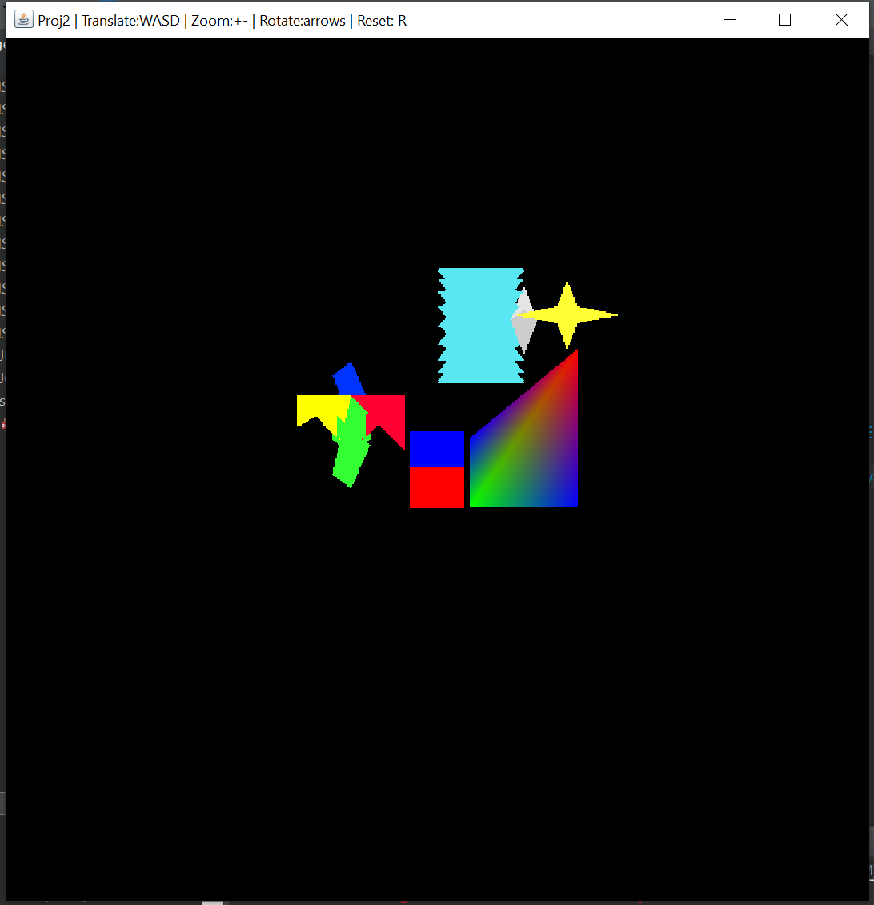

Test Case 2

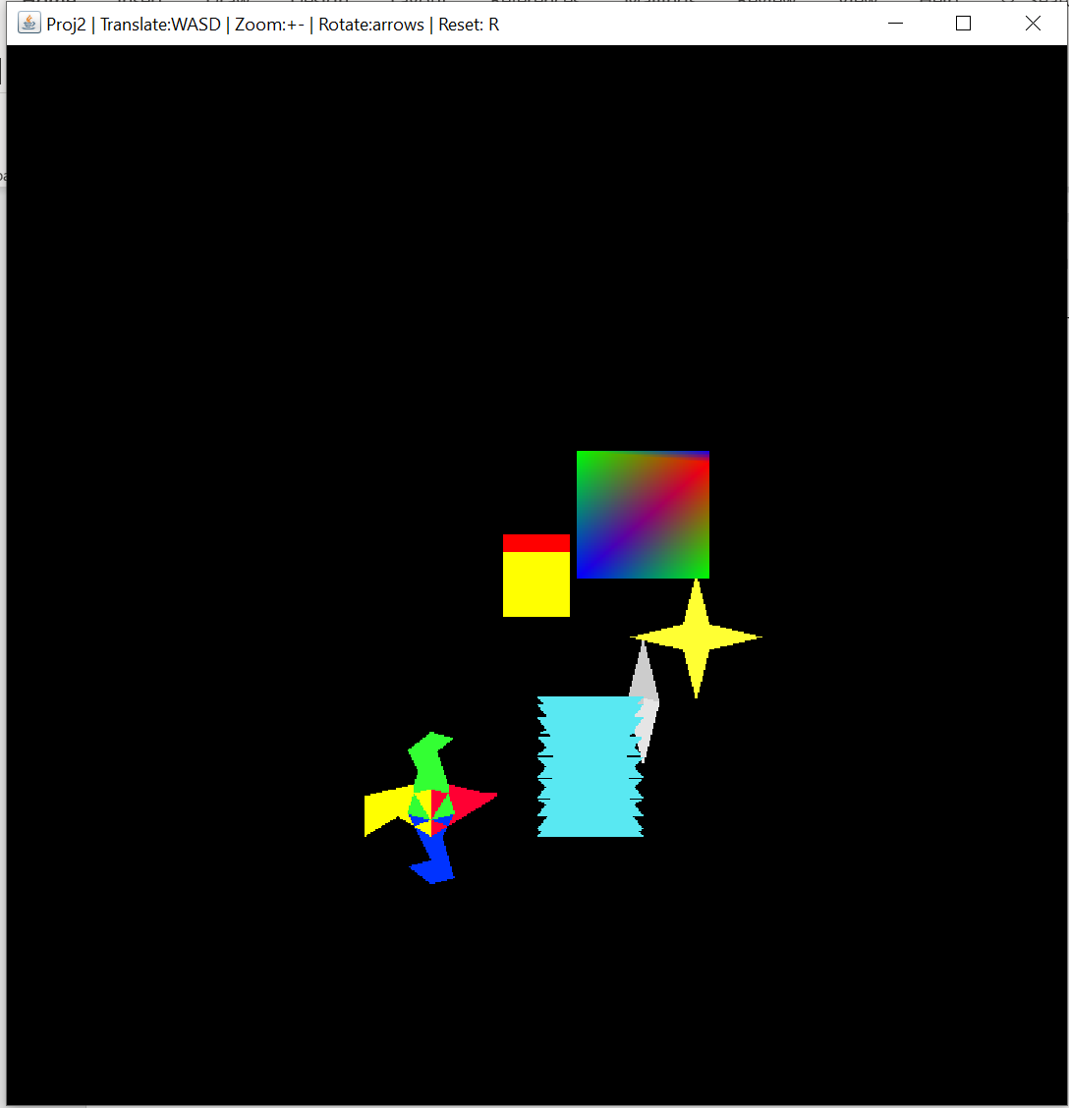

**Test Case 3**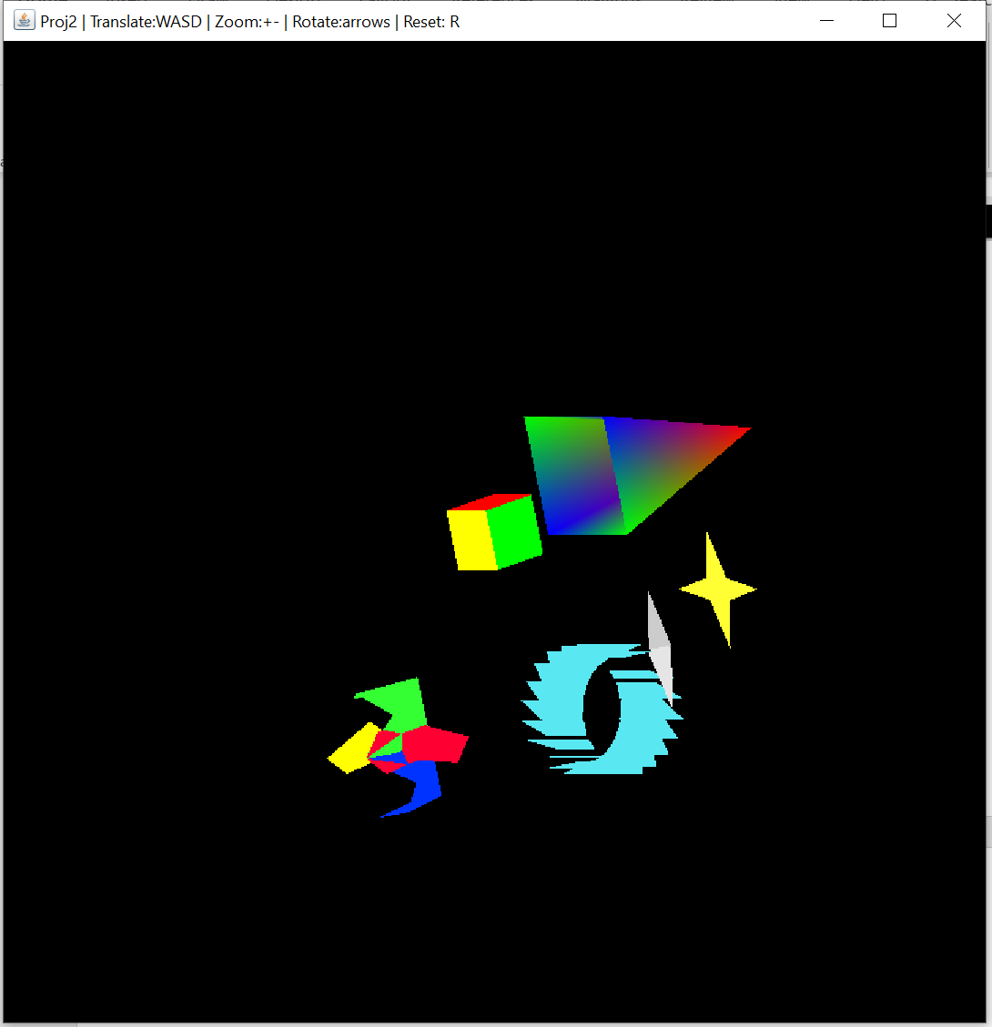

**Test Case 4**

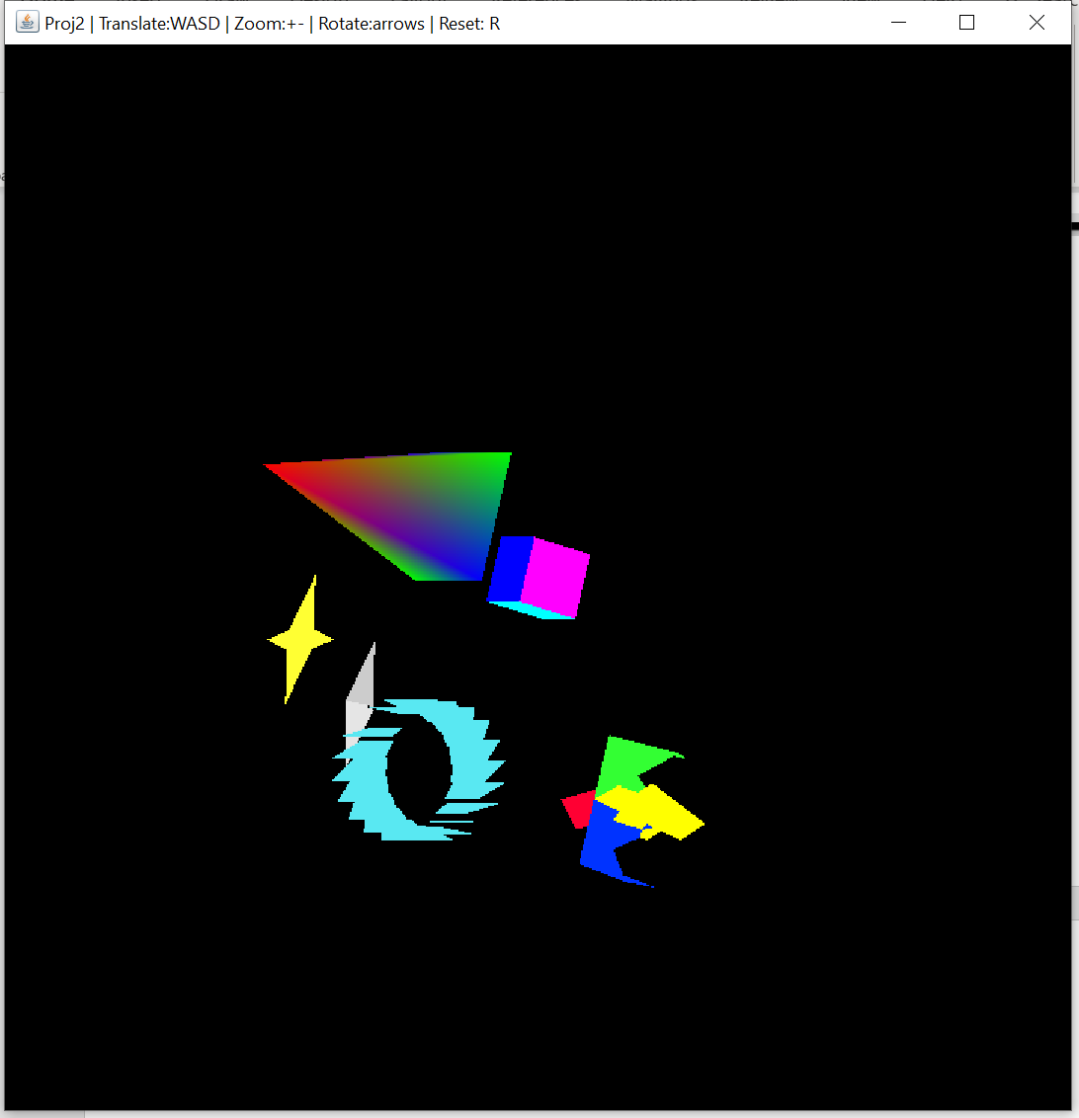

**Test Case 5**

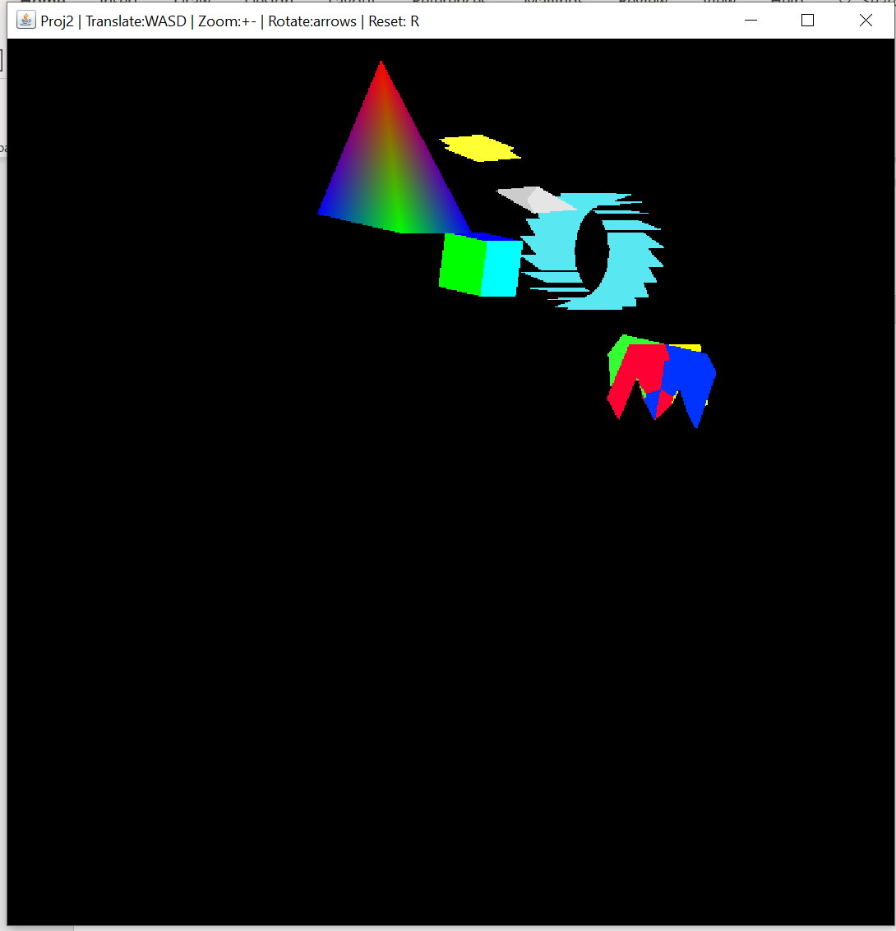

**Test Case 6**

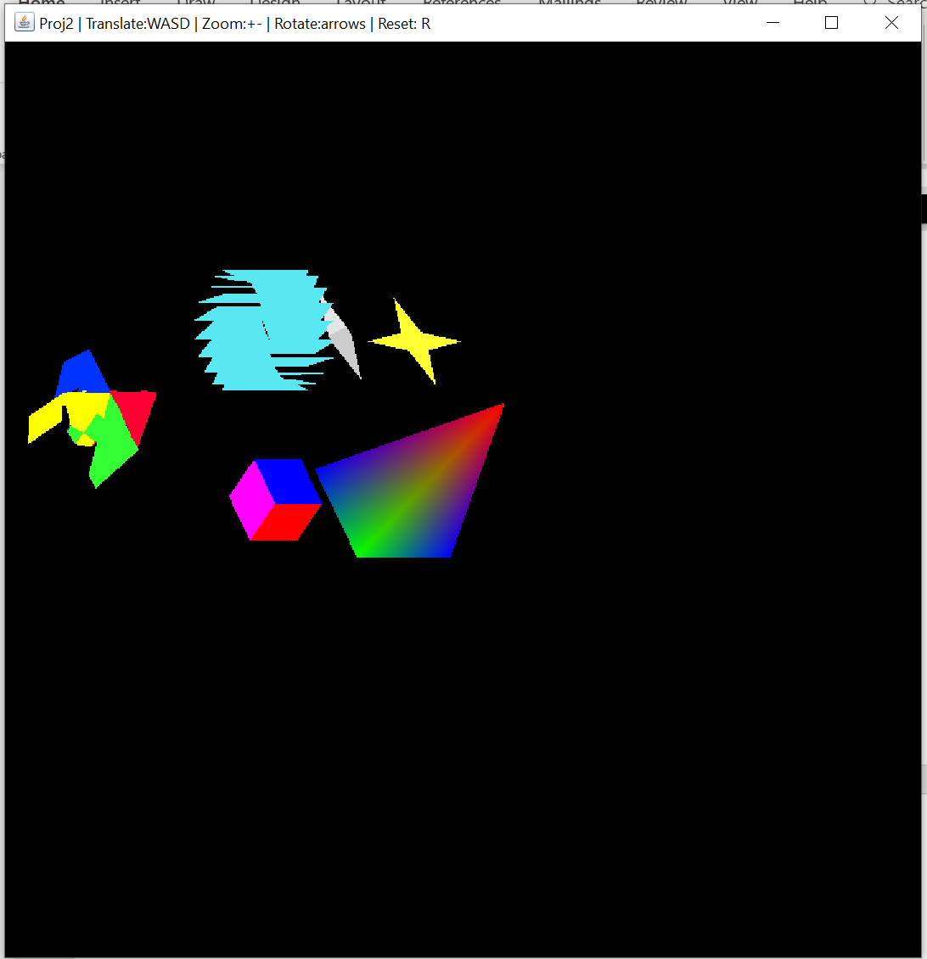

**Test Case 7**

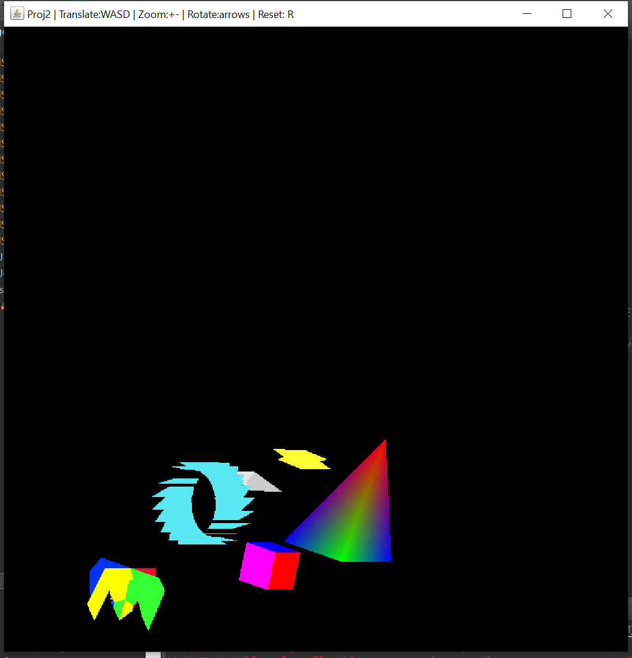

**Test Case 8**

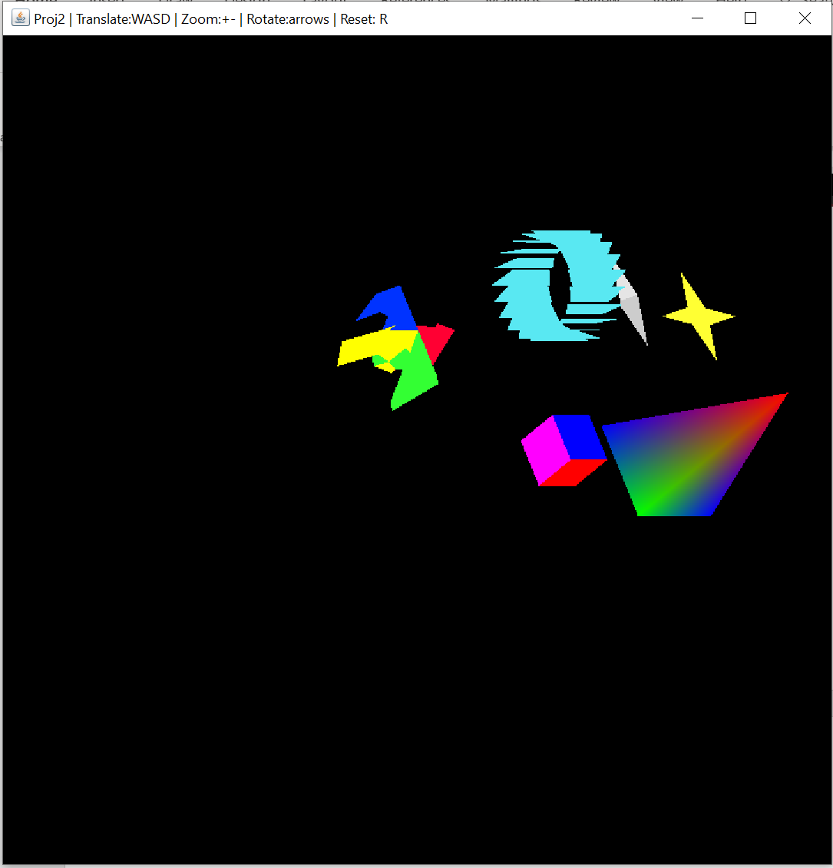

**Test Case 9**

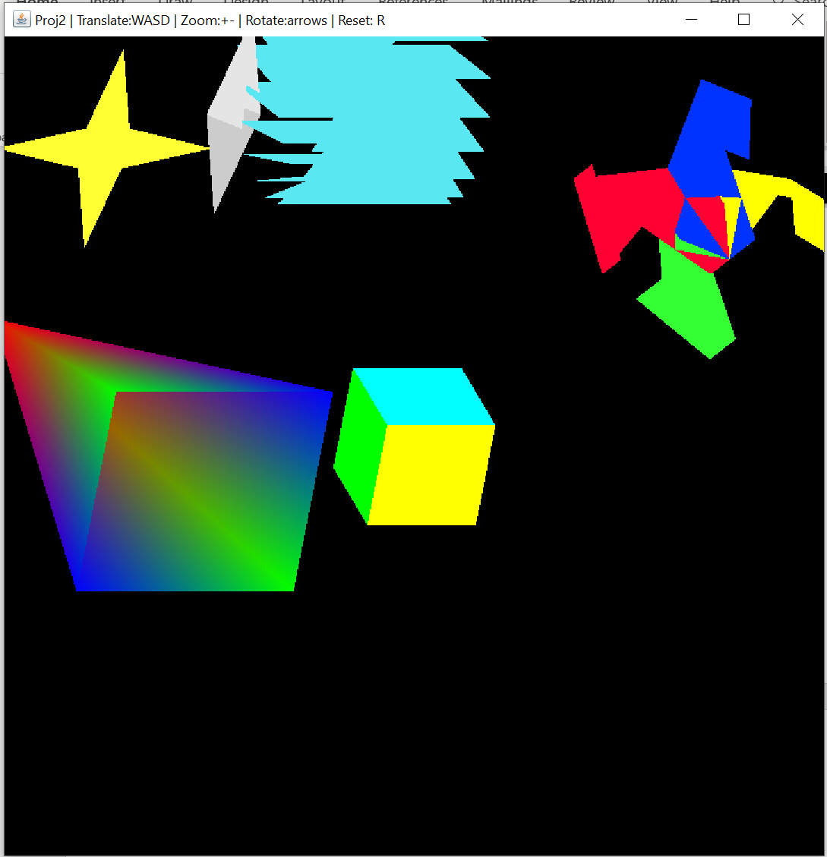

**Test Case 10**

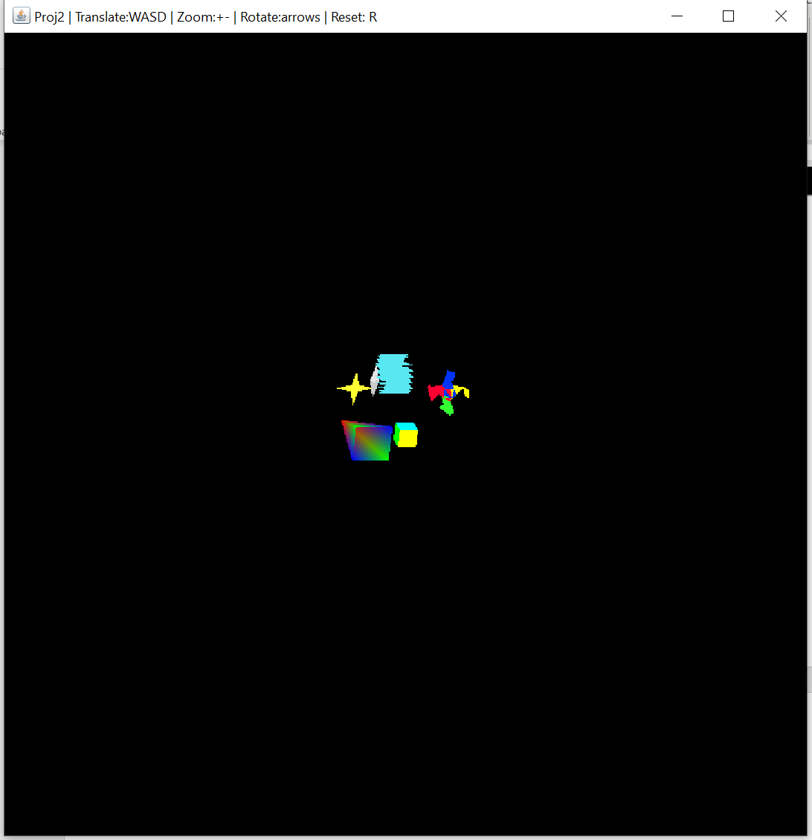

**Test Case 11**

