Kresimir Tokic  
CMSC405 (2205)  
7/23/20

Project 3 Documentation

**Test Case:**

|  |  |  |  |  |
| --- | --- | --- | --- | --- |
| **Test Case** | **Testing what? (input)** | **Expected Output** | **Actual Output** | **Pass/Fail** |
| 1 | rotation around x axis negatively (up arrow key) | image rotates circular around x | image rotates circular around x | Pass |
| 2 | rotation around x axis positively (down arrow key) | image rotates circular around x | image rotates circular around x | Pass |
| 3 | rotation around y axis negatively (left arrow key) | image rotates circular around y | image rotates circular around y | Pass |
| 4 | rotation around y axis positively (right arrow key) | image rotates circular around y | image rotates circular around y | Pass |
| 5 | rotataion around z axis negatively (page up key) | image rotates circular around z | image rotates circular around z | Pass |
| 6 | rotation around z axis positively (page down key) | image rotates circular around z | image rotates circular around z | Pass |
| 7 | return to default (home key) | image returns to start position | image returns to start position | Pass |
| 8 | animate lights check box | three directional lights change positions | three directional lights change positions | Pass |
| 9 | animate shapes check box | shapes rotate around their respective axis | shapes rotate around their respective axis | Pass |
| 10 | 6 shapes load & 4 lights shine (on load) | 7 shapes load & 4 lights shine (on load) | 8 shapes load & 4 lights shine (on load) | Pass |

**Screen Shots**

Initial Launch Screen   
Note: Screen shots have been resized to fit page.

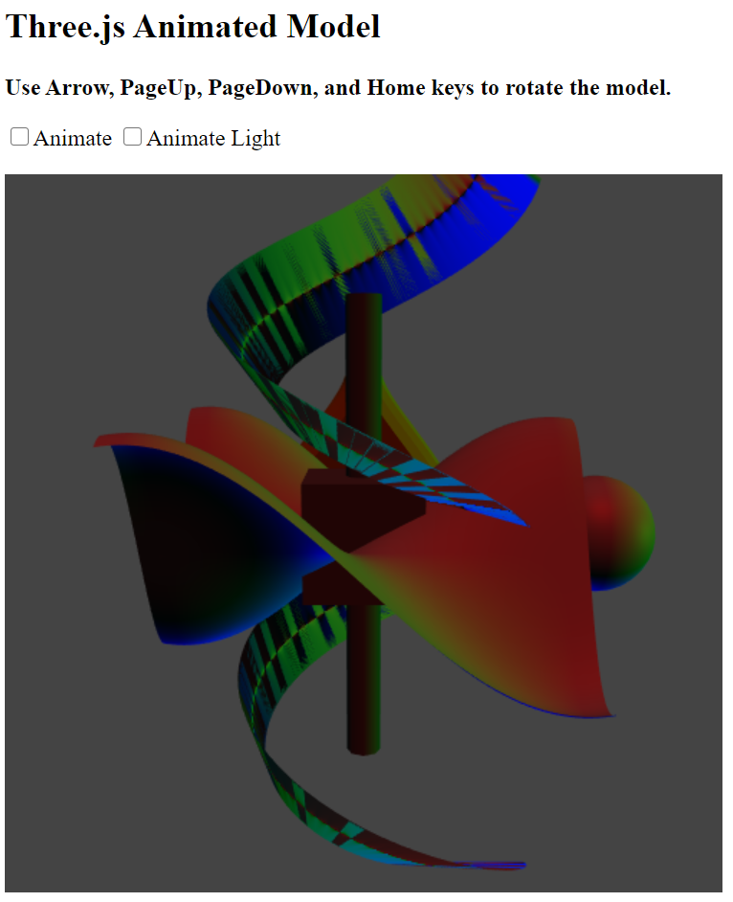

**Test Case 1**

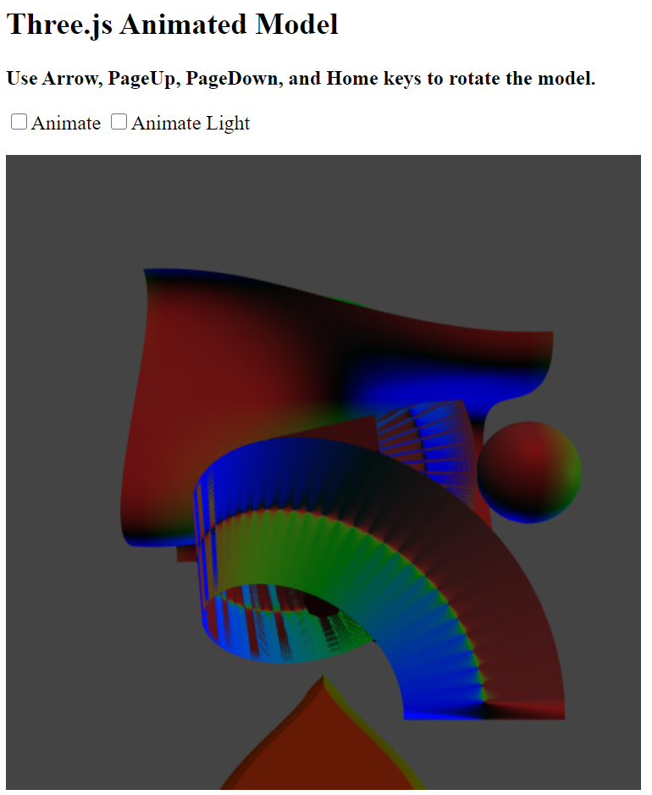

Test Case 2

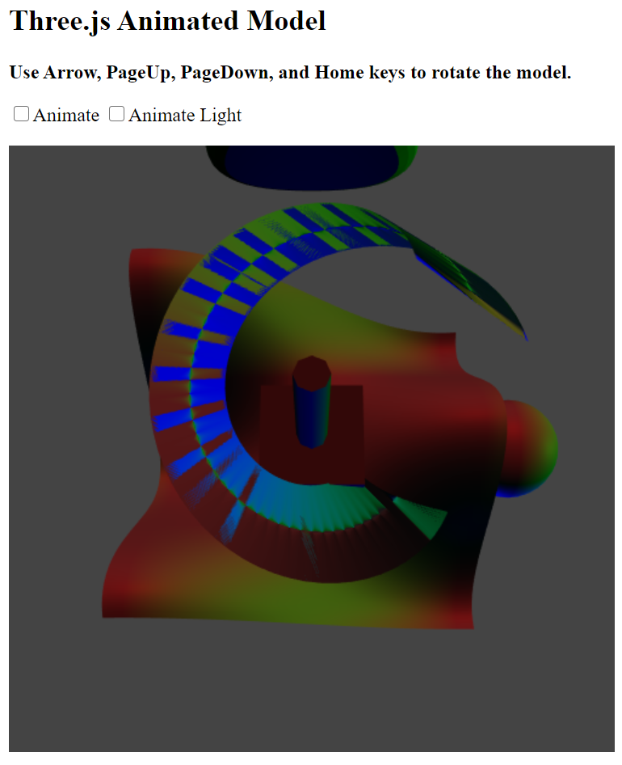

**Test Case 3**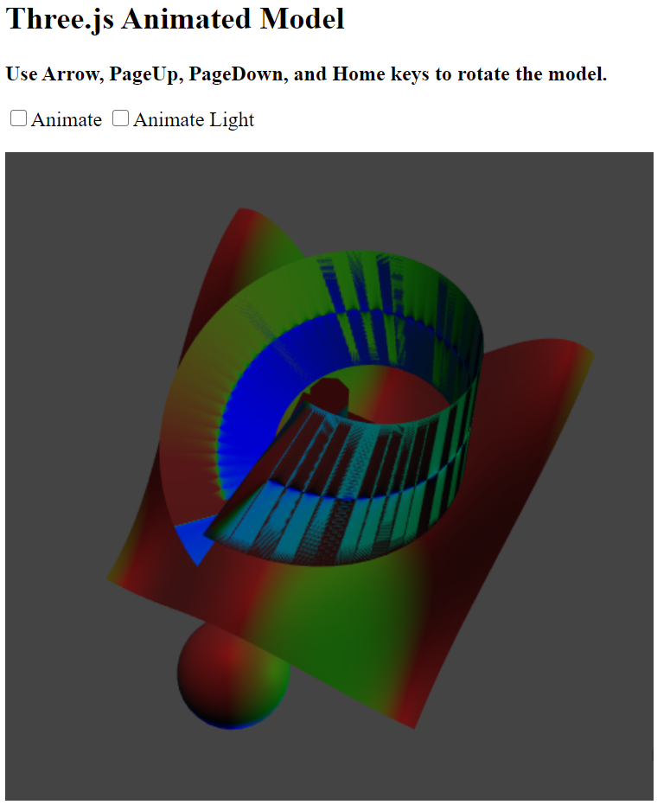

**Test Case 4**

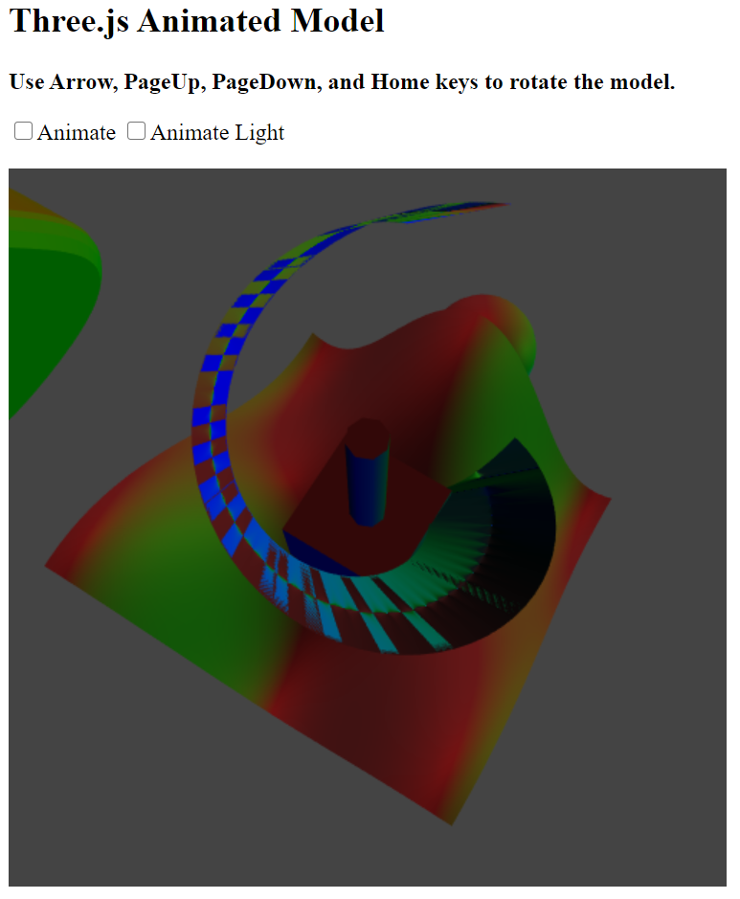

**Test Case 5**

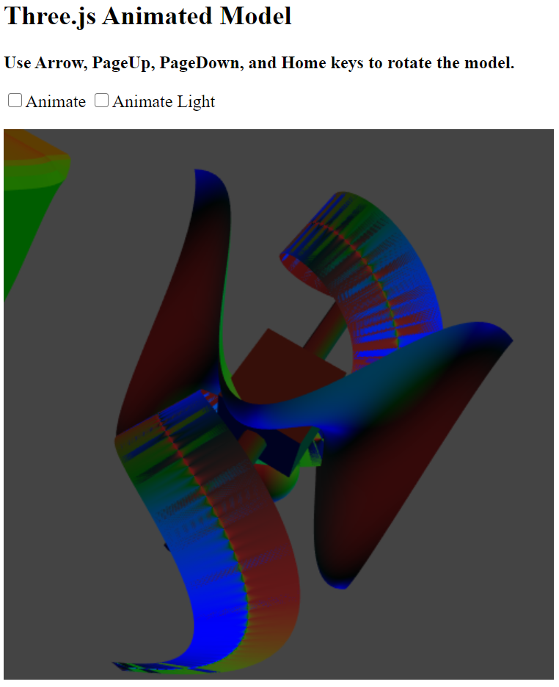

**Test Case 6**

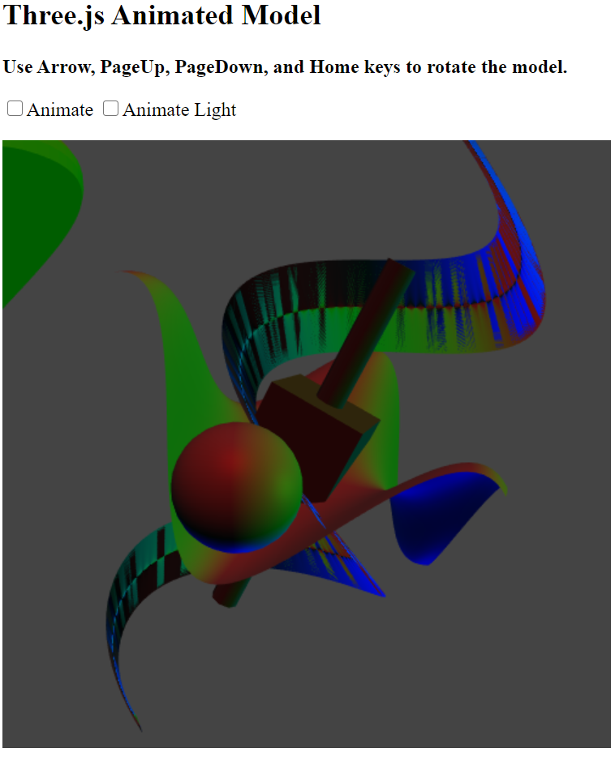

**Test Case 7**

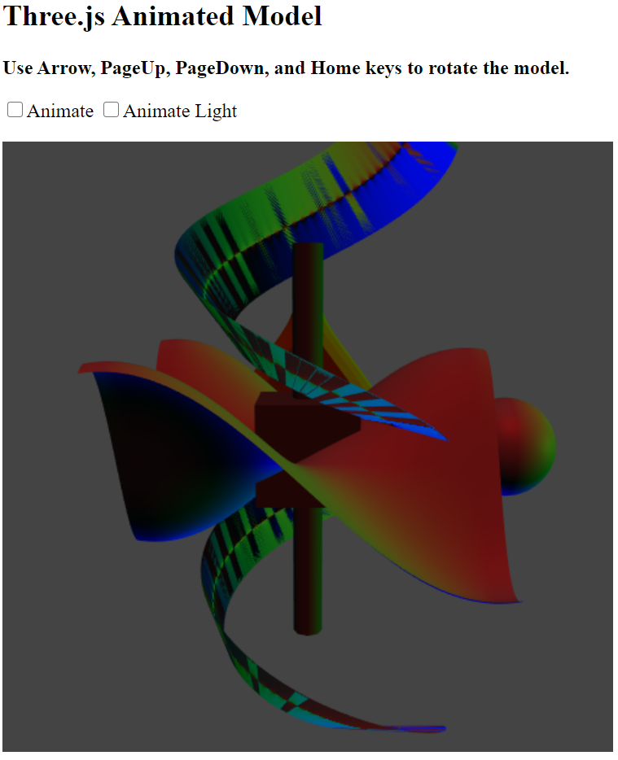

**Test Case 8**

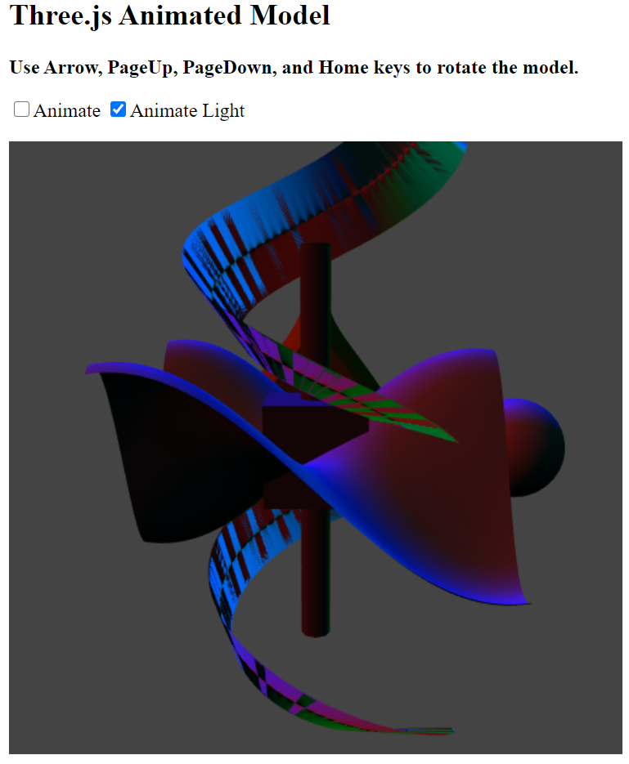

**Test Case 9**

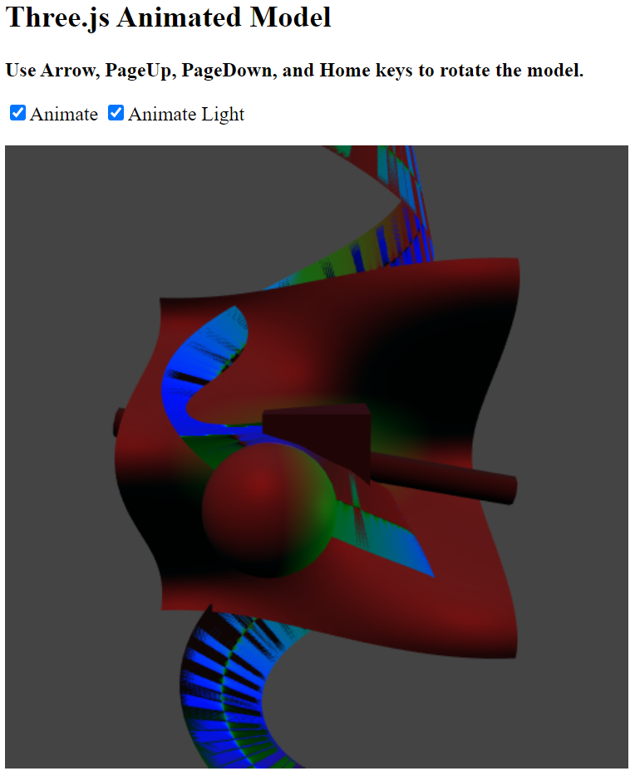

**Test Case 10**

