Kresimir Tokic  
CMSC412 Final Project  
10/5/20

Test 1

Initial launch showing initial menu options, select 0 to exit program  
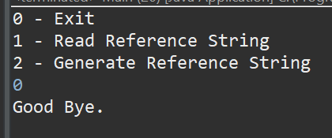

Attempt to select an item not in the menu  
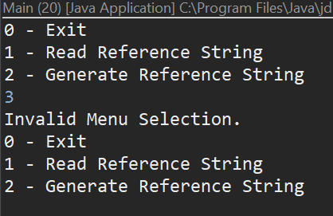

Relaunch, select 2 to generate and display random reference string, then show full menu  
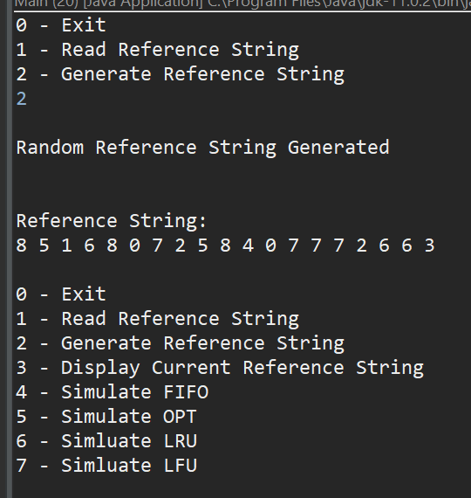

Select menu option 1, enter reference string from homework  
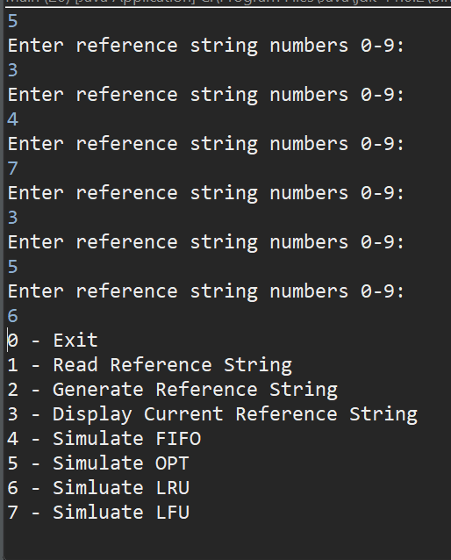

Select 3 to display the current reference string  
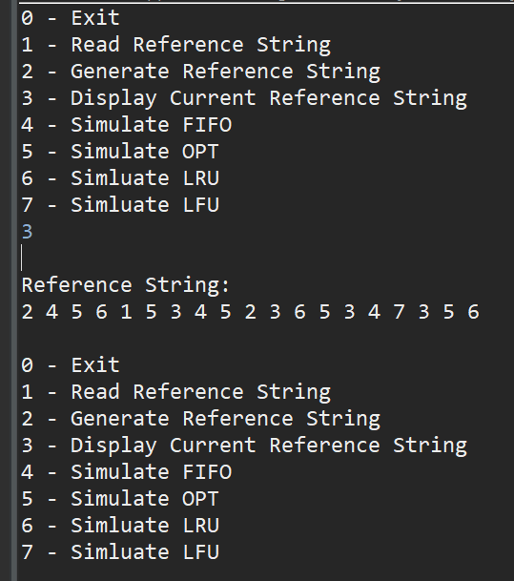

The following screen shots represent beginning, middle, ending of each simulation using the reference string and physical frame counts from the previous homework assignment.

Select 4 to Simulate FIFO (beginning of algorithm)  
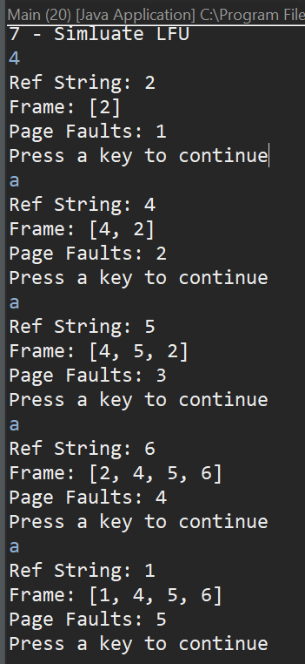

Simulate FIFO (Middle of algorithm)  
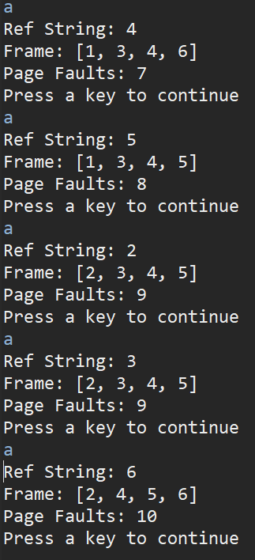

Simulate FIFO (end of algorithm)  
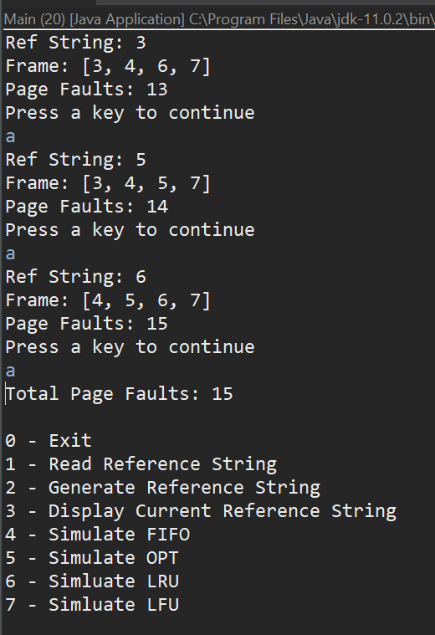

Choose 5 – Simulate OPT (begging of algorithm)  
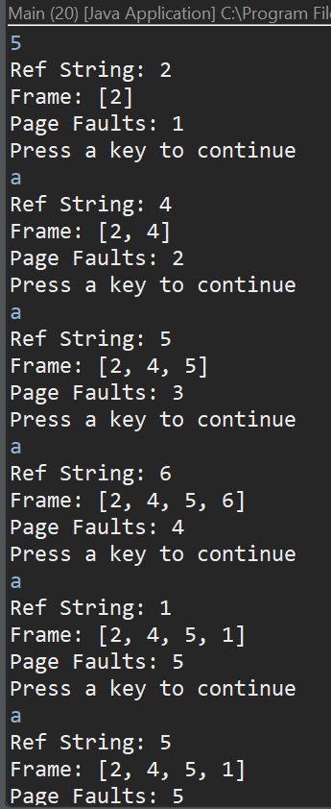

Simulate OPT (middle)  
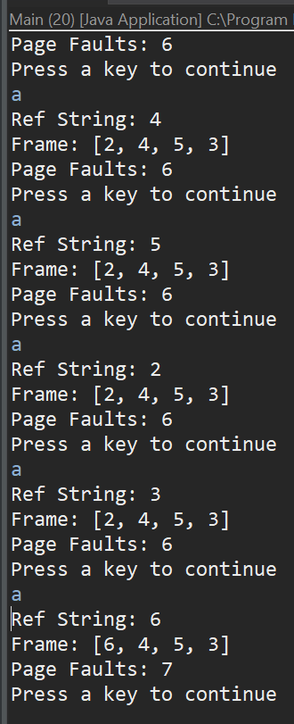

Simulate OPT (end)  
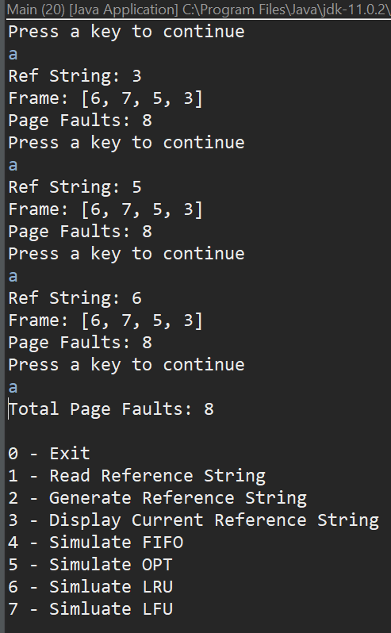

Choose 6 – Simulate LRU (beginning)  
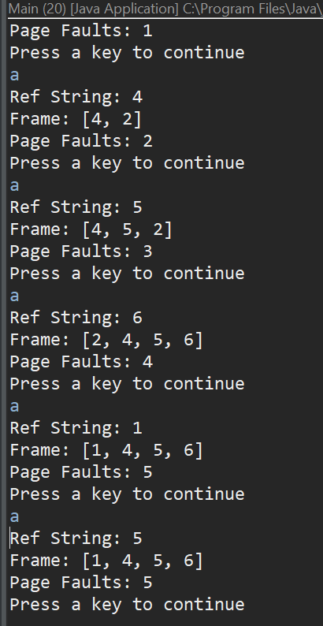

Simulate LRU (middle)  
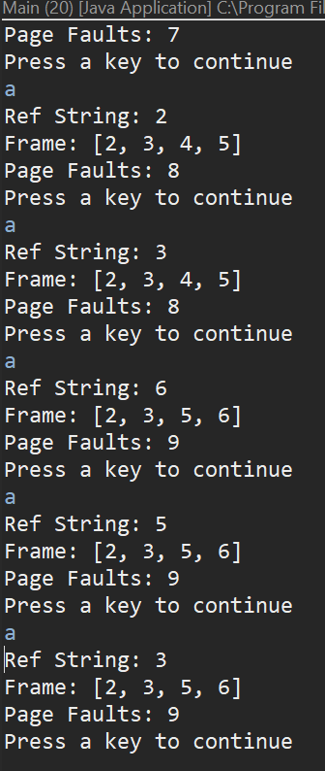

Simulate LRU (end)  
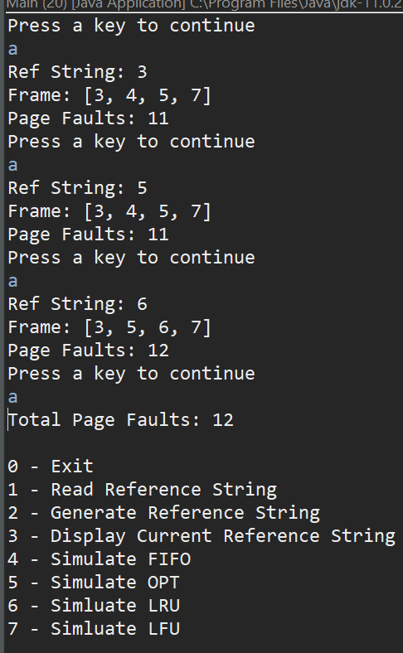

Choose 7 – Simulate LFU (beginning)  
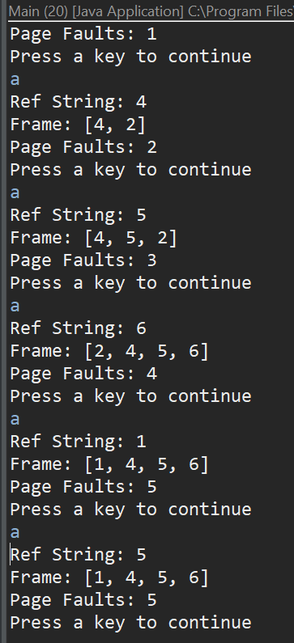  
  
  
Simulate LFU (middle)  
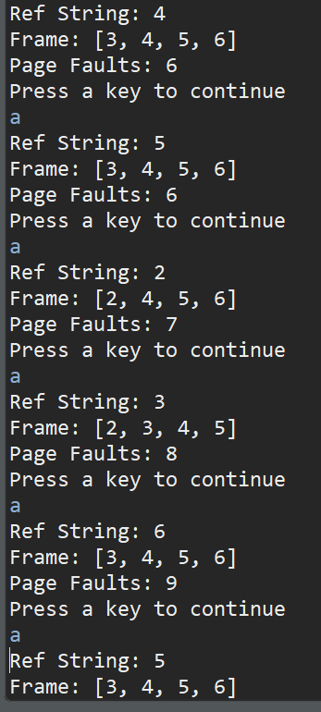

Simulate LFU (end)  
