Kresimir Tokic  
CMSC412 Final Project  
10/5/20

Test 2

The following screen shots represent the beginning, middle, and ends of each of the simulations using the reference string 0 1 2 3 4 5 6 7 8 9 0 9 1 8 2 7 3 6 4 5 and N=5.

FIFO (beginning)  
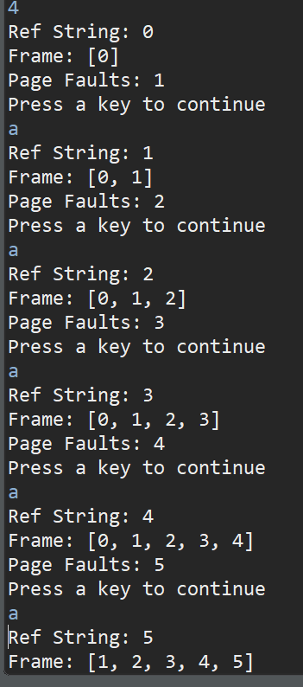

FIFO (middle)  
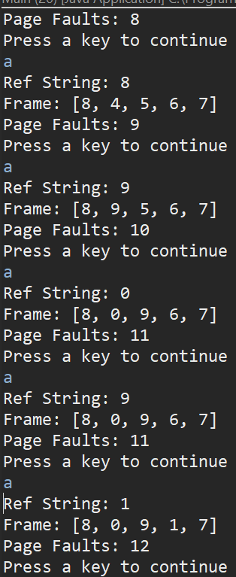

FIFO (end)  
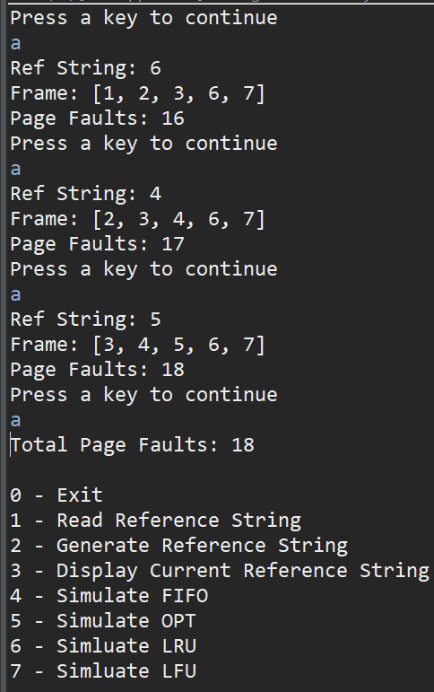

OPT (beginning)  
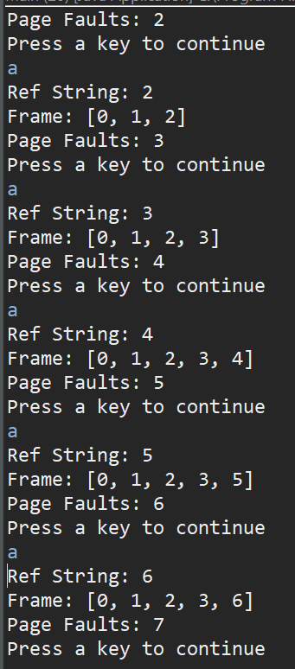

OPT (middle)  
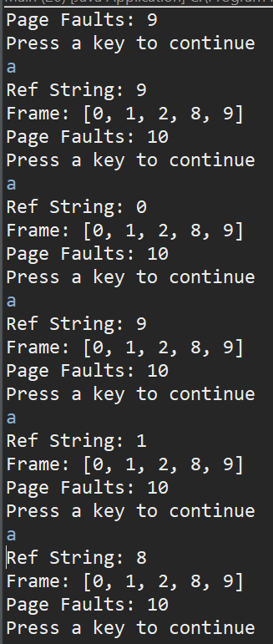

OPT (end)  
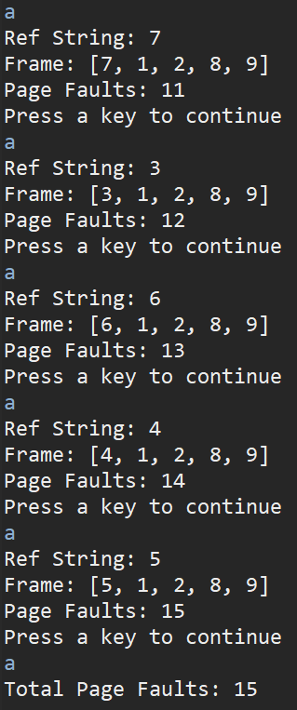

LRU (beginning)  
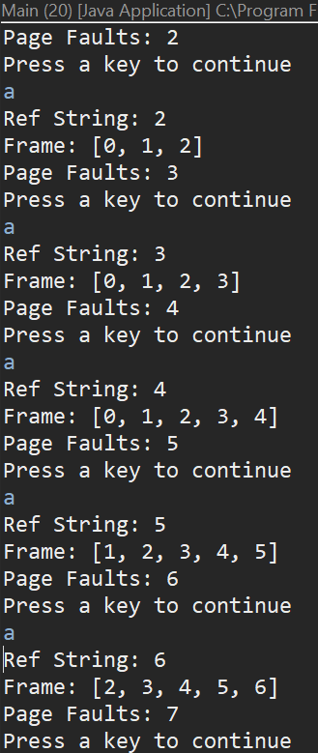

LRU (middle)  
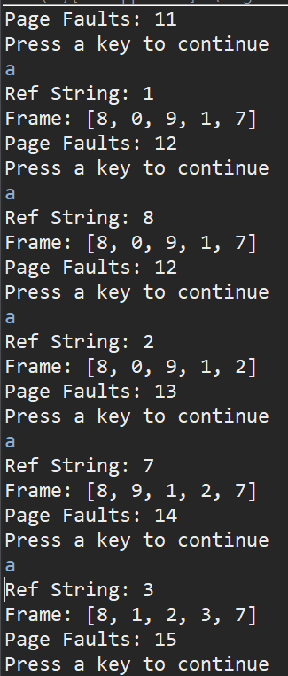

LRU (end)  
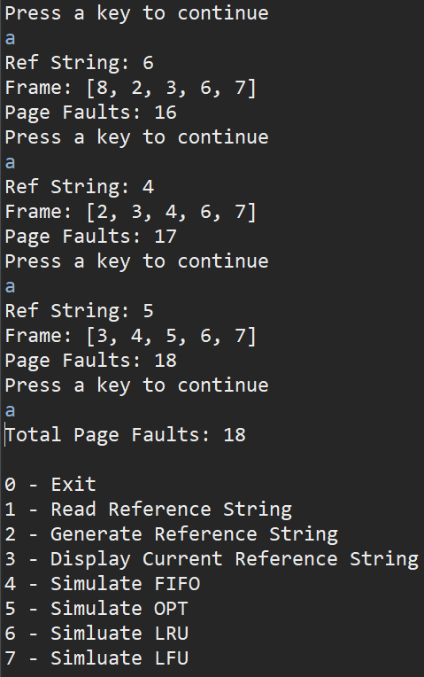

LFU (beginning)  
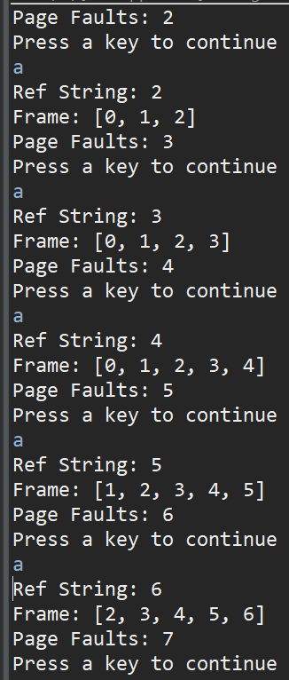

LFU (middle)  
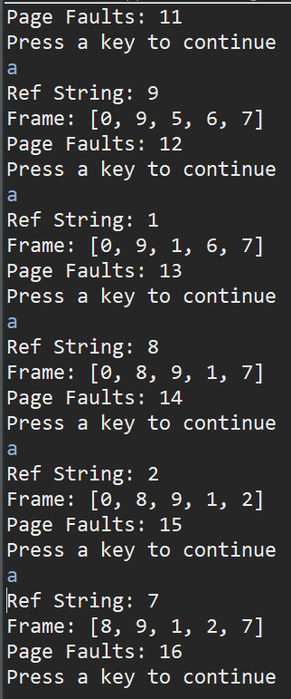

LFU (end)  
