Kresimir Tokic  
9/19/20  
CMSC412 Homework5  
  
Initial launch hides other menu options until a valid directory is selected.  
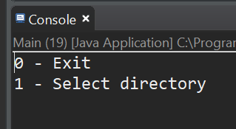

Enter 0 to exit  
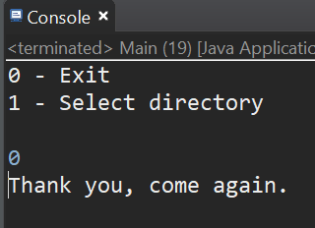

Enter non-integer  
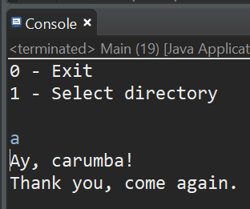

Enter 1 and invalid directory  
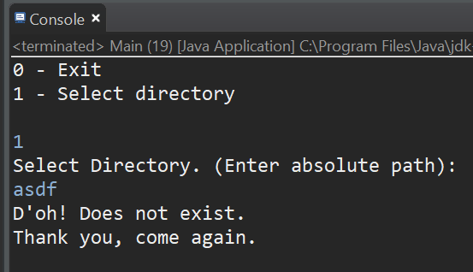

Enter 1 and valid directory  
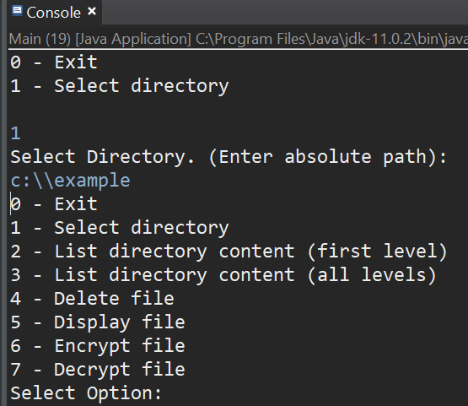

Select 2  
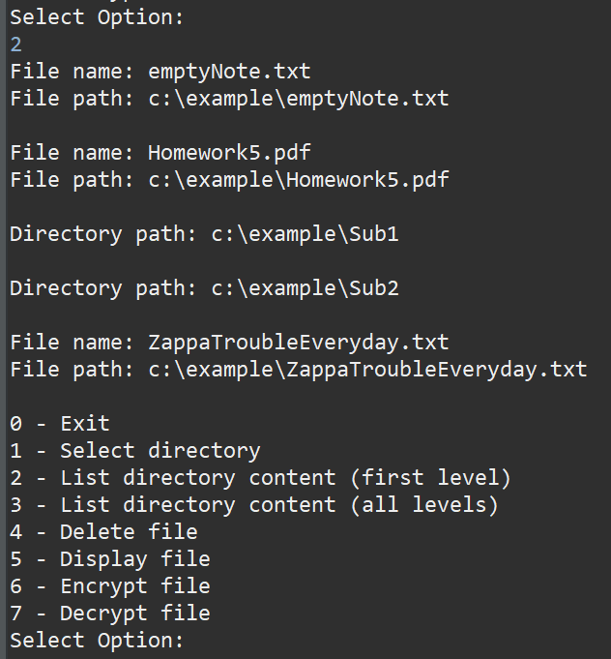

OS Screen Shot  
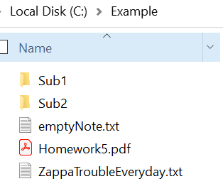

Select 3  
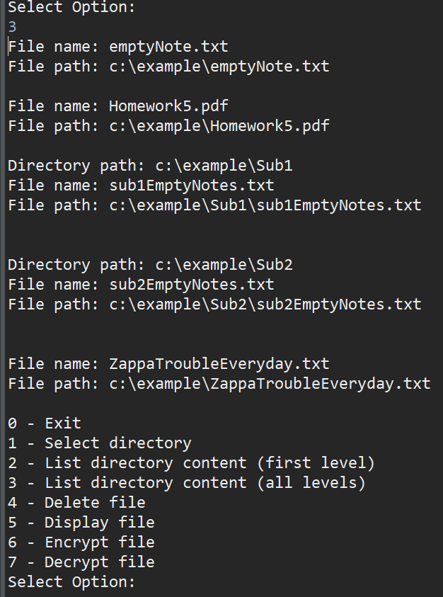

OS Screen Shots  
c:\\Example\  
  
c:\\Example\Sub1  
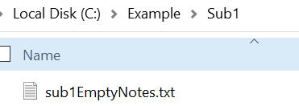

C:\\Example\Sub2  
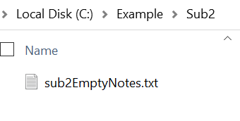

Select 4 and enter invalid file name  
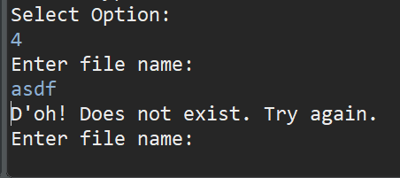

Enter valid file name  
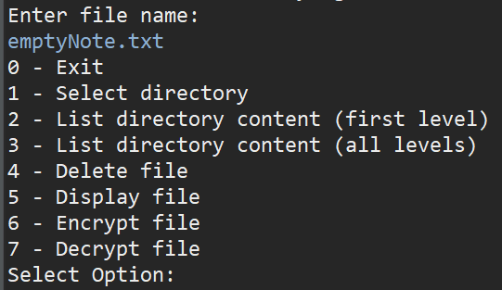

OS Screen Shot  
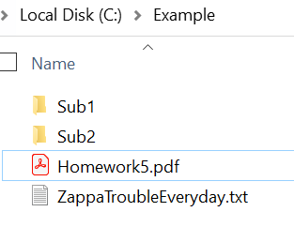

Enter 5 and invalid file name  
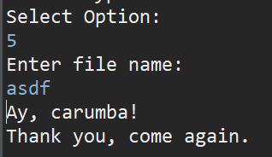

Enter valid file name  
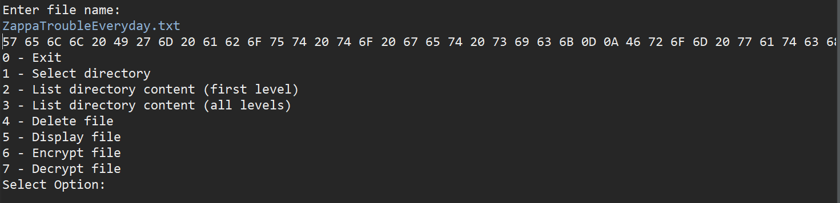

Enter 6 and invalid password  
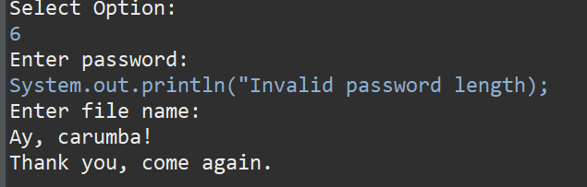

Enter 6 with valid password but invalid file name  
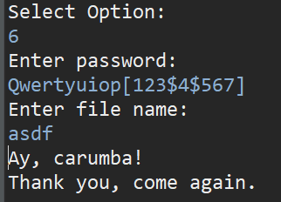

Enter 6 with valid password and valid file names  
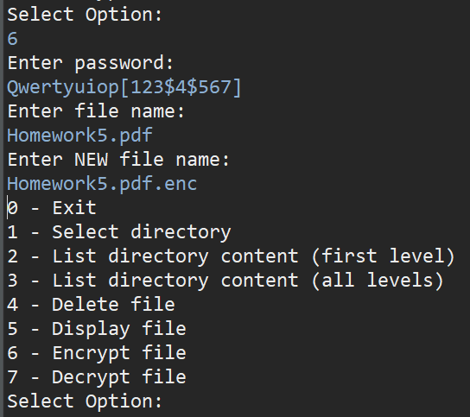

OS Screen Shot  
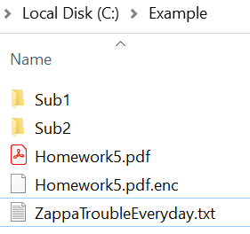

Enter 7 with valid password and file names  
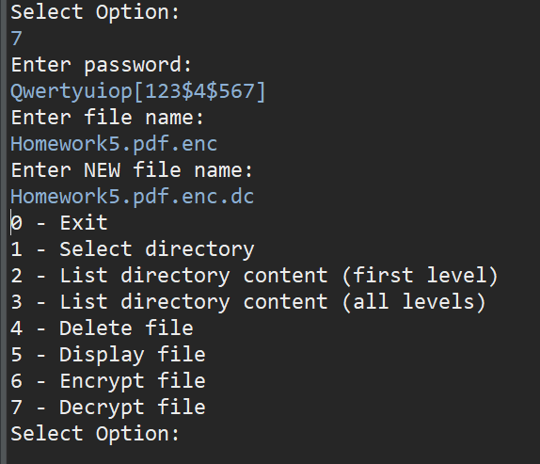

OS Screen Shot  
