Kresimir Tokic  
05/28/19  
SDEV300 6380

Lab 2

**Web Site Screen Shots**

Launch Index.html

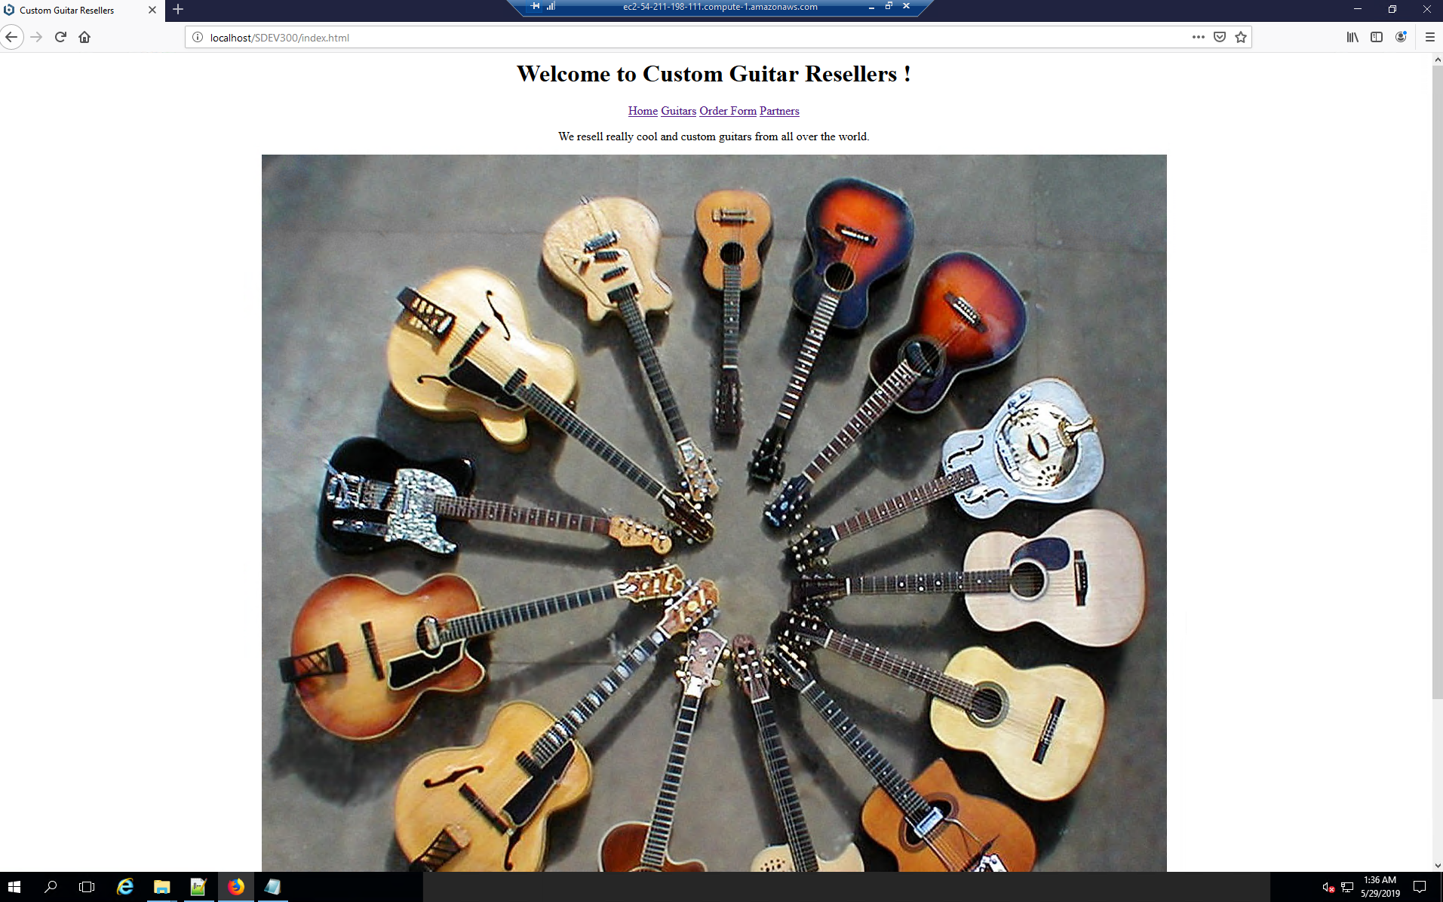

Click guitars link in navigation bar launching guitars.html

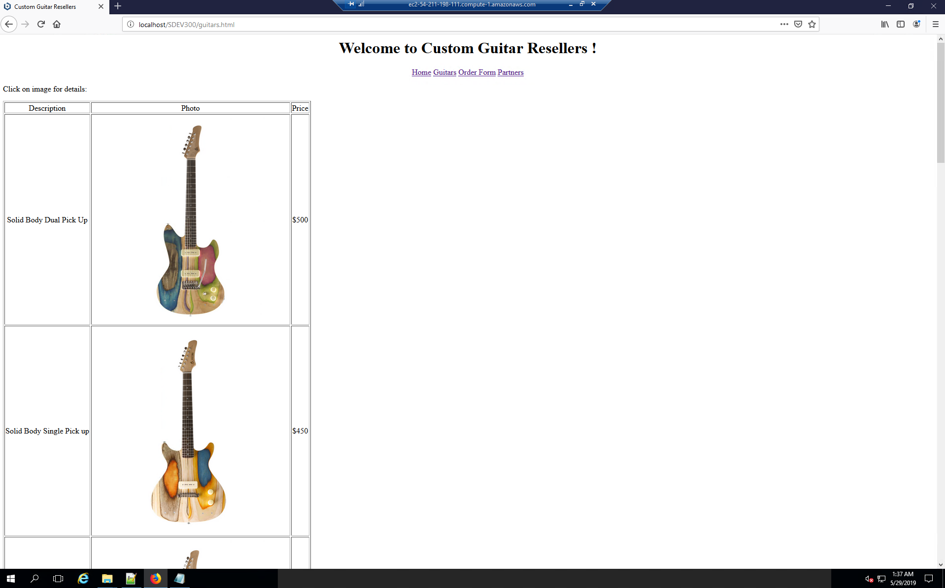

Clicking first image in table launches item details “/details/solidDual.html”

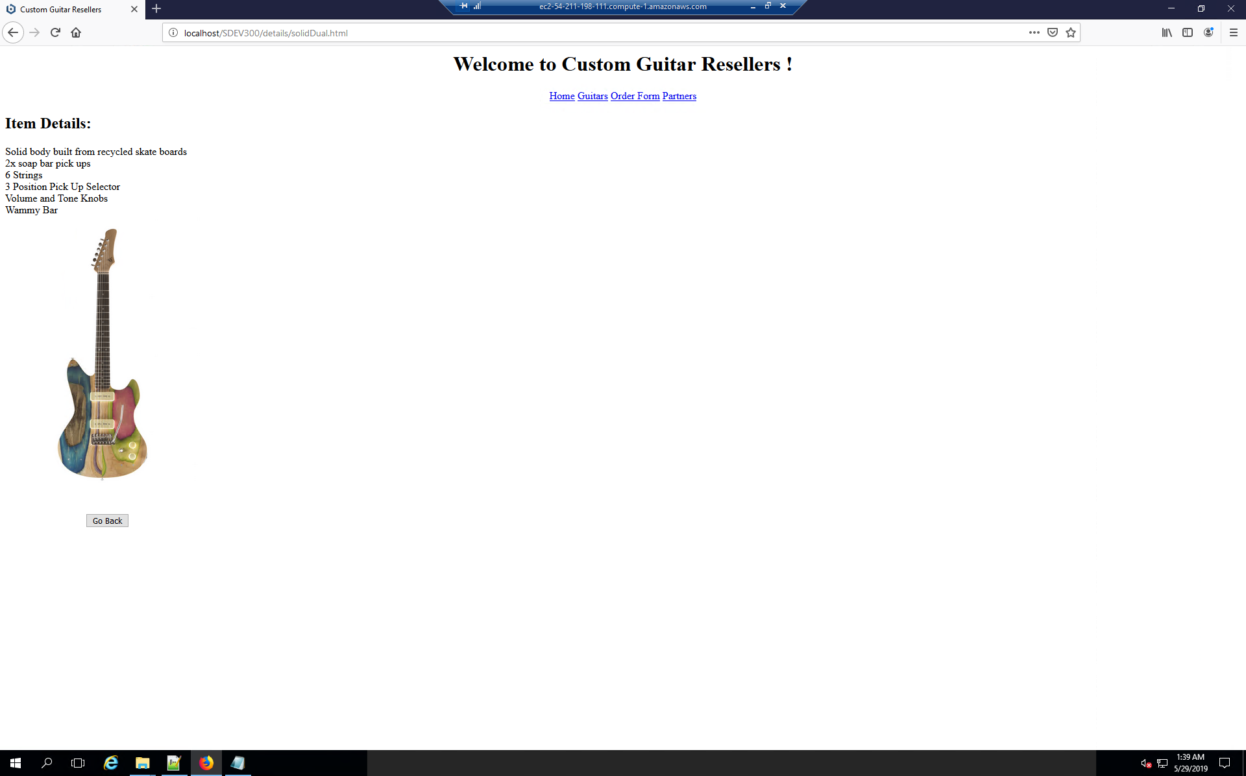

Clicking “Go Back” button runs JS script returning to previous page



Clicking “order” link at top nav bar launches orderForm.html

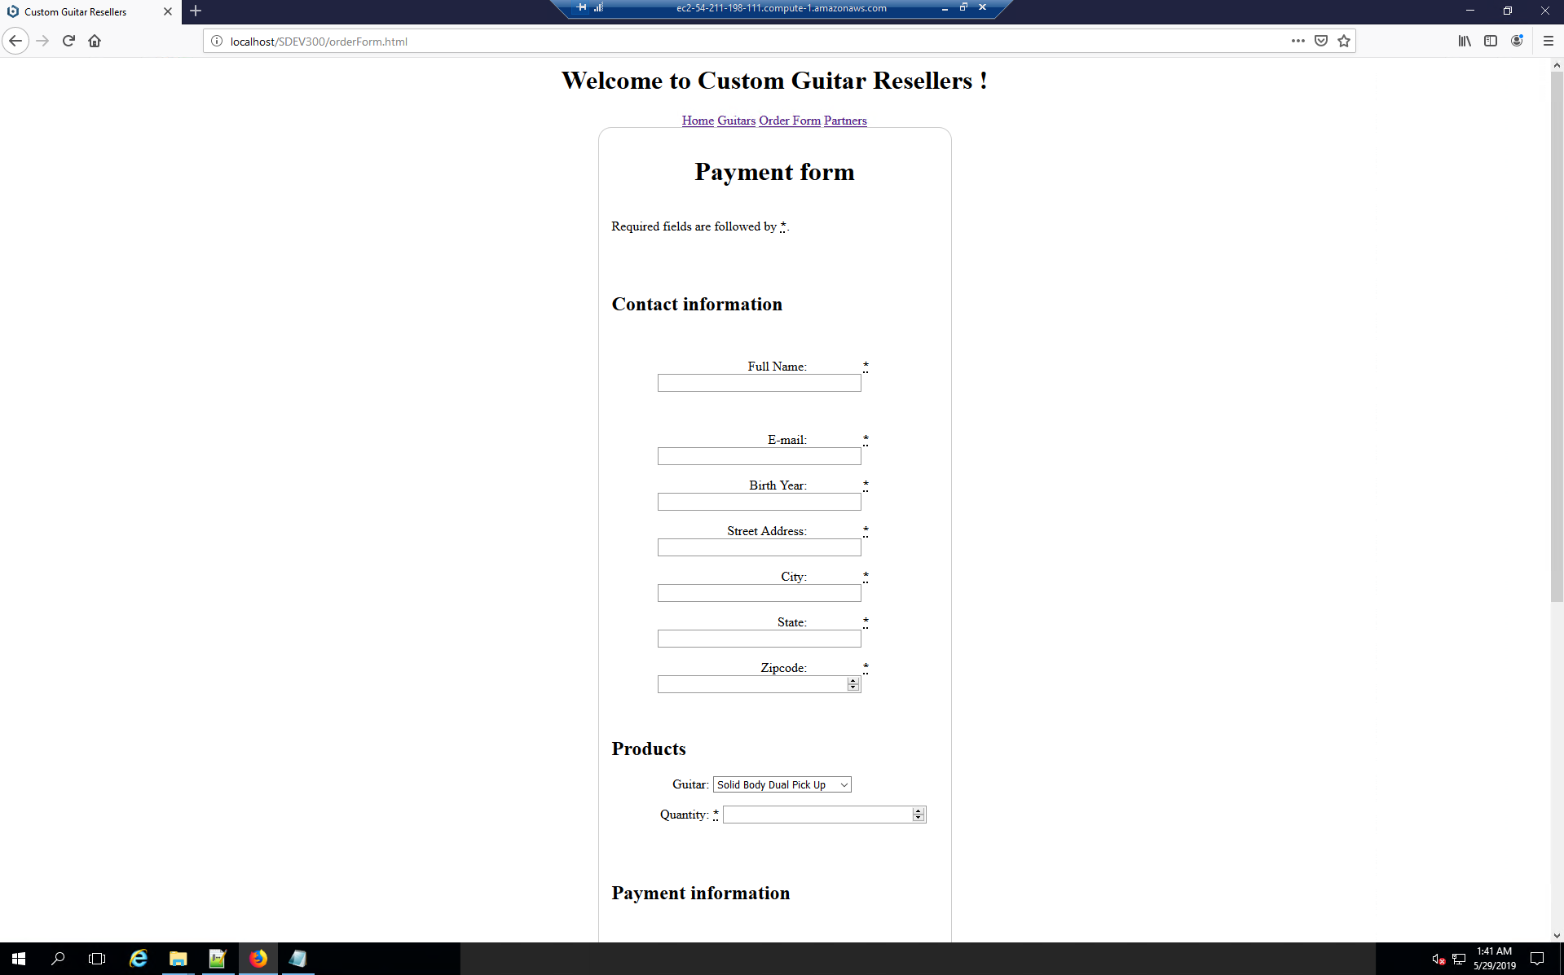

Clicking “partners” link at top nav bar launches partners.html

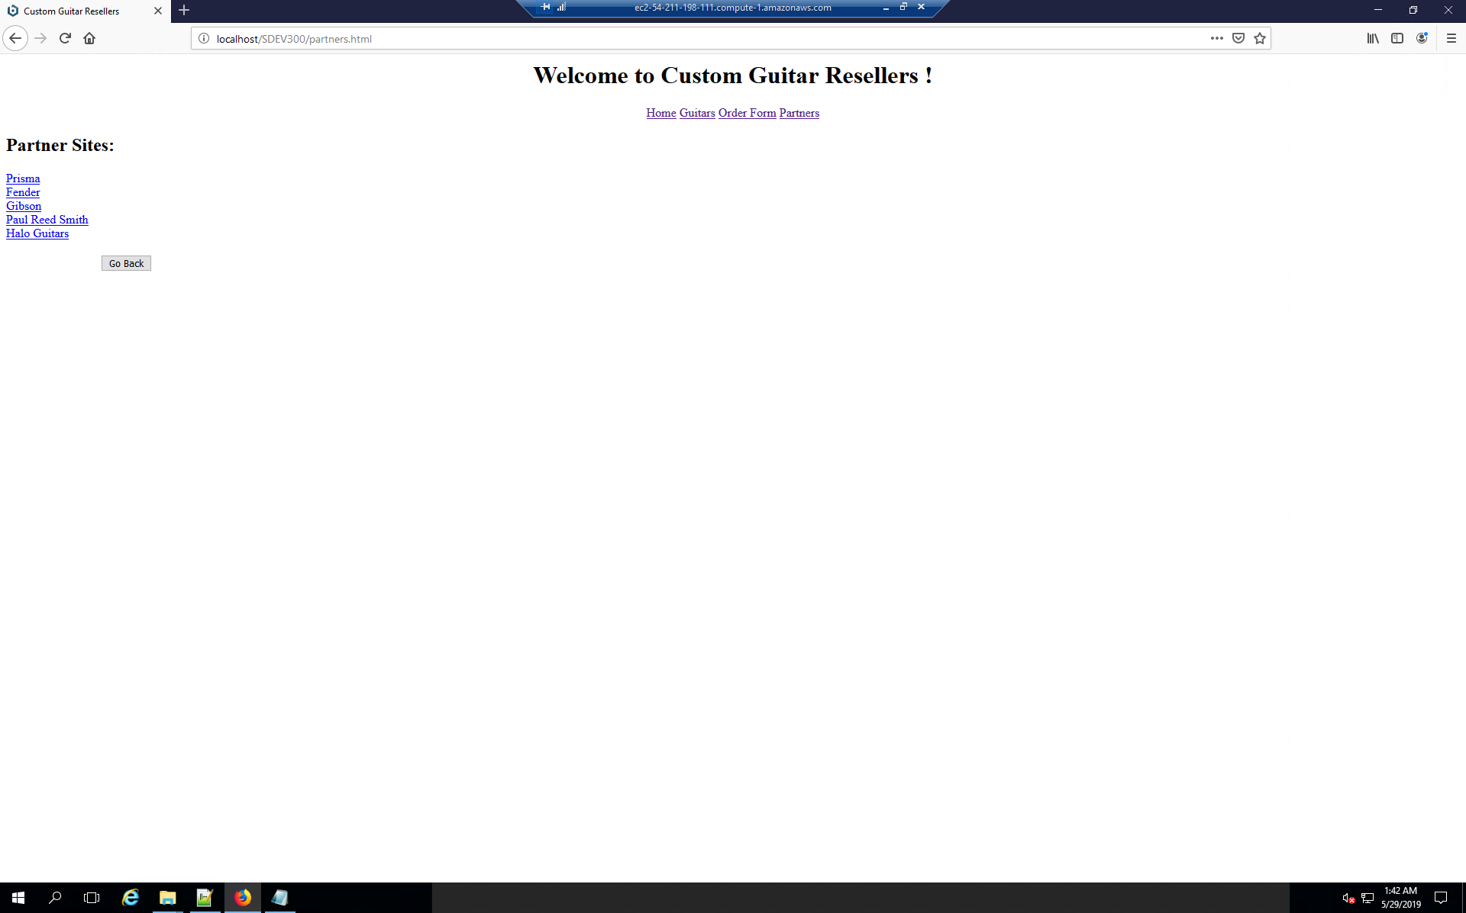

Clicking “Prisma” link takes you to prismaguitars.com

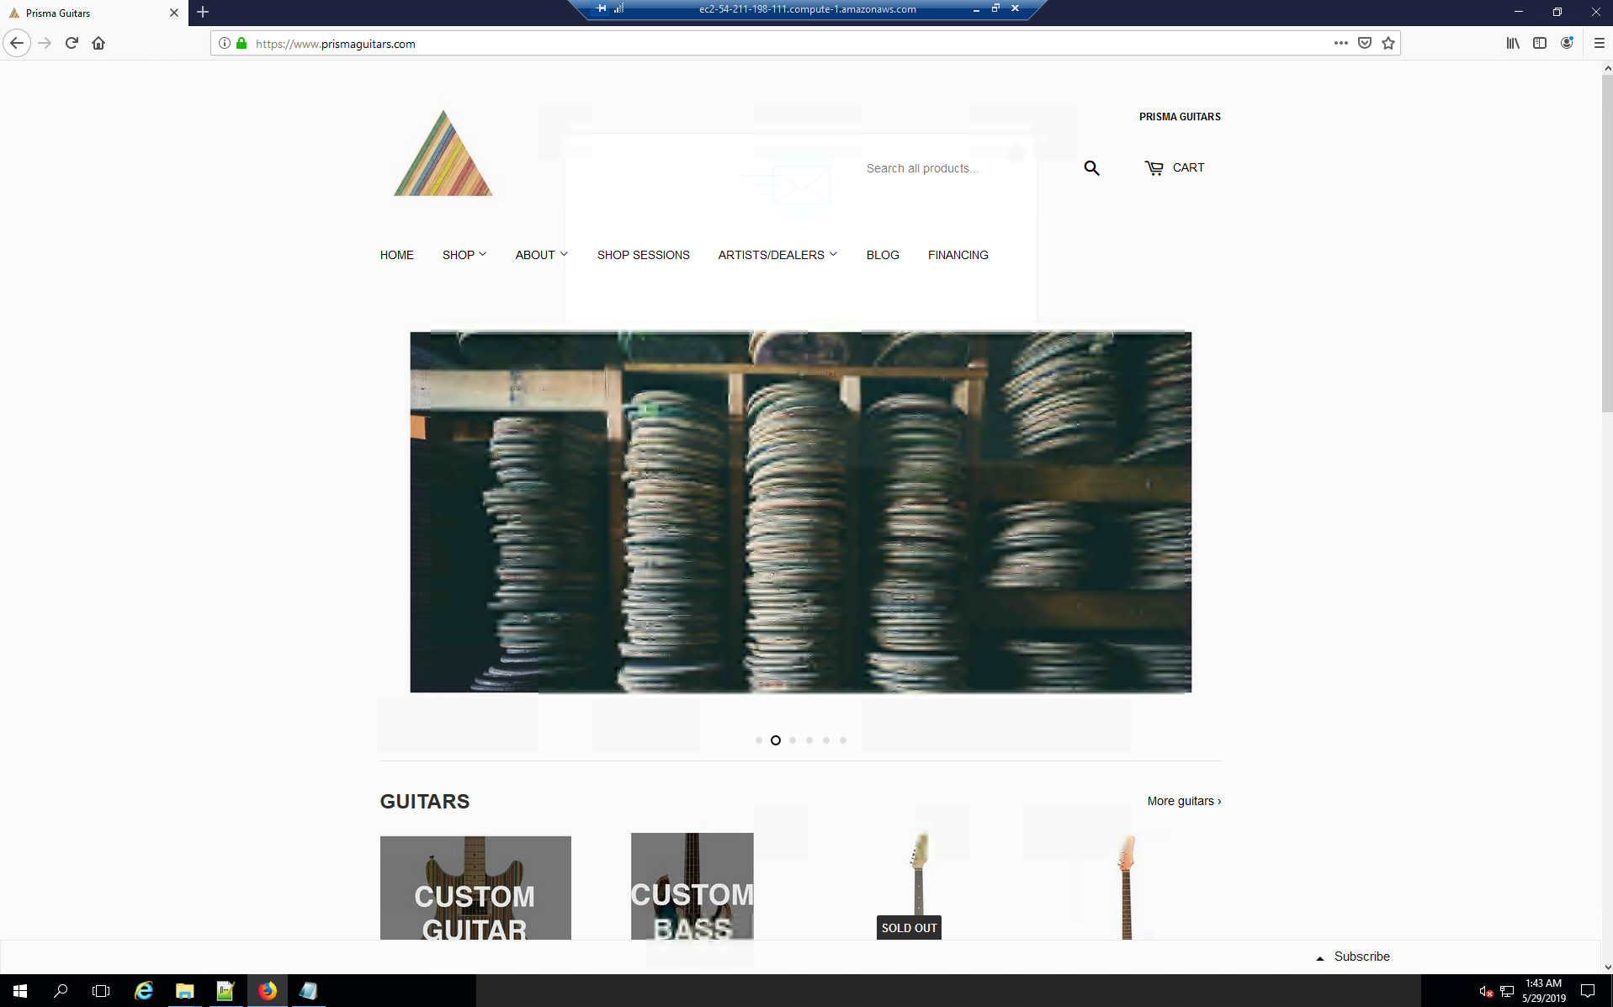

**Log Analysis**

[28/May/2019:21:32:28 +0000] "GET /SDEV300/index.html HTTP/1.1" 200 1360

Completed successful request. 200 represents a successful access. 1360 represents the size of data requested.

[28/May/2019:21:35:41 +0000] "GET /SDEV300/index.html HTTP/1.1" 200 1385

After modifying the file, successful request complete.

[28/May/2019:21:41:33 +0000] "GET /SDEV300/index.html HTTP/1.1" 200 1540

After modifying the file, successful request complete.

[28/May/2019:21:41:33 +0000] "GET /SDEV300/styles.css%3C/head%3E%3Cbody%3E%3Ch1%3EWelcome%20to%20Custom%20Guitar%20Resellers%20!%20%3C/h1%3E%3Cp%3E%3C!--%20About%20--%3E%3Cp%3EWe%20resell%20really%20cool%20and%20custom%20guitars%20from%20all%20over%20the%20world.%20Take%20a%20look%20at%20our%20guitars.%3Cul%3E%3Cli%3EElectric%20Guitars%20%3C/li%3E%3Cli%3EAcoustic%20Guitars%3C/li%3E%3Cli%3EElectric%20Bass%20Guitars%3C/li%3E%3Cli%3EAcoustic%20Bass%20Guitars%3C/li%3E%3Cli%3EDIY%20Kits%3C/li%3E%3C/ul%3E%3C/p%3E%3C!--%20Merchandise%20and%20links%20in%20a%20table%20--%3E%3Cp%3ECheck%20out%20our%20Gutiars:%3C/p%3E%3Ctable%20border= HTTP/1.1" 403 765

Access to file forbidden, I think I didn’t include the styles.css correctly at this time. 403 represents a permission error when attempting to access data. 765 represents the size.

[28/May/2019:21:41:55 +0000] "GET /SDEV300/index.html HTTP/1.1" 200 1541

Edit fixed.

[28/May/2019:21:41:55 +0000] "GET /SDEV300/styles.css%3E%3C/head%3E%3Cbody%3E%3Ch1%3EWelcome%20to%20Custom%20Guitar%20Resellers%20!%20%3C/h1%3E%3Cp%3E%3C!--%20About%20--%3E%3Cp%3EWe%20resell%20really%20cool%20and%20custom%20guitars%20from%20all%20over%20the%20world.%20Take%20a%20look%20at%20our%20guitars.%3Cul%3E%3Cli%3EElectric%20Guitars%20%3C/li%3E%3Cli%3EAcoustic%20Guitars%3C/li%3E%3Cli%3EElectric%20Bass%20Guitars%3C/li%3E%3Cli%3EAcoustic%20Bass%20Guitars%3C/li%3E%3Cli%3EDIY%20Kits%3C/li%3E%3C/ul%3E%3C/p%3E%3C!--%20Merchandise%20and%20links%20in%20a%20table%20--%3E%3Cp%3ECheck%20out%20our%20Gutiars:%3C/p%3E%3Ctable%20border= HTTP/1.1" 403 769

Bad CSS style sheet again.

[28/May/2019:21:41:55 +0000] "GET /SDEV300/styles.css%3E%3C/head%3E%3Cbody%3E%3Ch1%3EWelcome%20to%20Custom%20Guitar%20Resellers%20!%20%3C/h1%3E%3Cp%3E%3C!--%20About%20--%3E%3Cp%3EWe%20resell%20really%20cool%20and%20custom%20guitars%20from%20all%20over%20the%20world.%20Take%20a%20look%20at%20our%20guitars.%3Cul%3E%3Cli%3EElectric%20Guitars%20%3C/li%3E%3Cli%3EAcoustic%20Guitars%3C/li%3E%3Cli%3EElectric%20Bass%20Guitars%3C/li%3E%3Cli%3EAcoustic%20Bass%20Guitars%3C/li%3E%3Cli%3EDIY%20Kits%3C/li%3E%3C/ul%3E%3C/p%3E%3C!--%20Merchandise%20and%20links%20in%20a%20table%20--%3E%3Cp%3ECheck%20out%20our%20Gutiars:%3C/p%3E%3Ctable%20border= HTTP/1.1" 403 769

Bad again.

[28/May/2019:21:42:14 +0000] "GET /SDEV300/index.html HTTP/1.1" 200 1541

Fixed.

[28/May/2019:21:42:14 +0000] "GET /SDEV300/styles.css%3E%3C/head%3E%3Cbody%3E%3Ch1%3EWelcome%20to%20Custom%20Guitar%20Resellers%20!%20%3C/h1%3E%3Cp%3E%3C!--%20About%20--%3E%3Cp%3EWe%20resell%20really%20cool%20and%20custom%20guitars%20from%20all%20over%20the%20world.%20Take%20a%20look%20at%20our%20guitars.%3Cul%3E%3Cli%3EElectric%20Guitars%20%3C/li%3E%3Cli%3EAcoustic%20Guitars%3C/li%3E%3Cli%3EElectric%20Bass%20Guitars%3C/li%3E%3Cli%3EAcoustic%20Bass%20Guitars%3C/li%3E%3Cli%3EDIY%20Kits%3C/li%3E%3C/ul%3E%3C/p%3E%3C!--%20Merchandise%20and%20links%20in%20a%20table%20--%3E%3Cp%3ECheck%20out%20our%20Gutiars:%3C/p%3E%3Ctable%20border= HTTP/1.1" 403 769

Continuing to edit style sheet with errors.

[28/May/2019:21:42:14 +0000] "GET /SDEV300/styles.css%3E%3C/head%3E%3Cbody%3E%3Ch1%3EWelcome%20to%20Custom%20Guitar%20Resellers%20!%20%3C/h1%3E%3Cp%3E%3C!--%20About%20--%3E%3Cp%3EWe%20resell%20really%20cool%20and%20custom%20guitars%20from%20all%20over%20the%20world.%20Take%20a%20look%20at%20our%20guitars.%3Cul%3E%3Cli%3EElectric%20Guitars%20%3C/li%3E%3Cli%3EAcoustic%20Guitars%3C/li%3E%3Cli%3EElectric%20Bass%20Guitars%3C/li%3E%3Cli%3EAcoustic%20Bass%20Guitars%3C/li%3E%3Cli%3EDIY%20Kits%3C/li%3E%3C/ul%3E%3C/p%3E%3C!--%20Merchandise%20and%20links%20in%20a%20table%20--%3E%3Cp%3ECheck%20out%20our%20Gutiars:%3C/p%3E%3Ctable%20border= HTTP/1.1" 403 769

Continuing to edit style sheet with errors.

[28/May/2019:21:42:45 +0000] "GET /SDEV300/index.html HTTP/1.1" 200 1482

Fixed.

[28/May/2019:21:42:59 +0000] "GET /SDEV300/index.html HTTP/1.1" 200 1499

Modified index successfully.

[28/May/2019:21:42:59 +0000] "GET /SDEV300/styles.css%3E%20%20%3C/head%3E%3Cbody%3E%3Ch1%3EWelcome%20to%20Custom%20Guitar%20Resellers%20!%20%3C/h1%3E%3Cp%3E%3C!--%20About%20--%3E%3Cp%3EWe%20resell%20really%20cool%20and%20custom%20guitars%20from%20all%20over%20the%20world.%20Take%20a%20look%20at%20our%20guitars.%3Cul%3E%3Cli%3EElectric%20Guitars%20%3C/li%3E%3Cli%3EAcoustic%20Guitars%3C/li%3E%3Cli%3EElectric%20Bass%20Guitars%3C/li%3E%3Cli%3EAcoustic%20Bass%20Guitars%3C/li%3E%3Cli%3EDIY%20Kits%3C/li%3E%3C/ul%3E%3C/p%3E%3C!--%20Merchandise%20and%20links%20in%20a%20table%20--%3E%3Cp%3ECheck%20out%20our%20Gutiars:%3C/p%3E%3Ctable%20border= HTTP/1.1" 403 771

Stylesheet tweaks.

[28/May/2019:21:43:19 +0000] "GET /SDEV300/index.html HTTP/1.1" 200 1479

Fixed.

[28/May/2019:21:43:48 +0000] "GET /SDEV300/index.html HTTP/1.1" 200 1458

Tweaks.

[28/May/2019:21:44:04 +0000] "GET /SDEV300/index.html HTTP/1.1" 200 1479

Tweaks.

[28/May/2019:21:44:16 +0000] "GET /SDEV300/index.html HTTP/1.1" 200 1479

Refresh.

[28/May/2019:21:44:39 +0000] "GET /SDEV300/index.html HTTP/1.1" 200 1475

Tweaks.

[28/May/2019:21:52:47 +0000] "GET /SDEV300/index.html HTTP/1.1" 200 1438

Navigating site.

[28/May/2019:21:52:49 +0000] "GET /SDEV300/details/solidDual.html HTTP/1.1" 200 471

Navigating site.

[28/May/2019:21:56:35 +0000] "GET /SDEV300/details/solidDual.html HTTP/1.1" 200 541

Tweaks to product detail.

[28/May/2019:21:58:54 +0000] "GET /SDEV300/details/solidSingle.html HTTP/1.1" 200 525

Testing product detail.

[28/May/2019:22:01:23 +0000] "GET /SDEV300/details/hollowBody.html HTTP/1.1" 200 545

Testing product detail.

[28/May/2019:22:03:58 +0000] "GET /SDEV300/index.html HTTP/1.1" 200 1510

Navigating site.

[28/May/2019:22:04:40 +0000] "GET /SDEV300/index.html HTTP/1.1" 200 1584

Navigating site.

[28/May/2019:23:45:08 +0000] "GET /SDEV300/index.html HTTP/1.1" 200 1584

Refresh.

[29/May/2019:00:40:30 +0000] "GET /SDEV300/details/solidDual.html HTTP/1.1" 200 541

Testing product detail.

[29/May/2019:01:07:47 +0000] "GET /SDEV300/index.html HTTP/1.1" 200 623

Navigating.

[29/May/2019:01:07:47 +0000] "GET /SDEV300/style.css HTTP/1.1" 200 457

Calling style sheet.

[29/May/2019:01:07:56 +0000] "GET /SDEV300/guitars.html HTTP/1.1" 404 218

I forgot to include the file, resulting in 404 error.

[29/May/2019:01:08:20 +0000] "GET /SDEV300/guitars.html HTTP/1.1" 200 1174

Included it, and successful request.

[29/May/2019:01:08:20 +0000] "GET /SDEV300/style.css HTTP/1.1" 200 457

Calling style sheet.

[29/May/2019:01:08:29 +0000] "GET /SDEV300/orderForm.html HTTP/1.1" 200 1371

Checking order form

[29/May/2019:01:08:29 +0000] "GET /SDEV300/style.css HTTP/1.1" 200 457

Calling style sheet.

[29/May/2019:01:08:35 +0000] "GET /SDEV300/partners.html HTTP/1.1" 200 659

Testing partners page

[29/May/2019:01:08:35 +0000] "GET /style.css HTTP/1.1" 404 207

Missing style sheet

[29/May/2019:01:09:38 +0000] "GET /SDEV300/partners.html HTTP/1.1" 200 660

Testing partner page.