Level 1 Questions

1. What are the names of the latest three versions of Android?

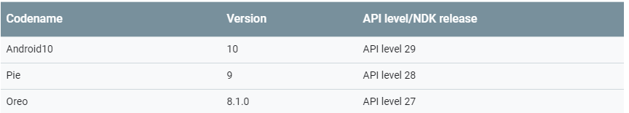

1. What does the abbreviation ART stands for?

Android Runtime (<https://en.wikipedia.org/wiki/Android_Runtime>)

1. What is Android Jetpack?

Jetpack is a suite of libraries, tools, and guidance to help developers write high-quality apps easier. These components help you follow best practices, free you from writing boilerplate code, and simplify complex tasks, so you can focus on the code you care about.

Jetpack comprises the [androidx.*](https://developer.android.com/jetpack/androidx) package libraries, unbundled from the platform APIs. This means that it offers backward compatibility and is updated more frequently than the Android platform, making sure you always have access to the latest and greatest versions of the Jetpack components.

1. Describe the difference between the fixed, wrap_content and match_constraint setting of the constraint layout?  
     
   fixed: fixed constraint, for example 123dp.  
   Wrap content : Setting a View's size to wrap_content will force it to expand only far enough to contain the values (or child controls) it contains.  For controls -- like text boxes (TextView) or images (ImageView) -- this will wrap the text or image being shown. For layout elements it will resize the layout to fit the controls / layouts added as its children.

Match_constraint:   
  
When a dimension is set to MATCH_CONSTRAINT, the default behavior is to have the resulting size take all the available space.

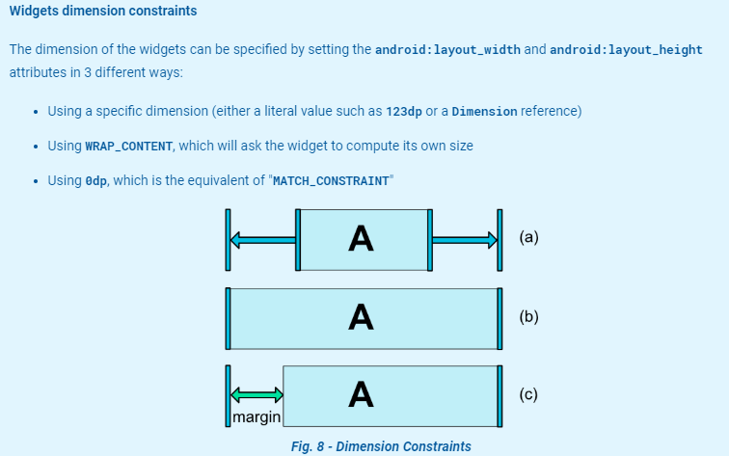

 (a) is wrap_content  
(b) is 0dp  
(c) with 0dp If margins are set, they will be taken in account in the computation   
<https://developer.android.com/reference/android/support/constraint/ConstraintLayout>

1. What does the abbreviation DP stand for and why do we need them?

 Density Independent Pixel, it varies based on screen density. This is used to be able to make the app responsive. (similar dimension on the different android devices available)

1. What is the purpose of the string.xml file?  
   XML itself is designed to give a great amount of flexibility in marking up and passing around arbitrary data. The string.xml file is doing this but just for strings.
2. Why is the layout in Android specified by .xml files?  Why not just have the layout in the code (Kotlin or Java)?  
   “Its because its simpler - tools can be written to manipulate a XML document far easier than understand java code, so the layout can be created and modified by a simple tool that does not need to also be a java parser.

Its also easier for people to describe a layout in XML than in java directly.”

(<https://softwareengineering.stackexchange.com/questions/307768/why-use-xml-in-android>)

1. What kind of information can be found in the manifest file?

“The manifest file describes essential information about your app to the Android build tools, the Android operating system, and Google Play. Among many other things, the manifest file is required to declare the following: The app's package name, which usually matches your code's namespace.”

(<https://developer.android.com/guide/topics/manifest/manifest-intro>)