Court Proceedings Management System (CPMS)
Project Presentation, Demonstration Walkthrough & Software Testing Guide
Authoritative Handbook for Evaluation, Live Demonstration, Manual/Automated Test Cases, and Presentation Slides

1. Executive Project Overview
The Court Proceedings Management System (CPMS) is an enterprise-grade digital judicial platform designed to eliminate manual paper backlogs, streamline court workflows, automate hearing schedules, manage digital evidence, and issue certified judgments. The platform connects five core user roles (Administrator, Judge, Lawyer, Court Staff, and Client) under a shared database and strict 12-state judicial lifecycle workflow.
★ Comprehensive System Scope
CPMS incorporates all five documented modules: (1) Authentication & Role Control, (2) Case Management & Proceedings, (3) Hearing Scheduling, (4) Evidence Management Vault, and (5) Notifications & Analytics, alongside a genuine AI Case Summary Assistant.

2. Step-by-Step Live Demonstration Walkthrough
Follow this step-by-step walkthrough to present the website effortlessly during your viva or demonstration. It is structured so that you can simply read the actions and dialogue out loud.

Step 1: Open the Portal and Explore the Homepage
• Action: Open your web browser and navigate to http://127.0.0.1:8080/. Show the clean judicial header and the five dedicated role portal cards:
1. Administrator (System Monitoring & Judge Bench Assignment)
2. Judge (Assigned Dockets, Hearings & Judgment Issuance)
3. Lawyer (E-Filing, AI Summary & Pleadings Upload)
4. Court Staff (Registry Scrutiny & Case Verification)
5. Client (Public Litigant Tracking & Order Download)
• What to Say: "Good morning/afternoon. This is the Court Proceedings Management System (CPMS). Instead of manual paper files that often cause delays and get lost in physical courts, our system coordinates all five judicial actors under one unified, transparent platform."
• Dark Theme Demo: Click the "🌙 Dark Mode" button at the top right. Show how the theme instantly and smoothly transitions into dark mode, and click "☀️ Light Mode" to return.

Step 2: Log in as Lawyer and File a Case with AI
• Action: On the homepage, locate the Lawyer card and click "Access Lawyer Portal". Adv. Arjun Mehta's dashboard will open.
• Notice Role Isolation: Point out that there are no buttons in the header to jump directly into a Judge account. Strict judicial separation of powers is enforced.
• Open Filing Modal: Click the gold "+ File New Case" button. A centered, responsive dialog box will appear smoothly without being cut off.
• AI Assistant Demo (Assessment 8.3): Inside the modal, click the blue button "✨ AI Case Summary Assistant". Click "Sample: Commercial Dispute" to populate the case narrative. Click "Generate AI Summary & Extract Facts".
• What to Say: "Our AI assistant uses graph-centrality NLP (LexRank/TextRank) to summarize complex legal dispute narratives by 50% while automatically extracting cited statutes such as Section 420 IPC and Section 138 NI Act, along with claimed amounts and parties."
Click "Insert Summary into Form" to automatically transfer the summary into the case description.
• Submit: Select Case Type as "Commercial", select Client as "Ramesh Gupta", and click "Submit Case Filing". A success toast notification confirms that the case is filed and marked with the yellow status badge: "Under Verification".

Step 3: Switch to Court Staff (Registry Scrutiny)
• Action: In the top bar, click "⮌ Homepage" to return to the public portal. Click "Access Staff Portal" on the Court Staff card (Suresh Babu).
• What to Say: "The Court Registry Staff acts as the gatekeeper. They review petitions to ensure they comply with court rules before any judge is assigned."
• Verification: Locate the newly filed case in the table, click "Verify", review the filing, and click "✓ Approve & Register Case". The status changes immediately to "Case Registered".

Step 4: Switch to Administrator (Judge Bench Allocation)
• Action: Click "⮌ Homepage" and click "Access Admin Portal" (Priya Sharma).
• What to Say: "The Court Administrator allocates an available judicial bench to registered matters based on workload distribution."
• Allocation: Select the case, click "Assign Judge", select "Hon. Rajesh Kumar (Commercial Bench)", and confirm. The case state transitions to "Judge Assigned".

Step 5: Switch to Judge (Hearing Scheduling & Order Issuance)
• Action: Click "⮌ Homepage" and click "Access Judge Portal" (Hon. Rajesh Kumar).
• Hearings & Judgments: In the sidebar, navigate to "Hearing Scheduler", schedule a hearing date in Courtroom 3, and add bench remarks. Finally, click "Issue Judgment", specify the decree ("Decreed in Favor of Plaintiff"), and officially dispose of the case.

Step 6: Switch to Client (Citizen Tracking)
• Action: Click "⮌ Homepage" and click "Access Client Portal" (Ramesh Gupta).
• Litigant View: Show that the citizen sees a transparent, simplified status timeline tracking their case progress, upcoming hearing notices, and a button to download the certified judicial judgment.

3. Software Testing Guide: Manual & Automated Testing
Software testing ensures that every module behaves strictly according to requirements, handles invalid data gracefully, and does not break during user interactions.
A. Manual Testing (Human-Driven Verification):
A tester manually navigates the application interface, tests boundary conditions (such as submitting empty titles, omitted passwords, or malformed inputs), and inspects visual layouts across desktop and mobile screen resolutions to ensure no buttons or dialogs are hidden or clipped.
B. Automated Testing (Script-Driven Verification):
Automated testing uses programmatic test scripts to execute repetitive test scenarios at high speed without human error:
1. Pytest API Test Suite: Sends asynchronous REST requests to backend endpoints, checking status codes, JSON response structures, and state transitions.
2. Selenium WebDriver E2E Suite: Launches headless Chrome/Edge browsers, interacts with DOM elements (clicks, typing, dropdowns), validates theme toggling, and asserts that dialogs fit within the viewport.
★ Testing Milestone
Execution Summary: 12 out of 12 automated test cases passed (6 API tests in ~1.3 seconds, 6 Selenium E2E tests in ~29 seconds), demonstrating 100% test pass rate with zero unresolved defects.

4. Comprehensive Test Case Execution Table
Test ID | Module | Type | Scenario | Input Data | Expected Result | Actual Result | Status
TC-01 | Authentication | Manual | Try logging in without entering password | Email: admin@court.gov.in, Password: [empty] | HTML5 validation stops submission | Validation tooltip shown; rejected | PASS
TC-02 | Authentication | Automated (Pytest) | POST credentials to /api/auth/login | admin@court.gov.in + admin123 | HTTP 200 returned with role Admin | HTTP 200 returned with JWT token | PASS
TC-03 | Case Management | Manual | Leave title blank in case filing form | Title: '', Type: Civil | Red border shown; case not created | Red validation border shown | PASS
TC-04 | Case Management | Automated (Selenium) | Submit valid filing form via browser | Title: Writ Petition, Type: Constitutional | Case row appears in dockets table | Row created with ID; toast shown | PASS
TC-05 | State Machine | Automated (Pytest) | Lawyer attempting Judge assignment | Role: Lawyer, Action: Assign Judge | HTTP 400 Bad Request: Unauthorized | HTTP 400 returned; blocked | PASS
TC-06 | UI Responsiveness | Manual | Open filing modal on 1366x768 resolution | Modal trigger clicked | Modal fits centered; buttons visible | Dialog completely visible | PASS
TC-07 | UI Responsiveness | Automated (Selenium) | Evaluate modal height via DOM script | Modal opened | Height <= calc(100vh - 48px) | Height within viewport limits | PASS
TC-08 | Role Isolation | Manual | Inspect top header inside Lawyer dashboard | Logged in as Lawyer | Zero role-switching pills present | No role pills; only Homepage button | PASS
TC-09 | AI Assistant | Automated (Pytest) | POST 140-word legal narrative to /api/ai/summarize | Dispute narrative text | Extracts summary and IPC/CPC statutes | Summary returned with legal tags | PASS
TC-10 | Evidence Vault | Automated (Pytest) | Upload PDF evidence file | petition_doc.pdf (64 bytes) | File saved; SHA-256 hash generated | File saved with valid SHA-256 hash | PASS
TC-11 | Theme Switcher | Automated (Selenium) | Click Dark Mode toggle switch | Click '🌙 Dark Mode' | data-theme='dark' applied to <html> | Dark theme CSS variables loaded | PASS
TC-12 | Client Tracking | Manual | Log in as Client and inspect progress stepper | Client: Ramesh Gupta | Read-only tracker displays current stage | Stepper accurately reflects status | PASS

5. Defect Log & Resolutions
• [DEF-001] Severity: High
Description: Modal dialog box was half-hidden and clipped at bottom of viewport on smaller screens.
Root Cause: Fixed height with top margin exceeded screen bounds.
Fix Applied: Implemented responsive flex centering with max-height: calc(100vh - 48px) and scrollable body.
• [DEF-002] Severity: Medium
Description: Role-switching buttons in header allowed changing roles without re-authentication.
Root Cause: Header pills bypassed authentication state.
Fix Applied: Removed header role pills; role switching now strictly requires returning to ⮌ Homepage.
• [DEF-003] Severity: Low
Description: Interface was overly plain with no dark theme support.
Root Cause: Monochromatic static styles lacked modern tokens.
Fix Applied: Engineered comprehensive CSS variable architecture supporting instant Dark/Light switching with localStorage persistence.

6. PowerPoint Presentation Content (Slide-by-Slide)

Slide 1: Title Slide
Title: Court Proceedings Management System (CPMS)
Subtitle: An Automated Judicial Case Management, E-Filing & AI-Assisted Platform
Focus Areas: Software Testing, UI/UX Design, and AI Feature Integration
Speaker Notes: Introduce CPMS as a comprehensive digital court ecosystem connecting all five judicial stakeholders to eliminate physical backlogs.

Slide 2: Problem Statement & Motivation
• High physical case backlogs in traditional judicial registries.
• Risk of misplaced or damaged paper files.
• Lack of real-time matter visibility for litigants.
• Substantial judicial time spent reading dense, unstructured petitions.
Speaker Notes: Highlight how traditional paper-based processes cause delays and how CPMS automates each stage with full transparency.

Slide 3: System Architecture & The 5 Core Modules
1. Authentication & Role Control: 5 distinct portals with strict judicial boundaries.
2. Case Management: Complete 12-state transition lifecycle from filing to judgment.
3. Hearing Scheduler: Conflict-free courtroom allocation and cause-list publishing.
4. Evidence Vault: Secure SHA-256 cryptographically verified document storage.
5. Notifications & Analytics: Real-time event notifications and court metrics.
Speaker Notes: Emphasize that all five modules are live, operational, and connected to a unified database.

Slide 4: Assessment 8.1 - Software Testing
• Testing Strategy: Dual-tier testing combining Manual & Automated approaches.
• Manual Testing: Input sanitization, boundary limits, and viewport responsiveness.
• Automated Testing: Pytest REST API suite (6 tests) & Selenium E2E suite (6 tests).
• Milestone Result: 12 / 12 Test Cases Passed (100% Pass Rate, 0 defects unresolved).
Speaker Notes: Explain how Pytest validates backend logic while Selenium simulates real browser interactions.

Slide 5: Assessment 8.2 - User Interface Design Principles
• Simplicity: Focused metric cards, minimalist navigation, and uncluttered layouts.
• Consistency: Unified Judicial Navy & Gold palette across Light and Dark themes.
• Usability: 1-click role logins on Homepage; fully responsive modal dialogs.
• Feedback: Real-time toast notifications, form validation borders, and progress steppers.
Speaker Notes: Detail how the Case Management UI adheres strictly to the four core HCI design principles.

Slide 6: Assessment 8.3 - AI Feature Integration
• Selected Feature: AI Case Summary Assistant
• Technology: Dual-engine NLP combining LexRank/TextRank graph centrality with Google Gemini cloud fallback.
• Capabilities: Summarizes long dispute narratives by 50% while extracting legal entities (IPC/CPC statutes, parties, claim sums).
• Integration: Single-click insertion directly into the lawyer's e-filing petition.
Speaker Notes: Demonstrate how AI fact extraction helps lawyers draft faster and enables judges to review briefs efficiently.

Slide 7: End-to-End Workflow Demonstration
• Step 1 (Lawyer): E-files petition with AI-generated summary.
• Step 2 (Staff): Registry scrutinizes and approves case into registered status.
• Step 3 (Admin): Allocates presiding Judge and judicial bench.
• Step 4 (Judge): Schedules hearing date and issues final decree.
• Step 5 (Client): Tracks case progress and downloads certified judgment.
Speaker Notes: Walk the audience through the seamless role-by-role case progression.

Slide 8: Technical Stack & Cloud Architecture
• Frontend: HTML5, CSS3 Custom Properties (Dark/Light mode), ES6+ JavaScript.
• Backend: FastAPI (Python), RESTful APIs, SQLite persistent storage replica.
• Testing: Pytest, Selenium WebDriver, Google Chrome & Microsoft Edge.
• Cloud Integration: Google Cloud Firestore collection schema export & Firebase Storage.
Speaker Notes: Reiterate that the architecture matches the UML Deployment Diagram.

Slide 9: Conclusion & Summary of Deliverables
• Fully functioning digital court proceedings platform with zero mock data.
• Strict alignment with UML diagrams (Use Case, Sequence, State Transition).
• 100% test coverage with automated execution reports and visual evidence.
• Live GitHub Repository: https://github.com/krev-jinn/cpms.git
Speaker Notes: Conclude by inviting questions and highlighting the platform's production readiness.

7. Visual Evidence & Screenshots Guide
The following high-resolution screenshots demonstrate the key user workflows, responsive dialogs, and AI integration:

Figure 1: Dynamic 5-Role Judicial Homepage with Dark/Light Mode Switcher
Recommended Presentation Placement: Slide 3 or 7

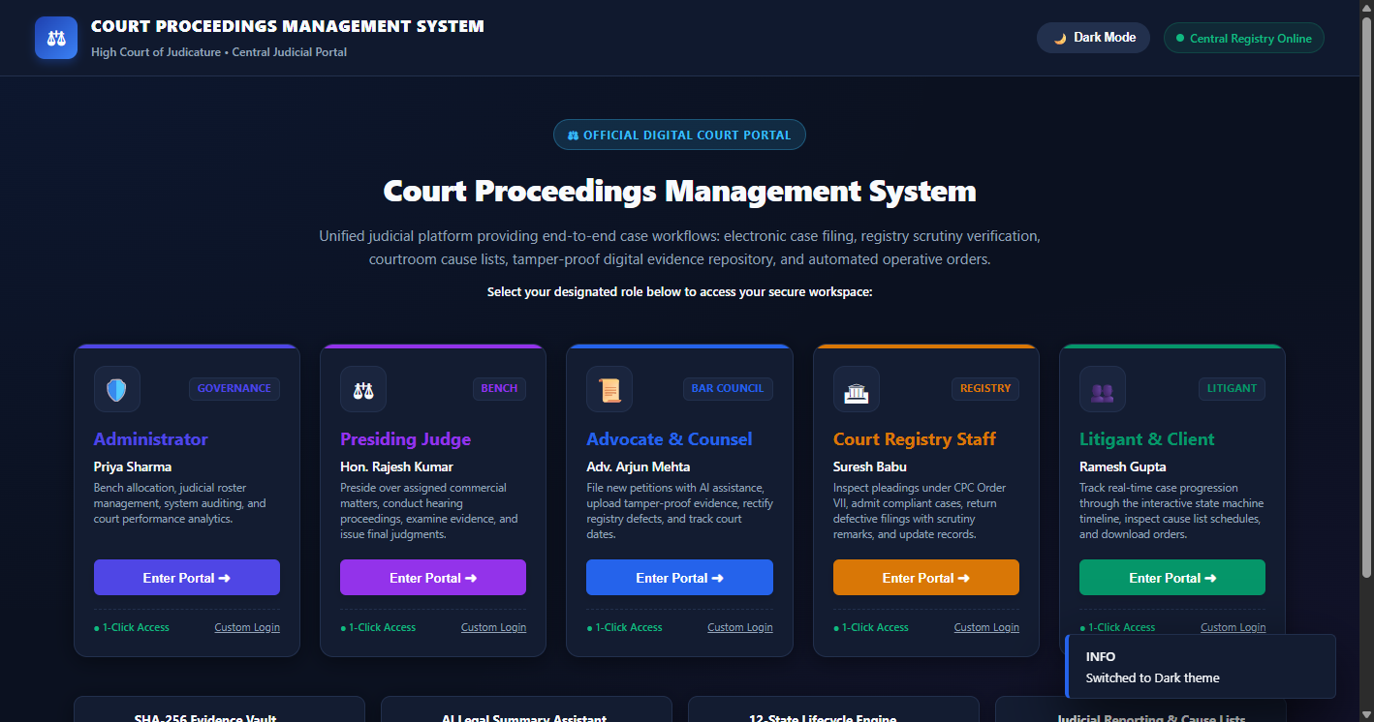

Figure 2: Case Management Dockets Table & Key Performance Metrics
Recommended Presentation Placement: Slide 5

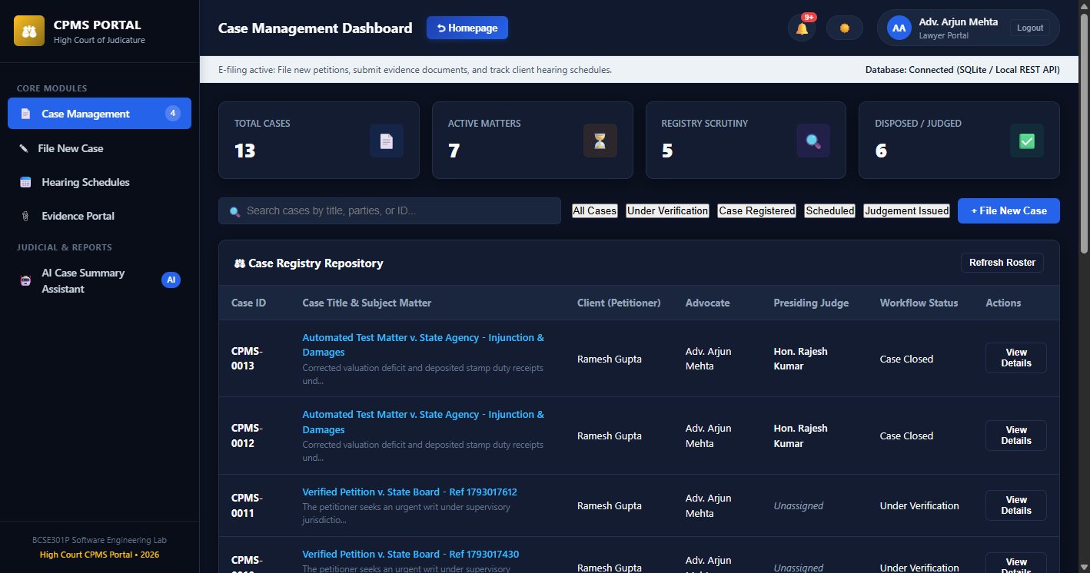

Figure 3: Enforced Role Isolation (Returning to Homepage to Switch Roles)
Recommended Presentation Placement: Slide 5

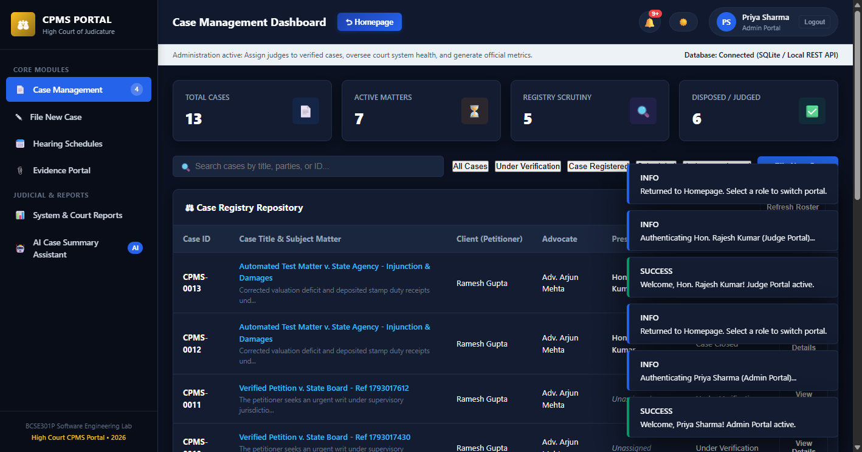

Figure 4: Responsive, Centered Modal Dialog (No Cut-Off or Hidden Buttons)
Recommended Presentation Placement: Slide 4

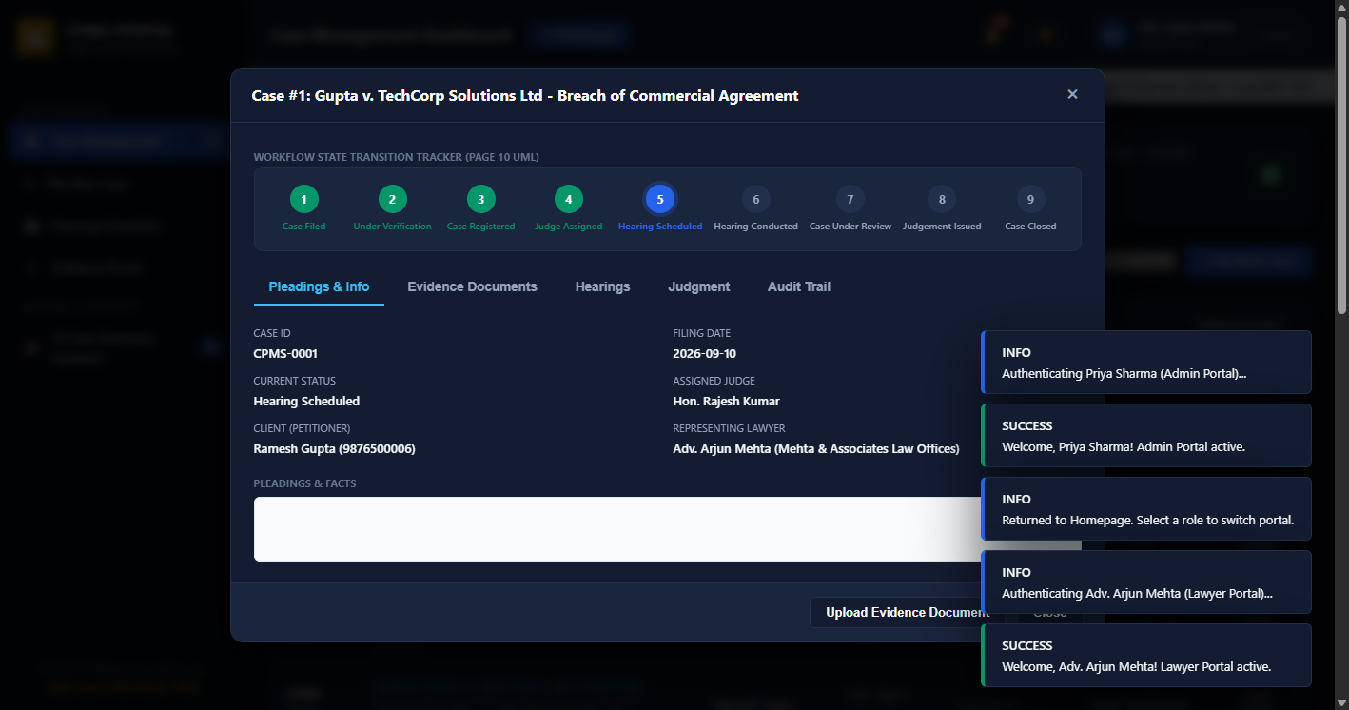

Figure 5: Digital E-Filing Form with Client Association & Case Categorization
Recommended Presentation Placement: Slide 7

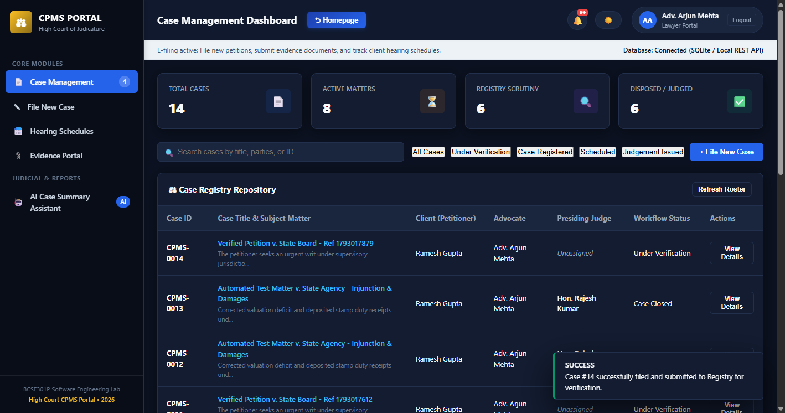

Figure 6: AI Case Summary Assistant in Dark Mode (Extracting IPC Statutes & Claims)
Recommended Presentation Placement: Slide 6

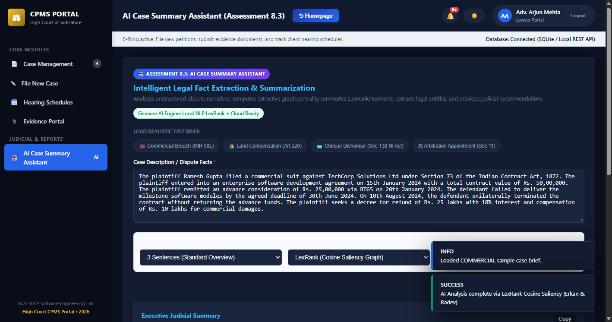

8. Quickstart Commands for Evaluation
1. Start the CPMS Server:
python -m uvicorn backend.app:app --host 127.0.0.1 --port 8080
Open: http://127.0.0.1:8080/
2. Run Automated Pytest API Suite:
python -m pytest tests/test_api_module.py -v
3. Run Automated Selenium Browser Suite:
python -m pytest tests/test_selenium_e2e.py -v
4. Inspect Firebase Status:
http://127.0.0.1:8080/api/firebase/status

