Project Virtuoso
Rina Krevat
Advisor: Prof. Stephen H Lane
University of Pennsylvania

Abstract
This project is an interactive musical conducting experience where audio and visuals are affected by human motion. By capitalizing on popular motion capture technology such as the Microsoft Kinect, we can engage the user in a multi-sensory experience. The user will be able to affect different features of a midi symphony track through a series of gestures similar to those of a musical conductor. A series of particle systems on the screen will also respond to the motions through changes in color, size, and speed. While existing projects of the sort focus solely on either the audio or the visual, the purpose of this project is to explore where these experiences of movement, sight, and hearing meet and enhance one another. This project can have applications in musical education, as well as entertainment – both in the home and in a professional setting.

Project Blog: http://something.blogspot.com
GitHub Repository: https://github.com/krevat/Senior-Design

INTRODUCTION
Itay Talgam said in a TEDx-Jaffa talk, “The joy [of the orchestra] is about enabling other people’s stories to be heard at the same time… this is the true experience of a live concert.” In this project, we add another person’s story to the symphony, yours.
In what ways can we augment the experience of listening to music? By either controlling the sound – the actual medium of music, or by adding another dimension. Being able to affect the amplitude (loudness, volume) or the tempo (speed, rhythmic rate), as well as being able to cue sections of a symphony, would put the listener in control. Introduce the idea of human motion, and the listener is now a conductor. While this idea alone is a great way to merge technology with traditional music, by adding a visual component, the experience is now all-encompassing.
At concerts, particularly rock concerts, different songs are expressed with different stage lighting. Although a lighting designer is in charge of the lights, the design is somewhat random and up to the discretion of the designer. For the virtual conductor in this project, introducing visuals on a screen that correspond with changes in music, can create a visual experience that is not arbitrary, but intrinsically connected to sound and motion.
Aside from being visually and musically stimulating, this project has possible contributions for both the average consumer and for large-scale productions.
- From an educational standpoint, children and teens can get exposed to conducting in a fun and engaging way. By being able to both see and hear what they are dong, the concepts of conducting and musical manipulation can be understood by visual, auditory, and kinesthetic learners alike.
- If the ideas of this system are applied to a larger-scale production, classical music concerts can be enhanced with the light and images just like rock concert-goers have been able to enjoy, with the additional benefit of the visuals being directly related to the conductor in real-time.

Design Goals
The target audience for this project includes families interested in musical education who will use the product recreationally. Further renditions could be of use to professional orchestras interested in adding to their current concert-going experience.

Projects Proposed Features and Functionality
The program will be able to load midi tracks for the use. The user will be able to change the tempo and amplitude of the track, as well as change the different instrumental sections, or in the case of a choral midi track, cue different sections of the choir.

RELATED WORK
Perhaps the most important section of your proposal is related work. In this section, create a taxonomy of prior work relevant for your project. Here you demonstrate that you have read and understand what others in the field have done. This ensures you (1) know the state-of-the-art, (2) are not directly copying others work, and (3) you know the performance levels you must achieve to make a contribution. As you discuss each related work, make note of how each has advanced the field. Then, enumerate how your project extends and enhances prior work.

Relevant Research
In 1991, researchers at Carnegie Mellon University developed a MIDI conductor to allow a conductor to control the tempo of a MIDI performance used as an accompaniment to a live performer [DB91]. By tapping on a key, the computer was able to change the tempo of a MIDI track to assist in rehearsals. With modern motion cature technologies, a conductor need not press on a keyboard key – s/he may simply conduct as usual.
Music is not just a technical medium to be exploited, but an art form to be explored. The associations between color and music have been researched, based on the shared emotions that they evoke. It has even been shown that “the same piece can be associated with different colors on the basis of manipulating tempo alone.” [ST11] This type of research is helpful in visualizing what the music is doing. Faster tempos can be represented by different colors, shades, and brightness values than slower tempos, among other findings.

Motion Capture Methods
The Microsoft Kinect has been a great success with motion tracking technology. With the development of a sign language translator, the Kinect proved that it has the ability to recognize these subtle movements. Sign language, just like any other language, has patterns “linguistic elements, but based on gestures rather than spoken words.” [CLP*13]. While conducting is an art form, it is similar to sign language in that—like Talgam said (see Introduction)—it tells a story.
The Nintendo Wii remote, or Wiimote, is also a way to capture motion. While the data it collects might be less “noisy” than that of the Kinect, because of its internal hardware, the Wii does not distinguish where in the xyz plane the motion is coming from, only relative motion.

Similar Projects
Nintendo released a game called “Mii Maestro” which allows users to wave the Wiimote like a baton and affect the tempo of an orchestral piece [M08]. The obvious pitfalls with this game are that “there’s more to being a conductor than just goading the orchestra into a faster or slower tempo,” [M08] but the game’s appeal proved that conducting music is something that attracts a wide audience and not just classical music connoisseurs.
The Kinductor, developed during Kinect Code Camp in 2011 puts the user “on the podium and in control of a full symphonic orchestra using just your hands and Kinect.” [Kin11] The Kinductor works by using one or both hands to control tempo, and one arm to cue a section of an orchestra. The implementation is simple but does not take actual conducting methods into consideration. It also offers nothing visually stimulating for the user.
Another noteworthy project was the UBS Virtual Maestro, “an interactive conducting system designed by Immersion Music to simulate the experience of orchestral conducting” [NIS*09] To visualize the experience, they used a video of an orchestra and changed the speed of the video to match the tempo of the user. This is one way to augment the conducting experience in a non-abstract way. While effective, it only was able to respond to tempo.

PROJECT PROPOSAL
This project will translate human motion into musical manipulation and visually interesting graphics. The goal is to create a highly unique and enriching experience for the user.

Anticipated Approach
This task will be accomplished by garnering motion capture data. A series of gestures will be translated into meaningful instructions to modify MIDI files using a C++ audio library such as FMOD. Both the Kinect and FMOD seamlessly integrate with Unity, which will serve as the container and visualizer of information.

Target Platforms
The Microsoft Kinect will be used (if it fails, Wii is another option). Code will be written using the Microsoft Kinect for Windows SDK in C++ and the resulting audio/visuals will be displayed through Unity.

Evaluation Criteria
The crux of this project is the experience; it must be seamlessly functioning, and also, importantly, inviting. The important part is to make it appear externally as an interactive art installation, while internally maintaining integrity as an academic endeavor.

RESEARCH TIMELINE
Project Milestone Report (Alpha Version)
- A “complete” product with the few, essential features
- Tempo and amplitude of music will be able to be altered
- Highly rudimentary visuals to represent the instruments on screen

Project Final Deliverables
List what you will deliver at the end of the semester
- More sophisticated sound control
- Particle systems on screen with visual characteristics representing the sound with psychologically accurate characteristics
- Option of an orchestral piece or a four-part choir piece
- Documentation

Project Future Tasks
- This project has potential applications to larger-scale productions, which would not be able to be tackled in six months. By using real lights, instead of an animation on screen, the conducting motions could affect the lighting of a stage in an auditorium. Other iterations of the project with various hardware would be interesting, as would being able to experiment with projection.
- MIDI is the obvious choice for this project because of the way that it is standardized and easily manipulated. Being able to analyze and change real symphony tracks would be difficult (impossible?) and are out of scope of this project.

(remove line)

You will fill in the following sections as you make progress on your project, particularly for the alpha review and the final deliverable. In these sections, list pseudo-code, charts, images, examples, etc. to show what you’ve done over the course of the semester.

Method

RESULTS

CONCLUSIONS and FUTURE WORK
APPENDIX
- Optional Appendix
Some text here. Some text here. Some text here.

(remove line)

References
[CLP*13] | Chen, X., Li, H., Pan, T., Tansley, S. Zhou, M.: Kinect Sign Language Translator expands communication possibilities. Microsoft Research. October 2013.
[DB91] | Dannenberg, R. B., Bookstein, K.: Practical Aspets of a Midi Conducting Program. Proceedings of the 1991 International Computer Music Conference (1998), pp. 537-540.
[Kin11] | Kinductor. http://kinductor.codeplex.com/. 2011.
[M08] | Michaels, S. System lets Wii users conduct a virtual orchestra. The Guardian. 2008.
[NIS09] | Nakra, T., Y. Ivanov, P. Smaragdis and C. Ault. 2009. The UBS Virtual Maestro: an Interactive Conducting System. In proceedings of New Interfaces for Musical Expression 2009 conference. Pittsburgh, PA USA. June 2009.
[ST11] | Schloss, K.B., Tsang, T.: Associations between Color and Music are Mediated by Emotion and Influenced by Tempo. The Yale Review of Undergraduate Research in Psychology (2011), vol. 2, pp. 82–93.

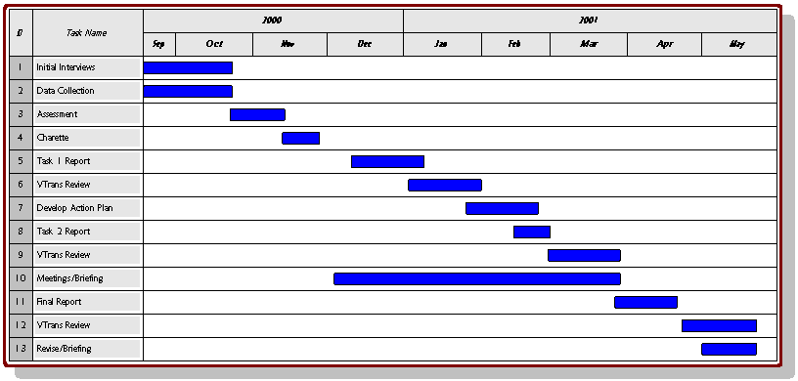
Figure 2: Proposed timeline

http://www.ted.com/talks/itay_talgam_lead_like_the_great_conductors.html

