Designing Interactive Geographic Maps to Demonstrate Ranked Data of Universities Worldwide

Kevin Hennessey, Sarah Buckingham

**Abstract**— We propose a design interactive geographical maps which incorporates ranked data to help students and members of academia assess university performance and overall success.



**1. Introduction**

Our group has decided to investigate the relationships of university ranking metrics and the nations which host those universities. To complete this task, we will develop a visualization that encodes ranked data onto a geographic map. There exist several ranked values within the data set. Our visualization will incorporate multiple interactive elements that will change the visualization displayed. Firstly, the user will be able to determine which ranking will be displayed on the graph at a given time. Secondly, the user will be able to choose whether they wish to display the average university ranking by country, the sum of all university rankings, as well as the minimum university ranking and maximum university ranking by home country.

# Background on the Data

The data set we have chosen to perform this analysis and visualization can be accessed here: https://www.kaggle.com/mylesoneill/world-university-rankings?select=cwurData.csv

This data was compiled through multiple university ranking systems such as The Times Higher Education World University Ranking and the Shanghai Ranking in 2015. The data displays the top 1024 universities and colleges worldwide as well as the country in which they reside in the year 2015. Additionally, the dataset provides other types of rankings, such as the national ranking, ranking based on quality of education, ranking based on quality of faculty, or ranking based on the number of students.

# MethoD

We have provided 3 possible visualizations for the final implementation. The components which will be included within our visualization are university name, country of university, world ranking, national ranking, ranking by quality of education, ranking by faculty, ranking by publication, and ranking by university population. Each of these rankings will be coordinated by the country in which the institution resides. This aspect proposes a problem when a country has multiple universities within the top 1024 world-wide. Coordinating by home country also forgoes being able to investigate the individual institutions which rank the highest. So, in addition to having a geographic map encoded with data values, our visualization will have a secondary aspect which shows institutional rankings. These rankings may be displayed in a simple ordered list such as in design proposal 3, or they could be represented with a bar graph such as design proposal 2. For our geographic map, ranking values will be displayed through luminance of that particular country, and the ranking will also be demonstrated by position within the subplot visualization.

Design solution 1

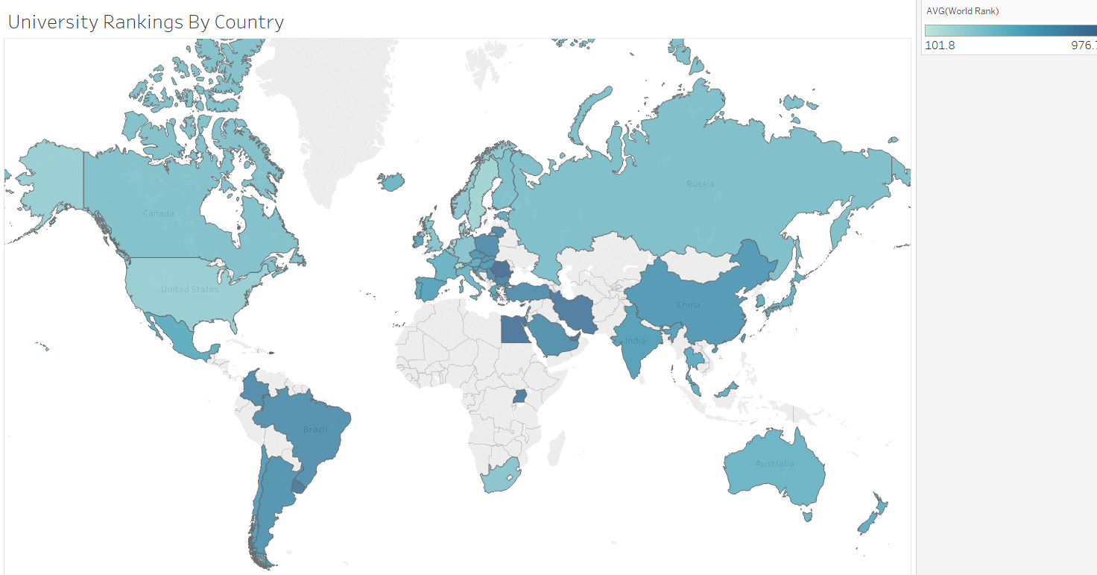

* 1. Design solution 2
  2. A picture containing chart

     Description automatically generated
  3. Design solution 3
  4. A picture containing diagram

     Description automatically generated



# Implementation

For this project we will utilize excel and R for data cleaning and manipulation. We have already pre-processed the data so that a country’s unique code is present within the data. Development of our visualization will be completed utilizing D3.

## Timeline

**Week 1 (3/23 – 3/30):** Gain familiarity with the dataset and perform exploratory analysis. Develop a world map in D3 using GeoJSON. Meeting regularly on Tuesdays after class for ~1-2 hours to work on code and discuss progress.

**Week 2 (3/31 – 4/6):** Build interaction component of visualization. Interaction will modify both statistical measures and type of university ranking.

**Week 3 (4/7 – 4/13):** Complete visualization and write report summarizing process, and result of project. If completion of visualization finishes early, we can begin implementing the list feature in conjunction to our world map. This list feature would follow the same interactive drop-down directions as the world map.

**Final Days (4/14 - 4/16):** Finish final touches of project and review written report. Submit project by 8:59pm on 4/16.

# Discussion

Our group has decided to begin implementing the geographical world map from design proposal 1. There exist several resources already published which will provide a baseline for developing our map graphic. Additionally, such a visualization will be most helpful in answering our task, which is identifying countries that have the highest quality universities based on a plethora of rankings.

Additionally we have incorporated a list ranking in conjunction with the map visualization. This list resembles the right-hand side of proposal 2. As it stands currently, an interactive geographic map does not identify the actual institutions that are highly ranked within our data, but only demonstrate the rankings on a country level. With the inclusion of a ranked list that changes given the values entered by the interactive component of our design, the user will be able to glean far more insights about the rank of institutions and their host country.

We have decided to create a geographic map to be able to represent where the institutions are located since that is a key aspect of the dataset we are using and the questions we are interested in trying to answer. Additionally we have decided to utilize luminance to indicate the values of ranking metrics in our geographic map. We have decided on a luminance encoding because it is difficult to show a specific value, in this design ranking, through size or shape because those are already best represented by keeping the geographic map as is, leaving color to be the best variable to visualize these values instead.

# Final Implementation

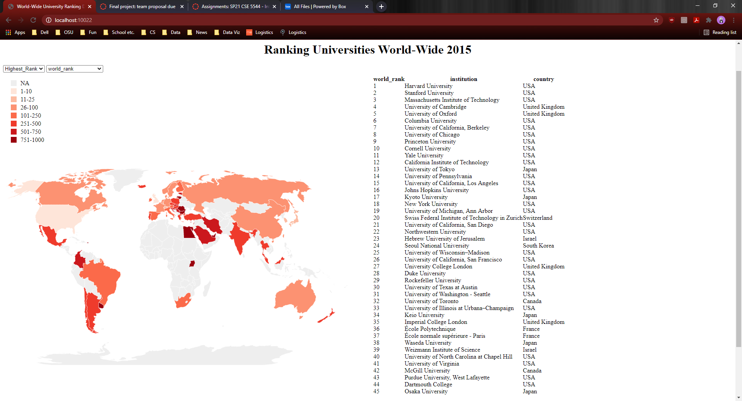

# Conclusion

This project delivered an interactive dashboard which demonstrates the various rankings of international institutions. This visualization provides valuable information to members of academia and students across the world. Additionally, the geographic dimension of this project helps to provide valuable information on the current state of a country’s higher education. Our statistical calculations allow for a multitude of tasks to be accomplished and help provide the user with a more robust understanding of a country’s educational standings and the rankings of its institutions.

The addition of our dual interactive components and ranking table allows further queryable information to the user. The table of ranked higher education institutions expands upon the summary values which are encoded in the luminance of the geographic map. We believe that the combination of text and geographic encoding is both a visually understandable synthesis of the data which are presenting. Overall the visualization offers key insights of the current state of higher education and can be utilized to understand overall trends world-wide academia.